Biosecurity Incident Management System: Marine pest version

Version 1.0, 2020

© Commonwealth of Australia 2020

**Ownership of intellectual property rights**

Unless otherwise noted, copyright (and any other intellectual property rights, if any) in this publication is owned by the Commonwealth of Australia (referred to as the Commonwealth).

**Creative Commons licence**

All material in this publication is licensed under a Creative [Commons Attribution 4.0 International Licence](https://creativecommons.org/licenses/by/4.0/legalcode) except content supplied by third parties, logos and the Commonwealth Coat of Arms.

Inquiries about the licence and any use of this document should be emailed to [copyright@agriculture.gov.au](mailto:copyright@agriculture.gov.au).

C:\Documents and Settings\west merryn\Local Settings\Temporary Internet Files\Content.Word\by.png

**Cataloguing data**

This publication (and any material sourced from it) should be attributed as: Marine Pest Sectoral Committee 2020, *EMP Plan: Biosecurity Incident Management System: Marine pest version*, Department of Agriculture, Water and the Environment, Canberra, November, 2020. CC BY 4.0.

This publication is available at [marinepests.gov.au/what-we-do/publications](http://www.marinepests.gov.au/Pages/map/American-slipper-limpet.aspx)

Marine Pest Sectoral Committee Secretariat

Department of Agriculture, Water and the Environment

GPO 858 Canberra ACT 2601

Telephone 1800 372 746 (local calls) +61 2 6272 5232 (international)

Email [mpsc@AWE.gov.au](mailto:mpsc@AWE.gov.au)

Web [marinepests.gov.au](http://www.marinepests.gov.au/)

Contents

1. Introduction 1

1.1 Authority 1

1.2 Purpose 1

1.3 Scope and application 2

1.4 Existing incident management arrangements 2

1.5 Review 3

2. Context 4

2.1 Marine biosecurity 4

2.1.1 What is a marine pest? 4

2.1.2 What makes a national marine pest emergency? 4

2.2 Biosecurity incidents 5

2.3 Preparing for biosecurity incidents 5

2.4 Managing response to biosecurity incidents 6

2.4.1 Strategic policy and direction 6

2.4.2 Operational policy and implementation 6

2.5 Phases of a biosecurity response 7

2.5.1 Investigation and alert phase 7

2.5.2 Operational phase 8

2.5.3 Stand-down phase 9

2.5.4 Relief and recovery 10

2.6 Application of the Biosecurity Incident Management System 10

2.6.1 Responsibilities at national, state/territory, local and field levels 10

2.7 Classification of biosecurity incidents 14

2.7.1 Level one incident 14

2.7.2 Level two incident 15

2.7.3 Level three incident 16

2.7.4 Level four incident 18

2.7.5 Level five incident 18

3. The Biosecurity Incident Management System 19

3.1 Features of the Biosecurity Incident Management System 19

3.1.1 Flexibility 19

3.1.2 Scalability 19

3.1.3 Common terminology 19

3.2 Incident management principles 21

3.2.2 Functional approach 21

3.2.3 Span of control 22

3.3 The incident management team 23

3.3.1 Incident management function 24

3.3.2 Operations function 27

3.3.3 Planning function 30

3.3.4 Public information function 36

3.3.5 Logistics function 38

3.3.6 Finance and Administration Function 41

Glossary 44

Appendices 46

Appendix A: Associated National Documents 46

Appendix B: Relief and recovery roles in a biosecurity response context 48

# Introduction

## 1.1 Authority

This document has been prepared by a working group and endorsed by the Marine Pest Sectoral Committee on 13 May 2020.

Each response to a biosecurity incident has its own independent set of considerations that are determined by the environment and the marine pest species. The Biosecurity Incident Management Systems (BIMS) document details general response information that can be used by all biosecurity sectors. Additional information outlined in these text boxes relate to marine-pest biosecurity incidents or in some cases other pertinent information.

This manual was developed at the request of the Marine Pest Sectoral Committee (MPSC). The original BIMS manual material has not been altered, additional information is clearly marked. BIMS terminology therefore has been retained despite changes that have occurred in terminology in other management manuals (for example AUSVETPLAN, AIIMS).

For more information on responding to marine pest incidents, refer to the other publications in the Emergency Marine Pest Plan (EMPPlan) series.

## 1.2 Purpose

The purpose of this document is to provide guidance in contemporary practices for the management of biosecurity incident response and initial recovery operations in Australia.

The Biosecurity Incident Management System is a uniform approach for managing the response to biosecurity incidents and can be applied to all biosecurity sectors. It is based on established incident management systems, which are widely recognised and used throughout Australia.

The development and articulation of the Biosecurity Incident Management System is directly linked to the [Intergovernmental Agreement on Biosecurity](http://www.agriculture.gov.au/biosecurity/partnerships/nbc/intergovernmental-agreement-on-biosecurity) (IGAB), Schedule 7 outcome of:

An enhanced level of preparedness and consistent response arrangements across jurisdictions to assist in the effective and timely management of biosecurity incidents and emergencies.

This system contributes significantly towards achieving one of the priority reform areas of IGAB Schedule 7:

Maintain clearly defined and consistent emergency response arrangements that are recognised and practiced by all jurisdictions across each level of government.

Adoption of this system will lead to efficiencies in preparedness activities, such as planning, training and exercising. It will also enhance the existing pool of human resources available from other agencies that may be able to assist in emergency responses.

## 1.3 Scope and application

The scope of this document is primarily focused at using the Biosecurity Incident Management System for managing the response (including initial recovery) to biosecurity incidents.

The system is an ‘all hazards’ approach that:

* represents the most contemporary approach to incident management
* co-exists with and complements current, sector-specific and jurisdictional response arrangements
* is contextualised to a biosecurity environment
* can be applied to all biosecurity incidents, irrespective of sector or scale of response
* provides a guide for personnel working within operations centres established at national, state/territory, local and field levels
* is consistent with contemporary incident management systems employed by other emergency response agencies across Australia and in other countries, including
  + Australasian Inter-Services Incident Management System (AIIMS)
  + Australia Emergency Coordination System (AECS)
  + Critical Incident Management System (CIMS)–New Zealand
  + National Incident Management System (NIMS)–United States.

## 1.4 Existing incident management arrangements

A range of state, territory and Commonwealth legislation, as well as sector-specific policy and plans may be relevant in a biosecurity response, with applicability dependent upon the nature of the incident. Legislation may impose certain obligations and/or provide powers enabling certain response actions. The Control Centres Manual is intended to complement these established arrangements.

Figure 1 shows the documentation framework for biosecurity responses across national and state/territory levels. Details of the relevant national documents are provided at Appendix A.

Figure 1 Documentation framework for biosecurity responses

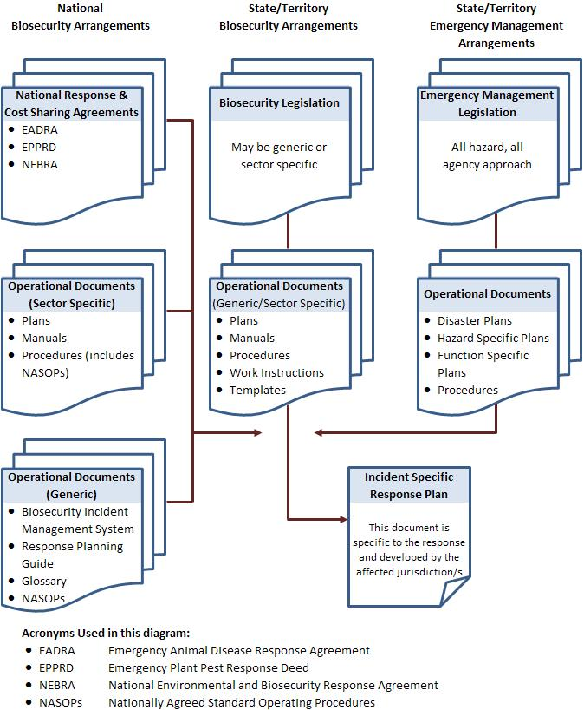

**EADRA** Emergency Animal Disease Response Agreement. **EPPRD** Emergency Plant Pest Response Deed. **NEBRA** National Environmental and Biosecurity Response Agreement. **NASOPs** Nationally Agreed Standard Operating Procedures.

## 1.5 Review

This document will be reviewed regularly by the Biosecurity Emergency Preparedness Working Group.

# Context

## 2.1 Marine biosecurity

### 2.1.1 What is a marine pest?

Marine pests are non-native marine plants or animals that harm Australia’s marine environment, social amenity or industries that use the marine environment, or have the potential to do so if they were to be introduced, established (that is, forming self-sustaining populations) or spread in Australia’s marine environment.

### 2.1.2 What makes a national marine pest emergency?

The following is a guide to determine a national marine pest emergency.

1. The description of the organism matches a species in the Australian Priority Marine Pest List or the National Priority List of Exotic Environmental Pests and Diseases that is either exotic or previously introduced but has extended beyond its known range, or
2. Incursion by an introduced marine pest that fulfils at least one (or more) of the following:
3. the species detected is likely to be of national significance (see the NEBRA for national significance criteria)
4. the species detected has a demonstrable: invasive history, impact on the economy, the environment, human health or social amenity; or the Consultative Committee on Introduced Marine Pest Emergencies (CCIMPE) agrees that it may be a threat
5. the species detected is inferred as having potential to have major impacts in Australia based on predicted or known interactions between the species and characteristics of Australian environments and marine communities
6. one or more relevant translocation vectors still present a risk of introduction..

If the investigation indicates that a marine pest emergency is highly likely, the notifying party will inform the CCIMPE and will direct implementation of the alert phase.

#### Additional things to consider during a marine pest emergency

* Water and vessels are important vectors (including ballast water).
* There are different considerations for control options in an aquatic environment as opposed to the terrestrial environment.
* Extensive bodies of water may be involved, requiring long-term planning and movement restrictions for eradication or control to be successful.
* Accessing incursion sites may require specialist equipment and operators including boats and divers.
* Engagement of industry is usually critical as local knowledge and experience is essential.
* Weather and water conditions may temporarily preclude any activity, including surveillance.
* There may be limited information on the biology of the target organism (see rapid response manual: Nature of the pest).
* Work health and safety risks relating to response operations for example, drowning, enclosed spaces, electricity, hypothermia, slip hazards, dangerous marine species, diving safety.
* Use of chemicals in aquatic environments presents issues not encountered in terrestrial environments, including different regulations.

## 2.2 Biosecurity incidents

Under the [National Environmental Biosecurity Response Agreement](https://www.coag.gov.au/about-coag/agreements/national-environmental-biosecurity-response-agreement-nebra), biosecurity is defined as:

…mitigating the risks and impacts to the economy, the environment, social amenity or human health associated with pests and diseases’ entering, emerging, establishing or spreading. Biosecurity incidents therefore are ‘events which increase the likelihood of biosecurity risks being realised.

Biosecurity incidents range in impact and duration. More severe incidents can have significant impacts on the economy, environment and/or affected communities, and take several months to resolve.

Biosecurity is generally managed within the appropriate biosecurity sectors:

* animal health (terrestrial and aquatic)
* plant health
* introduced marine pests
* vertebrate pests
* weeds
* environmental pests and disease.

Typically, states and territories have primary responsibility for preparing for and responding to biosecurity incidents within their borders. The Australian Government also has a role in providing national leadership and coordination in preparing for and responding to biosecurity incidents.

A unique feature of biosecurity emergency management is that potentially affected industries play a significant role in preparing for and responding to biosecurity incidents. To this extent industry bodies have committed to support preparedness and response to incidents through maintaining national plans and sector-specific response agreements.

## 2.3 Preparing for biosecurity incidents

Preparing for biosecurity incidents includes developing arrangements to ensure that, should a pest or disease outbreak occur, all those resources and services needed to respond can be efficiently mobilised and deployed. Typical preparedness activities include:

* identifying and assessing the risk
* developing policy, arrangements and plans
* establishing resources, systems and processes
* training response personnel
* educating stakeholders and potentially affected industries and communities
* conducting exercises
* evaluating preparedness and response activities.

## 2.4 Managing response to biosecurity incidents

When detected, the usual response to biosecurity incidents is to firstly contain and then eradicate the causative agent or species. This may include surveillance to determine the extent of the problem and likely success of any eradication program, followed by further surveillance, to ensure return to a pest/disease free status has been achieved.

The response to any biosecurity incident will necessitate the establishment of an organisational structure, specific to the management of that incident. This structure will have two functions:

* provision of strategic policy and direction
* planning and implementation of operational activities.

### 2.4.1 Strategic policy and direction

#### Consultative Committee on Introduced Marine Pest Emergencies (CCIMPE)

The CCIMPE provides national coordination for managing marine pest incidents and comprises senior biosecurity representatives from each Australian jurisdiction with coastal borders (the Australian Capital Territory is not represented). The CCIMPE is chaired by the Australian Chief Environmental Biosecurity Officer. The CCIMPE is the national technical body that advises the National Management Group (NMG) whether an incursion by an introduced marine pest represents a marine pest emergency (in a national context), and whether the species involved meets the requirements under the NEBRA for cost sharing. The CCIMPE also coordinates the national technical response and makes recommendations on possible stand‑down phase activities (such as monitoring). All suspected detections of marine pests considered to be exotic to Australia, or range extensions of established marine pests should be reported to the CCIMPE secretariat ([CCIMPE@awe.gov.au](mailto:CCIMPE@awe.gov.au)) within 24 hours.

Where the response to a biosecurity incident does not warrant the establishment of a national consultative committee or national management group, strategic policy and direction for the management of the response to an incident is provided by the affected jurisdiction’s agency executive.

### 2.4.2 Operational policy and implementation

Operational policy and implementation is coordinated through the establishment of operations centres at levels appropriate for the particular incident. The key consideration is that the management of activities and relevant decisions are made at the lowest practical level.

In the case of a biosecurity incident of national significance, the response will require a coordinated approach, across multiple government agencies and affected industries. Consequently, response activities will occur and be managed at multiple levels, these may include:

* national
* state/territory
* local
* field.

These levels and their respective responsibilities are further described in section 2.6.1.

## 2.5 Phases of a biosecurity response

The response to a biosecurity incident can be broken down into three phases: the investigation and alert phase, the operational phase and the stand-down phase.

Not all detections of marine pests will initiate a response involving all phases. Certain responses (such as detection of marine pests on vessels) may be truncated as the vessel’s actions and response may be adequate to mitigate biosecurity risks. The phases are not mutually exclusive and activities of several phases of response may run concurrently.

### 2.5.1 Investigation and alert phase

The investigation and alert phase begins when a notifying party declares that, based on an initial analysis of the pest or disease, an outbreak of a pest or disease exists or has the potential to exist.

This phase exists while accurate confirmation of the diagnosis is made and the likely extent of the pest or disease outbreak is scoped. If requested, a response plan is prepared by the affected jurisdictions.

During the investigation and alert phase:

* investigation and related activities are usually managed using ‘normal business’ arrangements, with staff and operations centres being placed on standby in anticipation of initiating an operational response
* a national consultative committee may be established
* a national management group may be established.

Specific actions taken by national consultative committees and national management groups during the investigation and alert phase are described in national response agreements and supporting documentation.

The initial report of a suspected marine pest may come from port surveys, in water vessel inspections, slipway operators, environmental surveillance, fishers, members of the public, or routine field and surveillance activities.

The alert phase of a marine pest response is in effect while confirmation and identification of a suspected marine pest is pending, and an incident management team is assessing the nature and extent of the suspected incursion. During the alert phase:

* all relevant personnel in the affected jurisdiction are to be notified that an emergency alert exists
* an incident management team is appointed to confirm the identification of the suspected marine pest and to determine the likely extent of an incursion
* preparations for containment measures are commenced to manage the risk of marine pest spread from affected sites (for example, operational boundaries of restricted areas are established for potential vectors)
* the findings of an emergency investigation are communicated to the CCIMPE and the NMG (if convened) to enable a decision to be made on whether to proceed to the operations phase.

If an emergency investigation shows there is no incursion by a marine pest of concern or there is an incursion but it is unlikely to be eradicable, the notifying party will:

* investigate whether existing containment measures are adequate or develop measures to minimise the risk of marine pest spread by human activity
* provide a situation report to the CCIMPE and, convene a CCIMPE teleconference to enable consultation with all jurisdictions
* on reaching agreement from CCIMPE on actions to be taken, request that the stand‑down phase be implemented.

If the emergency investigation shows there is an incursion by a marine pest of concern and it is potentially eradicable, the notifying party will:

* ensure appropriate emergency containment measures are continued to minimise the potential for marine pest translocation, both from and within an infested area
* provide a situation report to the CCIMPE, seek agreement or advice on response measures, and request assistance (if required) to develop a National Biosecurity Incident Response Plan (NBIRP). Delimitation surveillance may be required and advice provided by the CCIMPE on methodology
* submit a NBIRP for urgent consideration by the CCIMPE representatives and request a CCIMPE teleconference to enable consultation with all jurisdictions
* following CCIMPE endorsement, submit the NBIRP to the NMG for consideration of national cost‑sharing arrangements to help resource a national biosecurity incident response—the NMG will manage national coordination of the response, the CCIMPE will provide technical advice on measures required
* the [methodology to guide responses to marine pest incursion under the National Environmental Biosecurity Response Agreement](https://cebra.unimelb.edu.au/research/data-and-information/response-to-a-marine-pest-incursion) (NEBRA) can be used to assist undertaking a benefit-cost analysis, which is a requirement if seeking national cost-sharing under the NEBRA.

### 2.5.2 Operational phase

The operational phase commences when the presence of the pest or disease is confirmed and activities under a response plan are implemented. Typically the aim of the operational phase is to contain and/or eradicate the pest or disease.

During the Operational Phase:

* operations centres will be established at the appropriate levels (national, state and/or local), to manage strategic and operational aspects of the response.
* a national consultative committee may be established
* a national management group may be established.

Specific actions taken by appropriate national consultative committees and national management groups during the operational phase are described in national response agreements and supporting documentation.

Upon initial containment or eradication of the pest or disease, further work may be required to determine proof of freedom. Proof of freedom may include a period of research and/or surveillance activities and will end when the national management group determines (on advice from the national consultative committee) that the response has been effective.

If it is determined that the pest or disease cannot be eradicated a transition to managing the pest or disease outbreak may take place. This would occur outside the current national cost sharing agreements.

In responses where national cost-sharing is being considered by the NMG, the Operations phase commences when the marine pest (emergency) response is confirmed. During the operations phase of a national biosecurity incident response:

* all relevant personnel and agencies should be notified that a response is being undertaken in the affected jurisdiction/s
* control measures initiated in the alert phase should remain in place to manage the risk of marine pest spread from affected sites
* measures to eradicate the marine pest from infested sites if advised by the CCIMPE should be implemented
* information should be documented for continued actions and future reference
* regular situation reports should be communicated to the CCIMPE forum.

### 2.5.3 Stand-down phase

The stand-down phase commences when either:

* the investigation and alert phase fails to confirm the presence of a pest or disease
* the response strategy has been effective
* eradication of a pest or disease is not considered feasible, cost effective or beneficial

or

* the relevant national management group formally declares that the pest or disease outbreak is over.

During the stand-down phase:

* operations centres will
  + develop and implement an on-going management program, if required
  + recover, decommission and dispose of stores and equipment
  + arrange appropriate archiving of all records
  + finalise accounts
  + conduct debriefings and record all learnings
  + develop an action plan to address learnings
* the national consultative committee, if established for the response, will conclude its activities and stand down
* the national management group, if established for the response, will conclude its activities and stand down.

Specific actions taken by national consultative committees and national management groups during the stand down phase are described in national response agreements and supporting documentation.

The stand‑down phase is in effect when, following appropriate consultation between the affected jurisdiction and the CCIMPE, all agree that there is no need to progress or continue with a national biosecurity incident response. During the stand‑down phase:

* a systematic approach to winding down operations must be taken to ensure operational effectiveness is not jeopardised
* all personnel, agencies and industry contacts involved in the emergency response are to be notified of the stand down
* where pest is not eradicable, alternative long-term management options are to be considered and the most appropriate option—given the risk and required investment—implemented
* transition to management or recovery will be considered as part of stand down
* the outcomes of the response, and information on the management of the species going forward, should be communicated to stakeholders.

The stand‑down phase must commence once operational objectives have been achieved, or otherwise in accordance with advice provided by the CCIMPE and agreed by the NMG. The advice that an emergency eradication operational response is no longer needed must be communicated to the affected jurisdiction/ s.

### 2.5.4 Relief and recovery

Recovery is the coordinated process of supporting emergency-affected individuals and communities in the reconstruction of the physical infrastructure and restoration of emotional, social, economic and physical well-being and the environment. In relation to biosecurity emergencies, restoration of environmental values may be of particular concern and a significant component of the recovery effort.

Relief and recovery is likely to include coordination of support and the provision of information to affected communities to mitigate the impacts of a pest or disease.

Appendix 2 provides guidance on relief and recovery roles in the context of biosecurity incidents.

## 2.6 Application of the Biosecurity Incident Management System

### 2.6.1 Responsibilities at national, state/territory, local and field levels

The Biosecurity Incident Management System has application at the national, state/territory, local and field levels. While it is acknowledged that the focus and structure will be different at each of these levels the key principles that underpin the Biosecurity Incident Management System are equally applicable.

The Biosecurity Incident Management System is reliant on interaction with broader biosecurity response arrangements, including national consultative committees and national management groups, as well as interaction with the whole of government emergency management arrangements. As shown in Figure 2, the national consultative committees, national management groups and agency executives all collaborate to provide direction for the state and/or national Coordination Centres.

Figure 2 Responding to biosecurity incidents

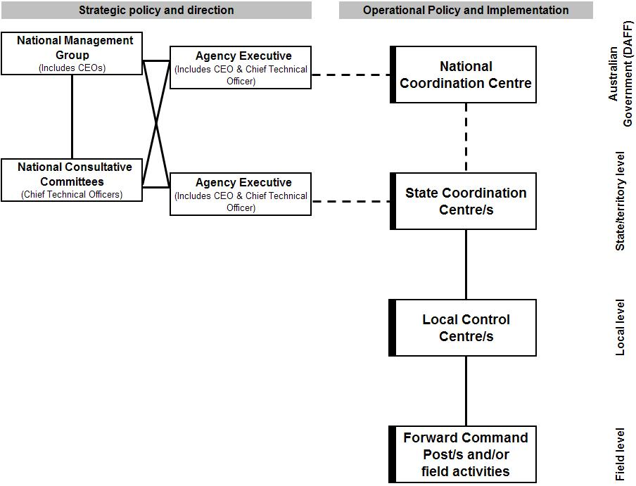

The Agency Executive has an integral role in the management of a biosecurity incident and they form a vital link between their jurisdiction and the national aspects of the response. In this role the Agency Executive have responsibility for the higher level policy direction, that is put into effect through national, state, local and field level activities.

This Biosecurity Incident Management System also recognises that state, territory and national emergency management arrangements apply (or have relevance) to biosecurity incidents. In cases where an effective response requires resources beyond the capacity of the state/territory biosecurity agency additional resources will be sought in accordance with state/territory whole-of-government and/or national arrangements. This requires effective liaison with the relevant state/territory emergency management agency.

#### National responsibilities

The Australian Government Department of Agriculture, Water and the Environment has developed arrangements for managing its responsibilities during the response to biosecurity incidents. These arrangements include an Incident Management Framework which is consistent with the Biosecurity Incident Management System and complementary to arrangements described in sector-specific arrangements, such as AUSVETPLAN, EMPPlan, AQUAVETPLAN and PLANTPLAN. This ensures a nationally coordinated and consistent approach to the management of biosecurity incidents.

When established, the centre from which the Australian Government Department of Agriculture, Water and the Environment manages its responsibilities is known as the National Coordination Centre. In some circumstances the Australian Government may have responsibility for the overall control of response activities. These situations are rare and usually occur where there is little or no state/territory involvement in the response (such as Commonwealth land or off-shore incidents).

#### State/territory responsibilities

During the response to a biosecurity incident, the affected state/territory biosecurity agency will manage its responsibilities in accordance with the relevant national, state and/or territory biosecurity arrangements and state/territory emergency management arrangements. This may include the establishment of a State Coordination Centre.

When established, the State Coordination Centre will have primary responsibility for the coordination of activities across the state and generally should not become involved in the management of on ground activities. In some circumstances it may be appropriate to combine state and local operations in one centre. If this occurs staff need to be able to separate strategic, state wide activities, from operational activities, being conducted at a local or field level.

#### Local responsibilities

During the response to a biosecurity incident, the responsible state/territory biosecurity agency may choose to establish Local Control Centres to manage certain operational aspects of the response.

When established, the Local Control Centre will have primary responsibility for planning, conducting and supporting all operational activities in its geographical area of responsibility.

Depending on the complexity or extent of the response it may be necessary to establish more than one Local Control Centre. The focus of each Local Control Centre’s activities will be guided by the objectives established at the state level. The Local Control Centre’s Incident Management Team will identify what needs to be achieved by the Local Control Centre, how this will be achieved and allocate responsibilities. These arrangements will normally be documented in an Incident Action Plan which is approved by the Incident Manager at the local level and disseminated (either in writing or verbally) to those with responsibility for implementing activities.

At the local level all major incident management functions will normally be applied, namely Incident Management, Operations, Planning, Public Information, Logistics and Finance and Administration.

In the case of a level one or level two incident (see section 2.7), the Local Control Centre may be the highest level of control applied to the response. In this case the state/territory’s Agency Executive will provide the required policy and strategic direction for the management of the incident.

#### Field responsibilities

At this level, teams will be deployed by the Local Control Centre to undertake tasks in the field including:

* investigation–sample collection to enable diagnosis or identification of a pest or disease and/or surveillance tasks to determine the extent of a pest or disease spread
* infected/infested premises operations–tasks associated with managing containment and treatment or eradication of a pest or disease at an infected/infested property or place.

When planning tasks in the field, close liaison with local water user groups (marinas, water sports clubs, tour operators, fishers, aquaculture operators, etc.) should be considered. In many cases water users will have the best knowledge of local conditions and also equipment suitable for working in the field.

Decontamination of potentially infested material including boats, aquaculture equipment, fishing equipment etc. will require setup of appropriately contained decontamination points.

During a marine pest response, areas may be categorised (Figure 3) to direct response actions.

* Infested Area (IA)—may be all or part of an area in which a marine pest emergency is known or deemed to exist (for example pending confirmation of marine pest identification).
* Dangerous Contact Area (DCA)—area in proximity to an IA in which the marine pest has not been detected but due to potential for infestation will be subject to movement restrictions as for IA. This area may increase in the short term due to tidal movements or local currents carrying marine pest propagules.
* Suspect Area (SA)—area that is linked to the IA through tracing or identified as an ‘at-risk’ area, with the potential to harbour the marine pest. Again, knowledge of currents and other water movements is essential to predict potential movements along with knowledge of vessel movements in the region.
* Restricted Area (RA)—declared or gazetted area around an IA that is subject to intensive surveillance with movement controls on potential vectors.
* Control Area (CA)—a declared or gazetted area that surrounds a RA in which defined conditions apply to the entry or exit of potential vectors or specified risk items. Movement of infrastructure out of this area may be controlled and may include restrictions on movement of materials unless appropriate biosecurity measures are applied (for example cleaning or decontamination for equipment).

Figure 3. Areas used during a marine pest response

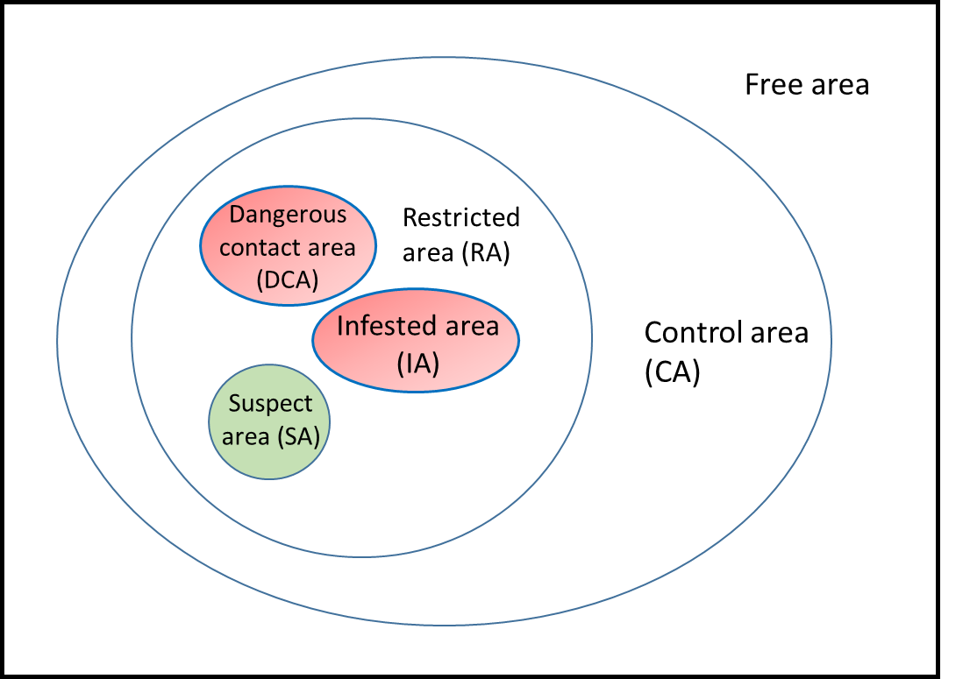

Public access to boat ramps, jetties, recreational fishing areas, etc., may be restricted during a response. This can be problematic if long-term restrictions are applied.

If an area can be isolated (for example a gated marina, a canal area with controls of water movement) immediate isolation is an ideal measure to limit spread of marine pests.

In most marine areas currents and tides will aid potential spread of marine pest propagules (from either spawning or, in some cases, fragments). Knowledge of these will be critical in delimitation and threat assessment. Information on the local habitat together with knowledge of the environmental requirements and biology of the marine pest are essential as lack of habitat availability may also limit spread (for example a species requiring hard rocky surfaces may not survive settlement on sandy substrates along beaches).

If required, one or more Forward Command Posts may be established to manage field activities in a finite geographic location with a focus on achieving an identified task or range of tasks, allocated by higher level command.

Reasons for establishing a Forward Command Post include to:

* manage activities associated with a number of premises in a small geographic area
* act as an assembly point for activities associated with remotely located premises
* manage specific operational tasks that need to be undertaken within a specified area, such as vaccination, trapping, or aerial spraying.

When established the Forward Command Posts will report directly to the Operations Manager in the Local Control Centre.

## 2.7 Classification of biosecurity incidents

Not all incidents and responses are the same. Therefore, there is a need to identify and communicate the classification or level of incident, to ensure that the appropriate level of coordination, resources and support are provided in order to achieve a successful resolution. This section provides guidance on the levels of incident response and their application.

### 2.7.1 Level one incident

A level one incident is a localised response, being managed by local resources with little or no external support. Facilities for managing the response are small-scale.

Different organisational structures may be applicable to a level one incident depending on context. In Figure 4, the Incident Manager manages all functions and the Agency Executive provides appropriate strategic policy and direction.

Figure 4 Level 1 incident organisational structure (undelegated)

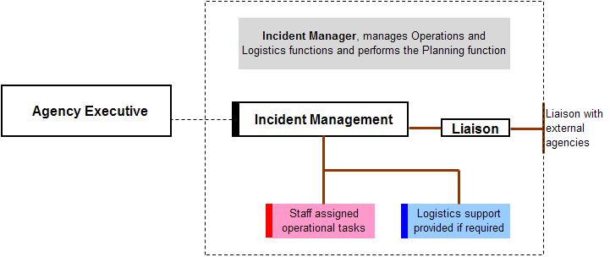

In Figure 5 the Incident Manager delegates the Operations function, manages the Logistics function and performs the Planning function. The Agency Executive provides appropriate strategic policy and direction.

Figure 5 Level 1 incident organisational structure with delegated Operations function

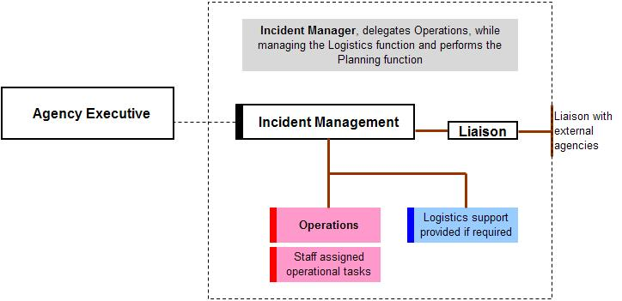

In Figure 6 the Incident Manager delegates the Operations function to one person and the Planning and Logistics functions to another. The Agency Executive provides appropriate strategic policy and direction.

Figure 6 Level 1 incident organisational structure with delegated Operations, and Planning and Logistics functions

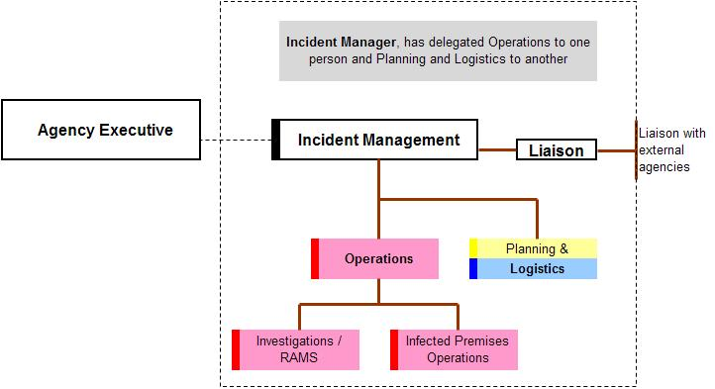

In these three examples, all activities are managed by the Incident Manager. They utilise the organisations’ normal facilities and infrastructure, without the need for the establishment of a dedicated State Coordination Centre.

### 2.7.2 Level two incident

A level two incident is a local or regional response, being managed primarily at the local level, with some support being coordinated by the state. A dedicated Local Control Centre and perhaps small-scale State Coordination Centre may be required to manage the response.

One possible arrangement (Figure 7) consists of a Local Control Centre where the Incident Manager has delegated the Operations, Logistics and Planning functions. The Local Control Centre manages all activities within its geographic area of responsibility. A small State Coordination Centre is established from which strategic planning is undertaken and some logistical support coordinated. The Agency Executive provides strategic policy and direction to the Incident Manager within the State Coordination Centre. A strong link exists between state and local levels to ensure operational activities are managed in line with the strategic policy and direction.

Figure 7 Level 2 incident organisational structure

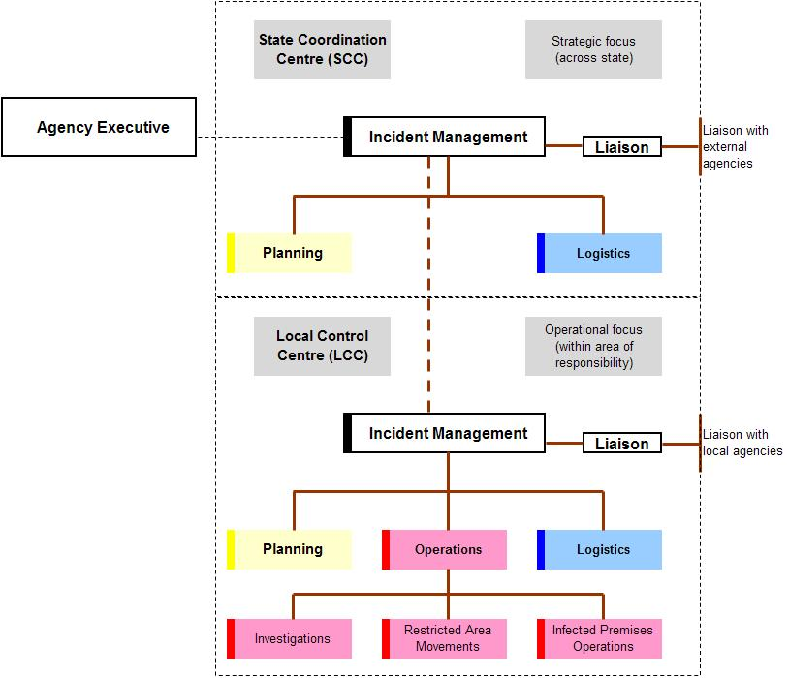

### 2.7.3 Level three incident

A level three incident is a state wide response, being managed primarily at a state/territory level. This may include the establishment of one or more Local Control Centres and a fully operational State Coordination Centre. Some resource support may be provided from outside the responsible agency or state.

In the example in Figure 8, some operations functions have been identified at a state level. This would only occur if the State Coordination Centre has taken responsibility for operational activities outside the Local Control Centres areas of responsibility.

Figure 8 Level 3 incident organisational structure

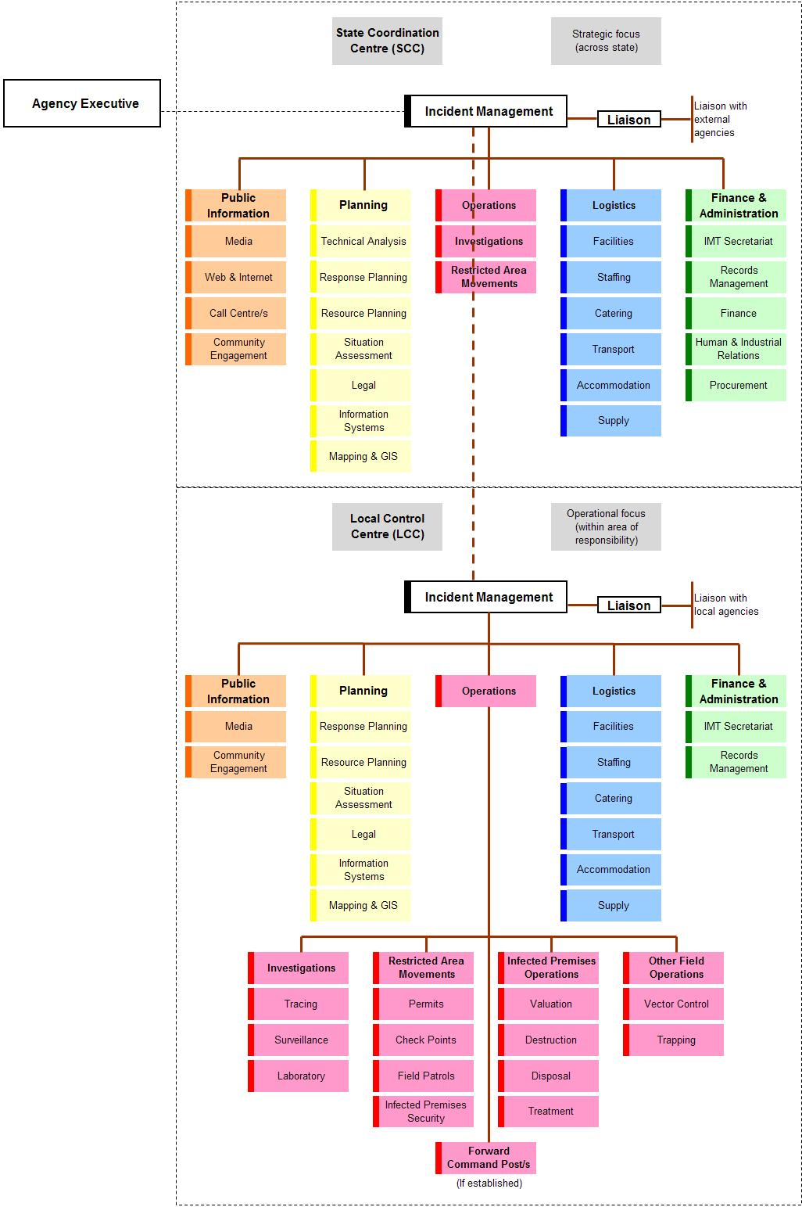

### 2.7.4 Level four incident

A level four incident is where one or more jurisdictions are involved in managing the response to a biosecurity incident. One or more of the involved jurisdiction’s resources or established arrangements are insufficient for the response and the National Coordination Centre is required to coordinate nationally available support to the affected jurisdictions.

### 2.7.5 Level five incident

A level five incident is where one or more jurisdictions are involved in managing the response to a biosecurity incident. The national resources are insufficient for the response and the National Coordination Centre is required to coordinate international support to affected jurisdictions.

Irrespective of the level of incident response within a jurisdiction the National Coordination Centre may be operating to deal with national issues, such as quarantine and/or international trade issues, which have little or no immediate impact on the level of response applied by a state/territory.

# The Biosecurity Incident Management System

The initial response to any incident or emergency is usually reactive in nature. Available resources are dispatched to the site of an incident and upon arrival, decisions are made as to how resources are employed and actions are adjusted based on available resources and immediate operational needs.

Incident management, through the response planning process will move the initial reactive response to a well-planned, proactive operation that allocates incident resources to meet the response aim and objectives and allows for continual assessment of progress towards resolving the incident.

## 3.1 Features of the Biosecurity Incident Management System

The Biosecurity Incident Management System forms the basis for a consistent and effective management framework for all biosecurity incidents. It provides:

* flexibility
* scalability
* common terminology.

### 3.1.1 Flexibility

The organisational structure required to manage any given incident is based upon the nature and scope of that particular incident. If one individual can manage all major functional areas simultaneously, no further organisation is necessary. If, due to the scale or workload of the response, one or more of the functional areas requires its own management structure, staff will be identified to be responsible for a particular area.

Within the Biosecurity Incident Management System the first functional management assignments will be made by the relevant Incident Manager. These assignments may be made in the order of Operations, Logistics, Planning, Public Information and finally Finance and Administration. This is not a set rule and the needs of the incident may mean that a different order is applied.

### 3.1.2 Scalability

The organisational structure required to manage an incident is developed in a modular fashion and is based on the operational needs of the particular incident. This allows it to be scaled up and down as the incident progresses and the operational tempo varies.

In response to level one or level two incidents the organisational structure may be small and compact, and operating only at a single local level, within one jurisdiction. In response to level three or higher incidents it may be necessary to establish response structures at multiple local and state locations, as well as at a national level.

### 3.1.3 Common terminology

For the Biosecurity Incident Management System to be effective across sectors and levels of incident response, including multi-jurisdictional or national incidents, common terminology must be applied to organisational elements, such as position titles, resources and facilities.

Throughout this document, terminology that is consistent with other incident management systems has been applied and should be incorporated into the management of biosecurity incidents. Some examples include:

* command, control and coordination
* strategic, operational and tactical planning.

These terms and their application in a biosecurity context are defined here.

#### Command

This relates to the internal direction of the members and resources of an organisation in the performance of the organisation’s roles and tasks. Authority to command is established in legislation or by agreement with an organisation. Command relates to organisations and operates vertically within an organisation.

#### Control

This is the overall direction of activities in an emergency situation. Authority for control is established in legislation or in an emergency plan and carries with it the responsibility for tasking other organisations in accordance with the needs of the situation. Control relates to situations and operates horizontally across organisations.

#### Coordination

This is the bringing together of organisations and elements to ensure an effective response, primarily concerned with the systematic acquisition and application of resources (organisation, human and equipment) in accordance with the requirements imposed by the threat or impact of an emergency. Coordination relates primarily to resources and operates vertically within an organisation, as a function of the authority to command, and horizontally across organisations, as a function of the authority to control.

#### Strategic planning

This refers to the practice and science of employing a national, state and/or territory capacity to resolve the incident. Strategic planning will inform operational planning by establishing strategic objectives. It is generally of a long-term nature and is mindful of the impact that other factors may have on achieving the overall response objectives.

#### Operational planning

This refers to the planning and conduct of response activities. It is at this level that strategy is implemented by assigning activities, tasks and resources to the response. Operational planning will focus on the upcoming operational period but will consider planning requirements for subsequent operational periods.

#### Tactical planning

This refers to the planning and conduct of on-ground activities and is characterised by the application of resources and actions to achieve a specific objective. Tactical planning will focus on the duration of the task at hand and is undertaken within individual task teams.

## 3.2 Incident management principles

The Biosecurity Incident Management System is underpinned by three key principles:

1. Response to incidents is managed through setting, communicating and achieving objectives (management by objectives).
2. A response framework is established that is based around the functions that need to be performed (functional approach).
3. The number of people or groups being supervised by each person involved in the response is limited to a workable number (span of control).

#### 3.2.1 Management by objectives

This is a management style where the Incident Manager, under the direction of the responsible agency’s executive and in consultation with the Incident Management Team, determines how the desired outcomes will be achieved. These outcomes, or objectives, are then communicated, through the chain of command, to everyone involved so they know and understand the direction being taken during the response operation.

In biosecurity incidents, response policy and strategic direction is often provided by the responsible agency’s executive, who have responsibility for negotiating and determining an agreed national approach to a biosecurity incident, through the relevant national consultative committees and national management groups. These response policies and strategic directions are communicated to Incident Managers who have responsibility for developing and implementing an operational response to the incident. This will include the development and communication of response objectives, which may be identified at the national, state/territory and local levels. In any case, objectives need to be consistent with those set at the higher level.

The overall aim, objectives and response strategies are documented in a strategic, incident-specific response plan. These higher level objectives are interpreted at each level of the response and appropriate operational objectives developed at each level. These operational objectives and processes should be articulated in an Incident Action Plan. The level of detail included in Incident Action Plans will vary depending on the level at which they are being developed and applied.

In the case of a marine pest response, an incident-specific emergency marine pest response plan will be created.

### 3.2.2 Functional approach

This refers to the use of specific functions to manage the response to an incident. Although these functions are consistent through national, state/territory and local levels of response, their application at each of these levels may vary, depending on the objectives being set for the level at which they are being applied. The Biosecurity Incident Management System is based around six functions.

#### Incident Management

This is the overall management of activities associated with an operations centre, site or geographic location, necessary for the response to an incident. The area or responsibilities being managed must be clearly defined to ensure that there is no encroachment on other’s area of responsibility. Incident management can be applied in the form of command, control and/or coordination, and may also be referred to as Incident Command or Incident Control.

#### Operations

This is the tasking and application of resources required to respond to the incident in order to achieve the operational objectives set by the Incident Management function.

#### Planning

This is the collection, collation, analysis (or interpretation) and dissemination of information. It also includes the development of the written plans required for the response to the incident.

#### Public Information

Sometimes referred to as public relations, this is the management of public information and perceptions. This function is primarily responsible for interfacing with the public and media with incident related information requirements.

#### Logistics

This is the acquisition and provision of human and physical resources, facilities, services and materials required to support achievement of the objectives set by the Incident Management function.

#### Finance and Administration

This is the management of records and information flow required to ensure the smooth and efficient running of an operations centre. It may also include the administration of finance, human resource and/or procurement processes associated with the response.

#### Liaison (optional)

This additional optional function may be included in the framework. The Liaison function acts as the point of contact for communication and coordination between the Incident Management function and external agencies and organisations. It is normal for external organisations to provide a Liaison Officer to represent their organisation, with authority, and to work within an operations centre.

Where external resources are employed within the incident management framework, they work as part of the identified function. For example, an emergency service organisation may be employed to perform an operational function. This would involve them working within the Operations section of the operations centre.

An Incident Manager is responsible and accountable for all these functions (Figure 9). Depending on the size and complexity of the incident, they may elect to delegate one or more functions.

Figure 9 Incident management functions

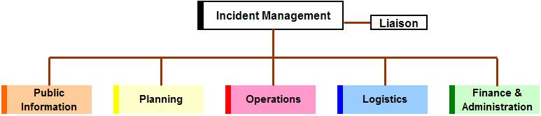

### 3.2.3 Span of control

This relates to the number of groups or individuals which can be successfully supervised by one person. Where span of control is exceeded, the supervising officer should consider delegating responsibilities to others. Conversely, where the span of control is lower or tasks are fewer (for example in a de-escalating incident) the supervisor may resume responsibility or reorganise delegation to contract the structure to fit the tasks required.

During the response to biosecurity incidents, the environment in which supervision is required can rapidly change and become detrimental if not managed effectively. Under span of control, up to five reporting groups or individuals is considered to be desirable, as this maintains a supervisor’s ability to effectively task, monitor and evaluate performance.

## 3.3 The incident management team

The Incident Management Team is established by the Incident Manager. This team works from its designated operations centre in order to achieve the objectives established for that centre.

Staff performing incident management functions should have the appropriate skills, knowledge and experience. Where this is not possible, appropriate training, coaching and/or mentoring should be provided until such time that staff are comfortable with the functions for which they have responsibility.

The Incident Manager is responsible for identifying the staff required to perform the incident management functions. The Incident Manager may choose to undertake all functions or delegate them to other staff. As a response matures it is likely that the number of staff performing various functions will change.

The Incident Manager may choose to appoint staff to defined functions, or appoint staff to work within a section of the response, in which case the section manager will have responsibility for identifying the functions being performed by staff. The first approach provides certainty to staff about duties but can be inflexible. The later approach provides more scope for flexibility but may rely on staff being multi-skilled across a range of functional roles.

Figure 10 identifies the range of functions that may be needed and their relationship to each other. Functions may be combined. For example, in a Local Control Centre the Logistics function may combine with the Finance and Administration function to work as one section.

Figure 10 Incident management framework

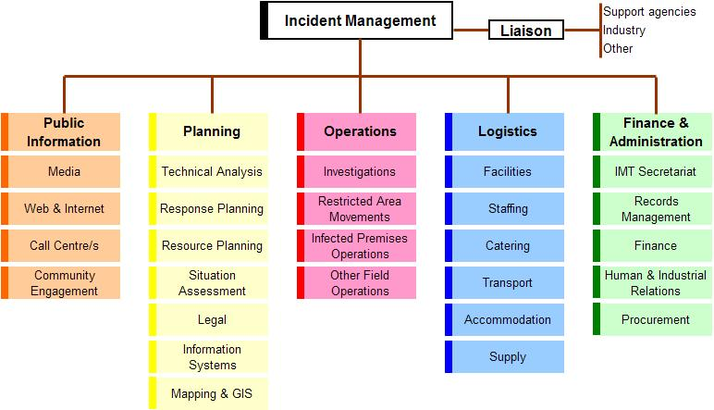

### 3.3.1 Incident management function

The Incident Management function is responsible for the overall management of activities within a particular geographic area of responsibility.

At a local level, this could apply to the ‘control’ or ‘restricted area’ assigned as the responsibility of a particular centre and only in relation to activities that have been assigned as the responsibility of that centre.

At a state level, this could apply to the activities across the state, however it is recognised that at a state and national level this function is more about coordination of support services and resources, rather than actually controlling activities.

The Incident Management function covers several roles (Figure 11). In small-scale incidents the Incident Management function may be performed by one person (such as the Incident Manager). In larger-scale or complex incidents it may be necessary to use a small team of people to perform this function.

Figure 11 Incident Management function

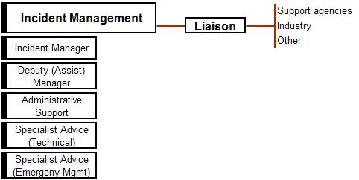

#### Incident Manager

This role is the focal point for the management of all activities, within the operations centre’s area of responsibility. Specific responsibilities may include:

* appoint staff to perform functions within the Incident Management Team
* oversee activities performed by the relevant Incident Management Team
* ensure response activities are conducted in accordance with jurisdictional legislation and nationally agreed response arrangements
* report to the agency’s executive (through appropriate chain of command) on implementation and progress of planned response activities
* liaise with support agencies, industry and other organisations, through their designated Liaison Officers.
* ensure a safe work environment is established and maintained. If necessary Safety Officers can be appointed who work across all functional areas of the organisation.

During a marine pest response:

* the Incident Manager need not have marine pest expertise, however knowledge of the marine environment and associated factors is recommended
* the Incident Manager should be supported by [technical specialists](#_Specialist_Advice_(Technical)) who do have knowledge of the marine pest.

#### Deputy (or Assistant) Incident Manager

This role assists the Incident Manager to undertake specific responsibilities. Depending on the complexity of the incident it may be necessary to appoint more than one Deputy Incident Manager. When appointed this role may:

* relieve or stand in for the Incident Manager during periods of absence
* be assigned oversight responsibilities for specific functions within the response.

#### Administrative (or Executive) Support

This role provides administrative support to the Incident Manager. Specific responsibilities may include:

* coordinate routine correspondence and communication (verbal and electronic) on behalf of the Incident Manager
* manage the Incident Manager’s diaries and appointments
* other duties directed by the Incident Manager.

#### Specialist Advice (Technical)

This role provides guidance and advice to the Incident Manager on technical issues associated with the response. This may be performed by an individual specialist or may include the establishment of expert working groups to consider and advise on specific issues of a technical nature.

Technical specialists supporting a marine pest response may include:

* relevant stakeholders or industries such as capture fisheries, aquaculture, port authorities, marinas
* taxonomists
* Field surveillance specialists, including divers and ROV operators biologists
* epidemiologists
* geospatial analysts
* animal welfare advisors*
* environmental protection agencies
* economic and environmental impacts experts
* meteorologists
* water managers
* toxicologists or contaminants experts
* flow modelling experts
* engineers
* W/O H&S experts.

Note: Animal welfare legislation and regulation may differ across jurisdictions. Information on destruction of aquatic animals can be found in the AQUAVETPLAN destruction manual and the EMPPlan Marine Pests Management Manual. Heightened perceptions of animal welfare issues may mean that, even where there are no requirements for welfare of, for example invertebrates, care on treatment and messaging is required.

#### Specialist Advice (Emergency Management)

This role provides guidance and advice to the Incident Manager on emergency management policy, procedures and processes, including the implementation and application of the Biosecurity Incident Management System to the specific incident.

#### Liaison function

The Liaison function creates the link between the Incident Management function and external agencies and organisations. In a small-scale response this function may be undertaken by the Incident Manager or Deputy Incident Manager. In a large-scale response it may be necessary to appoint dedicated staff to manage this function. Using this approach means that external agencies and organisations are required to provide Liaison Officers who work through the Liaison function.

When appointed, agency or organisation Liaison Officers should come with:

* the ability to communicate with their own agency or organisation (such as radio, telephone, internet)

and

* the authority to make decisions and commit resources on behalf of their agency or organisation.

Liaison Officers may need to perform a function within the Incident Management Team that is relevant to their agency or organisation’s area of responsibility. For example a Liaison Officer, representing an affected industry, may need to assist with aspects of Community Engagement (within the Public Information section) and/or Situation Assessment (within the Planning section). In such an example one person can ‘wear many hats’ and needs to be mindful of the separation that exists between the functions and their specific responsibilities at a point in time.

During a marine pest response, industry and community liaison is vital to ensure adequate access to sites, local navigational and environmental knowledge, and sensitivities including sites of cultural significance.

##### Local knowledge

This includes; recreational and wild catch fishers, boat charterers, aquaculture operators, local environmental groups, Indigenous Australians.

##### Liaison with public

Responses may involve a degree of public or interest group engagement. This includes liaison with stakeholders who use marine environments for recreational purposes (for example recreational fishers, divers, boaters) and other groups who may be affected by restricted access to waterways.

##### Liaison with industry

It is important to develop relationships with industry. They can be a source of knowledge, infrastructure and contacts in a response. They can also assist in identifying personnel who would be useful in a response. For example, aquaculture facilities may provide access to suitable vessels and personnel to assist with the response. People with appropriate skills in handling boats, diving equipment, aquaculture equipment etc. are essential in a marine response. In remote areas the only equipment available may be privately owned and positive engagement is critical to ensure access to essential equipment and expertise.

##### Liaison for indigenous organisations and service providers

This includes indigenous rangers whose skills, knowledge and activities may be important in a marine pest response. In particular awareness of access to sites may need consideration.

### 3.3.2 Operations function

The Operations function is responsible for the tasking and application of resources required to respond to the incident, in order to achieve the operational objectives set by the Incident Management function. The Operations function is responsible for monitoring and managing operational performance against the set objectives.

As the operational objectives will vary from one centre to the next, the composition of the Operations function will vary based on these objectives. For example a Local Control Centre’s objectives may be focused on surveillance and investigation of a pest or disease within a defined area, while at the National Coordination Centre’s objectives may be more focused on maintaining international markets and Australia’s favourable trade position.

The Operations function may be established within Local Control Centres, State Coordination Centres and/or the National Coordination Centre. Depending upon the size and complexity of the response, it may be necessary to establish several units to manage the range of operations activities for the incident (Figure 12).

Where operational activities are focused on containment, treatment and or eradication of a pest or disease such units typically consist of:

* Investigations unit
* Restricted area movements unit
* Infected/infested premises operations unit
* Other field operations unit
* Forward command posts.

Figure 12 Operations function

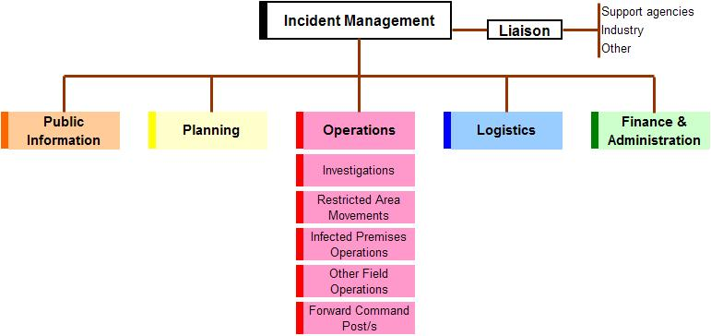

#### Investigations unit

This is responsible for tracing, surveillance and sampling activities within the operations centre’s area of responsibility. These actions are focused on identifying the source and spread of the identified pest or disease and, where appropriate, proving freedom from the pest or disease.

In some cases it may be necessary to establish specific units to deal with:

* tracing
* surveillance
* laboratory.

In a marine pest response this unit will also be responsible for receipt of samples from the public or other stakeholders (e.g. for example fishers, vessel cleaning contractors) if they are participants.

#### Restricted area movements

This is responsible for establishing control over the movement of animals, animal products, plants, plant products, vehicles, other things and people into, within and out of the restricted areas, in order to limit the spread of the pest or disease.

Vehicles may include, submersible equipment, vessels and vehicles (conveyances). Diving equipment, nets and gear used in the response must stay within the restricted area and not be used elsewhere unless decontaminated in an appropriately contained area.

In some cases it may be necessary to establish specific units to deal with:

* permits
* check points
* field patrols
* Infected/infested premises security.

Management of all vessels in control areas is essential. This includes:

* tracing at-risk vessels that departed the area before the control area is declared (may be covered by investigations unit)
* vessels entering the control area (for example cruise liners, fishing boats and cargo ships)
* directing at-risk vessels to approved inspection/decontamination sites.

Refer to generic rapid response manual for further information.

#### Infected/infested premises operations

This is responsible for all activities on infected/infested and dangerous contact premises, in order to contain and eradicate the pest or disease.

In some cases it may be necessary to establish specific units to deal with:

* valuation
* destruction
* disposal
* treatment (decontamination, disinfection and disinsection).

The destruction and disposal of aquatic organisms and contaminated water can present difficulties not posed by terrestrial organisms (see [AQUAVETPLAN](https://www.agriculture.gov.au/animal/aquatic/aquavetplan) and EMPPlan Marine Pest Management Manual).

It is important to evaluate sites to be investigated, surveyed or treated, to:

* identify hazards (for example water, electricity, slippery surfaces)
* identify suitable sites and methods for disposal
* map at-risk infrastructure
* identify facilities that can assist with response activities (for example jetties, cranes, boat ramps)
* understand geography and hydrology (for example currents, depths, tides, submerged obstructions)
* identify surrounding land use (for example residential areas may need to be considered during the response for access, public perceptions of response activities, etc.)
* comply with environment or local government regulations regarding use of chemicals in aquatic environments.

#### Other field operations

These may include, but are not limited to:

* vector control
* trapping
* vaccination
* wild animal control.

More information on vector management can be found in the [generic rapid response manual](https://www.marinepests.gov.au/what-we-do/emergency/rapid-response-manuals).

#### Forward command post/s

If required, these are established and managed by the Operations function within a Local Control Centre. Forward Command Posts will report directly to the manager of the Operations function

Staff appointed to manage the Operations function will:

* interact with the Planning function to develop the operations portions of any plans (at a local level this may include the development of Incident Action Plans)
* request resources needed to implement planned operational activities
* supervise implementation of the planned operational activities.

Figure 13 illustrates the expansion of the Operations function into the various units that may need to be considered within a Local Control Centre, where operational activities will be the focus of the centre’s activities.

Figure 13 Operations function within a Local Control Centre

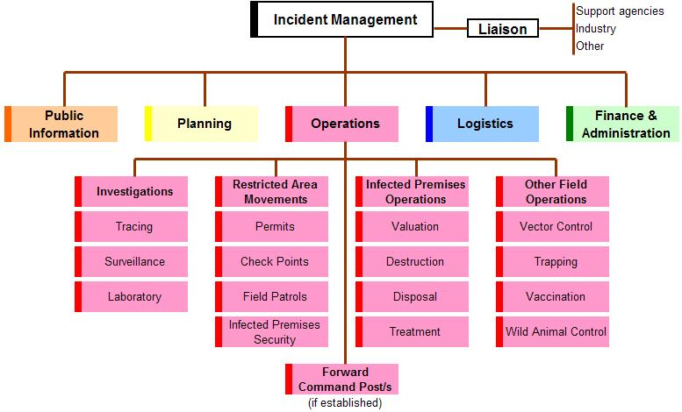

In some cases the Operations function within a Local Control Centre may also have responsibility for air and/or water activities, in which case appropriately titled units may need to be established to manage these activities.

### 3.3.3 Planning function

The Planning function is responsible for the collection, collation, analysis (or interpretation) and dissemination of information. It also includes the development of written plans for the response to the incident. The Planning function acts as an information centre, by providing information that contributes to the situational awareness of all staff involved in the response.

The Planning function may be established within Local Control Centres, State Coordination Centres and/or the National Coordination Centre. Depending upon the size and complexity of the response, it may be necessary to establish several units to manage the range of planning activities for the incident. These could include:

* technical analysis
* response planning
* resource planning
* situation and assessment
* legal
* information systems
* mapping and geographic information systems.

Types of information that can be collected for suspect or infested areas in a marine pest response include:

* GPS coordinates and maps
* weather forecast
* local hydrology (for example tide times, currents)
* marine pest description (including biology for example reproduction, larval characteristics, temperature or salinity tolerances)
* vessel movements
* biomass or density of target species
* native species or habitat susceptible to impacts from the incursion or response activities
* fishing zones
* affected areas
* surrounding land use including stakeholders
* existing activities that may be impacted (for example aquaculture)
* liaison for future activities planned in the area (for example regattas, boat shows, fishing tournaments etc.).

For efficiency, pre-prepared forms are useful to record information and decisions during a marine pest response. Examples include: templates for IMT meeting agendas, Preliminary Information Data Sheets (PIDS), insurance forms, movement permits, property inspection forms, vehicle logs, and vehicle repair logs. Examples of templates can be found in the [Biosecurity Emergency Management Response Planning Guide](https://www.agriculture.gov.au/sites/default/files/sitecollectiondocuments/animal-plant/pihc/bepwg/biosecurity-emergency-managementresponse-planning-guide.pdf).

Efficient and effective record keeping where industry has been involved in a response will enable accurate payment (if required) for assistance rendered (for example boat use).

Figure 13. Planning function

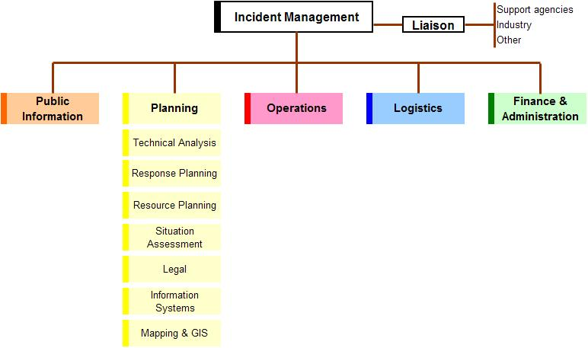

**GIS** Geographic Information Systems.

#### Technical analysis

This provides specialised knowledge and experience that may be necessary to support response activities.

The function collects technical data about the incident and undertakes analysis to anticipate rates of spread, impact, and similar, and predict the escalation or de-escalation of an incident. This may include the epidemiology and/or pathology of an incident.

The outputs from technical analysis include intelligence that assists with decision making and provides guidance for the planning of activities, such as movement restrictions, tracing, surveillance and vaccination.

Technical analysis will be of particular importance in the marine environment where access may be limited due to tidal cycles, for taxonomic and ecological advice for both the marine pest and other local fauna and flora, and knowledge of local currents or other anomalies not present on maps or charts.

#### Response planning

Strategic and/or operational response planning may be required.

Strategic planning is usually performed at a state and/or national level, looking at state/territory wide activities and those issues that have relevance across the state/territory. The strategic planning function has primary responsibility for the compilation and maintenance of the state/territory’s incident-specific response plans.

At a national level strategic planning may include the aggregation of state/territory outputs, to contribute to a nationally consistent approach to the management of the response.

Operational planning is most likely to occur at the Local Control Centre and will focus on activities within the local control centre’s area of responsibility. Operational planning may be undertaken at a state level if the State Coordination Centre has taken on responsibility for operational activities.

The Response Planning function will need to work closely with the Operations section and will have primary responsibility for the compilation and maintenance of the operations centre’s Incident Action Plans.

Marine pest response activities that may require planning include:

* in-water cleaning or treatment, and treatment of biofouling waste
* dry docking or slipping
* treatment and discharge of ballast water
* destruction and disposal procedures
* decontamination protocols for a variety of marine equipment
* waste removal and disposal of marine pests
* field work requirements, including OH&S requirements
* diving activities
* on water operations
* collation of field data and analysis
* off target impact assessment mapping
* communication with relevant stakeholders.

#### Resource planning

This is responsible for projecting or forecasting the resource requirements such as facilities, equipment, human, financial and supporting resources and services required to achieve the objectives set for their operations centre’s area of responsibility. In a State Coordination Centre, resource planning will consider resource requirements across the state, where in a Local Control Centre, resource planning will consider resources requirements within the assigned area of responsibility.

This function needs to work closely with the Logistics Section to ensure that resource planning is realistic and achievable.

Specialised equipment may be required in a marine pest response. Equipment may include:

* boats or vehicles—which may be loaned or leased from industry or other stakeholders
* assembled response kits that might include Remotely Operated Vehicles (ROVs), diving and sample collection equipment
* wrap or encapsulation tools (including tools to cut wraps to size, tape or ropes to secure the object being wrapped, and any other tools to prevent leakage during biofouling treatment)
* other treatment gear (for example equipment needed for hull cleaning or treatment)
* surveillance gear (for example submersible cameras or ROVs
* personal protective equipment
* sampling equipment (for example eskies, sample containers, fixatives, trawls, sediment grabs and nets)
* equipment to distribute and mix the chemicals in the area being treated (for example pumps and pond aerators).

Specialised services that may be required in a marine pest response include:

* vessel hire and vessel operators
* divers or ROV operators
* dry-docking facilities
* commercial vessel cleaners
* ballast water management units
* tugs
* rangers (including indigenous rangers)
* inspection and treatment facilities
* marine pest treatment specialists
* species identification services.

#### Situation and assessment

This is primarily responsible for acquisition and maintenance of situational awareness and sharing of that ‘picture’ through visualisation and sharing systems. This function collects and collates incident information. It produces and disseminates current information about the developing incident, including the production of regular Situation Reports for use within the operations centre and/or external distribution.

This function also has responsibility for the maintenance of visual displays within the operations centre, such as the incident’s status board.

Marine related terminology is often technical or specific; it is important to ensure that information to be shared is simple, in plain English, and understandable to people who may be unfamiliar with the marine environment.

Weather forecasts will also need to cover marine forecasts and tides.

#### Legal

This function provides legal services and advice to ensure that response activities are conducted in accordance with appropriate state, territory and/or Commonwealth legislation. This may include but is not limited to:

* arranging proclamations, delegations and orders
* advising on the legality of proposed policy decisions and operational activities
* providing legal advice on specific issues, as they arise
* briefing staff on their responsibilities in regard to legal issues.

Legislation governing a marine pest response may vary between jurisdictions. Response personnel should be aware of the relevant legislation and regulations that apply to the affected jurisdiction/s and ensure all aspects of the response comply. This is not limited to biosecurity specific legislation. Several authorities may be involved and responsibilities should be clearly defined as part of response preparedness to avoid confusion.

Relevant guidance and national legislation:

*APVMA -* [*www.apvma.gov.au/node/1061*](https://apvma.gov.au/node/1061)

*Discharge into waterways-* [*www.waterquality.gov.au/guidelines*](http://www.waterquality.gov.au/guidelines)

*Ballast water-* [*www.agriculture.gov.au/biosecurity/avm/vessels/ballast*](http://www.agriculture.gov.au/biosecurity/avm/vessels/ballast)

*Biofouling -* [*www.agriculture.gov.au/biosecurity/avm/vessels/biofouling*](http://www.agriculture.gov.au/biosecurity/avm/vessels/biofouling)

*EPBC act –* [*www.environment.gov.au/epbc*](http://www.environment.gov.au/epbc)

*Biosecurity act –* [*www.agriculture.gov.au/biosecurity/legislation/biosecurity-legislation*](http://www.agriculture.gov.au/biosecurity/legislation/biosecurity-legislation)

*Anti-fouling coatings and in-water cleaning -* [*www.agriculture.gov.au/biosecurity/avm/vessels/biofouling/anti-fouling-and-inwater-cleaning-guidelines*](http://www.agriculture.gov.au/biosecurity/avm/vessels/biofouling/anti-fouling-and-inwater-cleaning-guidelines)

State/Territory and commonwealth jurisdiction for waters[*www.ga.gov.au/scientific-topics/marine/jurisdiction/maritime-boundary-definitions*](http://www.ga.gov.au/scientific-topics/marine/jurisdiction/maritime-boundary-definitions)

See Appendix E of the [generic rapid response manual](https://www.marinepests.gov.au/what-we-do/emergency/rapid-response-manuals#generic-manual) for guidance on state on territory legislation relating to marine pest responses.

#### Information systems

This includes responsibility for the management of electronic information management systems, used within the jurisdiction and for the production of the required outputs from these systems including for national reporting needs.

In some cases the information systems function may sit with other sections within the response organisation. If this is the case there needs to be close liaison with the Situation and Assessment function to ensure the appropriate management of all electronic and hardcopy information.

Data collection or management systems used during a marine pest response may vary between jurisdictions. General considerations include:

* types of information that the system must capture (for example location, species, management details)
* data sharing capacity
* customised versus generic systems for data collection
* data collected should be consistent with the agreed National Minimum Data Standards, and align with information needs such as information required by the CCIMPE through the PIDS form.

#### Mapping and GIS (Geographic Information Systems)

This works closely with the Situation and Assessment function and Information Management function to collate incident-specific geographic information and data, to produce appropriate products and outputs (such as electronic and paper maps). These products may be required for inclusion in planning documents and will be used by other staff within the operations centre, as well as those deployed in the field.

Additional information on operational planning practices and processes that can be followed during the response to a biosecurity incident are included in the Biosecurity Emergency Management–Response Planning Guide.

### 3.3.4 Public information function

The Public Information function is responsible for the management of public information generated from and received by the operations centre. This includes the general public, affected individuals, businesses and the media.

The Public Information function may be established within Local Control Centres, State Coordination Centres and/or the National Coordination Centre. Depending upon the size and complexity of the response, it may be necessary to establish several units to manage the range of public information activities for the incident. These could include:

* media
* web and internet
* call centres
* community engagement.

Figure 14. Public Communication function

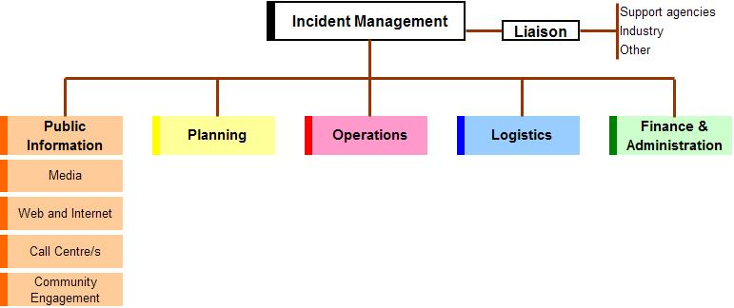

#### Media

This function is likely to be performed at a local, state and national level. This function will have responsibility for:

* developing materials for use in media briefings
* obtaining the relevant approval for media releases
* informing media and conduct media briefings
* consider and oversee appropriate use of social media
* arranging for tours and other interviews or briefings as requested
* obtaining media information that can be useful to incident planning and management.

The media spokesperson should have sufficient experience, seniority and professional standing to be credible. As marine issues can have heightened sensitivities due to the number of stakeholders involved multiple media options will need to be engaged. A central ‘source of truth’ as used in emergency disaster responses in some jurisdictions is highly desirable. The National Communication Network (NCN) coordinate national messaging of responses.

#### Web and internet

This function is likely to be performed at a state and national level. This function is primarily responsibility for posting information relating to the incident onto agency and/or national websites, including the national pest and disease website (www.outbreak.gov.au), and other web based interfaces including social media.

This function may also have responsibility for managing the organisations internet infrastructure.

#### Call centre/s

This function is likely to be performed at a state and national level. This function will have primary responsibility for supervising and facilitating the establishment and maintenance of a call centre facility, as a source for stakeholder information. Such call centres may be internally hosted by the response agency or outsourced to another organisation or commercial provider.

The Australian Government Department of Agriculture and a number of state/territory agencies have established arrangements with agencies such as Centrelink to provide call centre services during the response to biosecurity incidents.

#### Community engagement

This relates to the affected communities. Most applicable at a local and state level, it may involve engaging with individuals either directly or indirectly affected, as well as affected industries and their member organisations. This function may include establishing community resource centres, to act as face to face meeting points for members of the affected communities, industries and government.

It needs to liaise closely with relief and recovery agencies to ensure appropriate support is provided to affected communities.

Consider whether a marine pest response will impact any native marine species or areas that are culturally important to stakeholders. It is important to engage with representatives of affected and potentially affected communities and organisations or businesses.

Other stakeholders to consider:

* Aboriginal communities
* recreational fishers
* aquaculture industry members
* marinas, ports or slipways
* boaters or divers
* marine infrastructure contractors
* tourism industry
* defence vessels
* nearby residents.

### 3.3.5 Logistics function

The Logistics function is responsible for the acquisition and provision of human and physical resources, facilities, services and materials required to support achievement of the objectives set by the Incident Management function.

The Logistics function may be established within Local Control Centres, State Coordination Centres and/or the National Coordination Centre. Depending upon the size and complexity of the response, it may be necessary to establish several units to manage the range of logistics activities for the incident.

These could include:

* facilities
* staffing
* catering
* transport
* accommodation
* supply.

Figure 15 Logistics function

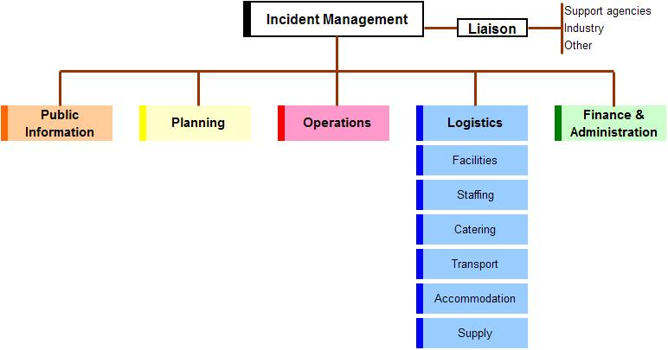

#### Facilities

This function may be required whenever an operations centre is established at local, state or national levels. This function will have primary responsibility for providing fixed facilities for the incident and may include:

* operations centre, forward command posts and assembly area buildings, whether fixed or mobile (such as transportable buildings or tents)
* catering or feeding areas
* temporary sleeping facilities
* sanitary facilities

Specific physical and spatial requirements of operation centres:

* close to affected area (usually along coastline) so may be remote. Consider availability of accommodation and communications in remote areas or popular tourist destinations
* storage of chemicals
* storage of boats or vehicles
* specific decontamination needs
* cleaning of boats, aquatic vehicles, and specific marine equipment
* in-field support for divers (for example showers, compressors)
* new suspect or infected areas may be detected far from the initial site.

Non-specific physical and spatial requirements of operation centres:

* sufficient floor space for personnel and equipment
* separation of different areas for biosecurity purposes
* sufficient number of working phones and computers
* security and restricted public access areas (consider a reception desk and implementing a visitor escort or sign-in process
* capacity for expansion (desirable)
* equipped to operate 24/7.

#### Staffing

This function is responsible for sourcing, acquiring, logging and tracking the human resources required for the response. Specific responsibilities may include coordinating incoming staff and briefing them on the nature of the disease, operation plans, current situation, structure of the operations centre, occupational health and safety arrangements and local conditions.

Sufficient numbers of trained staff are required in a marine pest response to enable rotation. This avoids overwork and fatigue. Consider the need to relieve personnel from their normal work activities in order to participate in the response. Additional staff may be available from the National Biosecurity Response Team through the CCIMPE.

Work health and safety (WHS) legislation varies between jurisdictions. Marine pest response-specific considerations include:

* appropriate training in equipment and chemical use
* personal protective equipment
* distribution of chemical treatments in water such as use of vessel propellers and other mixers
* diver-specific WHS (for example decompression, hypothermia)
* on-water specific WHS (for example hypothermia, sunstroke, potential for drowning)
* safe use of heat treatments (for example steam sterilisers, flame throwers)
* low visibility in certain conditions and in water
* dangerous marine animals (for example crocodiles, sharks and venomous jellyfish)
* working in remote locations, confined spaces or at heights.

Considerations during staff induction include:

* providing information on nature of the marine pest and the current situation
* providing information on general and specialist training
* advice on where to find additional information
* advice on employment conditions, structure of operation centre/s where work will occur, finance/transport/accommodation arrangements etc.

#### Catering

This function has primary responsibility for providing, or coordinating the provision of, meals and refreshments for response personnel, working in operations centres and in the field.

Where the provision of meals and refreshments is outsourced to another organisation or private contractor, this still needs to be coordinated from within the appropriate operations centre.

Care is required when staff are working extended or multiple shifts, to ensure their nutritional needs, commensurate with their shift and/or duties are met. The catering needs of staff working late or overnight shifts should not be overlooked by this function.

#### Transport

This function may be required where it is necessary to coordinate the transport of response personnel between centres, accommodation and/or field locations. If established, this function will have primary responsibility for:

* identifying the transport needs of response personnel
* identifying and source appropriate transport (hire-cars, taxis, buses, other)
* scheduling available transport to suit the needs of response personnel
* communicating transport arrangement to response personnel.

#### Accommodation

This function may be required where it is necessary to accommodate response personnel. If established, this function will have primary responsibility for:

* identifying the accommodation needs of response personnel
* identifying and sourcing appropriate accommodation.
* coordinating sourcing with the Facilities function if portable accommodation is identified
* scheduling available accommodation to suit the needs of response personnel
* communicating accommodation arrangements to response personnel.

#### Supply

This function may be required at local and state levels. This function will be primarily responsible for the acquisition and deployment of supporting equipment, consumables and services.

### 3.3.6 Finance and Administration Function

The Finance and Administration function is responsible for the management of records, information flow and miscellaneous items required to ensure the smooth and efficient running of an operations centre. It may also include the management of financial arrangements associated with the response.

The Finance and Administration function may be established within Local Control Centres, State Coordination Centres and/or the National Coordination Centre. Depending on the size and complexity of the response, it may be necessary to establish several units to manage the range of finance and administration activities for the incident.

These could include:

* Incident Management Team Secretariat
* records management
* finance
* human and industrial relations
* procurement.

Figure 16 Finance and Administration function

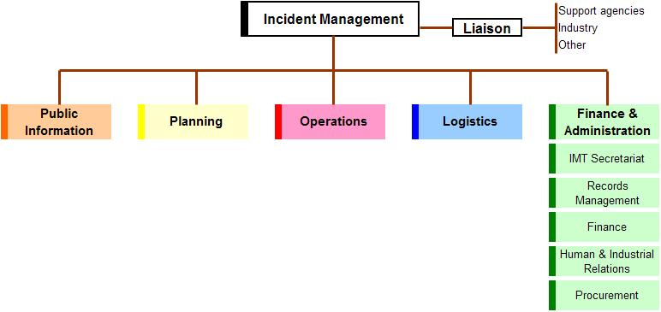

#### Incident management team secretariat

This will provide secretariat support to the whole Incident Management Team. Specific responsibilities include:

* organise meetings of the Incident Management Team, in accordance with the daily schedule of activities, or as advised by the Incident Manager
* create and maintain records (including minutes) of meetings and distribute as appropriate.

#### Records management

This is responsible for the overall management of all records (paper and electronic) received and generated by the Incident Management Team. This will include the establishment and management of processes for the collection, collation, storage and retrieval of these records.

#### Finance

This provides policy support to the Incident Manager, through provision of advice on financial issues such as cost sharing arrangements. This may also include the management of and accounting for all financial transactions (which may include claims for compensation).

#### Human and industrial relations

This provides policy support to the Incident Manager, through provision of advice on application of industrial relation rules. It may also include the management of human resource industrial issues and inequities that arise during the incident. Additionally, this unit should ensure that all personnel time records are accurately completed and provided to home agencies, according to established policies.

#### Procurement

This provides policy support to the Incident Manager and Incident Management Team on procurement issues, such as contracts, leases and related negotiations. This may also include the preparation and management of contracts and leases during the incident.

Many of the Finance and Administration functions are already performed as part of an organisations day-to-day business. Incident Management should use existing systems, processes and staff to perform the functions described in this section.

# Glossary

| Term | Definition |
| --- | --- |
| Biosecurity | Mitigating the risks and impacts to the economy, the environment, social amenity or human health associated with pests and diseases. |
| Biosecurity incident | An event which increase the likelihood of biosecurity risks being realised |
| Briefing | The process of advising personnel of the details of the incident or event with which they will be dealing |
| Command | The internal direction of the members and resources of an organisation in the performance of the organisation’s roles and tasks. Authority to command is established in legislation or by agreement with an organisation. Command relates to organisations and operates vertically within an organisation. |
| Control | The overall direction of activities in an emergency situation. Authority for control is established in legislation or in an emergency plan and carries with it the responsibility for tasking other organisations in accordance with the needs of the situation. Control relates to situations and operates horizontally across organisations. |
| Coordination | The bringing together of organisations and elements to ensure an effective response, primarily concerned with the systematic acquisition and application of resources (organisation, human and equipment) in accordance with the requirements imposed by the threat or impact of an emergency. Coordination relates primarily to resources and operates vertically within an organisation, as a function of the authority to command, and horizontally across organisations, as a function of the authority to control. |
| Debriefing | A meeting at the end of an operation with the purpose of assessing the conduct or result of an operation. |
| Forward command post | A field operations centre, subsidiary to a Local Disease Control Centre. |
| Incident | See Biosecurity Incident |
| Incident Action Plan | A statement of objectives, actions, tasks and responsibilities to be undertaken to contain or resolve an incident or emergency. An IAP will generally have application for a single operational period. |
| Incident management team | Normally comprises the Controller [Incident Manager], the Operations Manager/Director, Planning Manager and Logistics Manager, however other specialists may be included when necessary such as a species expert and legal services unit representative. They ensure that an incident or emergency is properly planned, adequately resourced, suitable implemented, effective and efficient. |
| Incident Manager | The individual responsible for incident activities, within their defined area of responsibility. An Incident Manager may be appointed at a local, state/territory and/or Australian Government level (may also be referred to as Incident Controller). |
| Liaison Officer | A representative from an agency [government or industry] involved in the incident response who works with the incident manger as part of the Incident Management Team and is in communication with the officer in charge of his or her respective agency. Liaison officers must have the authority to commit resources of the organisation they represent. |
| Local control centre | The operations centre from which all field operations aimed at containing and eradicating the pest or disease are managed. |
| National coordination centre | The centre established by DAWE to coordinate national and international activities and resource support to jurisdictions |
| Operational period | The period of time scheduled for execution of a given set of operational actions as specified in the Incident Action Plan |
| Operations centre | Generic term referring to any one of the National Coordination Centre, State Coordination Centre, Local Control Centre or Forward Command Post. |
| State coordination centre | The emergency operations centre established at a state level that coordinates the disease or pest control operations to be undertaken in that state or territory. |

The definitions provided are consistent with contemporary emergency management doctrine and may vary slightly to the way in which they are currently applied in a specific biosecurity sector. A full list of biosecurity incident terminology can be found in the [Biosecurity Emergency Management–Glossary](http://www.agriculture.gov.au/biosecurity/partnerships/nbc/nbepeg/glossary)

# Appendices

## Appendix A: Associated marine pest relevant national documents

Table A1 National response and cost-sharing agreements

| Title | National sponsor/owner | Subject | Purpose and scope |
| --- | --- | --- | --- |
| National Environmental Biosecurity Response Agreement (NEBRA) | National Biosecurity Committee–Supported by Department of Agriculture | Biosecurity incidents, not covered by the EADRA or EPPRD | The purpose of the NEBRA is to establish national arrangements for response to nationally significant biosecurity where there are predominantly public benefits.  The scope of the NEBRA is to reduce the impacts of pests and diseases on Australia’s environment and social amenity. It establishes national response arrangements, including cost sharing, to be applied by agreement of the parties where there are no pre-existing arrangements. |

Table A2 National sector-specific biosecurity plans

| Title | National sponsor/owner | Subject | Purpose and scope |
| --- | --- | --- | --- |
| Australian Aquatic Animal Disease Veterinary Emergency Plan (AQUAVETPLAN) | Australian Government Department of Agriculture (DA) | Aquatic Animal disease emergencies | AQUAVETPLAN is a series of manuals that describe the proposed Australian approach to an aquatic animal disease emergency. These manuals outline national emergency preparedness, response and control strategies for aquatic animal disease emergencies in Australia. |
| Australian Emergency Marine Pest Plan (EMPPlan) | Consultative Committee on Invasive Marine Pest Emergencies (CCIMPE), through DAFF | Incursions by introduced marine pests | The EMPPlan consists of five species specific response manuals, one generic response manual, and an operational management manual to be released in early 2020. This manual is the BIMS manual with additional marine specific or essential update material. Additional material useful in a response is available at NIMPIS (to be re-released in late 2019) and the marinepests.gov.au website. |

Table A3 Generic operational documents

| Title | National sponsor/owner | Subject | Purpose and scope |
| --- | --- | --- | --- |
| Biosecurity Emergency Management – Biosecurity Incident Management System | Biosecurity Emergency Preparedness Working Group (BEPWG) | Generic approach to the management of biosecurity incidents | This document provides guidance in contemporary practices for the management of biosecurity incident response and initial recovery in Australia. It is primarily focused at using the Biosecurity Incident Management System for managing the response to (which includes initial recovery from) biosecurity incidents. |
| Biosecurity Emergency Management – Response Planning Guidelines | BEPWG | Response planning | This document provides guidance on planning practices and processes that could be followed during the response to biosecurity incidents. It is intended that this document be used by staff within operations centres established at national, state/territory, local and field levels, during the response to all types of biosecurity incidents. |
| Biosecurity Emergency Management – Glossary | BEPWG | Glossary of biosecurity response terminology | This document provides a list of nationally agreed terminology, commonly used during the response to biosecurity incidents. |
| Biosecurity Emergency Management – Evaluation and Lessons Management Guide | BEPWG | Evaluation of biosecurity preparedness and response activities | This document describes evaluation procedures and processes and provides tools that can be used in the evaluation of biosecurity emergency management preparedness, response and initial recovery activities. |

Note: Jurisdictions also maintain operational documentation relevant to their jurisdictional needs, legislation and emergency response arrangements. These include, but are not limited to; plans, manuals, operating procedures and works instruction

## Appendix B: Relief and recovery roles in a biosecurity response context

**Table B1 Relief and recovery roles in a biosecurity response context**

| **Impacts** | **Response agency roles** | **Other agencies roles** |
| --- | --- | --- |
| Families and individuals suffering loss or trauma as a result of:   * the destruction of stock or crops that may have been built up over an extended period and the consequent sudden loss of livelihood and sense of purpose * personal trauma resulting from the destruction of pets * possible changes in community perception of those whose stock/crops are affected by the disease/pest. | Community information regarding the disease or pest incursion, response operations and likely consequences.  Provision of information and updates to affected families and businesses on the progress of response operations, their consequences and resolution.  Management of animal welfare issues arising from incursion and/or response operations. | Personal counselling and support services.  Temporary financial relief.  Rural counselling services may play a role in advising affected farmers on access to financial and other relevant services.  Translation and interpreting services where required. |
| Business and individuals that are dependent on the affected industry. | Community information regarding the disease or pest incursion, response operations and likely consequences.  Provision of information and updates to affected families and businesses on the progress of response operations, their consequences and resolution.  Use of local capacity to support response operations wherever practicable. This may include purchasing goods and services from suppliers in affected areas and/or employing, for response tasks, displaced workers from affected enterprises. | Referral to relevant support services/financial relief providers.  Temporary financial relief.  Translation and interpreting providers. |
| Measures that support restocking/replanting and the return of an industry to pre-incident levels of activity. | Advice and referral to relevant support services. | State/territory community relief and recovery arrangements.  Rural counselling services may play a role in advising affected farmers on access to financial and other relevant services. |
| State/territory legislation may provide for compensation for the death of domestic animals in prescribed circumstance. Such compensation is covered by the relevant national cost-sharing agreement where applicable. | Administration of claims. | na |
| Support for transition to alternative activities where an affected producer does not wish or is not able to recommence pre-incident activities. | Advice and referral to relevant support services. | Support and advice coordinated through inter-agency cooperation.  Rural counselling services may play a role in advising affected farmers on access to financial and other relevant services. |
| Coordination of measures to enable re-establishment of trade. | Through national arrangements and/or in consultation with relevant state/territory agencies as appropriate. | State/territory economic/regional development agency–advisory and/or support services. |
| Measures to restore environmental values. | Through national arrangements and/or in consultation with relevant state/territory agencies as appropriate. | Agencies with significant land management responsibility to act in relation to their respective areas of responsibility. |
| Develop recovery plans for tourism. | na | State/territory tourism agencies. |

**na** Not applicable.