# National biofouling management guidelines for commercial fishing vessels

Version 1.0, 2009

© Commonwealth of Australia 2009

**Ownership of intellectual property rights**

Unless otherwise noted, copyright (and any other intellectual property rights, if any) in this publication is owned by the Commonwealth of Australia (referred to as the Commonwealth).

**Creative Commons licence**

All material in this publication is licensed under a Creative [Commons Attribution 4.0 International Licence](https://creativecommons.org/licenses/by/4.0/legalcode) except content supplied by third parties, logos and the Commonwealth Coat of Arms.

Inquiries about the licence and any use of this document should be emailed to [copyright@agriculture.gov.au](mailto:copyright@agriculture.gov.au).

C:\Documents and Settings\west merryn\Local Settings\Temporary Internet Files\Content.Word\by.png

**Cataloguing data**

This publication (and any material sourced from it) should be attributed as: Marine Pest Sectoral Committee 2018, National biofouling management guidelines for commercial fishing vessels, Department of Agriculture and Water Resources, Canberra, November. CC BY 4.0. Document modified in 2018 to meet accessibility requirements.

This publication is available at [marinepests.gov.au/what-we-do/publications](http://www.marinepests.gov.au/Pages/map/American-slipper-limpet.aspx)

Marine Pest Sectoral Committee Secretariat

Department of Agriculture and Water Resources

GPO 858 Canberra ACT 2601

Telephone 1800 372 746 (local calls) +61 2 6272 5232 (international)

Email [mpsc@agriculture.gov.au](mailto:mpsc@agriculture.gov.au)

Web [marinepests.gov.au](http://www.marinepests.gov.au/)

**Disclaimer**

These guidelines are part of a series of documents setting out a consensus view of effective biofouling management practices.

The guidelines are made available on the understanding that the Commonwealth of Australia is not thereby engaged in rendering professional advice. The Commonwealth does not warrant the accuracy, currency or completeness of the guidelines, or their relevance for any particular purpose. In particular, it should be noted that legislation, regulations and by-laws may vary between different jurisdictions and ports in Australia. Consequently, the guidelines do not purport to state what is necessary or sufficient to comply with laws applying in any place.

Before relying on the guidelines in any important matter, users should obtain appropriate professional advice to evaluate their accuracy, currency, completeness and relevance for their purposes.

Contents

Introduction 1

1 Vessel maintenance 2

1.1 Maintaining trailered vessels onshore 2

1.2 Maintaining non-trailered vessels 2

1.3 Hull protection 4

2 Vessel operations 6

2.1 Normal deck activities 6

2.2 During fishing activities 7

2.3 Managing live tanks and well ballast systems 7

3 Reporting and emergency responses 8

3.1 Emergency pest outbreaks 8

3.2 Reporting interactions with marine pests 8

Glossary 9

Contacts 9

**Figures**

Figure 1 Niche areas where biofouling can accumulate on a commercial fishing vessel 3

**Photos**

Photo 1 Unloading the catch 1

Photo 2 Steel crayfish vessel hoisted for hull cleaning and repainting 2

Photo 3 Sea chest showing high levels of biofouling 4

Photo 4 Medium-level biofouling on the propeller and rudder of a commercial vessel 6

Photo 5 Fishing nets with captured seaweed and other biological debris 7

## Introduction

Preventing marine pest outbreaks is critical. They can significantly impact the marine environment, human health and the economy, and have adverse effects on marine and coastal industries and values. By the time a new marine pest is detected in an environment, the chances of successful eradication are low. Efforts must then focus on containment and management which has a considerable economic and ecological cost.

Marine pests are mainly spread by ballast water and biofouling on vessels hulls and in niche areas and pipe work. While biofouling levels on vessels may seem insignificant, the pest potential of some species allows them to breed quickly from small numbers, with risk of a marine pest outbreak further increased by the frequency of vessel visits to a particular area.

The Australian commercial fishing industry has developed the following voluntary national biofouling management guidelines to help prevent introduction of marine pests and protect the marine environment, businesses, fishing grounds and ports from the impacts of marine pest outbreaks. The guidelines provide information for vessel owners, skippers, engineers and crews about vessel maintenance, operations, reporting and emergency response to outbreaks.

National biofouling management guidelines have also been developed for the recreational vessel and commercial vessel sectors. Similar documents titled [National Biofouling Management Guidelines](http://marinepests.gov.au/what-we-do/publications) have also been developed for non-trading vessels and the petroleum production and exploration industry.

Photo 1 Unloading the catch

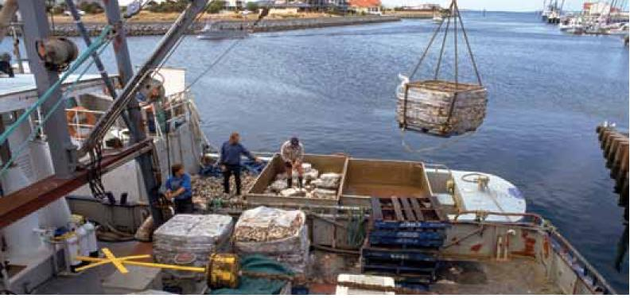

## Vessel maintenance

### Maintaining trailered vessels onshore

* Check for and remove entangled or attached biological matter from the boat and trailer (seaweed).
* Check outboard and hull fixtures for water that could harbour potential marine pests (including trimming outboard down to let water out of the gearbox housing).
* Rinse the boat inside and out with fresh water, drain and if possible, allow to dry if moving to another location within 48 hours.
* Regularly remove slime from the hull to prevent the build-up of heavier secondary biofouling.
* Dispose of any biological matter, including known marine pests, in bins or to landfill so that it cannot be returned to the water.

### Maintaining non-trailered vessels

These directions apply to any vessels that have raw water Internal Water Systems (IWS).

* Conduct hull scraping at a designated on-shore facility (marina or slipway with waste trapping facilities) (Photo 2).
* Dispose of all biological matter that is removed from the vessel at on-shore facilities so that it cannot be returned to the water.
* Clean potential refuge spaces that could harbour marine pests (Figure 1) and, if possible, allow to dry.
* Treat Internal Water Systems by cleaning intake and outlet points and by periodically flooding with fresh water prior to moving between regions.

Photo 2 Steel crayfish vessel hoisted for hull cleaning and repainting

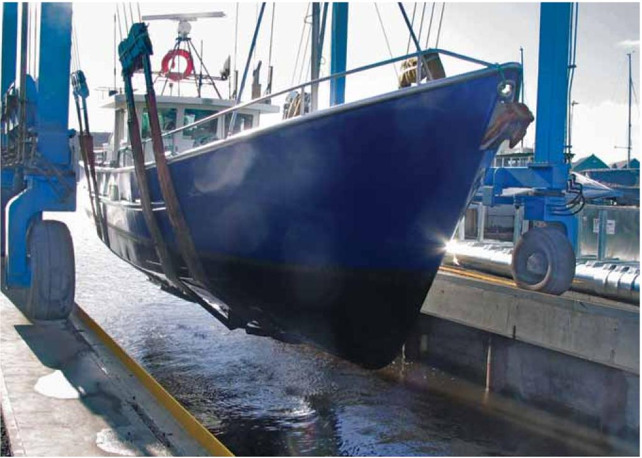

Image: Aquenal Pty Ltd.

Figure 1 Niche areas where biofouling can accumulate on a commercial fishing vessel

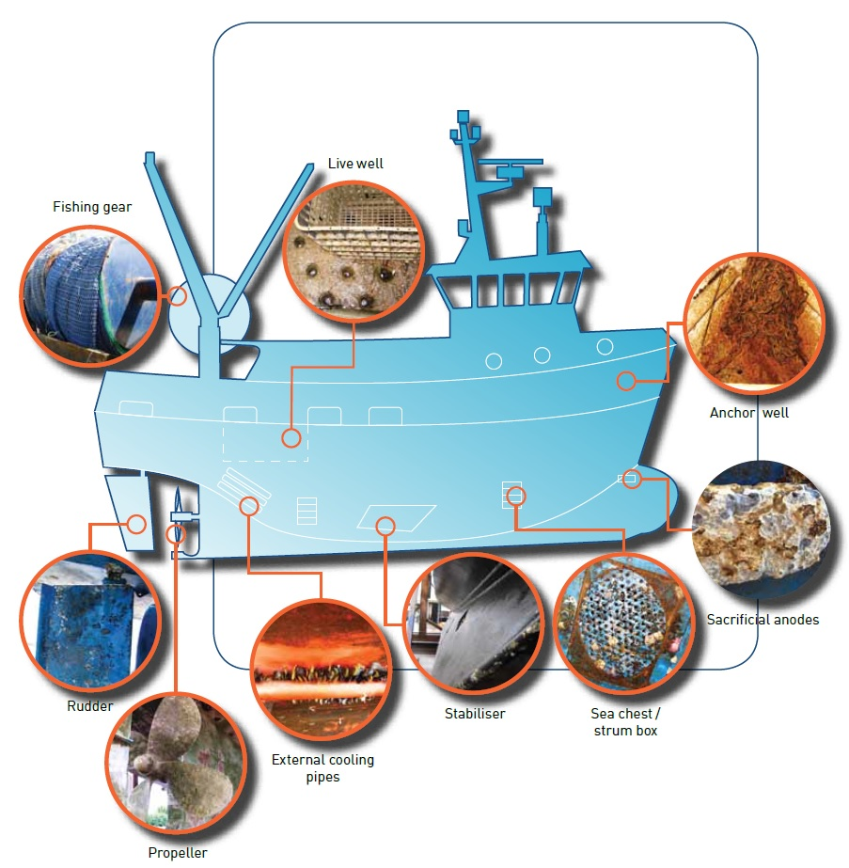

Note: Illustration adapted from a diagram provided by Mermaid Marine Australia Ltd.

### Hull protection

#### Hull cleaning

Biological matter removed during hull cleaning must be contained or collected, and treated and/or disposed of at on-shore facilities. If conducting hull servicing independently, remember to obtain relevant permits to discard biological matter at an approved disposal site.

Photo 3 Sea chest showing high levels of biofouling

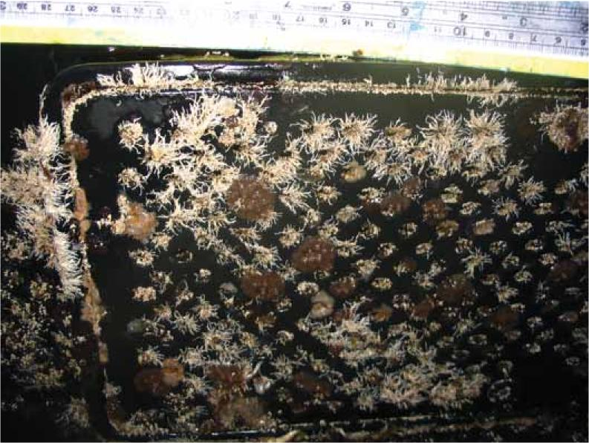

Image: Aquenal Pty Ltd.

#### Antifouling coating

Consult an antifouling coating supplier for advice as required and select the most appropriate coating system, based on:

* vessel operating location (tropical vs temperate)
* vessel type/operating conditions
* vessel construction materials.

Note that antifouling products containing tributyltin (TB71) cannot be used in Australia

Apply and remove antifouling products at licensed vessel maintenance facilities. Premises and application should comply with the ANZECC Code of Practice for Antifouling and In-Water Hull Cleaning and Maintenance (1997), the [Anti-fouling and in-water cleaning guidelines](http://www.agriculture.gov.au/biosecurity/avm/vessels/biofouling/anti-fouling-and-inwater-cleaning-guidelines) and product manufacturer’s instructions.

Antifouling should be renewed according to the minimum frequency recommended by the paint manufacturer. Assess the effectiveness of antifouling coatings on vessels that are immobile for a prolonged period and if necessary clean the hull and re-apply antifouling coating prior to proceeding to sea.

#### Inspection of unpainted surfaces

Some surfaces (such as propellers or echo sounders) cannot be pained and are more susceptible to biofouling and must be inspected regularly. If they are fouled, any biological matter should be removed and disposed of at onshore disposal facilities.

Commercially available greases or other specified coatings can be applied to surfaces such as propellers to help keep them clean.

#### Record keeping

Keep records of hull maintenance and antifouling coatings in the vessel's operations and maintenance manuals. Records may include antifouling product invoices (brand and type), place and date of application, date for renewal and a record of any official inspection carried.

## Vessel operations

### Normal deck activities

* Clear decks and any refuge areas on deck that may harbour a marine pest, such as spaces under winches and around deck fittings.
* Clean and dry mooring lines that have biofouling attached.
* Clear warps and anchors of biological matter and mud/sand as they are hauled.
* Regularly clean anchor and chain wells and lockers.

Photo 4 Medium-level biofouling on the propeller and rudder of a commercial vessel

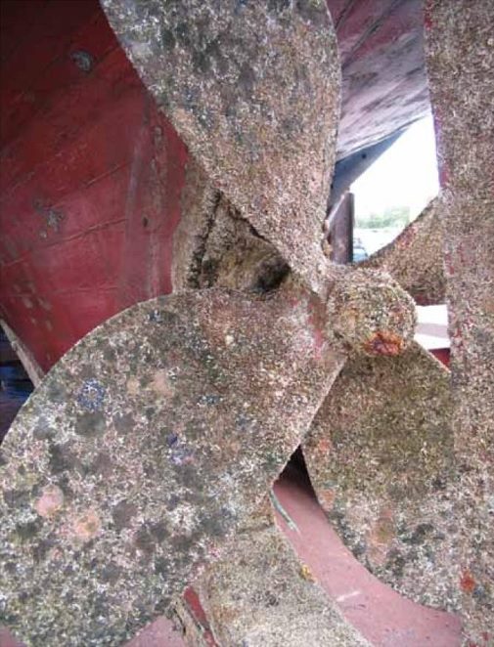

Image: Aquenal Pty Ltd.

### During fishing activities

Divers should ensure that biological material entangled in dive gear is not transported to other dive sites.

* Use locally sourced bait wherever possible to prevent the introduction of pests and diseases.
* Return bycatch to the sea as near as possible to the point of capture.
* If gear is cleaned in port dispose of biological waste at on-shore facilities.
* Streaming of nets should be undertaken as close as possible to fishing grounds.
  + Nets should be dried out regularly or prior to transfer to another boat to ensure living biological matter is not translocated. Be aware that streaming of nets by trawlers has the potential to move marine pests around. If you know that a marine pest is in your area or you suspect one might be, do not stream your nets to clean them.

Photo 5 Fishing nets with captured seaweed and other biological debris

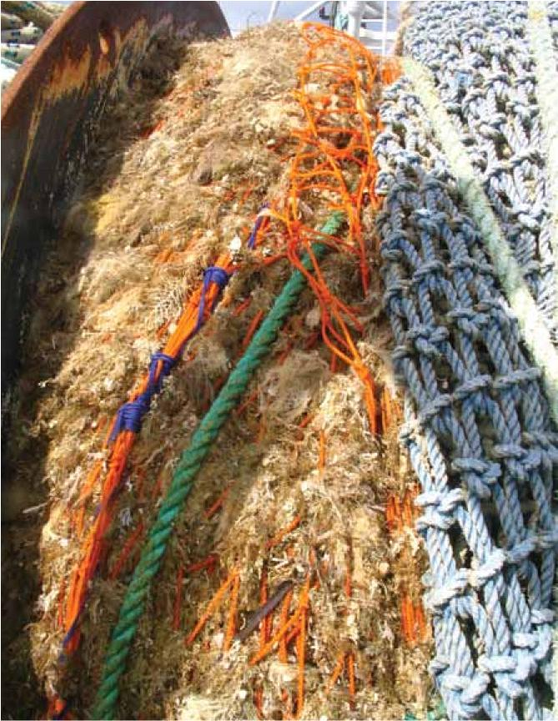

Image: Aquenal Pty Ltd.

### Managing live tanks and well ballast systems

* Ballast water should be exchanged in accordance with the Australian Ballast Water Management requirements.
* Regularly clean and check live tanks, live wells and well holes for marine pests or biological matter.

## Reporting and emergency responses

### Emergency pest outbreaks

If a marine pest outbreak occurs, additional measures such as reporting of voyage plans or restrictions to specific ports or areas may be required. These would be broadcast by relevant state/territory authorities and may be managed on a fleet-by-fleet basis. Your state/territory authority will inform you of the details of the particular marine pest and the outbreak.

You may be requested to help in the event of a response to an emergency situation such as a marine pest outbreak.

### Reporting interactions with marine pests

Be aware of encounters with unidentified organisms, known marine pests or potential marine pests that may lead to the accidental movement of species. Signs of a suspected marine pest could include unusually heavy biofouling, dominance of the fouling by one species, or a 'new' species not seen before in your region.

Report any new sightings of these species or any other unusual species to the relevant local authority. Call your local authority if you are concerned about a particular species (see the [Marine Pests](http://www.marinepests.gov.au/report) website for contact details).

Be aware of marine pest infestations in your fishing grounds and minimise the risk of moving these species around.

If in doubt, keep a sample of the marine pest of concern. Freeze the specimen and hand it to the relevant authority as soon as possible.

Time, date, location, depth and population details should be recorded when a suspected outbreak is noticed in a new area.

## Glossary

| Term | Definition |
| --- | --- |
| antifouling | Coatings on underwater superstructures that reduce the ability for organisms to anchor to the structure as a substrate. |
| ANZECC | Australian and New Zealand Environment and Conservation Council |
| biofouling | The attachment of marine organisms to any part of a vessel, or any equipment attached to or on board the vessel, fishing gear, mooring devices and the like. |
| domestic fishing vessels | Vessels that operate within Australian waters under fishing vessels Australian jurisdictions (Australian fishing vessels). |
| entrainment | The pick-up of a potential marine pest by a vessel, in water in the vessel, or attached to the hull. |
| establishment | The potential pest separates from the vessel and survives in the new locality. |
| IWS | Internal water systems that carry raw water in a vessel for cooling or cleaning uses. |
| marine pest | Any exotic marine species that may pose a threat to Australia's marine environment or industry, if introduced, established or spread. (Where exotic marine species is defined as any species not normally considered to occur and that may or may not be present in Australia's marine environment). |
| niche areas/niches | A protected or refuge area of relatively constant conditions in which marine organisms can escape detection or drying out. Also areas that are not coated in antifouling paint or areas where antifouling coating breakdown is common enabling the settlement of marine organisms. |
| strainer box/strum boxes | The enlarged terminal on the suction end of a pipe and forming a strainer, which prevents the entrance of material liable to choke the pipe. |
| TBT | Tributyltin products widely used in antifouling products until recently. These products are now banned in Australia. |
| translocation | The act of moving a marine pest from one locality to another. |
| sector | Any marine based industry or recreational group capable of introducing or translocating an exotic marine species. |
| well holes | Openings between live wells in vessels that allow circulation of seawater. |

## Contacts

For more information about marine pests and biofouling management guidelines contact your local state/territory fisheries officer or visit the [Marine Pests](http://www.marinepests.gov.au/) website.