Notes from MPSC for the period - June 2022- October 2022

The Marine Pest Sectoral Committee (MPSC) held its 24th Committee Meeting and Partners’ Workshop via a hybrid format at the Sydney Institute of Marine Science (SIMS) on 26-27 October 2022.

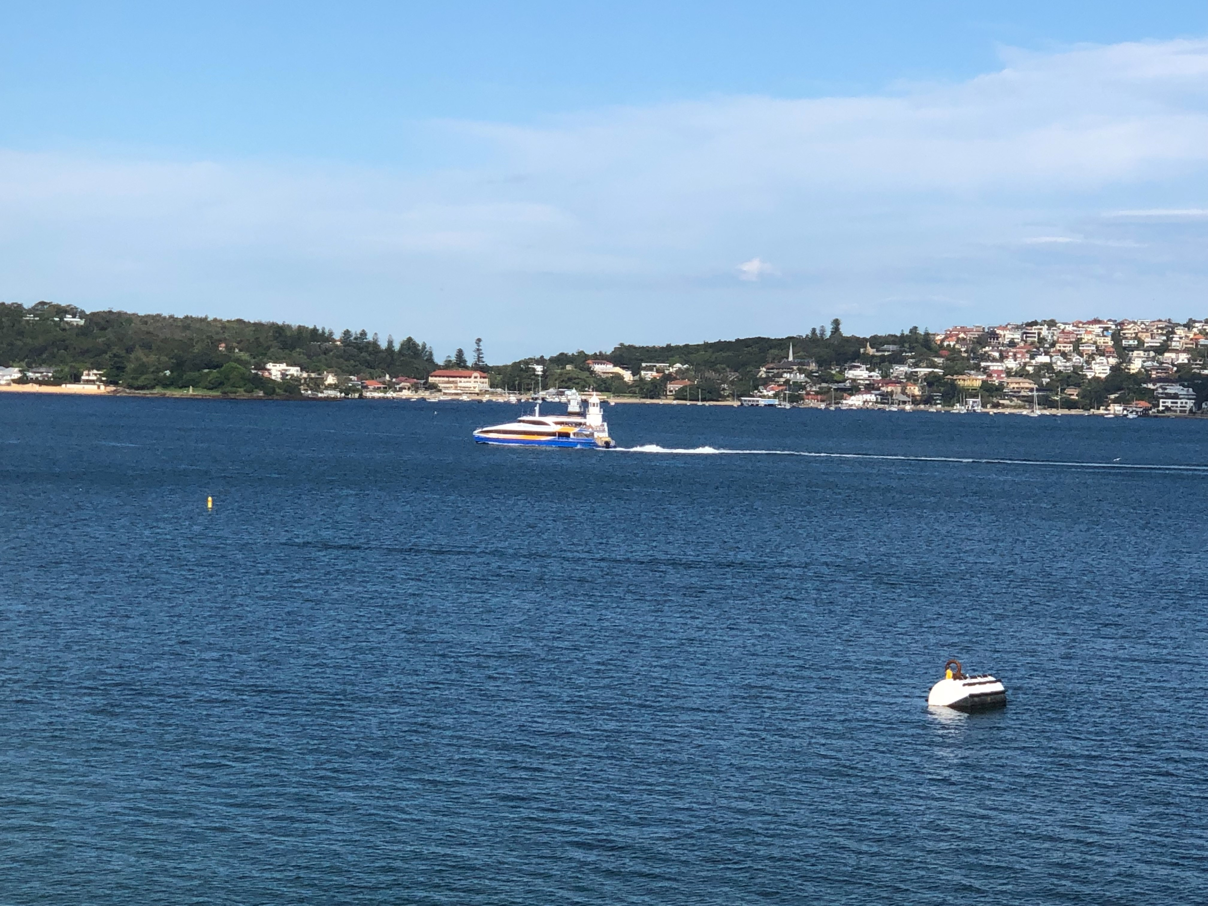
Notes from the Chair

MPSC utilised a hybrid format to allow members, partners and observers who cannot travel to participate. MPSC will continue to strive to work with its partners and stakeholders to improve Australia’s marine pest biosecurity.
The Partners’ Workshop focused on innovative surveillance techniques. The workshop showcased the use of new and emerging techniques by States, the Northern Territory, Australian Government and stakeholders in undertaking marine pest surveillance.
View from SIMS facility
The workshop facilitated two-way dialogue between the partners and experts in molecular techniques and eDNA surveillance. The MPSC partners, observers, and members were also given a tour of the SIMS facilities.
MPSC has made significant progress on the delivery of MarinePestPlan 2018-2023 across multiple aspects of marine pest management including surveillance, preparedness, emergency response and stakeholder engagement. I would like to thank everyone for their continued commitment to marine pest biosecurity and especially those who contributed to facilitate discussions on molecular techniques at the Partners Workshop. These forums provide an important opportunity to discuss and coordinate marine pest surveillance and management undertaken by jurisdictions and partners.
The MPSC meeting reviewed the MPSC work plan for 2022/23, received an update from MPSC task groups and discussed the development of a national policy for proof of freedom. The status of activities under the MarinePestPlan 2018–2023 was a particular focus. It was noted that MarinePestPlan will end in June 2023 and the committee agreed for a review to be undertaken. The review will commence in 2023/24 and identify the strengths and opportunities for improvement in objective setting and the development, implementation and extension of activities.
Implementation of the National Marine Pest Surveillance Strategy 2021-2026 was a key focus of the MPSC meeting. It is important that members, observers and partners engage in this national strategy. To support this, it was agreed that additional out of session meetings and papers would be developed to prioritise activities and coordinate their delivery.
This was my first meeting as Chair and I would like to take this opportunity to thank the MPSC members, observers and industry partners for the productive and constructive MPSC sessions and for valuable contributions to the committee. I look forward to working with all of you in the future.
Matthew Osborne
Chair MPSC24

MPSC24 Partners’ Workshop
The MPSC24 Partners’ Workshop was held via hybrid mode on the 26 October 2022, with the theme focused on innovative marine pest surveillance techniques. A total of 61 participants participated in the workshop.
The workshop began with presentations from New South Wales (NSW) showing their experience with innovative marine pest surveillance techniques followed by a presentation from Melbourne University on characterising biofouling using underwater hull scanner technology.
There was a lot of emphasis on applying molecular techniques for marine pest surveillance in Australia. The South Australian Research and Development Institute (SARDI) presented on a validated approach to molecular surveys for marine pests and Deakin University presented on optimising molecular tools for marine pest surveillance.
Two presentations highlighted work being undertaken by CSIRO that can support marine pest surveillance. This included opportunities to integrate marine pest reference material into CSIRO’s National Biodiversity DNA Library (NBDL), field deployable eDNA sampling systems and innovative data management platforms.
The latter part of the Partners’ Workshop involved updates and discussion from several key MPSC stakeholders from sectors such as boating industries, port authorities, environmental non-governmental agencies, Defence, and the jurisdictions. Topics of interest included the effectiveness of communicating with stakeholders and partners.
It was agreed that the theme for the next Partners’ Workshop will be communication and engagement activities for marine pest biosecurity.
Any feedback and suggestions are welcomed and can be sent to mpsc@agriculture.gov.au. These will be used in preparation for the next Partners’ Workshop.

MPSC High Priority Work Items
Since MPSC23, MPSC has progressed the following high priority work items.

National Strategic Plan for Marine Pest Biosecurity: MarinePestPlan 2018-2023
The MarinePestPlan 2018–2023 implementation period ends June 30, 2023. MPSC noted the status of MarinePestPlan 2018–2023 activities and provided comments on the activities that are unlikely to be completed within the implementation period.

Out of the 29 activities listed in MarinePestPlan 2018–2023:
- 21 activities are complete
- 6 have commenced
- 2 are yet to commence.
More information on MarinePestPlan 2018-2023 activities and current status can be found on the Marine Pests website.

National Marine Pest Surveillance Strategy
To-date, 1 activity has been completed, 10 have commenced and 4 have not commenced.
More information on National Marine Pest Surveillance Strategy 2021-26 activities and current status can be found on the National Marine Pest Surveillance Strategy website.

Passive Surveillance Education and Awareness (PSEA)
Passive surveillance materials for marine pests are now complete for both the ports and marinas sectors through consultation with the PSEA Task Group and key stakeholders. All ports and marinas materials have been distributed to the jurisdictions for use. Passive surveillance materials for the diver and aquaculture sectors are currently being developed.

Emergency Response (EMPPlan)
The development of the new response manuals for invasive marine bivalves is expected to be progressed this financial year.

Proof of freedom policy for marine pest biosecurity
MPSC is developing policy for determining proof of freedom for marine pests. This work is expected to be completed in 2023.

Jurisdictional updates
Since the last update to MPSC23, there has been progress on a range of marine pest biosecurity work:

Australian Government (AG)
- Progressed implementation of national biofouling management regulations. On 15 June 2022, the Department of Agriculture, Fisheries and Forestry introduced national biofouling management regulations for international vessels arriving in Australia. An education phase will be in place until 15 December 2023 to inform vessel operators of their obligations under the requirements.
- Undertook an audit of marine pest surveillance activities that have taken place in Commonwealth waters. The audit identified several marine pest detections. Surveillance data relating to these detections have been uploaded to the National Introduced Marine Pest Information System (NIMPIS).
- Maintained marine pest surveillance activities across northern Australia through the Indigenous Ranger Biosecurity Program. The Indigenous Rangers have detected multiple marine pests including Asian green mussel (Perna viridis) and black scar oyster (Magallana bilineata), which has established at multiple locations in Far North Queensland information on these species and wheere they have been detected in Australia is available via NIMPIS.
- Invested in research to improve marine pest surveillance tools and techniques including remotely operated underwater vehicles and molecular and modelling techniques.

New South Wales (NSW)
- NSW Department of Primary Industries (DPI) have completed the first year of marine pest surveillance activities in accordance with the five-year marine pest species surveillance plan (2022-2026). Activities have commenced in four of the six nominated priority ports. Preliminary results from the biannual surveillance have shown no detections of target marine pest species.
- The Australian Navy conducted surveillance for the carpet sea squirt (Didemnum vexillum) at several naval sites throughout New South Wales to determine if the species has been introduced via vessel movement from Western Australia. Similar surveillance activities were carried out by DPI in Sydney based locations. There were no confirmed detections of the carpet sea squirt (D. vexillum).
- An investigation into red macroalgae in several bays in Sydney Harbour resulted in positive confirmation for marine pest species, Grateloupia turuturu and Pachymeniopsis lanceolata. G. turuturu is listed as prohibited matter under the NSW Biosecurity Act 2015. P. lanceolata is noted as a marine pest species, however, is not listed as notifiable or prohibited matter in NSW legislation. DPI does not consider these detections to be an immediate threat and will continue to monitor the species and implement relevant biosecurity measures for any detections of G. turuturu.
- DPI has appointed a temporary Aquatic Policy and Project Officer to assist with the development and implementation of the Marine Estate Management Strategy (MEMS) marine pest awareness campaign. This campaign will target key stakeholders through attendance and representation at relevant recreational and industry related events.

Northern Territory (NT)
- Marine pest surveillance, risk mitigation and communication activities continued during this period.
- Two transient detections of Asian green mussels (Perna viridis) were managed in conjunction with Western Australia and Queensland.

Queensland (QLD)
- Queensland continues to deliver the Queensland Seaports eDNA Surveillance (Q-SEAS) program in partnership with port authorities to facilitate early detection of marine pest threats and continues to respond to and manage risks associated with detections of invasive marine species as they arise.
- A detection of Asian green mussel (Perna viridis) on a cruise vessel in another jurisdiction lead to QLD requesting risk mitigation actions be undertaken before the vessel entered QLD waters.
- Detections of black scar oysters (Magallana bilineata) continue with recent reports resulting in the extension of the known range of the species which now reaches north to Elim Beach and south to Mission Beach.
South Australia (SA)
- South Australia have commenced drafting an In-water Cleaning of Vessels in SA - Guidance Document.
- SA has commenced site visits with marina and slipway operators to highlight marine pest issues, further the understanding of local biosecurity issues, discuss opportunities for upgrades, and improve education and engagement.
- Molecular surveillance has been completed for ports of Thevenard, Port Lincoln, Port Giles, Klein Point and Port Adelaide.

Tasmania (TAS)
- The detection of Pacific oysters (Magallana gigas) in Tasmania’s Wilderness World Heritage Area at Port Davey has raised awareness of the need for increased surveillance and hull hygiene for vessels visiting the area.
- Recently the range of the invasive species Japanese seaweed (Undaria pinnatifida) extended to Stanley, northwest Tasmania and has been reported to the Invasive Species Branch in the Department of Natural Resources and Environment, Tasmania. Discussions with the Institute for Marine and Antarctic Studies (IMAS) are continuing to understand expansion implications.

Victoria (VIC)
- Victoria has established its marine surveillance program across all Victorian commercial ports (Melbourne, Hastings, Geelong and Portland).
- The program utilises settlement plate arrays and eDNA water samples to detect the presence of marine pest species.
- Victoria also continues to build capacity for responding to established marine pest species and fund marine pest research activities.

Western Australia (WA)
- Western Australia has been involved in a range of marine biosecurity science, compliance, policy, and communications activities since the last report.
Highlights of the activities include:
  - the continued State-wide Array Surveillance Program (SWASP) of 10 ports across the State.
  - ongoing array & surveillance activities at Garden Island, WA.
  - ongoing response to the carpet sea squirt (Didemnum vexillum) at HMAS Stirling.
  - multiple responses to detection of Asian green mussel (Perna viridis) on vessels operating in WA.
  - successful completion of the marine biosecurity survey of the Port of Christmas Island.

Upcoming MPSC Meetings

MPSC24
The twenty-fifth MPSC meeting and corresponding Partners’ Workshop will be held via hybrid mode in June 2023 and will be hosted by Queensland.
Dates for the Partners’ Workshop and the committee meeting are yet to be decided.

