Highlights from November 2024 – May 2025

The Marine Pest Sectoral Committee (MPSC) held its 29th Committee Meeting and Partners’ Workshop in Fremantle, Western Australia, on 20-21 May 2025 in a hybrid format.

From the Chair
It was a pleasure to chair the MPSC Committee Meeting and Partners’ Workshop for the second time, as Co-Chair.
The MPSC29 Partners’ Workshop brought together attendees from a range of sectors, key topics and presentations including updates on domestic ballast water management, biofouling mandatory instrument and in-water cleaning, invasive marine pest control and surveillance in the Pilbara region, and surveillance activities in the Northern Territory, use of eDNA in marine pest surveillance and monitoring for invasive marine species (IMS). Additionally, partners, members and observers shared valuable updates on respective work on national marine pest management efforts and highlighting the importance of collaboration among stakeholders.
During the Committee Meeting, we advanced several key priorities including progressing of the MPSC Strategic workplan 2025, the MarinePestPlan 2018–2023 review and development of the second MarinePestPlan, emergency response manuals, and implementation of the National Marine Pest Surveillance Strategy 2021–2026.
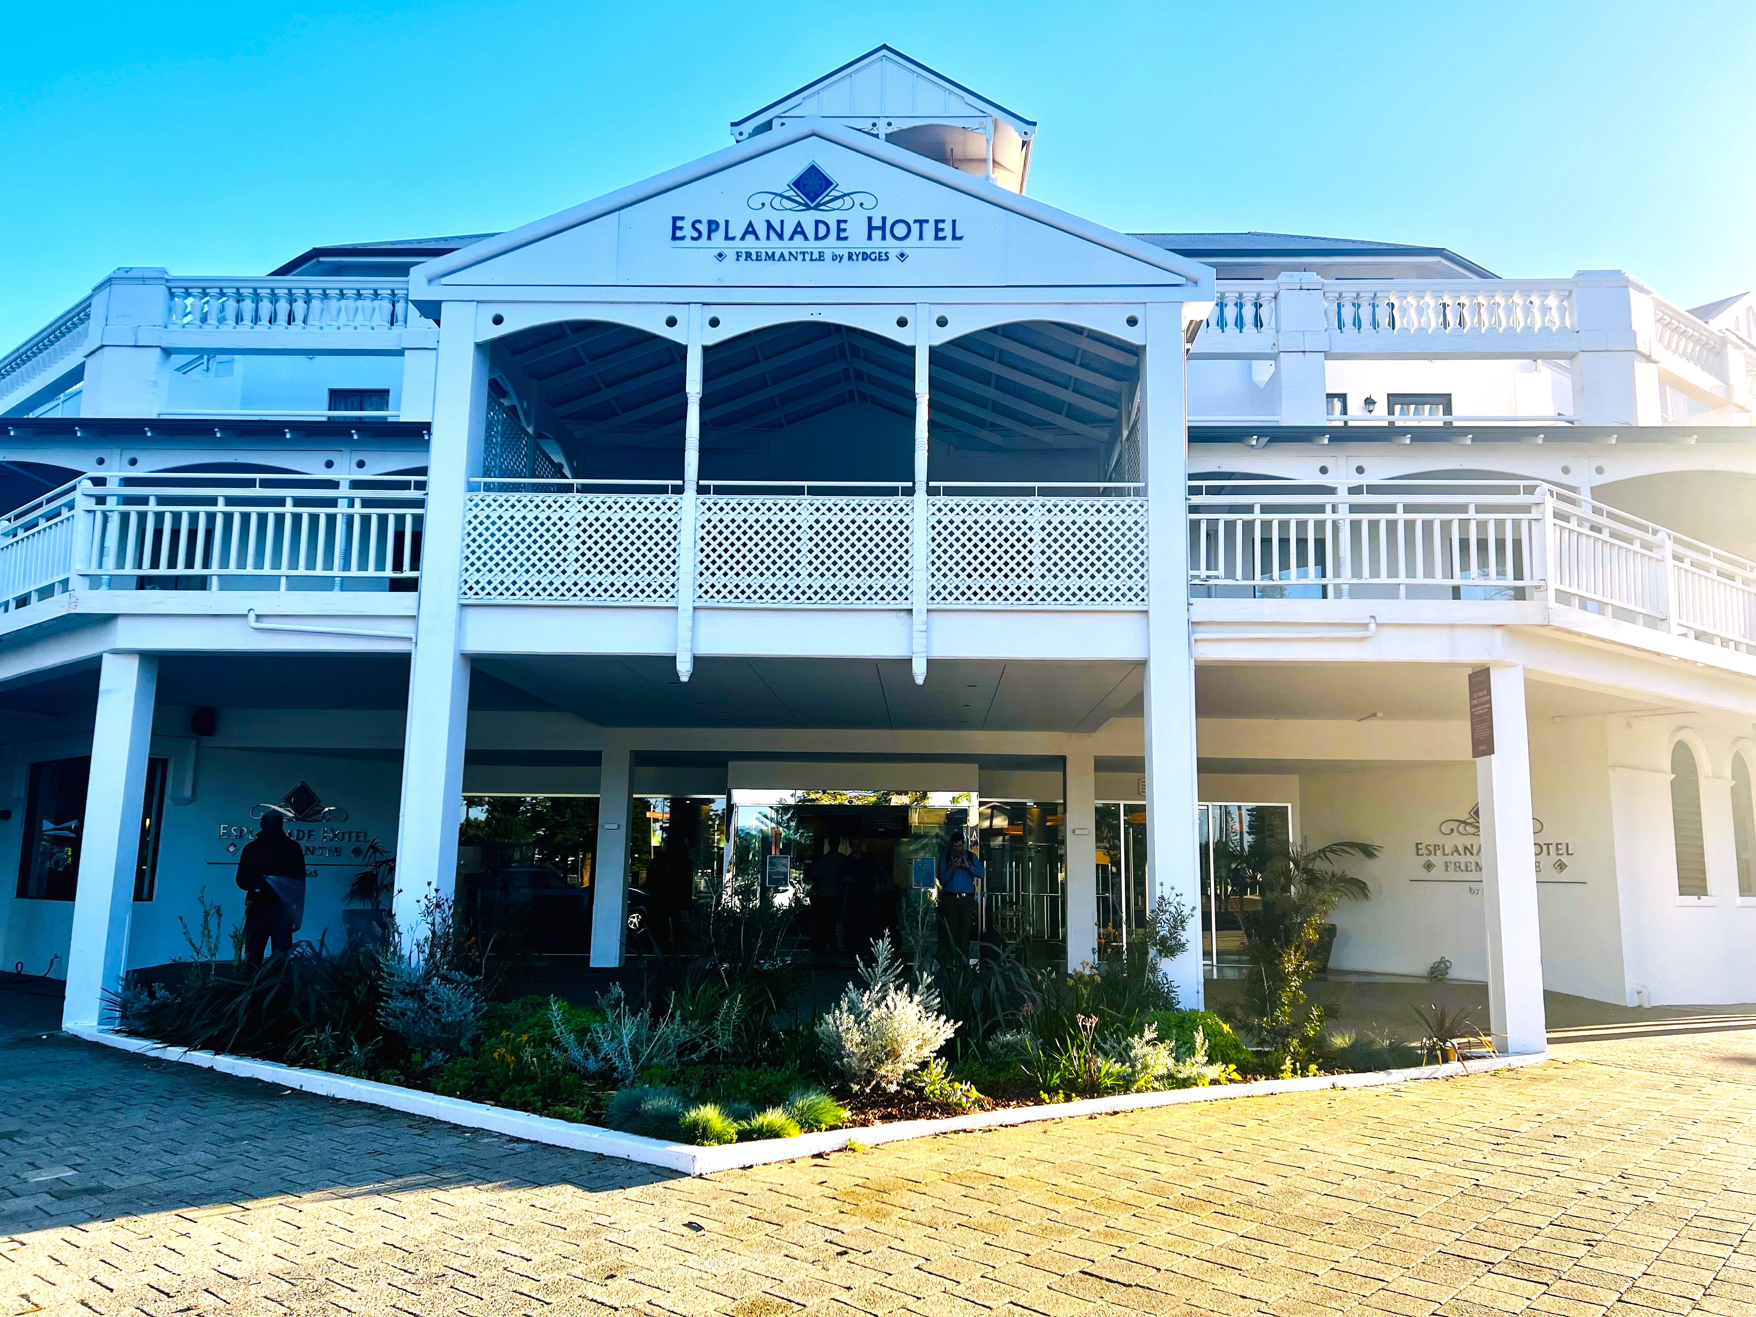
I thank all Committee members, observers, and partners for your continued support, collegiality, and constructive contributions as we progress our shared marine biosecurity goals. I look forward to the next meeting.
Shalan Scholfield, Co-Chair - MPSC29

MPSC29 Partners’ Workshop
The workshop brought together 29 in-person attendees and a broad range of stakeholders from across the marine biosecurity sector.
The workshop led to insights on some of the following collaborative projects:
Figure 1: MPSC29 meeting venue: Esplanade Hotel, Fremantle, WA
Image credit: Nira Chowdhury
- Domestic ballast water management update: DAFF outlined domestic ballast water management, regulatory history and an overview of policy review timelines and outcomes. The presentation emphasised the importance of stakeholder engagement for the policy review, including the shipping industry and government biosecurity agencies.
- Biofouling mandatory instrument and in-water cleaning: DAFF presented on the biofouling mandatory instrument and in-water cleaning. In April 2025, the International Maritime Organization (IMO) agreed to develop an international legally binding framework (Biofouling Convention) for the control and management of ships’ biofouling to minimise the transfer of invasive aquatic species. As a member state of the IMO, Australia will be involved in the development of the Convention.
- In-water hull cleaning with capture – Auditing methodology and compliance with new guidelines: Fremantle Ports, Franmarine (commercial dive company) and the Western Australian Department of Primary Industries and Regional Development (WA DPIRD) co-presented on assessing compliance of Franmarine's in-water hull cleaning (IWHC) system against the exposure draft of the Australian antifouling and in-water cleaning guidelines.
- Updates on national marine pest matters: Partners across shipping, ports, energy, research, and citizen science reported on marine pest biosecurity efforts and collaboration. The session highlighted partner collaboration on marine pest biosecurity, including at a national, state and territory level. MPSC members and observers provided updates on marine pest management activities.
- Invasive marine pest controls and surveillance in Pilbara waters: Chevron Australia presented on invasive marine pest controls and surveillance in Pilbara waters. Chevron operates a comprehensive biosecurity management system to protect the conservation values of Pilbara waters, which includes stringent vessel controls, a robust surveillance program, and proactive biosecurity management measures.
- Marine pest surveillance in the Northern Territory: The Northern Territory Department of Agriculture and Fisheries (NT DAF) presented on enhancing marine pest surveillance in the NT, including the importance of continuous monitoring, rapid response, and the integration of new technologies like environmental DNA (eDNA) for early detection of marine pests.
- Why watch for Marine Pests: WA DPIRD presented on research to assess the importance of understanding individual’s motivations and fostering collaboration to enhance marine pest surveillance and biosecurity efforts. More information here: ABARES – How to make general surveillance work.
- Development of the second MarinePestPlan: DAFF provided an overview of stakeholder engagement for the development of the second MarinePestPlan, including ensuring it addresses shared priorities effectively. Next steps for engagement activities were also outlined. For further information contact: MarinePestPlan@aff.gov.au.
- Using eDNA for marine pest surveillance – experiences from the past, present status, and future directions: Curtin University presented on the use of environmental DNA (eDNA) for marine pest surveillance, covering past experiences, current status, and future directions. The presentation highlighted the evolution of eDNA technology, its current applications in marine pest surveillance, and ongoing efforts to enhance its effectiveness and usability.

MPSC High Priority Work Items
The Committee has advanced several strategic priorities:

MarinePestPlan 2018–2023 Review
The 2018-2023 review report was published on the Marine Pests website in March 2025. Development of the second MarinePestPlan is underway with strong industry and government engagement to occur.

National Marine Pest Surveillance Strategy 2021–2026
Implementation of the 2021-26 National Marine Pest Surveillance Strategy is ongoing, with 2 activities completed and 13 in progress.
A CSIRO supported model within the iNaturalist platform is now operational which is capable of identifying species occurring outside their expected ranges.

Emergency Response Task Group
The Response manual for invasive marine bivalves has been published on the Marine Pests website. The draft invasive ascidian response manual and updates to the northern Pacific seastar (Asterias amurensis) response manual are progressing.
Communication, Education and Engagement Task Group
Updated marine pest educational resources list are available on the OceanWatch website. Work is ongoing with universities and TAFE institutes on standardised marine biosecurity messaging for schools and tertiary courses, plus a tailored surveillance training module.
Marine Biosecurity Research Network Task Group
45 partners from universities, government agencies, museums, and other research institutions have expressed interest to join the network. It aims to strengthen national marine pest research by sharing priorities, fostering collaboration, and providing a platform for coordinated technical efforts and strategic direction.
Current Status of Marine Pest Task Group
Development of guidelines for determining the current status of marine pests in progress, to be used in conjunction with the policy principles to guide future marine pest surveillance in Australia.
Didemnum vexillum Management Task Group
An after-action review workshop was held in May 2025 to assess the national coordination arrangements for marine pest responses, to improve Australia’s marine pest response capabilities.
In-water Cleaning Exercise Task Group
A new task group has been formed to plan a national in-water cleaning exercise to clarify regulatory roles and strengthen vessel biosecurity management.

Upcoming MPSC Meetings
The MPSC30 meeting and Partners’ Workshop will be held in in Canberra in November 2025.

The MPSC uses a hybrid format to host its meetings and partners' workshops to enable participation from MPSC members, observers, and partners who are unable to attend in-person.
Co-chair is Dr. Bertie Hennecke from the Environmental Biosecurity Office at the Australian Government Department of Agriculture, Fisheries and Forestry (DAFF).

