# National biofouling management guidelines for non-trading vessels

Version 1.0, 2009

© Commonwealth of Australia 2009

**Ownership of intellectual property rights**

Unless otherwise noted, copyright (and any other intellectual property rights, if any) in this publication is owned by the Commonwealth of Australia (referred to as the Commonwealth).

**Creative Commons licence**

All material in this publication is licensed under a Creative [Commons Attribution 4.0 International Licence](https://creativecommons.org/licenses/by/4.0/legalcode) except content supplied by third parties, logos and the Commonwealth Coat of Arms.

Inquiries about the licence and any use of this document should be emailed to [copyright@agriculture.gov.au](mailto:copyright@agriculture.gov.au).

C:\Documents and Settings\west merryn\Local Settings\Temporary Internet Files\Content.Word\by.png

**Cataloguing data**

This publication (and any material sourced from it) should be attributed as: Marine Pest Sectoral Committee 2018, National biofouling management guidelines for non-trading vessels, Department of Agriculture and Water Resources, Canberra, November. CC BY 4.0. Document modified in 2018 to meet accessibility requirements.

This publication is available at [marinepests.gov.au/what-we-do/publications](http://www.marinepests.gov.au/Pages/map/American-slipper-limpet.aspx)

Marine Pest Sectoral Committee Secretariat

Department of Agriculture and Water Resources

GPO 858 Canberra ACT 2601

Telephone 1800 372 746 (local calls) +61 2 6272 5232 (international)

Email [mpsc@agriculture.gov.au](mailto:mpsc@agriculture.gov.au)

Web [marinepests.gov.au](http://www.marinepests.gov.au/)

**Disclaimer**

These guidelines are part of a series of documents setting out a consensus view of effective biofouling management practices.

The guidelines are made available on the understanding that the Commonwealth of Australia is not thereby engaged in rendering professional advice. The Commonwealth does not warrant the accuracy, currency or completeness of the guidelines, or their relevance for any particular purpose. In particular, it should be noted that legislation, regulations and by-laws may vary between different jurisdictions and ports in Australia. Consequently, the guidelines do not purport to state what is necessary or sufficient to comply with laws applying in any place.

Before relying on the guidelines in any important matter, users should obtain appropriate professional advice to evaluate their accuracy, currency, completeness and relevance for their purposes.

Contents

Introduction 1

Overview 1

Purpose and scope 1

Delineation of responsibility 2

1 Biofouling risk management 3

1.1 The biofouling pathway 3

1.2 The benefits of managing biofouling risks 4

1.3 Assessing the biofouling risk 5

1.4 Mitigating the biofouling risk 8

2 Management of vessels 10

2.1 Introduction 10

2.2 Biofouling reduction and management measures 11

3 Specific vessel classes 22

3.1 Barges 22

3.2 Lighters 23

3.3 Heavy lift vessels 24

3.4 Dredges 24

3.5 Cable ships 25

3.6 Customs vessels 26

3.7 Defence vessels 27

3.8 Harbour and coastal patrol vessels 28

3.9 Research vessels 28

3.10 Ferries 29

3.11 Charter boats 30

3.12 Water taxis 31

3.13 Pilot boats 31

3.14 Tugs and line handling boats 32

3.15 Super yachts 33

3.16 Tall ships 34

3.17 Trailered vessels 34

4 Recording and reporting 36

4.1 Record keeping 36

4.2 Reporting 36

Appendix A: Marine pest threats to Australia 37

Introduced marine pest threats 37

More information 38

Appendix B: Biofouling record book 39

Vessel details 39

Entries in the biofouling record book 40

Glossary 42

**Tables**

Table 1 Categories of non-trading vessels 2

**Figures**

Figure 1 Generic approach to biofouling risk assessment 9

Figure 2 Niche areas where biofouling can accumulate on a non-trading vessel 12

Figure B1 Example vessel diagram for biofouling record logbook 39

**Photographs**

Photo 1 Asian green mussel colonisation and establishment 3

Photo 2 Non-trading vessel in dry-dock for cleaning and maintenance 4

Photo 3 Hull cleaning and antifouling paint renewal to reduce biofouling risks 5

Photo 4 Primary biofouling establishing in areas where antifouling coating is damaged 6

Photo 5 Niche areas such as sea chests may shelter marine pests 7

Photo 6 Vessels operating at low-speed/low-activity accumulate significant biofouling 14

Photo 7 Stored anchor chain with biofouling 15

Photo 8 Preparation of surfaces for application of antifouling paint 16

Photo 9 Qualified diver undertaking in-water inspection and biofouling removal 18

Photo 10 Inspection of internal seawater system to identify areas of biofouling build-up 20

Photo 11 Assess the biofouling risk before relocating a decommissioned vessel 21

## Introduction

### Overview

Under the National System for the Prevention and Management of Marine Pest Incursions (the National System) voluntary biofouling management guidance documents have been developed for a range of sectors operating within Australian waters.

Along with most shipping and boating sectors in Australia, non-trading vessels have been recognised as presenting a risk of marine pest translocation and introduction via biofouling. The voluntary biofouling management guidance for non-trading vessels has been developed to assist industry manage this risk. Similar [National biofouling management guidelines](http://marinepests.gov.au/what-we-do/publications) have been developed for a range of sectors including commercial vessels, recreational vessels, and commercial fishing vessels.

Marine species and pests can be translocated to and around Australia via biofouling on vessel hulls and in damp or fluid-filled spaces (niche areas) such as anchor lockers, bilges, sea chests or internal seawater systems. Marine pests are species with invasive traits that can cause significant adverse impacts to marine industries, the environment, human health and/or amenity if introduced, established or translocated within Australia, as well as generating substantial costs for eradication attempts or ongoing management.

Applying the recommendations within this document and implementing effective biofouling controls can also assist vessel operators to minimise:

* hull and propeller inefficiency, resulting in a decrease in fuel consumption and increase in range and speed
* corrosion of pipework, valves and other internal seawater system components
* blocked or impeded flow into and within internal seawater distribution systems, resulting in increased efficiency of cooling, air conditioning and fire-fighting systems
* increased maintenance efforts and repair costs associated with clearing biofouling from blocked systems.

Further information on marine pest threats to Australia can be found at Appendix A.

### Purpose and scope

These recommendations provide practical management options for operators of non-trading vessels for the management of biofouling hazards associated with vessels and equipment. These recommendations only cover biofouling. Details of other marine pest management measures for marine pest risks such as ballast water can be found on the [Marine Pests](http://www.marinepests.gov.au) website.

This guidance document will be periodically reviewed to ensure that the content remains current and practical to industry and end users.

Non-trading vessels encompassed by these recommendations come in several categories.

Table 1 Categories of non-trading vessels

| Vessel category | Vessel type |
| --- | --- |
| General | Barges  Cable ships  Dredges  Heavy lift vessels  Lighters (including oil recovery vessels)  Research vessels  Tall ships  Trailered vessels  Super yachts |
| Government owned, contracted or chartered | Customs launches  Defence vessels  Harbour and inshore patrol vessels, including:   * fisheries vessels * marine administration vessels * marine safety vessels * national/marine parks vessels * water police vessels * coastal patrol vessels |
| Transport service vessels | Charter boats  Pilot boats  Ferries  Tugs and line handling boats  Water taxis |

Note: Transport service vessels may at times be owned, contracted or chartered by governments.

#### Cruise vessels

Although cruise vessels are considered to be non-trading vessels, their size, operational activity and maintenance regimes are similar to that of commercial vessels. See the [National biofouling management guidelines for commercial vessels](http://www.marinepests.gov.au/commercial/vessels/biofouling-commercial).

#### Offshore support vessels and pipelay vessels

These vessels are classed as non-trading vessels but are variable in their operational activities and spend much of their time working for the petroleum production and exploration industry. See the [National biofouling management guidelines for the petroleum productions and exploration industry](http://www.marinepests.gov.au/commercial/offshore-infrastructure/biofouling).

### Delineation of responsibility

It is recommended that when applying these recommendations, any Australian Government, state, Northern Territory or local regulations be considered.

For more information on marine pests, management methods, and associated regulations, see the [Marine Pests](http://www.marinepests.gov.au) website.

## Biofouling risk management

### The biofouling pathway

For a vessel or equipment to cause a biofouling marine pest incursion, three key steps need to occur:

1. colonisation and establishment of the marine pest on a vector (vessel, equipment or structure) in a donor region (a home port, harbour or coastal project site where a marine pest is established)
2. survival of the settled marine pests on the vector during the voyage from the donor to the recipient region
3. colonisation (for example, by reproduction or dislodgement) of the recipient region by the marine pest, followed by successful establishment of a viable new local population.

At each step there are factors that affect the total number of individual organisms and species that successfully survive to the next stage of the biofouling pathway.

These three steps provide the foundation for understanding, managing and assessing whether a particular vessel and equipment will have a low or high risk of causing a marine pest incursion.

Photo 1 Asian green mussel colonisation and establishment

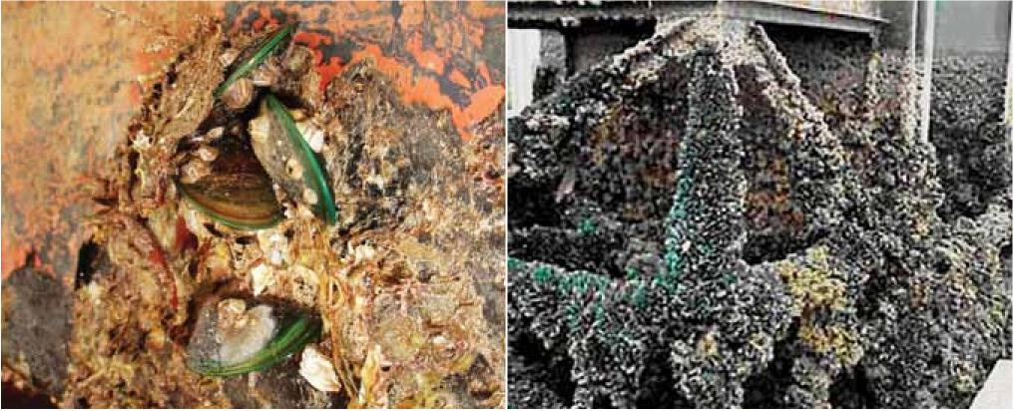

Note: Asian green mussels can survive sea journeys on the keel of a vessel (left) and establish in new areas such as this submerged power station infrastructure (right).

Image: NT Government, Chris Gazinski, courtesy Mote Marine Laboratory.

### The benefits of managing biofouling risks

Ensuring that appropriate biofouling risk reduction measures are implemented is advantageous for the non-trading vessel sector for reasons including:

* avoiding inadvertent marine pest incursions (not inspecting potentially high risk vessels until after their arrival at a location dearly poses much greater incursion risks than if the vessel’s biofouling has previously been managed)
* avoiding the costs and delays of having to manage emergency vessel slipping and cleaning if a marine pest is discovered on the vessel after its initial mobilisation
* reducing the risk that the non-trading vessel sector may be implicated in the translocation or introduction of a marine pest.

Regular vessel maintenance is the best defence against invasive marine species (Photo 2).

Photo 2 Non-trading vessel in dry-dock for cleaning and maintenance

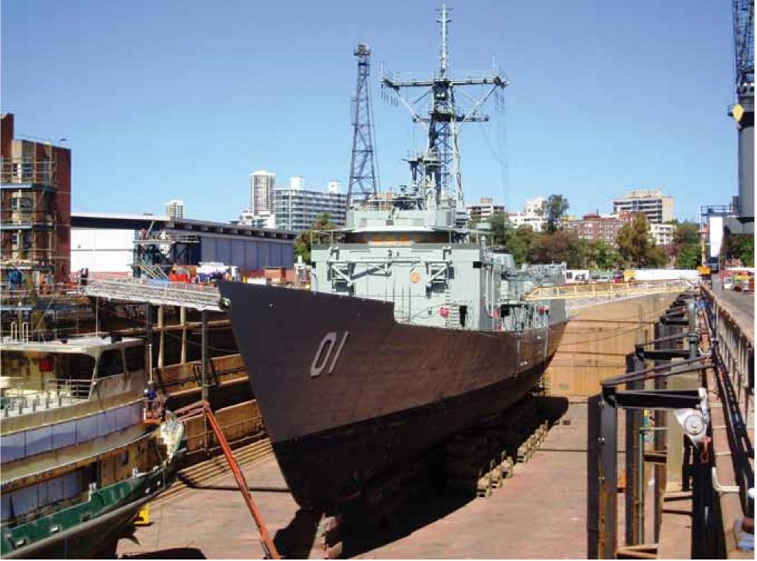

Image: John Polglaze, URS Australia.

### Assessing the biofouling risk

Several factors need to be considered when assessing the risk of a vessel or equipment assisting in the translocation of a marine pest and to reduce the likelihood of an incursion.

#### Cleaning

Vessel systems need to be cleaned both externally and internally.

Surface cleaning involves the removal of biofouling in a licensed vessel maintenance facility (such as a dry-dock) prior to departure from locations with a known or potential marine pest (Photo 3).

Internal seawater systems are treated to prevent or remove biofouling. Design features can assist with this, such as the fitting of a cathodic anode system to prevent biofouling.

Photo 3 Hull cleaning and antifouling paint renewal to reduce biofouling risks

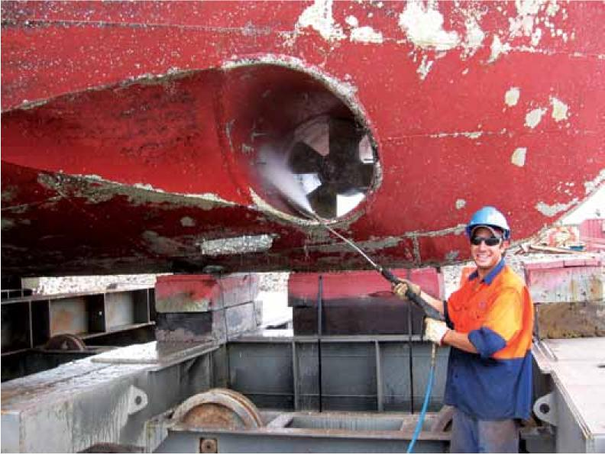

Image: Mermaid Marine Australia Ltd.

#### Antifouling coating

Any wetted surface that is not protected by an antifouling coating will accumulate greater levels of biofouling than a coated surface (Photo 4).

The effectiveness of an antifouling coating depends on several factors including its age, type, suitability to vessel, surface type and type of operations as well as its history of use in relation to the manufacturer’s recommendations.

Photo 4 Primary biofouling establishing in areas where antifouling coating is damaged

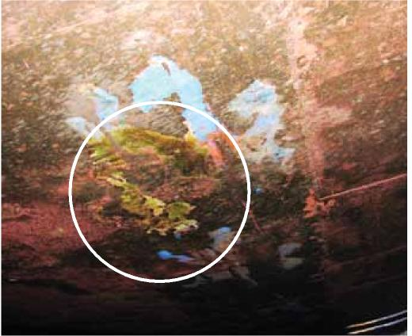

Image: Forgacs Engineering Pty Ltd.

#### Condition of vessel surface

Different vessel types and designs vary in susceptibility to biofouling. Sheltered areas and/or surfaces without antifouling coating provide a location where many marine species are protected from strong water flow, avoiding dislodgement and allow settlement and growth (Photo 5). This includes mobile species such as fish, crustaceans, sea-stars and marine snails.

Photo 5 Niche areas such as sea chests may shelter marine pests

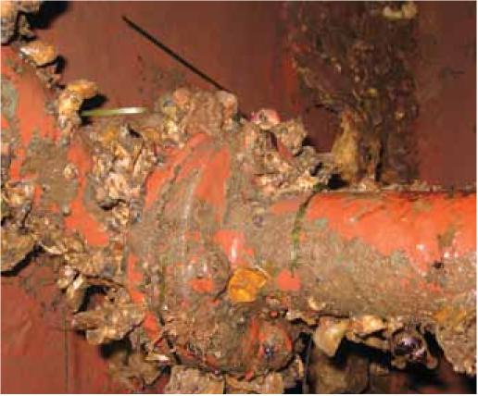

Most marine species cannot tolerate prolonged exposure to air and are transported on primarily submerged equipment and hull surfaces. Removal from the water (desiccation) can be an effective control option for marine pests, depending on the species and life history stage concerned and the relative humidity of the drying environment. As a general guide, complete removal (no contact with water) and exposure to direct sunlight, warm temperatures and low humidity will kill most marine species within seven days. However, any compromise on these conditions such as exposure to sea spray can enable some species to survive up to eight weeks

#### Operation and voyage profiles

The longer a wetted surface remains stationary or moving at low-speed (less than 5 knots) in port or coastal waters (or on longer slow voyages such as towing), the more likely it is to accumulate biofouling, and for any marine pests to survive. Vessels frequently undertaking low-speed and/or low-activity operations may need to apply a specialised antifouling coating, as many brands rely on minimum vessel speeds to activate biocide layers or to wash off any biofouling.

Survivorship of marine pests is greater on east-west voyages (which remain within a similar latitude band) than on north-south (trans-equatorial) routes where temperature changes are greater. The shorter the transit across oceans, the more chance that the marine species will survive temperature change and/or limited food sources available in oceanic waters. Since almost all marine pests are coastal and harbour species, vessels operating in offshore deep-water environments are less likely to accumulate or translocate marine pests, compared to vessels or equipment that operate in ports and shallow coastal waters

Once transported, the risk of successful marine pest establishment can be assessed based on the similarity of the departure and arrival regions. Relevant properties include:

* water temperature range
* salinity range
* water depth range
* habitat range (substrate types).

The assessment of biofouling risk should be guided by reference to any Australian Government, state, Northern Territory or local regulations.

### Mitigating the biofouling risk

A risk assessment should be undertaken to examine factors influencing the translocation risk posed by particular vessels. As the risks vary from vessel to vessel the assessment should be undertaken in an objective, transparent, consistent and readily reportable way. Figure 1 shows the basic components of a risk assessment process for assessing and managing vessels and equipment intended to be moved to or within Australian waters.

If vessels or equipment are found to have heavy biofouling or to pose a high risk of accumulating heavy biofouling, it is advised that biofouling mitigation treatments such as dry-docking, cleaning and antifouling renewal be considered. Section 2.2 provides general guidelines for vessel biofouling management, section 3 addresses the biofouling risks and management for specific vessel types.

It is important to maintain dear and detailed records of all biofouling mitigation, maintenance and repair activities carried out on a vessel. See section 4 for more detailed information on record keeping.

Figure 1 Generic approach to biofouling risk assessment

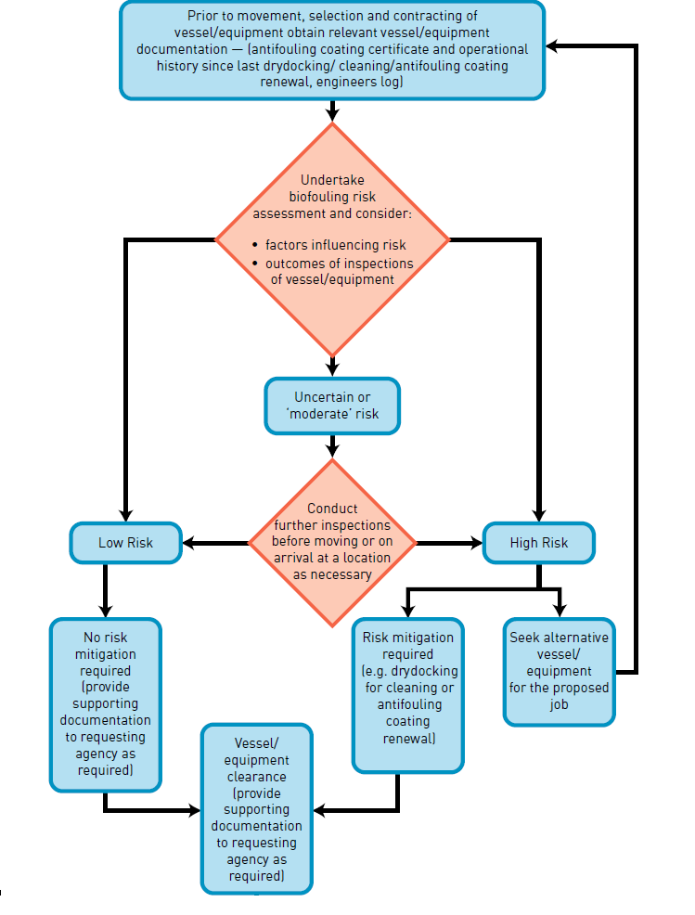

## Management of vessels

### Introduction

All vessels have some degree of biofouling, even those which may have been recently cleaned or had a new application of an antifouling coating. Research has shown that the biofouling process begins within the first few hours of a vessel’s immersion in water. Generally, the longer a vessel has been in water, the greater the size and complexity of its biofouling community.

The type, amount and location of biofouling is influenced by a number of factors, such as:

* vessel design and construction, particularly the number and design of niche areas subject to biofouling including hull fittings (Figure 2)
* the number, size and configuration of sea chests and other niche areas
* the layout, extent and configuration of internal seawater systems
* construction materials (for example, cupro-nickel pipes are less prone to biofouling than steel)
* any marine growth prevention systems (MGPS) (copper dosing or chlorination systems) which may be installed
* any active marine growth control procedures (such as regular propeller cleaning) which may be employed
* typical operating profile, including factors such as operating speeds including periods spent operating at low speeds, ratio of time underway compared with time alongside, moored or at anchor, and where the vessel is stored when not in use
* places visited, the duration of stay and the time of year of stay, particularly extended stays in ports or anchorages with similar conditions to other ports within Australia and/or where known or suspected marine pests may be present
* inspection and maintenance procedures
* maintenance history, including type, age and condition of any antifouling coating including factors such as nature of coatings, suitability of coating to the vessel operating profile, age, quality of application and maintenance including slipping and hull cleaning practices.

The biofouling which may be found on and in a vessel reflects the vessel’s design, construction, maintenance and operations. Each of these aspects introduces particular biofouling vulnerabilities but also offers opportunities to limit the extent and development of biofouling, with commensurate reduction in biosecurity risks.

These guidelines will provide suggested measures to minimise biofouling risks during each phase of a vessel’s life.

### Biofouling reduction and management measures

#### Design and construction

Any structural modifications to the hull or hull appendages should satisfy all relevant engineering standards and class requirements and be subject to approval, if appropriate, by regulatory authorities.

##### Hull voids and openings and other external niches

Small niches and sheltered inaccessible areas (Figure 2) should be excluded from vessels where practical in the design stage. Where the exclusion of niches is not practical, these can be designed so that they may be easily accessed for effective inspection, cleaning and application of antifouling coatings.

Other features reducing external biofouling include:

* rounded/bevelled protrusions on intake/outlet ports and similar areas to promote more effective application of an antifouling coating
* rounded corners on hull openings to promote more effective application of an antifouling coating
* grout/caulk in gaps in and behind sacrificial anodes and impressed current cathodic protection (ICCP) strips, when fitted.

##### Sea chests

To reduce biofouling of sea chests it is advised to minimise the number and size of sea chests and consider including:

* a simplified design to eliminate or minimise internal niche spaces and facilitate ease of access for in-water and dry-dock inspection, maintenance and painting
  + ideally sea chest interiors should feature smooth plates and wherever possible minimise internal structural members such as frames and stiffeners
* intake apertures/pipes flush with the sea chest interior surfaces
* rounded-as opposed to square- bars on intake grills
* easy access for divers to inspect and clean (including grates which can be open and shut by divers)
* MGPS or other method to eliminate biofouling
* 100 per cent free draining sea chests when the vessel is in a maintenance facility
* the option for sea chests to be blanked-off for in-water treatment of biofouling.

##### Internal seawater systems

Options to reduce biofouling of internal seawater systems:

* use cupro-nickel pipes rather than steel
* include an effective MGPS, ensuring that the point of injection of MGPS dosing is located in the sea chests or as close as practicable to inlets
* minimise bends, kinks and flanges
* promote ease of disassembly for inspection and cleaning
* include of filters and strainers and inspection ports.

Figure 2 Niche areas where biofouling can accumulate on a non-trading vessel

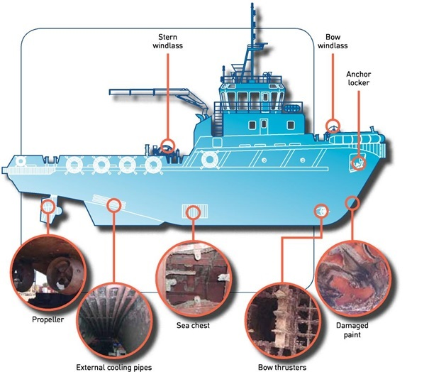

#### Operations

##### Selection of antifouling coatings

It is essential that vessel operators obtain technical advice from the antifouling coating manufacturer or the supplier as different antifouling coatings are designed for different vessel operating profiles (including operating speeds, activity, and maintenance and docking cycles). This will ensure the most appropriate antifouling coating is selected and applied correctly, with particular attention to surface preparation, coating thickness and the number of required coats (Photo 7).

Particular areas of focus when applying an antifouling coating include:

* high wear or low flow areas such as the bow area, rudder, or sea chest interiors
  + use a tailored, differential application of antifouling coatings to match required performance and longevity
* inner portions of the throats of intake/outlet ports (where accessible)
* areas not normally treated, such as main (and thruster/auxiliary) propellers and log probes
* surfaces and edges prone to coating damage
  + use cavitation resistant antifouling coatings, and edge retentive and high performance anticorrosive coatings.

##### Preparation for movement to or between operating areas

The highest risk of a marine pest translocation will occur when a vessel moves between two broadly similar marine biogeographic regions, either from overseas to Australia or within Australia.

This risk increases if certain predisposing factors occur, such as when the vessel:

* is heavily biofouled
* has been inactive or operated at low speeds for an extended period before the move between regions
* has a worn, ineffective or aged antifouling coating
* has areas where no antifouling coating is applied
* has operated in a port or area where a known or potential marine pest is known to occur.

To manage these risks, vessel operators should evaluate biofouling-related biosecurity risks before movement between locations.

Available measures to reduce risk:

* slip or drydock the vessel or undertake an inspection and thorough dean to remove biofouling, and repairing or replacing/renewing the antifouling coating
* conduct an in-water inspection by divers, and potentially undertake an in-water clean if appropriate (see section 2.2.3)
* inspect internal seawater systems, cleaning strainer boxes, and dosing or flushing these systems
  + the use of chemicals in the aquatic environment is governed by the Australian Pesticides and Veterinary Medicines Authority. [Check for chemical handling and use information](https://apvma.gov.au/node/10811)
* inspect and clean above water equipment and areas which may accumulate mud, sediments and/or marine pests, including dredge fittings, anchor cables and lockers, buoys, floats and booms and similar equipment
* provide prior advice to the relevant regulatory authorities of any concern regarding biofouling, and management actions undertaken or intended to be implemented.

##### Extended periods spent alongside, at anchor or operating at low speeds

During periods of low-speed/low-activity operations or inactivity, considerable biofouling can accumulate on underwater hull surfaces and niche areas (Photo 6). This is particularly the case in areas where an antifouling coating may be worn, damaged, depleted or not applied, or the antifouling coating applied is not designed for low activity or low-speed operations. The application of an antifouling coating optimised for use on low-speed vessels is critical for those vessels that typically operate at low speeds.

If a vessel has been inactive or has operated intermittently or continually at low speeds it may accumulate substantial biofouling in as little as a month, especially in circumstances where the vessel has not operated in accordance with antifouling coating manufacturer’s recommendations. If heavy biofouling is detected on a vessel, biofouling risk reduction measures need to be implemented before such a vessel moves to another location away from the port or anchorage where it has been stationary or operated at low speeds. These risk mitigation measures may incorporate a vessel inspection and appropriate cleaning before the vessel is moved from the location where it has been stationary.

Prior to undertaking in-water cleaning in Australia, approval from the relevant state/territory authorities must be granted and conditions may be imposed in line with the Australian and New Zealand Environment and Conservation Council (ANZECC) [Antifouling and in-water hull cleaning guidelines](http://www.agriculture.gov.au/biosecurity/avm/vessels/biofouling/anti-fouling-and-inwater-cleaning-guidelines) (see section 2.2.3 for more information on in-water cleaning).

Photo 6 Vessels operating at low-speed/low-activity accumulate significant biofouling

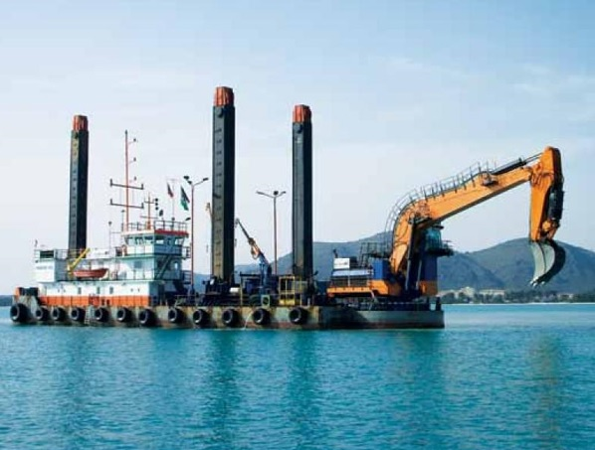

Image: Andy May, Van Oord Australia Pty Ltd.

##### Anchors and cables, berthing lines, booms and other floating equipment

Steps should be taken to ensure items periodically immersed in water, such as anchors and cables, ropes, fenders and small boats (tenders) are clean of biofouling such as entangled seaweed, mud and other sediments after recovery and before stowage. For example, a high pressure wash down (using a firehose if cable wash down spray is not fitted) should be used to clean anchors and cables of mud and sediment at the time of anchor retrieval.

Anchor wells and chain lockers should also be checked periodically and kept dear of biofouling, mud and sediments (Photo 7).

Photo 7 Stored anchor chain with biofouling

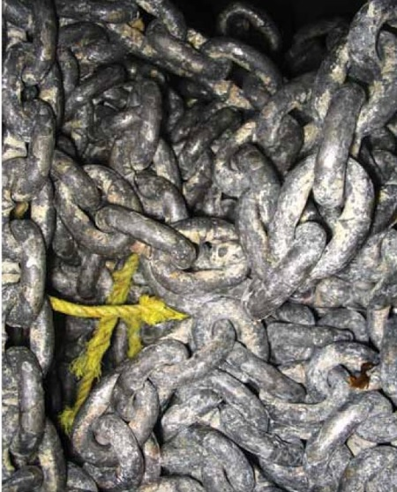

Image: Aquenal Pty Ltd.

#### Maintenance and repair

##### Slipping and dry-docking

Regular slipping or dry-docking of vessels should be undertaken to repair or renew the antifouling coating. To provide maximum protection, this maintenance should be undertaken within the life projected for the antifouling coating by the antifouling manufacturer or supplier, and a full antifouling coating reinstated on all painted underwater surfaces including areas of damage and degradation. Records of all maintenance and repair work completed on the vessel should be documented and receipts retained as verification of biofouling management activities.

When applying an antifouling coating to a vessel, it is essential that vessel operators obtain technical advice from the antifouling coating manufacturer or supplier. Ensure the most appropriate coating is selected and that it is applied according to the specification prepared for each application, with particular attention to surface preparation (Photo 8), coating thickness and the number of required coats.

Photo 8 Preparation of surfaces for application of antifouling paint

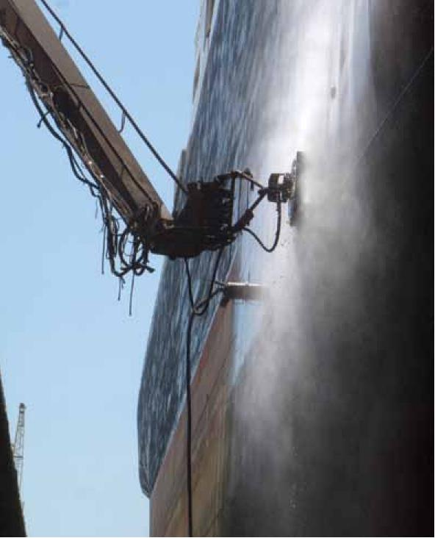

Image: John Lewis ES Link Services Pty Ltd.

Slipping or dry-docking of vessels is also the most effective means for inspection, detection and removal of biofouling from the hull and niche areas.

Along with the physical removal of biofouling, extended slipping or dry-docking also results in death of biofouling by desiccation (air exposure). However, some marine pests can survive or release reproductive propagules even after long periods of air exposure, particularly if attached in sheltered, damp niches out of direct sunlight. As a general guide, complete removal (no contact with water) and exposure to direct sunlight, warm temperatures and low humidity will kill most marine organisms within seven days. However, any compromise on these conditions can enable some organisms to survive up to eight weeks.

Most vessels are hydro- or grit-blasted as a standard practice whenever dry-docked and this will remove most external biofouling. It is essential that cleaning efforts during dry-dock or slipping specifically target niche areas.

To improve the effectiveness of biofouling removal of niche areas:

* clean any gaps between a fitting and the hull, such as may occur behind sacrificial anodes and stabilisers
* extend all retractable equipment, such as thrusters and dredge ladders, to permit access for cleaning of these fittings and any associated housings or voids
* open and clean sea chests, and physically remove any attached and detached biofouling debris, which may accumulate in them
* clean internal niches around shafts and propellers and nozzles, such as stern tubes, shaft couplings, ropeguards and bearings and rudder hinges
* clean other voids and niches, particularly apertures and orifices such as small bore intakes and outlets.

##### In-water inspection

In-water inspection is a useful way to inspect the condition of antifouling coatings and biofouling status of a vessel without the scheduling, logistics and expense associated with slipping or dry-docking. In-water inspections can be undertaken by divers or a remotely operated vehicle (Roy).

In-water dive inspections should be undertaken by suitably qualified and experienced divers familiar with biofouling and marine pests (Photo 9). Some agencies have recommended or accredited biofouling inspection divers to conduct these inspections.

Dive and remotely operated vehicle (ROV) surveys can be limited by visibility, available dive time compared with the area to be inspected and by difficulties accessing biofouling prone voids and niches.

It is recommended that when planning to conduct an in-water inspection, a formal procedure should be arranged to ensure that all accessible risk prone niches are examined. This involves:

* a suitably qualified and experienced diver or operator
* use of an inspection report sheet and photographic equipment
* assessment of known or likely biofouling risk areas and fittings
* appraisal of internal seawater system/s and niches (strainer boxes, anchor cable locker, bilge spaces)
* a precautionary approach assessing the amount and type of biofouling that may be present in inaccessible niches, such as sea chests and thruster tunnels, where grilles often prevent ROV or diver access
* where suspicious or suspected marine pests are detected, specimens should be collected and passed to the responsible regulatory authority for further examination. Consultation with the regulatory authority is advised on recommended collection and preservation methods
  + Generally, specimens collected should be preserved in a sealed container in a solution of 70 per cent ethanol/30 per cent fresh water or otherwise sealed and labelled in a plastic bag and stored in a freezer until they taken for identification. It is important to ensure that there is only one specimen per container/bag.
  + If arriving internationally all specimens must meet the [Australian Biosecurity Import Conditions.](https://bicon.agriculture.gov.au/BiconWeb4.0/)

In-water inspections should be undertaken periodically as a general means of routine surveillance. Additional inspections (in-water, or slipping or drydocking) may be required to address particular situations of elevated risk including:

* at the conclusion of an extended period of inactivity (several months or more) or low-speed operations
* when planning to move a vessel from an overseas location to Australia
* when planning to move a vessel from one region in Australia to another
* after a known or suspected marine pest is discovered on a vessel or within the vessel’s niche areas (such as the internal seawater systems) or a secondary translocation has occurred in proximity to a detection of a species of concern.

If considered necessary in-water inspections may be required by relevant regulatory authorities including the Australian Government and states and Northern Territory.

Photo 9 Qualified diver undertaking in-water inspection and biofouling removal

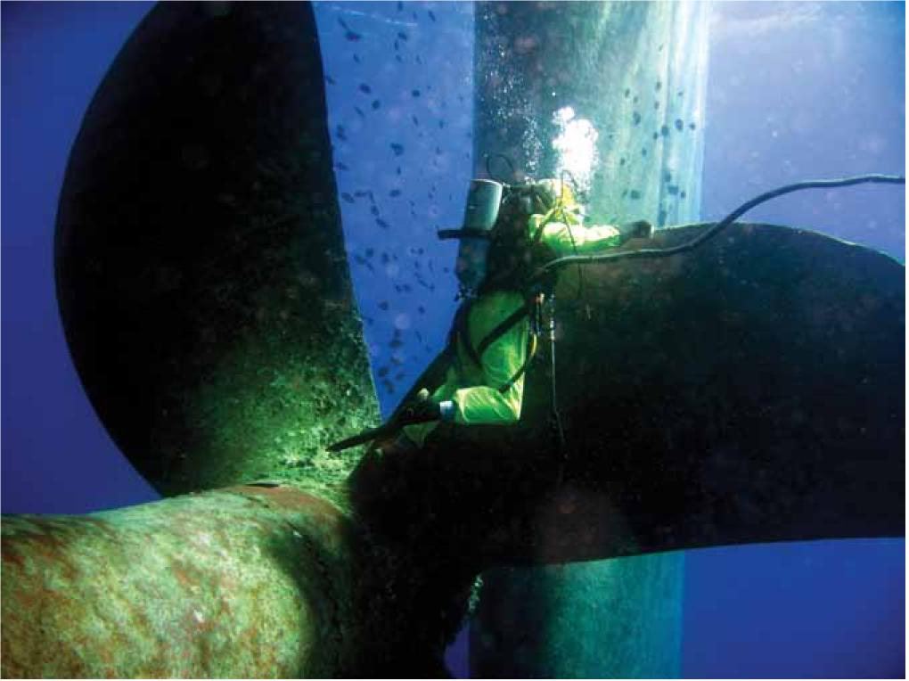

Image: Neptune Marine Services Ltd.

##### In-water cleaning of hulls and propellers

The removal of biofouling from vessel hulls and propellers is known to significantly improve a vessel's efficiency through the water and reduce the risk of translocating marine pests. However, scrubbing biofouled antifouling coatings not only prematurely depletes the antifouling coating and leads to rapid re-fouling but generates biofouling debris in the water column creating a pulse of biocide that can harm the local environment. To address this issue, many state and territory governments abide by Australian and New Zealand Environment and Conservation Council (ANZECC) [Antifouling and in-water hull cleaning guidelines](http://www.agriculture.gov.au/biosecurity/avm/vessels/biofouling/anti-fouling-and-inwater-cleaning-guidelines)

The ANZECC guidelines apply to in-water cleaning in Australian waters and stipulates that:

1. No part of a vessel’s hull treated with antifouling coating is to be cleaned in Australian waters without the written permission of the Harbour Master, local government or state environmental protection agency (administering authority).
2. In-water hull cleaning is prohibited, except under extra ordinary circumstances and permission will not normally be granted.
3. The cleaning of sea chests, and other niche areas may be permitted provided that any debris removed (including encrustation, barnacles, weeds) is not allowed to pass into the water column or fall to the sea bed and subject to any other conditions attached to the permit. An application seeking permission to carry out this work must be lodged with the administering authority at least five working days prior to the anticipated start date. Such application will detail how encrustations, barnacles and other debris will be contained and or collected for disposal as well as the method of disposal.
4. The polishing of ship’s propellers may be permitted subject to any conditions attached to the permit. An application seeking permission to carry out propeller polishing must be lodged with the administering authority at least five working days prior to commencement of the work.

Should a permit be granted, it is recommended that divers use the opportunity to inspect all niche areas for biofouling.

Areas that should be specifically inspected by divers (marked in Figure 2) include:

* rudder stock and hinge
* stabiliser fin apertures
* rope guards and propeller shafts
* cathodic protection anodes
* sea chests and bow thrusters
* overboard discharge outlets and sea inlets
* areas of antifouling coating damage or grounding.

##### Inspection and maintenance of internal seawater systems

Regular inspection of internal seawater systems can identify biofouling accumulations (Photo 10). Treatment of internal seawater systems offers a means of removing biofouling, leading to improved system performance while simultaneously reducing marine pest risks. Methods such as chemical treatment or freshwater flushing can be undertaken as either a periodic treatment or in response to a specific biofouling problem.

There are two chemical processes used to maintain seawater systems, chemical cleaning and chemical dosing. Chemical cleaning is the addition of an acid to dissolve or digest any established biofouling from the internal seawater system pipework. Chemical dosing is used as either a routine addition of chemical to the seawater system to keep pipework free of biofouling or a shock dose to eradicate established biofouling. Chemical dosing is a viable option when more rigorous treatment may be necessary.

The selection and application of chemical cleaning agents requires consideration of a number of factors including pipework configurations, components (including valves, joints and seals), materials (rubber, plastics, polycarbonates, polyvinyl chloride, alloys and solders) and their compatibility with the intended agent and method of application. If this option is used to treat internal seawater systems, disposing of all chemicals and materials must be done so using approved disposal locations and facilities.

Freshwater flushing can kill marine species if the infected pipework can be isolated for several days, however the resulting calcareous and organic debris may need chemical removal or high pressure flushing to avoid clogging. Chemical treatment to kill marine species can similarly leave the system fouled by shells and other chemical and biological residue.

The choice of treatment agent—and its correct usage and disposal—warrants appropriate consultation to avoid compromising pipework integrity, vessel safety and environmental protection. Research to identify effective and safe treatment methods for killing marine pests remains part of the development program for the National System. Further advice should be sought from authorities and product agents.

Photo 10 Inspection of internal seawater system to identify areas of biofouling build-up

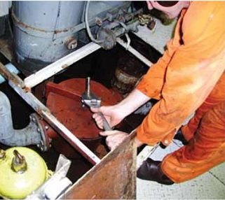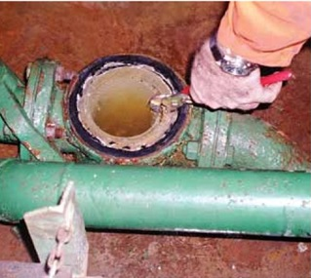

Images: URS Australia.

##### Decommissioning and disposal

Decommissioned vessels or those slated for sale are often stationary for extended periods in ports and anchorages before final disposal. During this period of inactivity considerable biofouling can accumulate on underwater hull surfaces and fittings. This is particularly the case when an antifouling coating is worn, damaged or depleted, or not designed for static performance, and in areas where the antifouling coating is not applied (such as niche areas). Vessels are often decommissioned at the end of a docking cycle, when the antifouling coating is at the end of its anticipated life.

A range of options exist to limit biofouling risks while a vessel is being prepared for decommissioning and disposal. These include:

* shutdown of internal seawater systems to starve and/or asphyxiate marine pests within the system
* use of an MGPS or other dosing routines for any internal seawater systems which remain in operation during the period of vessel inactivity
* blanking off sea chests (if not required for water uptake) external to the grates
* blanking off any other intakes and voids (such as bow thruster tunnels and rudder support strop holes) to reduce niche areas available to harbour marine pests.

Before a vessel which has been inactive is moved to another location away from the port or anchorage, an assessment of the hull and niche areas should be conducted (Photo 11), and any significant biofouling removed in accordance with relevant in-water cleaning guidelines and regulations (see section 2.2.3). This ensures that any biofouling that is obtained during the period of inactivity is from the location where the vessel was inactive. It also ensures that any marine pests will not be conveyed to another location within Australia. If the vessel is re-entering service, a dry-docking may be necessary to restore an effective antifouling coating on the hull and to ensure niches are free of biofouling.

Photo 11 Assess the biofouling risk before relocating a decommissioned vessel

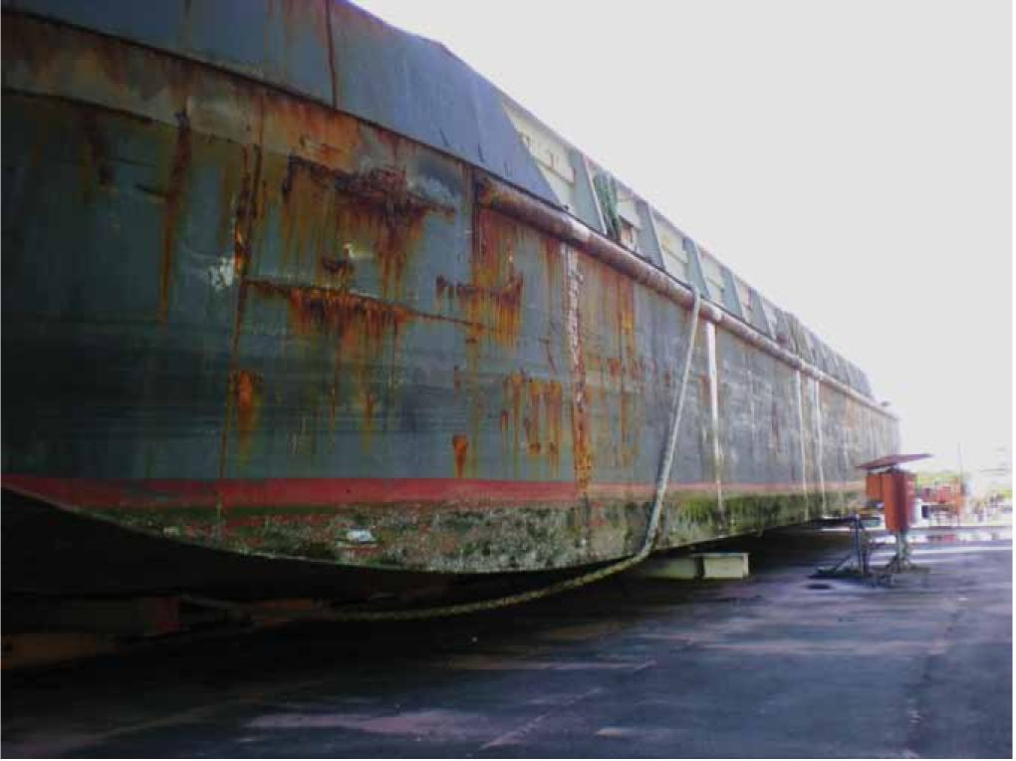

Image: Wallace McFarlane, Queensland Department of Primary Industries.

## Specific vessel classes

This section outlines issues and measures for operators to address differences in the design and operational characteristics of specific vessel classes which can facilitate biofouling. The vessel specific information contained in this section should be considered in conjunction with the general guidance presented in section 1 and section 2 of these recommendations.

Operators of vessel types not represented in this section should take guidance from the information presented in line with the most similar vessel types, taking account of comparable design and operating characteristics.

Any in-water hull cleaning should abide by the ANZECC Antifouling and in-water hull cleaning guidelines (see section 2.2.3) and in accordance with the antifouling coating manufacturer’s recommendations.

Furthermore, the removal, collection and disposal of biofouling and antifouling coatings in vessel maintenance facilities should abide by the ANZECC Code and occur at a licensed facility that has adequate waste management facilities to capture and dispose of collected matter.

### Barges

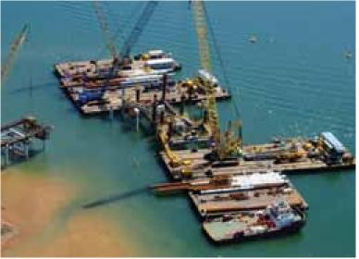

Barges can be susceptible to biofouling and assist in the translocation of marine pests due to:

* periods spent stationary or operating and being towed at low-speed in ports and coastal areas
* for towed barges, biofouling has little impact on their efficiency through the water, hence less incentive to adopt high performance antifouling coatings
* damage to antifouling coatings from work activities, and regular groundings (as for landing barges)
* mud, sediments and biofouling entangled in anchors and other related equipment
* transfers between coastal areas and islands, accentuating marine pest translocation risks.

These risks can be minimised by:

* selecting, applying and maintaining an effective antifouling coating appropriate to the vessel’s operating profile and docking cycle, including regular inspection, scheduled dry-dockings and cleaning and maintenance as necessary
* ensuring that anchors and cables are cleaned after use, and checked dear of mud, sediments, biofouling or entangled biofouling (seaweeds) before stowage
* physically removing any obvious biofouling from berthing lines (by hand and/or high pressure washdown), then leaving lines to thoroughly dry before stowage
* if the chosen antifouling coating is in line with the operating profile of the vessel regular maintenance regimes should be followed although due to the vessel’s operating profile, regular inspections of the niches areas may be necessary to ensure that they are free of biofouling
* using an effective MGPS or other inspection and treatment routines, for any internal seawater systems.

Operators of landing barges that regularly ground should be aware of the need for regular hull inspection and maintenance to prevent biofouling accumulation on damaged coating areas. It is also recommended that the antifouling coating be repaired as necessary to maintain its effectiveness and longevity.

Operators of barges servicing island communities and remote coastal areas and between Australian ports or moving internationally need to be aware of the risks of translocating marine pests. They should ensure that the hull remains as free of biofouling as practicable and that berthing lines, anchors, cables and other immersible gear are checked regularly and kept free of entangled biofouling, mud and sediments.

### Lighters

Lighters can be susceptible to biofouling and assist in the translocation of marine pests because they can spend long periods stationary or operating at low-speed in ports and coastal areas.

These risks can be minimised by:

* selecting, applying and maintaining an effective antifouling coating appropriate to the vessel’s operating profile and docking cycle, including regular inspection, scheduled dry-dockings and cleaning and maintenance as necessary
* physically removing any obvious biofouling from the berthing lines (by hand and/or high pressure washdown), then leaving lines to thoroughly dry before stowage
* undertaking a biofouling inspection, and if necessary, appropriate hull maintenance before relocation of a lighter from one port or coastal area to another.

### Heavy lift vessels

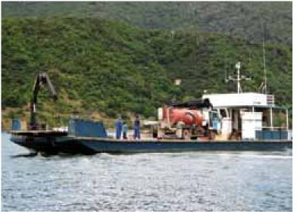

Management of biofouling risks for these vessels follows the general guidelines addressed in section 1 and section 2.

Heavy lift vessels may pose some risk according to the deck cargo they are carrying, such as small vessels, items of marine infrastructure or mobile drilling rigs which may be heavily biofouled. All cargo should be thoroughly inspected and cleaned of marine pests in the location where the cargo is loaded before transport.

Residual biofouling on heavy lift vessel cargo items may die due to desiccation during the period of transit, but this cannot be relied upon as some organisms can survive or release reproductive propagules after long periods of air exposure, particularly if in sheltered, damp niches out of direct sunlight or exposed to sea spray (see section 1.3.3).

### Dredges

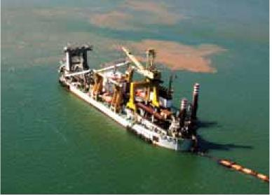

Dredges can be susceptible to biofouling and assist in the translocation of marine pests due to:

* long periods spent operating at low-speed in ports and coastal areas
* long periods spent stationary in ports and anchorages between jobs
* damage to antifouling coatings in some locations as a result of work activities
* surfaces, components and fittings not treated with antifouling coatings due to operating and material requirements
* entrainment and capture of mud, sediments and biofouling in dredge equipment and ancillary fittings
* transfers from one coastal area to another, facilitating marine pest translocation risks.

These risks can be minimised by:

* selecting, applying and maintaining an effective antifouling coating appropriate to the vessel’s operating profile and docking cycle, including regular inspection, scheduled dry-dockings, and cleaning and maintenance as necessary
* ensuring that anchors and cables are cleaned after use and checked dear of mud, sediments, biofouling or entangled biofouling (seaweeds) before stowage
* ensuring that cable lockers are checked and if necessary cleaned dear of mud, sediments, and entangled biofouling before transit of the dredge to another area
* undertaking biofouling inspections when deemed appropriate and in line with the maintenance schedule of the vessel. These should include the underwater hull area, and if necessary, thorough cleaning or flushing of suction and discharge pipes and hoses, hoppers, hopper doors and hinges, cutters, dredge ladders, trailing arms, buckets, pontoons and similar
  + This needs to occur particularly after a period of a month or more of inactivity or extended low-speed operation and before transit to another area
  + Where practicable, equipment should also be rinsed or flushed with fresh water
* using an effective MGPS or other inspection and treatment routines for internal seawater systems
* cleaning of internal seawater system strainers and emptying of decantation tanks (if fitted) at the completion of a dredging operation and before transit to another area
  + National guidelines for assessing dumping activities including dredging permit applications can be found on the [Department of the Environment and Energy website](http://www.environment.gov.au/topics/marine/marine-pollution/sea-dumping/dredged-material).

### Cable ships

Cable ships can be susceptible to biofouling and assist in the translocation of marine pests due to:

* extended periods spent moored or berthed in ports and anchorages between jobs
* surfaces, components and fittings not being treated with antifouling coatings due to operating and material requirements
* entrainment of mud and sediments in immersible working gear and recovered cables.

These risks can be minimised by:

* selecting, applying and maintaining an effective antifouling coating appropriate to the vessel’s operating profile and docking cycle including regular inspection, scheduled dry-dockings, cleaning and maintenance as necessary
* ensuring immersible and floating equipment (including pontoons and mooring system components) is inspected and cleaned after use and checked dear of mud, sediments, biofouling or entangled biofouling (seaweeds) before stowage
* ensuring that all mud, sediments and biofouling is, as far as practicable, cleared from cable or pipe recovered from the seabed. Any accumulation of this material on the deck or working areas of the vessel should be discarded in the source location, or contained on board for disposal ashore in appropriate waste disposal facilities
* undertaking a biofouling inspection and if necessary appropriate hull maintenance before relocation of a dredge from one coastal area or port to another. Particular attention should be given to areas and components where antifouling coatings are absent or damaged
* using an effective MGPS or other inspection and treatment routines, for internal seawater systems.

### Customs vessels

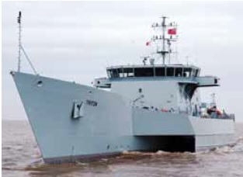

Customs vessels and their tenders can be susceptible to biofouling and assist in the translocation of marine pests due to:

* variable speed and activity in operation
* operations in varying coastal areas and remote islands
* operations in marine protected areas not normally visited by vessels, increasing the risk of translocating a marine pest to this area
* work in close proximity to vessels which represent elevated biofouling risks, with the risk for transfer of marine pests from one of these vessels to a Customs vessel or its tender.

These risks can be minimised by:

* selecting, applying and maintaining an effective antifouling coating appropriate to the vessel’s operating profile and docking cycle, including regular inspection, scheduled dry-dockings, and cleaning and maintenance as necessary
* undertaking regular biofouling inspection of the underwater hull area, and a clean if deemed necessary
* ensuring that anchors and cables are cleaned after use and checked dear of mud, sediments, biofouling or entangled biofouling (seaweeds) before stowage
* ensuring that cable lockers are periodically cleaned and checked dear of mud, sediments and entangled biofouling
* using an effective MGPS or other inspection and treatment routines, for internal seawater systems
* avoiding direct contact between a Customs vessel and illegal vessels of the type regularly intercepted during Customs patrols
* periodically inspecting the underwater surfaces and immersible gear (including anchor and cable) of embarked tenders to ensure these are dear of mud, sediments biofouling and entangled biofouling.

### Defence vessels

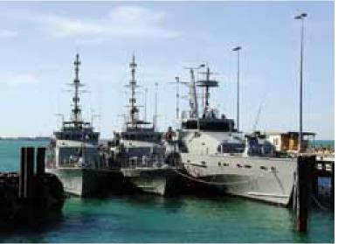

Defence vessels include a broad spectrum of vessel classes, some of which are similar in design and operation to other non-trading vessel categories such as barges (section 3.1), Customs vessels (section 3.6), harbour craft (section 3.8) and research vessels (section 3.9).

Defence vessels can be susceptible to biofouling and assist in the translocation of marine pests due to:

* variable speed and activity in operation
* extended periods of inactivity in port between operations and exercises, and during alongside maintenance procedures.

Australian Defence vessels are required to manage biofouling in accordance with the Defence Instruction on Policy for the Management of Ballast Water and Ship Biofouling.

Vessels under contract or charter to Australian Defence should seek guidance from the Australian Defence Instruction on Policy for the Management of Ballast Water and Ship Biofouling as well as any relevant information presented in these guidelines.

### Harbour and coastal patrol vessels

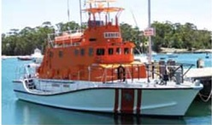

This category includes a variety of limited-range marine and harbour administration and patrol vessels such as those used by or for water police, fisheries, marine administration, marine safety (including search and rescue), national/marine parks and other coastal patrol vessels.

Operators are advised to maintain regular inspection and cleaning schedules to prevent biofouling and minimise the translocation of marine pests as a result of vessel movements.

Operators of trailered vessels should refer to section 3.17.

### Research vessels

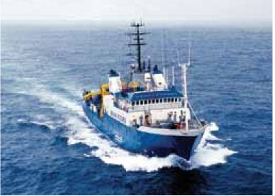

Research vessels and deployment of associated immersed and subsea equipment may assist in the translocation of marine pests.

These risks can be minimised by:

* selecting, applying and maintaining an effective antifouling coating appropriate to the vessel’s operating profile and docking cycle including regular inspection, scheduled dry-dockings, cleaning and maintenance as necessary
* ensuring that immersed and subsea equipment (including nets, bottom grabs and other sampling gear) is inspected and cleaned after use and checked to be dear of mud, sediments, biofouling or entangled biofouling (such as seaweed) and dried before stowage
* ensuring that all mud, sediments and biofouling is, as far as practicable, cleared from equipment recovered from the water column or seabed. Any accumulation of this material on the deck or working areas of the vessel should be discarded in the source location or contained on board for disposal ashore at a licensed facility that has adequate waste management facilities to capture and dispose of collected matter.

Additional general guidelines for managing vessel biofouling risks are listed in section 2.2.

### Ferries

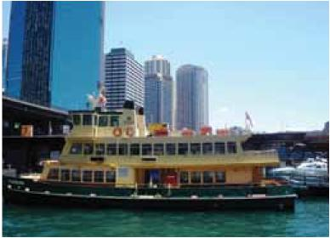

Ferries that move between separate coastal regions or mainland and offshore islands (Kangaroo Island, Rottnest Island and islands in the Great Barrier Reef region) pose a risk of assisting in the translocation of marine pests. As these vessels may be operating in pristine or sensitive marine environments, vessel operators need to be aware of the need to effectively reduce biofouling risks to protect the value of these locations on which their business may be based.

These risks can be minimised by:

* selecting, applying and maintaining an effective antifouling coating appropriate to the vessel’s operating profile and docking cycle, including regular inspection, scheduled dry-dockings, cleaning and maintenance as necessary
* ensuring that anchors and cables are cleaned after use, are dear of mud, sediments, biofouling or entangled biofouling (such as seaweed) before stowage
* ensuring that cable lockers are periodically inspected and cleaned of mud, sediments and biofouling
* use of an effective MGPS or other inspection and treatment routines for internal seawater systems.

Ferries that move within a particular port or estuarine area pose a reduced risk for translocating marine pests, particularly when they operate in a single location.

### Charter boats

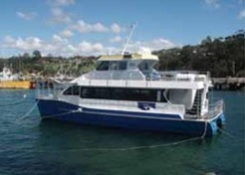

Charter boats can be susceptible to biofouling and assisting marine pest translocation. This is due to extended periods spent moored or berthed in ports and anchorages between jobs or in periods of low commercial demand.

Similar to ferries, charter boats tend to operate in pristine or sensitive marine environments, often undertaking numerous day trips from ports to nearby areas. These are regular, typically high speed movements, of generally well maintained vessels, however vessels may operate from inshore/ports or source waters with a history of marine pests/detections. Vessel operators need to be aware of the need to effectively reduce biofouling risks in order to protect the value of the locations on which their services depend.

These risks can be minimised by:

* selecting, applying and maintaining an effective antifouling coating appropriate to the vessel’s operating profile and docking cycle including regular inspection, scheduled dry-dockings and cleaning and maintenance as necessary
* slipping and cleaning vessels prior to commencement of the charter season including inspection and cleaning of internal seawater systems.

Charter vessels which visit isolated regions such as the Kimberley coast and outer areas of the Great Barrier Reef, need to be particularly vigilant to avoid the translocation of marine pests via biofouling into protected areas.

Operators of trailered vessels should refer to section 3.17.

### Water taxis

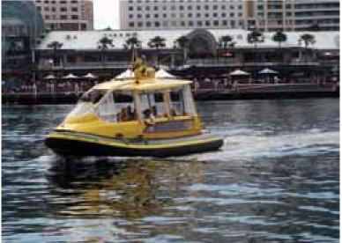

No specific measures are recommended for water taxis.

General guidelines for managing vessel biofouling risks are listed in section 2.2.

### Pilot boats

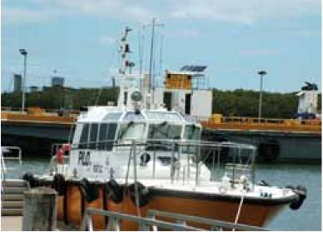

No specific measures are recommended for pilot boats.

General guidelines for managing vessel biofouling risks are listed in section 2.2.

### Tugs and line handling boats

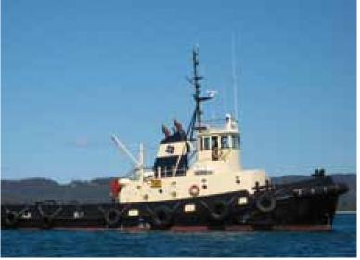

Harbour tugs and line handling boats can be susceptible to biofouling and assist in the translocation of marine pests due to:

* long periods spent operating at low-speed in ports and coastal areas
* long periods spent stationary in ports and anchorages
* damage to antifouling coatings as a result of work activities
* tug movement between ports or different coastal regions
* contact with berthing lines and cables from ships visiting that port from a different port.

These risks can be minimised by:

* selecting, applying and maintaining an effective antifouling coating appropriate to the vessel’s operating profile and docking cycle including regular inspection, scheduled dry-dockings, cleaning and maintenance as necessary
* ensuring that warps and lines are free of any biofouling or entangled biofouling by physical removal by hand and/or high-pressure hosing and allowed to thoroughly dry before being stowed or re-used in a new location
* visually inspecting lines received from visiting vessels to check that there is no obvious biofouling either attached or entangled.

### Super yachts

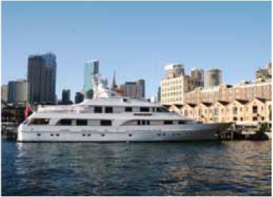

Super yachts can be susceptible to biofouling and assist in the translocation of marine pests due to:

* variable speed and voyage activity
* extended periods of inactivity in ports between voyages.

These risks can be minimised by:

* selecting, applying and maintaining an effective antifouling coating appropriate to the vessel’s operating profile and docking cycle, including regular inspection, scheduled dry-dockings, and cleaning and maintenance as necessary
* ensuring that anchors and mooring lines are cleaned after use, and checked dear of mud, sediments, biofouling or entangled biofouling (such as seaweed) before stowage
* ensuring that cable lockers are periodically inspected and cleaned of mud, sediments, and entangled biofouling
* using an effective MGPS or other inspection and treatment routines for internal seawater systems

Treatments listed in other sections can apply equally to vessels associated onboard super yachts that are periodically deployed, such as tenders and jet skis.

Additional general guidelines for managing vessel biofouling risks are listed in section 2.2.

### Tall ships

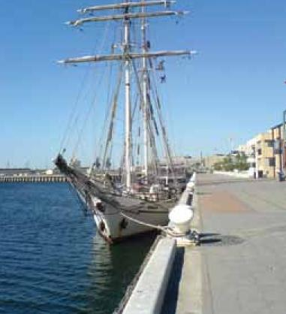

Tall ships often have wooden hulls and are sometimes referred to as slow moving wooden vessels. These include examples such as sail training vessels and vessel replicas. These vessels can be susceptible to biofouling and assist in the translocation of marine pests due to:

* low-speed and variable voyage activity
* extended periods of inactivity in ports between voyages
* wooden hulls vulnerable to infestation by marine wood boring organisms.

These risks can be minimised by:

* selecting, applying and maintaining an effective antifouling coating appropriate to the vessel’s operating profile and docking cycle, including regular inspection, scheduled dry-dockings and cleaning and maintenance as necessary
* ensuring that anchors and cables are inspected after use and cleaned of mud, sediments, biofouling or entangled biofouling (seaweeds) before stowage
* ensuring that cable lockers are periodically inspected and cleaned of mud, sediments, and entangled biofouling
* undertaking a biofouling inspection and, if necessary, appropriate hull maintenance before embarking on voyages.

### Trailered vessels

Apart from the normal risks posed by any vessel within the non-trading vessel sector, trailered vessels have the potential to translocate marine pests from one area to another via both the vessel and/or its trailer.

These risks can be minimised by:

* regularly inspecting and removing entangled or attached biofouling (including slime) from the external surfaces of the boat
* regularly inspecting and removing entangled biofouling, mud and sediment from the trailer
* thoroughly draining, cleaning and rinsing with freshwater the boat motors, hull fixtures (such as the cable locker and bait locker) and interior
* rinsing the vessel with freshwater (internal and external) and trailers before moving from one location to another.

## Recording and reporting

### Record keeping

It is recommended that vessel operators maintain a biofouling record book for each vessel. The book should record details of all inspections and biofouling management measures undertaken on that vessel.

A biofouling record book will assist in the assessment of the potential biofouling risk of a vessel and catalogue supporting documentation providing verifiable evidence that a vessel is unlikely to present an unacceptable biofouling risk. It is advised that copies/originals of all receipts and documentation are kept for verification of biofouling management conducted.

Information which should be recorded in a biofouling record book includes:

* details of the antifouling coating used, and where and when applied
* dates and location of slippings/dry-dockings, including the date the vessel was re-floated, and any measures taken to remove biofouling or to renew or repair the antifouling coating
* the date and location of in-water inspections, the results of those inspections and any corrective action taken to deal with observed biofouling
* details of fitted MGPS systems, their operation and maintenance and the dates and details of inspection and maintenance of internal seawater systems. This includes the results of those inspections and any corrective action taken to deal with observed biofouling and any reported blockages, reduced seawater pressures, elevated cooling temperatures that may imply biofouling build-up, as documented in the engineer’s log

An example of a biofouling record book and information to be recorded is included in Appendix B. This format is an example only. Vessel operators should check with jurisdictions about the preferred type and format of information required.

### Reporting

Vessel operators should notify the relevant regulatory agencies (see the [Marine Pests](http://www.marinepests.gov.au/report) website) on arrival within a state or territory, particularly if they find or suspect a marine pest is present on the vessel, to enable formal identification and initiation of appropriate management action. Signs of a suspected marine pest could include unusually heavy biofouling, dominance of the biofouling by one species or a ‘new’ species not seen before in the region.

Where suspicious or suspected marine pests are detected, specimens should be collected and passed to the responsible regulatory authority for further examination. However, wherever possible consult with the regulatory authority about their recommended collection and preservation methods. As a general guide collected specimens should be preserved in a sealed container in a solution of 70 per cent ethanol/30 per cent fresh water or otherwise sealed and labelled in a plastic bag and stored in a freezer until they taken for identification. It is important to ensure that there is only one specimen per container/bag. If arriving internationally all specimens must meet the [Australian Biosecurity Import Conditions.](https://bicon.agriculture.gov.au/BiconWeb4.0/)

## Appendix A: Marine pest threats to Australia

### Introduced marine pest threats

Biofouling is the growth of marine organisms on underwater surfaces. It is particularly common on and in vessels and other floating or immersed man-made objects. Biofouling can occur on vessel hulls and underwater fittings such as rudders and propellers, and in voids such as sea chests. It also occurs in the pipework of internal seawater systems, such as engine cooling circuits and other systems that draw seawater.

Along with other marine pest transport vectors such as ballast water, biofouling is a biosecurity concern because a vessel or other object carrying biofouling may transport a potential marine pest into Australian waters or between different regions within Australia.

Biofouling communities not only contain the more common types of marine species such as barnacles, tubeworms, bryozoans, mussels and algae but can also contain mobile species such as crabs, sea stars, small fish and associated parasites and diseases, including known invaders. Biofouling is also an important secondary vector for the regional spread of harmful species where an initial incursion may have been associated with another vector, such as ballast water or aquaculture. For example, the spread of the golden mussel Limnoperna fortunei in Brazil, which is believed to be primarily due to biofouling, is estimated at approximately 240 km per year up-river since its first invasion in 1991 (probably in ballast water).

Not all exotic marine species associated with biofouling represent a biosecurity threat. The Consultative Committee on Introduced Marine Pest Emergencies (CCIMPE) has undertaken an extensive literature review to establish a trigger or target list of exotic marine species considered to pose a high risk of a significant impact if introduced to Australian waters. Criteria have been established to judge these impacts. To meet the criteria, the species must have:

* demonstrated invasive history
* a high likelihood of having major impacts in Australia based on the available data and characteristics of Australian environments and marine communities
* demonstrated impacts in native or invaded ranges on:
  + economy
  + environment
  + human health and/or
  + amenity
* one or more relevant translocation vectors.

Harmful marine species translocated by biofouling may not only have serious impacts on the environment, society and industries but also ongoing costs associated with their management or eradication attempts. Some high impact marine species known to have been translocated by biofouling include: Asian green mussel (Perna viridis) in the Caribbean; dubbed tunicate (Styela clava) and sea vase (Ciona intestinalis) in Canada; an introduced alga (Hypnea musciformis) in Hawaii; and the black-striped mussel (Mytilopsis sallei) in Darwin Harbour, Australia where eradication costs in excess of $2 million.

Biofouling has been estimated to be responsible for:

* 74 per cent of non-indigenous marine invertebrates transported to the Hawaiian Islands (Eldredge and Carlon, 2002)
* 42 per cent of marine species unintentionally introduced into Japan (Otani, 2006)
* 69 per cent of adventive marine species arrivals in New Zealand, with a further 21 per cent possibly as biofouling or in ballast water (Cranfield et al., 1998)
* 78 per cent of introduced marine species in Port Philip Bay, Australia (Hewitt et al., 2004)
* more than half of the ship-mediated species introductions into the North Sea (Gollasch, 2002)
* 70 per cent of the species that have invaded coastal North America via ships have either been moved by biofouling alone, or could have been moved by biofouling and ballast water (Fofonoff et al., 2003)
* more than 70 per cent of introduced algal species around the world are believed to have been introduced via vessel biofouling, while only 15 per cent were likely via ballast water (Hewitt et al. 2007)
* the introduction of marine species to Australia, New Zealand and the North Sea between 1995 - 2002 alone, 77, 50 and 40 per cent of species respectively were introduced via vessel biofouling (Hewitt et al. in press).

Once a marine pest becomes established in Australia the possibility and/or success of eradication is usually low. Preventing the translocation and entry of a marine pest in the first instance is the most effective and cost-efficient means of protection and is the primary objective of the recommendations.

For marine pests which have already become established in Australian waters, eradication is generally impossible and management. Further action is aimed at containment of the pest to the locations where it has become established. Vessel biofouling controls are a major means of limiting the risk of translocation of marine pests to new areas.

### More information

Further information on biofouling management and biosecurity controls is available from the Australian Government or state and territory authorities. See the [Marine Pests website](http://www.marinepests.gov.au/) for contact details.

## Appendix B: Biofouling record book

This is an example of the information that may be included in a biofouling record book, and in record entries. Vessel operators should check with jurisdictions about the preferred type and format of information required.

### Vessel details

Time since last maintenance event (example slipping/dry-docking)

Name of vessel

Vessel type

Average cruising speed

Call sign

IMO no. (if applicable)

Vessel dimensions:

* length overall
* width (beam)
* draft (max and min)

Type of last full coating of antifouling applied to the vessel, date of application, facility where applied and type of any underlying antifouling coatings

Internal seawater systems in the vessel, including location of strainers, and any associated marine growth prevention systems (MOPS) and/or cleaning or dosing procedures.

Diagram of vessel indicating underwater hull form (Figure 3) which may include recognised biofouling niches.

Figure B1 Example vessel diagram for biofouling record logbook

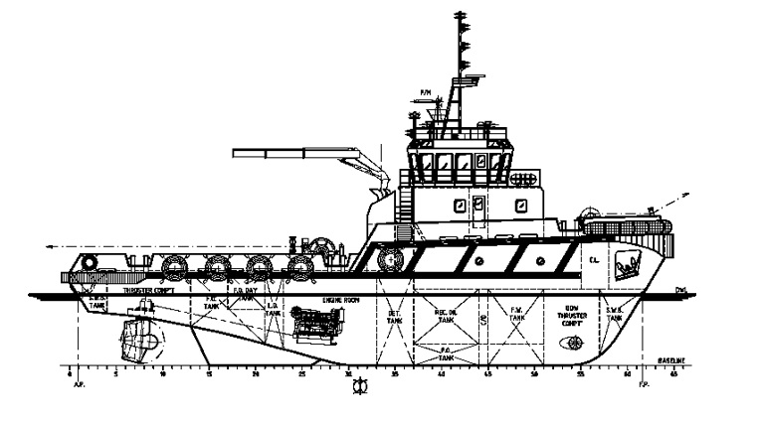

### Entries in the biofouling record book

#### Vessel maintenance

* a date and location that the vessel was removed from the water
* date that vessel was re-floated
* any hull cleaning that was performed, including areas cleaned and method used for cleaning
* any antifouling coating, including patch repairs, that was applied while dry-docked, detailing type of antifouling coating and areas applied, and surface preparation work undertaken
  + for example, complete removal of underlying antifouling coating or application of new antifouling coatings or seal coat over the top of existing antifouling coating
* details of the antifouling coating specifications applied to each area such as type, manufacturer, expected effective life, operating conditions required for coating to be effective (including any operational constraints such as not effective for long periods of lay-up), cleaning requirements and any other specifications relevant to coating performance
* name and signature of the person in charge of the activity.

#### Underwater hull area, fittings, niches and voids inspection

* date and location of dive survey and reason for survey
* area or side of the vessel surveyed
* general observations with regard to biofouling
  + extent of biofouling and predominant biofouling types such as mussels, barnacles, tubeworms, algae or slime.
* whether any suspected marine pests were found, and action taken
* name and signature of the person in charge of the activity.

#### Underwater hull area, fittings, niches and voids cleaning

* date and location of vessel when cleaning occurred
* hull areas, fittings, niches and voids cleaned and method used
* general observations with regard to biofouling
  + extent of biofouling and predominant biofouling types such as mussels, barnacles, tubeworms, algae or slime.
* whether any suspected marine pests were found, and action taken
* name and signature of the person in charge of the activity

#### Internal seawater systems inspection and cleaning/treatment

* date and location of vessel when inspection and/or cleaning occurred
* general observations with regard to biofouling of internal system
  + extent of biofouling and predominant biofouling types such as mussels, barnacles, tubeworms, algae or slime.
* any cleaning or treatment undertaken and procedures and materials used
* whether any suspected marine pests were found, and action taken
* name and signature of the person in charge of the activity

#### Levels of usage

Record any periods of time when the vessel was laid up for an extended period of time

* date and location where vessel was laid up
* maintenance action taken prior to and following period laid up
* precautions taken to prevent biofouling accumulation (such as sea chests blanked off).

#### Quarantine records

For vessels arriving internationally: details of inspection or review of vessel biofouling quarantine risk (where applicable):

* date and location of vessel when quarantine review occurred
* regulatory authority (AQIS) conducting the inspection/review and details of procedures followed or protocol adhered to and inspector’s involved
* result of quarantine inspection/review
* name and signature of the person in charge of the activity for the vessel.

#### Additional notes

Record any additional observations and general remarks that may be relevant.

## Glossary

| Terms | Definition |
| --- | --- |
| antifouling coating (AFC) | Any paint or other coating specifically designed to prevent or deter the attachment and growth of biofouling organisms on a surface. Includes biocidal coatings and fouling-release coatings |
| fouling release coatings | Non-biocidal coatings with surface properties that minimise the strength of adhesion of biofouling organisms resulting in detachment by vessel movement |
| ANZECC | Australian and New Zealand Environment and Conservation Council |
| bilge/spaces | The lowest and typically damp internal spaces of a hull where water can accumulate |
| biocide | A chemical substance that is poisonous to living organisms |
| biofouling | Marine organisms attached to any part of a vessel hull (including the hulls, rudders, propellers and other hull appendages) or internal seawater systems (including sea chests and pipe work), or any equipment or equipment spaces attached to or on board the vessel (including mooring devices, anchor wells, cable lockers, cargo spaces and bilges) |
| biofouling organism | Any species that attaches to natural or artificial substrates such as piers, navigation buoys, pilings or hulls or other organisms; including both attached organisms, and mobile organisms living on or between the attached biofouling. |
| biota | All biological organisms, including micro-organisms, plants and animals |
| chemical dosing | The slow and continuous injection of chemicals (in this context used to eradicate a pest) |
| dry-docking support strips (DDSSs) | The areas of the hull that are covered by supporting blocks when a vessel is dry-docked, hence fresh antifouling cannot be reapplied to these areas |
| entrainment | The capture of an organism within a flow or vector such as ballast water |
| exotic marine species | Any non-native species that may or may not be present in Australia’s marine environment |
| hull | The wetted surfaces of a vessel including its propulsion and steering gear, internal cooling circuits, sea strainers, bow thrusters, transducers, log probes, anchors, anchor chains, anchor lockers and bilge spaces |
| ICCP | Impressed current cathodic protection |
| introduce/introduction | Deliberate or unintentional human-assisted movement of a species to any location not part of its natural (native) range |
| invasive | Ability of an introduced species to spread across natural or semi-natural habitats by its own means and form dominant populations |
| marine pest | Any exotic marine species that poses a threat to Australia’s marine environment or industry, if introduced, established or translocated |
| MGPS | Marine growth prevention system |
| niche | Protected or refuge areas on a vessel that facilitate the settlement and survival of biofouling organisms |
| pathway | Route taken by vector’s from point A to point B |
| route | A geographic track or corridor taken or formed by a vector |
| ROV | Remotely operated vehicle |
| sea chest | A recess built into a vessel’s hull, covered by a coarse grill that contains one or more seawater intakes for engine cooling, ballast uptake, fire-fighting and other on-board functions |
| translocation | Only refers to the accidental or intentional transportation of an organism from one location to another, and does not refer to a successful introduction or incursion |
| vector | The physical means, agent or mechanism which facilitates the translocation of organisms from one place to another |
| vessel | Any ship, barge, mobile drilling unit, work boat, craft, launch, submersible or similar |

## Contacts

For more information about marine pests and biofouling management guidelines contact your local state/territory fisheries officer or visit the [Marine Pests](http://www.marinepests.gov.au/) website.