# National biofouling management guidelines for the petroleum production and exploration industry

Version 1.0, 2009

© Commonwealth of Australia 2009

**Ownership of intellectual property rights**

Unless otherwise noted, copyright (and any other intellectual property rights, if any) in this publication is owned by the Commonwealth of Australia (referred to as the Commonwealth).

**Creative Commons licence**

All material in this publication is licensed under a Creative [Commons Attribution 4.0 International Licence](https://creativecommons.org/licenses/by/4.0/legalcode) except content supplied by third parties, logos and the Commonwealth Coat of Arms.

Inquiries about the licence and any use of this document should be emailed to [copyright@agriculture.gov.au](mailto:copyright@agriculture.gov.au).

C:\Documents and Settings\west merryn\Local Settings\Temporary Internet Files\Content.Word\by.png

**Cataloguing data**

This publication (and any material sourced from it) should be attributed as: Marine Pest Sectoral Committee 2018, National biofouling management guidelines for the petroleum production and exploration industry, Department of Agriculture and Water Resources, Canberra, December. CC BY 4.0. Document modified in 2018 to meet accessibility requirements.

This publication is available at [marinepests.gov.au/what-we-do/publications](http://www.marinepests.gov.au/Pages/map/American-slipper-limpet.aspx)

Marine Pest Sectoral Committee Secretariat

Department of Agriculture and Water Resources

GPO 858 Canberra ACT 2601

Telephone 1800 372 746 (local calls) +61 2 6272 5232 (international)

Email [mpsc@agriculture.gov.au](mailto:mpsc@agriculture.gov.au)

Web [marinepests.gov.au](http://www.marinepests.gov.au/)

**Disclaimer**

These guidelines are part of a series of documents setting out a consensus view of effective biofouling management practices.

The guidelines are made available on the understanding that the Commonwealth of Australia is not thereby engaged in rendering professional advice. The Commonwealth does not warrant the accuracy, currency or completeness of the guidelines, or their relevance for any particular purpose. In particular, it should be noted that legislation, regulations and by-laws may vary between different jurisdictions and ports in Australia. Consequently, the guidelines do not purport to state what is necessary or sufficient to comply with laws applying in any place.

Before relying on the guidelines in any important matter, users should obtain appropriate professional advice to evaluate their accuracy, currency, completeness and relevance for their purposes.

Contents

Introduction 1

Overview 1

Purpose and scope 2

Delineation of responsibility 3

Further information 3

1 Biofouling risk management 4

1.1 Biofouling pathway 4

1.2 Benefits of managing biofouling risks 4

1.3 Assessing the biofouling risk 5

1.4 Mitigating the biofouling risk 7

2 Management of vessels 9

2.1 Introduction 9

2.2 Biofouling reduction and management measures 10

3 Management of immersible equipment 21

3.1 Anchoring arrays and gravity anchors 21

3.2 Spud cans 23

3.3 Seismic survey equipment 24

3.4 Seafloor sensing and geotechnical survey equipment 24

3.5 Remotely operated vehicles 25

4 Management of infrastructure 26

4.1 Overview 26

4.2 Concrete gravity structures 27

4.3 Decommissioning, removal or abandonment 28

5 Recording and reporting 31

5.1 Record keeping 31

5.2 Reporting 31

Appendix A: Marine pest threats to Australia 32

Introduced marine pest threats 32

Appendix B: Biofouling record book 34

Vessel details 34

Entries in the biofouling record book 35

Glossary 37

Contacts 38

**Table**

Table 1 Vessels, equipment and infrastructure used in the petroleum industry 2

**Figures**

Figure 1 Generic approach to biofouling risk assessment 8

Figure 2 Areas where biofouling can accumulate on a petroleum vessel 12

Figure B1 Example vessel diagram for biofouling record logbook 34

**Photographs**

Photo 1 Examples of infrastructure and vessels used by the petroleum industry 3

Photo 2 Hand-scraping biofouling in dry-dock 5

Photo 3 Hydroblasting biofouling from a vessel in dry-dock 7

Photo 4 Sponsons represent a niche area prone to biofouling 10

Photo 5 Sea chest open for cleaning and maintenance 11

Photo 6 Applying antifouling paint to a vessel in dry-dock 13

Photo 7 Anchor chain with sediment and biofouling to be cleaned 15

Photo 8 Inspection of internal seawater system to identify areas of biofouling build-up 19

Photo 9 Biofouling accumulating on an anchor array 22

Photo 10 Biofouled spud cans from a small jack-up rig 23

## Introduction

### Overview

Under the National System for the Prevention and Management of Marine Pest Incursions (the National System) voluntary biofouling management guidance documents have been developed for a range of sectors operating within Australian waters.

Along with most shipping and boating sectors in Australia, the petroleum production and exploration industry (henceforth referred to as the petroleum industry) has been recognised as presenting a risk of marine pest translocation and introduction via biofouling. This voluntary biofouling management guidance document has been developed to assist industry manage this risk. Similar [National biofouling management guidelines](http://marinepests.gov.au/what-we-do/publications) have been developed for other marine sectors including commercial vessels, recreational vessels, the aquaculture industry and commercial fishing vessels.

Marine species and pests can be translocated to and around Australia via biofouling on vessel hulls and in damp or fluid-filled spaces (niche areas) such as anchor lockers, bilges, sea chests or internal seawater systems. Marine pests are species with invasive traits that can cause significant adverse impacts to marine industries, the environment, human health and/or amenity if introduced, established or translocated within Australia, as well as generating substantial costs for eradication attempts or ongoing management.

Applying the recommendations within this document and implementing effective biofouling controls can also assist vessel operators to minimise:

* hull and propeller inefficiency, resulting in a decrease in fuel consumption and increase in range and speed
* corrosion of pipework, valves and other internal seawater system components
* blocked or impeded flow into and within internal seawater distribution systems, resulting in increased efficiency of cooling, air conditioning and fire-fighting systems
* increased maintenance efforts and repair costs associated with clearing biofouling from blocked systems.

More information on marine pest threats to Australia can be found at Appendix A.

### Purpose and scope

This guidance document provides recommendations for the management of biofouling hazards by the petroleum industry. This includes, but is not limited to the vessels, equipment and infrastructure listed in Table 1.

Table 1 Vessels, equipment and infrastructure used in the petroleum industry

| Vessel category | Vessel type |
| --- | --- |
| Vessels | Offshore support vessels (OSV) including:   * utility support vessels (USV) * platform supply vessels (PSV) * anchor handling tug supply vessels (AHTSV)   Mobile offshore drilling units (MODU) including:   * jack-up units * drillships * semi-submersible ships.   Crew transfer vessels (CTV/WT)  Diving support vessels (DSV)  Accommodation vessels (AV)  Seismic survey vessels (SSV)  Landing craft  Pipelay vessels  Floating production, storage and offloading vessels and floating storage and offloading vessels (FPSO/FS0)  Controlled source electromagnetic (CSEM) vessels |
| Immersible equipment and infrastructure | Remotely-operated vehicles (RCM  Production jackets  Concrete gravity structures (CGS)  Seabed anchor arrays  Subsea equipment such as heat exchangers and manifolds  Riser turret moorings (RTMs) and single anchor leg rigid arm moorings (SALRAMs) |
| Vessels that should refer to the National biofouling management guidelines for commercial vessels | Oil tankers  Gas carriers |
| Vessels that should refer to the National biofouling management guidance for non-trading vessels (heavy lift vessels) | Dredges (including rock dumping ships)  Water taxis  Barges |

Photo 1 Examples of infrastructure and vessels used by the petroleum industry

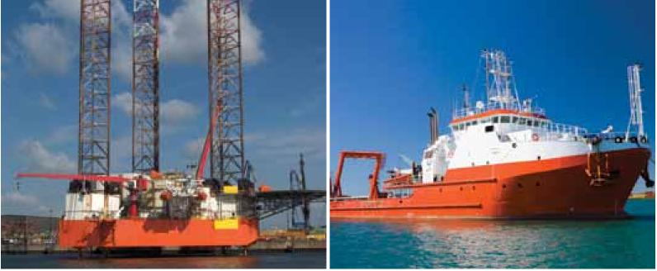

Images: Mermaid Marine Australia Ltd.

Oil tankers and gas carriers employed in the petroleum industry, including those working as shuttle tankers to petroleum production and exploration fields, are addressed by the [National biofouling management guidelines for commercial vessels](http://www.marinepests.gov.au/commercial/vessels/biofouling-commercial). These vessels exhibit operating profiles and biofouling risks more typical of commercial vessels.

Other specialist vessels periodically employed in the petroleum industry such as heavy lift vessels, dredges (including rock dumping ships), barges and water taxis are addressed by the [National biofouling management guidance for non-trading vessels](http://www.marinepests.gov.au/commercial/vessels/biofouling-non-trading)

The biofouling risks posed by vessels, immersible equipment and infrastructure in the petroleum industry is a reflection of their actual physical characteristics and the way they are operated. There is a degree of unavoidable overlap between these recommendations and guidelines developed for other maritime sectors. Details of other marine pest management measures such as ballast water management can also be found on the [Marine Pests](http://www.marinepests.gov.au) website.

This guidance document will be periodically reviewed to ensure that the content remains current and practical to industry and end users.

### Delineation of responsibility

It is recommended that when applying these recommendations, any Australian Government, state, Northern Territory or local regulations be considered.

For more information on marine pests, management methods, and associated regulations, see the [Marine Pests](http://www.marinepests.gov.au) website.

### Further information

The biofouling related risks posed by the petroleum industry have been characterised and assessed in the report Hazard analysis for marine biofouling in the Australian petroleum industry (URS, 2007). The hazard analysis was commissioned by the Australian Government and prepared as a collaborative venture with industry input and participation to form the basis for these recommendations.

## Biofouling risk management

### Biofouling pathway

For a vessel, equipment or infrastructure to cause a biofouling marine pest incursion, three key steps need to occur:

1. Colonisation and establishment of the marine pest on a vector (vessel, equipment or structure) in a donor region (a home port, harbour or coastal project site where a marine pest is established).
2. Survival of the settled marine pests on the vector during the voyage from the donor to the recipient region.
3. Colonisation (for example, by reproduction or dislodgement) of the recipient region by the marine pest, followed by successful establishment of a viable new local population.

At each step of the sequence there are factors that affect the total number of individual organisms and species that successfully survive to the next stage of the biofouling pathway.

These three steps provide the foundation for understanding, managing and assessing whether a particular vessel, equipment or installation deployment will have a low or high risk of causing a marine pest incursion.

### Benefits of managing biofouling risks

Ensuring that appropriate biofouling risk reduction measures are implemented is advantageous for the petroleum industry for reasons including:

* avoiding inadvertent marine pest incursions (not inspecting potentially high risk vessels until after their arrival at a new location dearly poses much greater incursion risks than if a vessel's biofouling has previously been managed)
* avoiding the costs and delays of having to manage emergency vessel slipping and cleaning if a marine pest is discovered on the vessel after its initial mobilisation
* reducing the risk that the petroleum industry may be implicated in the introduction or translocation of a marine pest event.

### Assessing the biofouling risk

Several factors need to be considered when assessing the risk of a vessel or equipment assisting in the translocation of a marine pest and to reduce the likelihood of an incursion.

#### Cleaning

Vessel systems need to be cleaned both externally and internally.

Surface cleaning involves the removal of biofouling in a licensed vessel maintenance facility (such as a dry-dock) prior to departure from locations with a known or potential marine pest (Photo 2).

Internal seawater systems are treated to prevent or remove biofouling. Design features can assist with this, such as the fitting of a cathodic anode system to prevent biofouling.

Photo 2 Hand-scraping biofouling in dry-dock

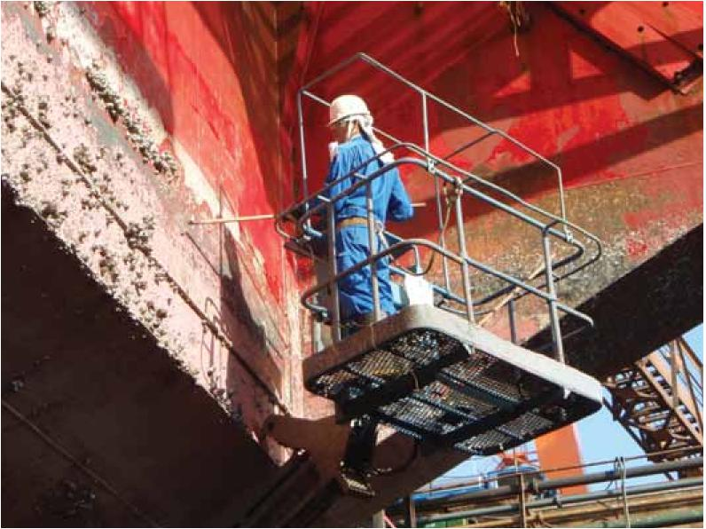

Image: John Polglaze, URS Australia.

#### Antifouling coating

Any wetted surface that is not protected by an antifouling coating will accumulate greater levels of biofouling than a coated surface.

The effectiveness of an antifouling coating depends on several factors including its age, type, suitability to vessel, surface type and type of operations as well as its history of use in relation to the manufacturer's recommendations.

#### Condition of vessel surface

Different vessel types and designs vary in susceptibility to biofouling. Sheltered areas and/or surfaces without antifouling coating provide a location where many marine species are protected from strong water flow, avoiding dislodgement and allow settlement and growth (Photo 5). This includes mobile species such as fish, crustaceans, sea-stars and marine snails.

Most marine species cannot tolerate prolonged exposure to air and are transported on primarily submerged equipment and hull surfaces. Removal from the water (desiccation) can be an effective control option for marine pests, depending on the species and life history stage concerned and the relative humidity of the drying environment. As a general guide, complete removal (no contact with water) and exposure to direct sunlight, warm temperatures and low humidity will kill most marine species within seven days. However, any compromise on these conditions such as exposure to sea spray can enable some species to survive up to eight weeks.

#### Operation and voyage profiles

The longer a wetted surface remains stationary or moving at low-speed (less than 5 knots) in port or coastal waters (or on longer slow voyages such as towing), the more likely it is to accumulate biofouling, and for any marine pests to survive. Vessels frequently undertaking low-speed and/or low-activity operations may need to apply a specialised antifouling coating, as many brands rely on minimum vessel speeds to activate biocide layers or to wash off any biofouling.

Survivorship of marine pests is greater on east-west voyages (which remain within a similar latitude band) than on north-south (trans-equatorial) routes where temperature changes are greater. The shorter the transit across oceans, the more chance that the marine species will survive temperature change and/or limited food sources available in oceanic waters. Since almost all marine pests are coastal and harbour species, vessels operating in offshore deep-water environments are less likely to accumulate or translocate marine pests, compared to vessels or equipment that operate in ports and shallow coastal waters.

Once transported, the risk of successful marine pest establishment can be assessed based on the similarity of the departure and arrival regions. Relevant properties include:

* water temperature range
* salinity range
* water depth range
* habitat range (substrate types).

The assessment of biofouling risk should be guided by reference to any Australian Government, state, Northern Territory or local regulations.

### Mitigating the biofouling risk

A risk assessment should be undertaken to examine factors influencing the translocation risk posed by particular vessels. As the risks vary from vessel to vessel the assessment should be undertaken in an objective, transparent, consistent and readily reportable way. Figure 1 shows the basic components of a risk assessment process for assessing and managing vessels and equipment intended to be moved to or within Australian waters.

If vessels or equipment are found to have heavy biofouling or to pose a high risk of accumulating heavy biofouling, it is advised that biofouling mitigation treatments such as dry-docking, cleaning and antifouling renewal be considered. Section 2 provides general guidelines for vessel biofouling management, section 3 and section 4 address the biofouling risks and management for petroleum industry-specific equipment and infrastructure.

It is important to maintain dear and detailed records of all biofouling mitigation, maintenance and repair activities carried out on a vessel. See section 5 for more detailed information on record keeping.

Photo 3 Hydroblasting biofouling from a vessel in dry-dock

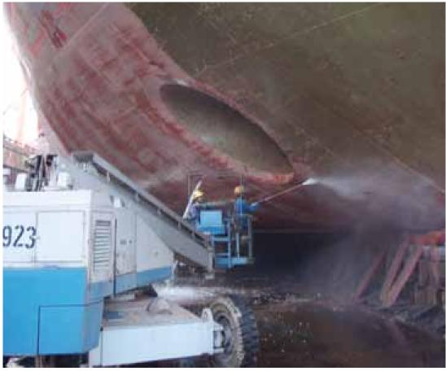

Image: John Polglaze, URS Australia.

Figure 1 Generic approach to biofouling risk assessment

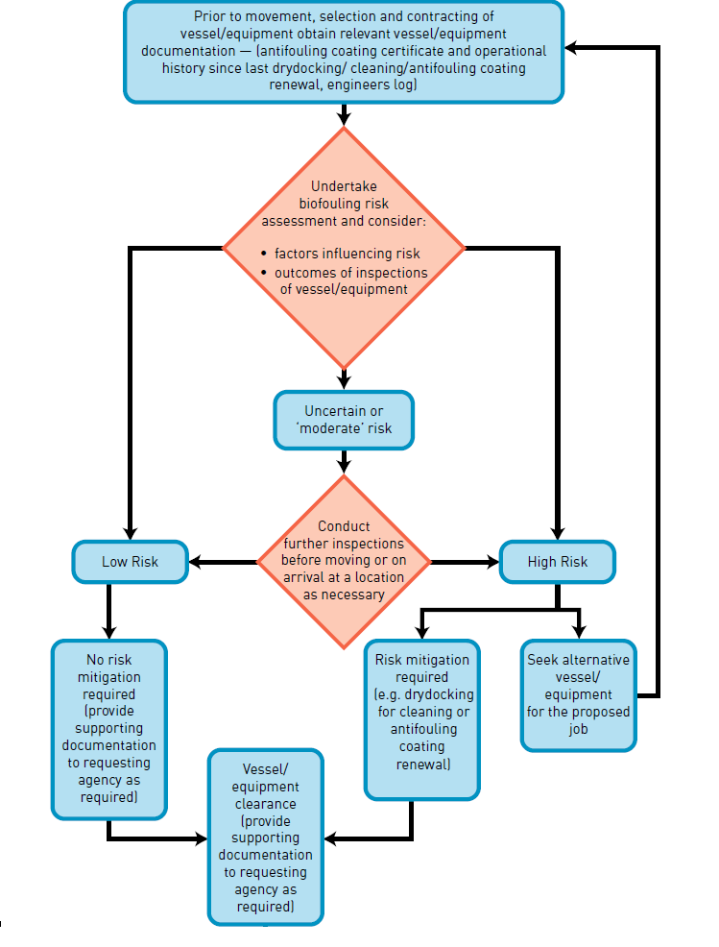

## Management of vessels

### Introduction

All vessels have some degree of biofouling, even those which may have been recently cleaned or had a new application of an antifouling coating. Research has shown that the biofouling process begins within the first few hours of a vessel's immersion in water. Generally, the longer a vessel has been in water, the greater the size and complexity of its biofouling community.

The type, amount and location of biofouling is influenced by a number of factors, such as:

* vessel design and construction, particularly the number and design of niche areas subject to biofouling including hull fittings (Figure 2)
* the number, size and configuration of sea chests and other niche areas
* the layout, extent and configuration of internal seawater systems
* construction materials (for example, cupro-nickel pipes are less prone to biofouling than steel)
* any marine growth prevention systems (MGPS) (copper dosing or chlorination systems) which may be installed
* any active marine growth control procedures (such as regular propeller cleaning) which may be employed
* typical operating profile, including factors such as operating speeds including periods spent operating at low speeds, ratio of time underway compared with time alongside, moored or at anchor, and where the vessel is stored when not in use
* places visited, the duration of stay and the time of year of stay, particularly extended stays in ports or anchorages with similar conditions to other ports within Australia and/or where known or suspected marine pests may be present
* inspection and maintenance procedures
* maintenance history, including type, age and condition of any antifouling coating including factors such as nature of coatings, suitability of coating to the vessel operating profile, age, quality of application and maintenance including slipping and hull cleaning practices.

The biofouling which may be found on and in a vessel reflects the vessel's design, construction, maintenance and operations. Each of these aspects introduces particular biofouling vulnerabilities but also offers opportunities to limit the extent and development of biofouling, with commensurate reduction in biosecurity risks.

These guidelines will provide suggested measures to minimise biofouling risks during each phase of a vessel's life.

### Biofouling reduction and management measures

#### Design and construction

Any structural modifications to the hull or hull appendages should satisfy all relevant engineering standards and class requirements and be subject to approval, if appropriate, by regulatory authorities.

##### Hull voids and openings and other external niches

Small niches and sheltered inaccessible areas (Photo 4) should be excluded from vessels where practical in the design stage. Where the exclusion of niches is not practical, these can be designed so that they may be easily accessed for effective inspection, cleaning and application of antifouling coatings.

Other features reducing external biofouling include:

* rounded/bevelled protrusions on intake/outlet ports and similar areas to promote more effective application of an antifouling coating
* rounded corners on hull openings to promote more effective application of an antifouling coating
* grout/caulk in gaps in and behind sacrificial anodes and impressed current cathodic protection (ICCP) strips, when fitted.

Photo 4 Sponsons act as a niche area prone to biofouling

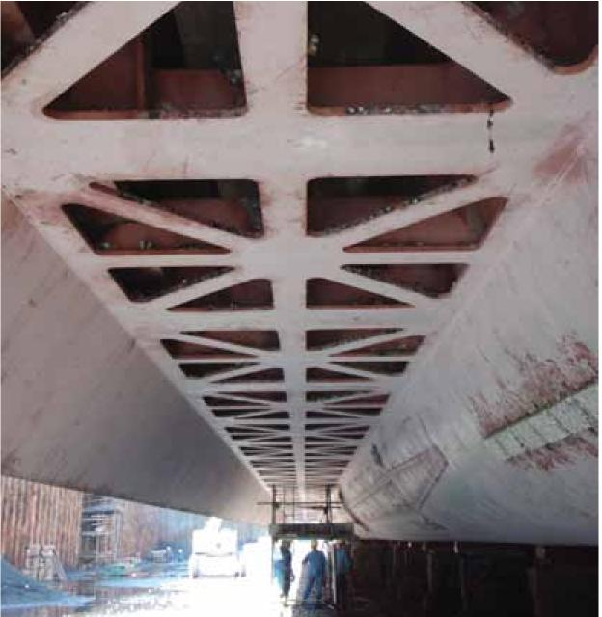

Image: John Polglaze, URS Australia.

##### Sea chests

To reduce biofouling of sea chests it is advised to minimise the number and size of sea chests and consider including:

* a simplified design to eliminate or minimise internal niche spaces and facilitate ease of access for in-water and dry-dock inspection, maintenance and painting
  + ideally sea chest interiors should feature smooth plates and wherever possible minimise internal structural members such as frames and stiffeners
* intake apertures/pipes flush with the sea chest interior surfaces
* rounded-as opposed to square- bars on intake grills
* easy access for divers to inspect and clean (including grates which can be open and shut by divers)(Photo 5)
* MGPS or other method to eliminate biofouling
* 100 per cent free draining sea chests when the vessel is in a maintenance facility
* the option for sea chests to be blanked-off for in-water treatment of biofouling.

Photo 5 Sea chest open for cleaning and maintenance

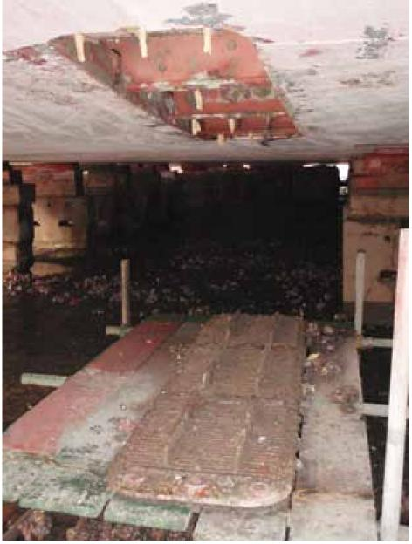

Image: John Polglaze, URS Australia.

##### Internal seawater systems

Options to reduce biofouling of internal seawater systems:

* use cupro-nickel pipes rather than steel
* include an effective MGPS, ensuring that the point of injection of MGPS dosing is located in the sea chests or as close as practicable to inlets
* minimise bends, kinks and flanges
* promote ease of disassembly for inspection and cleaning
* include of filters and strainers and inspection ports.

Figure 2 Niche areas where biofouling can accumulate on a petroleum vessel

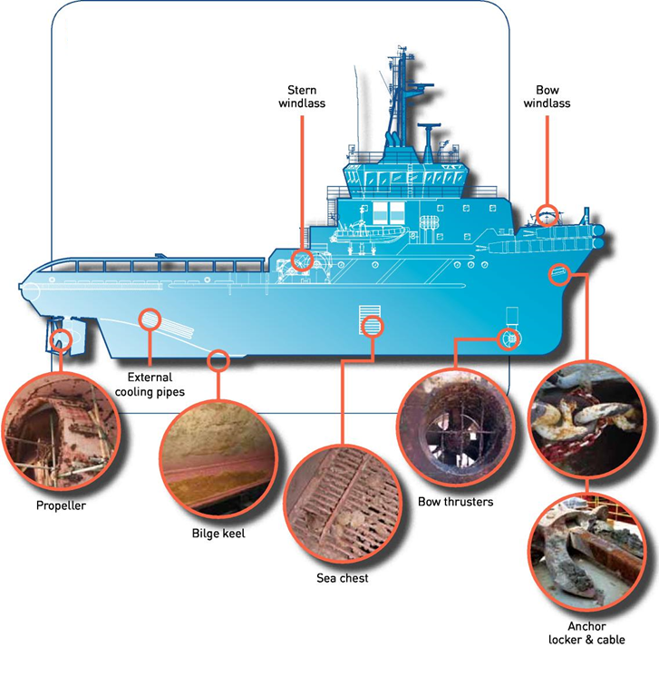

Image: Illustration adapted from a diagram provided by Mermaid Marine Australia Ltd.

#### Operations

##### Selection of antifouling coatings

It is essential that vessel operators obtain technical advice from the antifouling coating manufacturer or the supplier as different antifouling coatings are designed for different vessel operating profiles (including operating speeds, activity, and maintenance and docking cycles). This will ensure the most appropriate antifouling coating is selected and applied correctly, with particular attention to surface preparation, coating thickness and the number of required coats.

Particular areas of focus when applying an antifouling coating include:

* high wear or low flow areas such as the bow area, rudder, or sea chest interiors
  + use a tailored, differential application of antifouling coatings to match required performance and longevity
* inner portions of the throats of intake/outlet ports (where accessible)
* areas not normally treated, such as main (and thruster/auxiliary) propellers and log probes
* surfaces and edges prone to coating damage
  + use cavitation resistant antifouling coatings, and edge retentive and high performance anticorrosive coatings.

Photo 6 Applying antifouling paint to a vessel in dry-dock

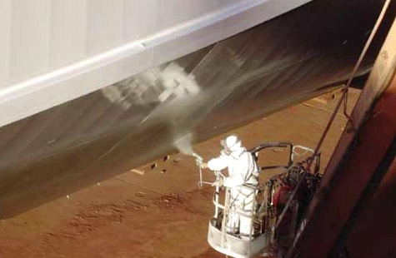

Image: Forgacs Engineering Pty.

##### Preparation for movement to or between operating areas

The highest risk of a marine pest translocation will occur when a vessel moves between two broadly similar marine biogeographic regions, either from overseas to Australia or within Australia.

This risk increases if certain predisposing factors occur, such as when the vessel:

* is heavily biofouled
* has been inactive or operated at low speeds for an extended period before the move between regions
* has a worn, ineffective or aged antifouling coating
* has areas where no antifouling coating is applied
* has operated in a port or area where a known or potential marine pest is known to occur.

To manage these risks, vessel operators should evaluate biofouling-related biosecurity risks before movement between locations.

Available measures to reduce risk:

* slip or dry-dock the vessel or undertake an inspection and thorough clean to remove biofouling, and repairing or replacing/renewing the antifouling coating
* conduct an in-water inspection by divers, and potentially undertake an in-water clean if appropriate (see section 2.2.3)
* inspect internal seawater systems, cleaning strainer boxes, and dosing or flushing these systems
  + the use of chemicals in the aquatic environment is governed by the Australian Pesticides and Veterinary Medicines Authority. [Check for chemical handling and use information](https://apvma.gov.au/node/10811)
* inspect and clean above water equipment and areas which may accumulate mud, sediments and/or marine pests, including dredge fittings, anchor cables and lockers, buoys, floats and booms and similar equipment
* provide prior advice to the relevant regulatory authorities of any concern regarding biofouling, and management actions undertaken or intended to be implemented.

##### Extended periods spent alongside, at anchor or operating at low speeds

During periods of low-speed/low-activity operations or inactivity, considerable biofouling can accumulate on underwater hull surfaces and niche areas. This is particularly the case in areas where an antifouling coating may be worn, damaged, depleted or not applied, or the antifouling coating applied is not designed for low activity or low-speed operations. The application of an antifouling coating optimised for use on low-speed vessels is critical for those vessels that typically operate at low speeds.

If a vessel has been inactive or has operated intermittently or continually at low speeds it may accumulate substantial biofouling in as little as a month, especially in circumstances where the vessel has not operated in accordance with antifouling coating manufacturer's recommendations. If heavy biofouling is detected on a vessel, biofouling risk reduction measures need to be implemented before such a vessel moves to another location away from the port or anchorage where it has been stationary or operated at low speeds. These risk mitigation measures may incorporate a vessel inspection and appropriate cleaning before the vessel is moved from the location where it has been stationary.

Prior to undertaking in-water cleaning in Australia, approval from the relevant state/territory authorities must be granted and conditions may be imposed in line with the Australian and New Zealand Environment and Conservation Council (ANZECC) [Antifouling and in-water hull cleaning guidelines](http://www.agriculture.gov.au/biosecurity/avm/vessels/biofouling/anti-fouling-and-inwater-cleaning-guidelines) (see section 2.2.3 for more information on in-water cleaning).

##### Anchors and cables, berthing lines, booms and other floating equipment

Steps should be taken to ensure items periodically immersed in water, such as anchors and cables, ropes, fenders and small boats (tenders) are clean of biofouling such as entangled seaweed, mud and other sediments after recovery and before stowage (Photo 7). For example, a high pressure wash down (using a firehose if cable wash down spray is not fitted) should be used to clean anchors and cables of mud and sediment at the time of anchor retrieval.

Anchor wells and chain lockers should also be checked periodically and kept dear of biofouling, mud and sediments.

Photo 7 Anchor chain with sediment and biofouling to be cleaned

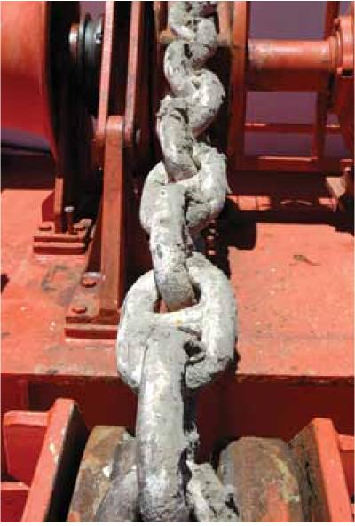

Image: Neptune Marine Services Ltd.

#### Maintenance and repair

##### Slipping and dry-docking

Regular slipping or dry-docking of vessels should be undertaken to repair or renew the antifouling coating. To provide maximum protection, this maintenance should be undertaken within the life projected for the antifouling coating by the antifouling manufacturer or supplier, and a full antifouling coating reinstated on all painted underwater surfaces including areas of damage and degradation. Records of all maintenance and repair work completed on the vessel should be documented and receipts retained as verification of biofouling management activities.

When applying an antifouling coating to a vessel, it is essential that vessel operators obtain technical advice from the antifouling coating manufacturer or supplier. Ensure the most appropriate coating is selected and that it is applied according to the specification prepared for each application, with particular attention to surface preparation, coating thickness and the number of required coats.

Slipping or dry-docking of vessels is also the most effective means for inspection, detection and removal of biofouling from the hull and niche areas.

Along with the physical removal of biofouling, extended slipping or dry-docking also results in death of biofouling by desiccation (air exposure). However, some marine pests can survive or release reproductive propagules even after long periods of air exposure, particularly if attached in sheltered, damp niches out of direct sunlight. As a general guide, complete removal (no contact with water) and exposure to direct sunlight, warm temperatures and low humidity will kill most marine organisms within seven days. However, any compromise on these conditions can enable some organisms to survive up to eight weeks.

Most vessels are hydro- or grit-blasted as a standard practice whenever dry-docked and this will remove most external biofouling. It is essential that cleaning efforts during dry-dock or slipping specifically target niche areas.

To improve the effectiveness of biofouling removal of niche areas:

* clean any gaps between a fitting and the hull, such as may occur behind sacrificial anodes and stabilisers
* extend all retractable equipment, such as thrusters and dredge ladders, to permit access for cleaning of these fittings and any associated housings or voids
* open and clean sea chests, and physically remove any attached and detached biofouling debris, which may accumulate in them
* clean internal niches around shafts and propellers and nozzles, such as stern tubes, shaft couplings, ropeguards and bearings and rudder hinges
* clean other voids and niches, particularly apertures and orifices such as small bore intakes and outlets.

##### In-water inspection

In-water inspection is a useful way to inspect the condition of antifouling coatings and biofouling status of a vessel without the scheduling, logistics and expense associated with slipping or dry-docking. In-water inspections can be undertaken by divers or a remotely operated vehicle (ROV).

In-water dive inspections should be undertaken by suitably qualified and experienced divers familiar with biofouling and marine pests. Some agencies have recommended or accredited biofouling inspection divers to conduct these inspections.

Dive and remotely operated vehicle (ROV) surveys can be limited by visibility, available dive time compared with the area to be inspected and by difficulties accessing biofouling prone voids and niches.

It is recommended that when planning to conduct an in-water inspection, a formal procedure should be arranged to ensure that all accessible risk prone niches are examined. This involves:

* a suitably qualified and experienced diver or operator
* use of an inspection report sheet and photographic equipment
* assessment of known or likely biofouling risk areas and fittings
* appraisal of internal seawater systems and niches (strainer boxes, anchor cable locker, bilge spaces)
* a precautionary approach assessing the amount and type of biofouling that may be present in inaccessible niches, such as sea chests and thruster tunnels, where grilles often prevent ROV or diver access
* where suspicious or suspected marine pests are detected, specimens should be collected and passed to the responsible regulatory authority for further examination. Consultation with the regulatory authority is advised on recommended collection and preservation methods
  + Generally, specimens collected should be preserved in a sealed container in a solution of 70 per cent ethanol/30 per cent fresh water or otherwise sealed and labelled in a plastic bag and stored in a freezer until they taken for identification. It is important to ensure that there is only one specimen per container/bag.
  + If arriving internationally all specimens must meet the [Australian Biosecurity Import Conditions.](https://bicon.agriculture.gov.au/BiconWeb4.0/)

In-water inspections should be undertaken periodically as a general means of routine surveillance. Additional inspections (in-water, or slipping or dry-docking) may be required to address particular situations of elevated risk including:

* at the conclusion of an extended period of inactivity (several months or more) or low-speed operations
* when planning to move a vessel from an overseas location to Australia
* when planning to move a vessel from one region in Australia to another
* after a known or suspected marine pest is discovered on a vessel or within the vessel's niche areas (such as the internal seawater systems) or a secondary translocation has occurred in proximity to a detection of a species of concern.

If considered necessary in-water inspections may be required by relevant regulatory authorities including the Australian Government and states and Northern Territory.

##### In-water cleaning of hulls and propellers

The removal of biofouling from vessel hulls and propellers is known to significantly improve a vessel's efficiency through the water and reduce the risk of translocating marine pests. However, scrubbing biofouled antifouling coatings not only prematurely depletes the antifouling coating and leads to rapid re-fouling but generates biofouling debris in the water column creating a pulse of biocide that can harm the local environment. To address this issue, many state and territory governments abide by Australian and New Zealand Environment and Conservation Council (ANZECC) [Antifouling and in-water hull cleaning guidelines](http://www.agriculture.gov.au/biosecurity/avm/vessels/biofouling/anti-fouling-and-inwater-cleaning-guidelines).

The ANZECC guidelines apply to in-water cleaning in Australian waters and stipulates:

1. no part of a vessel's hull treated with antifouling coating is to be cleaned in Australian waters without the written permission of the Harbour Master, local government or state environmental protection agency (administering authority)
2. in-water hull cleaning is prohibited, except under extra ordinary circumstances and permission will not normally be granted
3. the cleaning of sea chests, and other niche areas may be permitted provided that any debris removed (including encrustation, barnacles and weeds) is not allowed to pass into the water column or fall to the sea bed and subject to any other conditions attached to the permit. An application seeking permission to carry out this work must be lodged with the administering authority at least five working days prior to the anticipated start date. Such application will detail how encrustations, barnacles and other debris will be contained and or collected for disposal as well as the method of disposal
4. an application seeking permission to carry out 'propeller polishing' must be lodged with the administering authority at least five working days prior to commencement of the work.

Should a permit be granted, it is recommended that divers use the opportunity to inspect all niche areas for biofouling.

Areas that should be specifically inspected by divers (see Figure 2) include:

* rudder stock and hinge
* stabiliser fin apertures
* rope guards and propeller shafts
* cathodic protection anodes
* sea chests and bow thrusters
* overboard discharge outlets and sea inlets
* areas of antifouling coating damage or grounding.

##### Inspection and maintenance of internal seawater systems

Regular inspection of internal seawater systems can identify biofouling accumulations (Photo 8). Treatment of internal seawater systems offers a means of removing biofouling, leading to improved system performance while simultaneously reducing marine pest risks. Methods such as chemical treatment or freshwater flushing can be undertaken as either a periodic treatment or in response to a specific biofouling problem.

There are two chemical processes used to maintain seawater systems, chemical cleaning and chemical dosing. Chemical cleaning is the addition of an acid to dissolve or digest any established biofouling from the internal seawater system pipework. Chemical dosing is used as either a routine addition of chemical to the seawater system to keep pipework free of biofouling or a shock dose to eradicate established biofouling. Chemical dosing is a viable option when more rigorous treatment may be necessary.

The selection and application of chemical cleaning agents requires consideration of a number of factors including pipework configurations, components (including valves, joints and seals), materials (rubber, plastics, polycarbonates, polyvinyl chloride, alloys and solders) and their compatibility with the intended agent and method of application. If this option is used to treat internal seawater systems, disposing of all chemicals and materials must be done so using approved disposal locations and facilities.

Freshwater flushing can kill marine species if the infected pipework can be isolated for several days, however the resulting calcareous and organic debris may need chemical removal or high pressure flushing to avoid clogging. Chemical treatment to kill marine species can similarly leave the system fouled by shells and other chemical and biological residue.

The choice of treatment agent—and its correct usage and disposal—warrants appropriate consultation to avoid compromising pipework integrity, vessel safety and environmental protection. Research to identify effective and safe treatment methods for killing marine pests remains part of the development program for the National System. Further advice should be sought from authorities and product agents.

Photo 8 Inspection of internal seawater system to identify areas of biofouling build-up

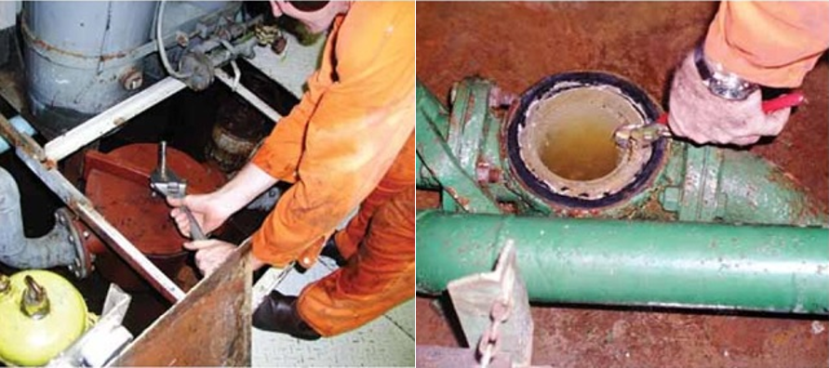

Images: URS Australia.

##### Decommissioning and disposal

Decommissioned vessels or those slated for sale are often stationary for extended periods in ports and anchorages before final disposal. During this period of inactivity considerable biofouling can accumulate on underwater hull surfaces and fittings. This is particularly the case when an antifouling coating is worn, damaged or depleted, or not designed for static performance, and in areas where the antifouling coating is not applied (such as niche areas). Vessels are often decommissioned at the end of a docking cycle, when the antifouling coating is at the end of its anticipated life.

A range of options exist to limit biofouling risks while a vessel is being prepared for decommissioning and disposal. These include:

* shutdown of internal seawater systems to starve and/or asphyxiate marine pests within the system
* use of an MGPS or other dosing routines for any internal seawater systems which remain in operation during the period of vessel inactivity
* blanking off sea chests (if not required for water uptake) external to the grates
* blanking off any other intakes and voids (such as bow thruster tunnels and rudder support strop holes) to reduce niche areas available to harbour marine pests.

Before a vessel which has been inactive is moved to another location away from the port or anchorage, an assessment of the hull and niche areas should be conducted, and any significant biofouling removed in accordance with relevant in-water cleaning guidelines and regulations (see section 2.2.3). This ensures that any biofouling that is obtained during the period of inactivity is from the location where the vessel was inactive. It also ensures that any marine pests will not be conveyed to another location within Australia. If the vessel is re-entering service, a dry-docking may be necessary to restore an effective antifouling coating on the hull and to ensure niches are free of biofouling.

## Management of immersible equipment

This section describes types of immersible equipment used by the petroleum industry for production and exploration operations. For each type of equipment examined several design and operational characteristics are addressed:

* deployment patterns and inherent risk
* cleaning and maintenance regime
* pack-up and transfer requirements
* abandonment and retrieval.

### Anchoring arrays and gravity anchors

#### Anchor deployment patterns and inherent risk

Anchoring arrays are used by semi-submersible mobile offshore drilling units (MODUs) and construction barges. Jack-up MODUs and jack-up barges do not usually use their anchors.

The arrays are usually recovered to topside locations at the completion of drilling or other worksite tasks, typically by assistance from an anchor-handling tug/supply vessel (AHT/AHTSV).

Anchors are hauled to the surface and located to above water line cradles, causing any marine growth to dry out between sites if voyage times are long. However many organisms can survive in damp shaded areas, including burrowing biota within sediment deposits on unwashed anchors and chains, increasing the risk of harbouring and translocating a marine pest (Photo 9).

In the case of pipeline installation projects, temporary gravity anchors comprising of sand-filled geotextile bags (approximately two tonnes) may be deployed along the route to assist pipelay vessel positioning and associated DSV operations.

#### Anchor cleaning and transfer requirements

Seawater spray-washing of anchors and cables during site retrieval operations is the simplest mechanism to remove accumulated biofouling and reduce the risk of transferring marine pests in the form of biofouling.

Sand-filled geotextile gravity anchors should have clean sand content sourced from the project region, such as from the dry upper shore or terrestrial sources. The bags are normally retrieved and can be readily washed at the project site. Sand may be left on the project site seafloor if the deposit site is in the same region as its origin.

Photo 9 Biofouling accumulating on an anchor array

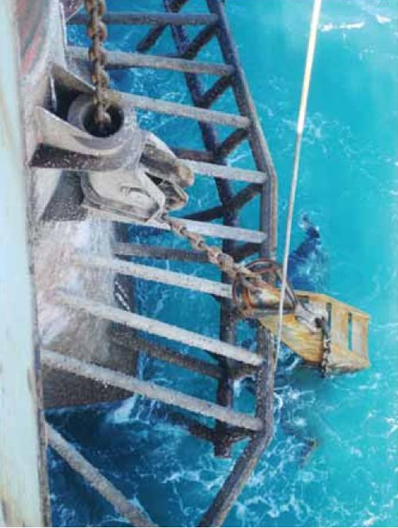

Image: Richard Piola, Cawthron Institute.

### Spud cans

#### Spud can deployment pattern and biofoulinq risk

The spud cans of small jack-up barges and the larger jack-up MODUs are sometimes detachable and replaceable. In these circumstances they can be considered as part of the immersible equipment (rather than an integral, immovable part of a jack-up's legs).

Their design, intimate contact with the seafloor and potentially uninterrupted periods of immersion during tows between drilling sites make them potentially important biofouling niches, particularly for trapping and transferring substantial quantities of sediment and associated seafloor biota (Photo 10).

The rapid wear and tear experienced by spud cans makes the use of an antifouling coating impractical.

#### Spud can cleaning and transfer requirements

Removal of accumulated biofouling from spud cans can be undertaken before departure either in-water by diver jetting or after recovery to deck or land following detachment. It is essential to ensure that all biological matter is contained, collected and disposed of at an onshore licensed waste reception facility or landfill site.

Removal of hard calcareous biofouling (such as barnacles, oysters, mussels or bryozoans.) from the narrow gaps within the spud can flanges is difficult and arduous by diver or hand scraping. Substantial deposits can be removed by sand-blasting.

Photo 10 Biofouled spud cans from a small jack-up rig

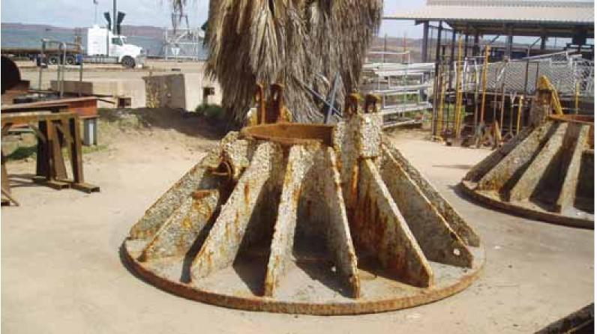

Image: URS Australia.

### Seismic survey equipment

#### Seismic sensor deployment pattern and biofoulinq risk

Immersible equipment carried by seismic survey vessels is typically stored along the aft lower and upper decks when not in use. The operational and maintenance needs of these items mean they do not normally pose a threat for biofouling accumulation and translocation. Experience indicates that most components are generally free of biofouling, except for the streamers where biofouling can be present in the joints. It is recommended that hairy fairleads be replaced between projects as these can be quickly biofouled.

Biofouling can settle and grow in the gaps of the collar joints. The collar joints provide niches enabling potential colonisation and entanglement of other biofouling biota, including seaweed. Unless the streamers are being deployed in shallow coastal waters, the most likely biofouling organisms in open, deep waters are goose barnacles and green filamentous seaweed (these are not marine pests). As the streamers are wound onto large, under-deck reels during mobilisation voyages, there is sufficient shade and moisture to prevent air-drying and desiccation.

A biofouling-mediated threat is potentially higher for bay-cable surveys, where the hydrophone lines are laid over shallow water and littoral substrates. A translocation would require the immersed lines to be retrieved, wrapped up and then mobilised to another project site without any washing and maintenance checks, or air-drying opportunities. Bay-cable surveys are rare in Australia and tend to trigger specific environmental assessment and management procedures.

#### Seismic sensor cleaning and transfer requirements

Routine cleaning, maintenance and storage practices of most seismic survey equipment will ensure a low biofouling transfer risk.

The exceptions include the hairy fairleads which should either be replaced or at least inspected and thoroughly cleaned between projects (this can be done by simple immersion in hot water and detergent). In the case of the streamers, attention should be paid to removing any collar joint biofouling when they are being wipe-cleaned during retrieval and storage operations, particularly at the end of a survey.

### Seafloor sensing and geotechnical survey equipment

#### Seafloor sensor deployment pattern and biofoulinq risk

Seafloor sensing gear (other than seismic) includes vessel-deployed side-scan sonar, multi-beam echo sounders, magnetometer units, sparkers and boomers. These sensors and sources are positioned or towed near the surface and receive a high level of maintenance attention and care. Consequently their potential ability to become infected and then translocate marine pests is low, except if the gear has been lost for several weeks in coastal waters and then retrieved in a fouled condition.

Seafloor sampling gear includes grabs, Okelrnan sleds, video sleds, penetrometers, bottom-towed refraction over outcrop drag array (ROODA) gear, plus various automatic (umbilical) or diver-attended seabed drilling units (rotary units, vibrocorers). The routine cleaning and maintenance requirements of seafloor sensing, sampling and coring equipment constrain their potential role as a biofouling vector.

#### Seafloor sensor cleaning and transfer requirements

Routine equipment cleaning, maintenance, drying and packing requirements are sufficient to maintain a low risk of any biofouling-mediated translocation of marine pests.

#### Retrieval of long-term, abandoned or lost seafloor sensor equipment

Occasionally it is possible for an item of equipment to be deployed, abandoned or lost on the seafloor for a lengthy period (together with its tethering, mooring or automatic surfacing/retrieval gear).

On these occasions it is important to ensure that biofouling growth and seafloor sediment is removed and disposed of at the point of retrieval. Alternatively, the material may be binned and stored for onshore disposal at a licensed waste reception facility or landfill site.

### Remotely operated vehicles

#### ROV deployment pattern and biofoulinq risk

The petroleum industry uses a wide range of remotely operated vehicles (ROVs). None should pose a threat of biofouling-mediated marine pest transfers due to their routine deployment, retrieval, wash down and maintenance cycles.

#### ROV cleaning and transfer requirements

Routine ROV cleaning, maintenance, drying and storage requirements are sufficient to maintain a low risk of any biofouling-mediated translocation of marine pests.

#### Retrieval of an abandoned or lost ROV

If a ROV, or parts of it, are recovered following their temporary loss or abandonment on the seafloor, the resultant level of biofouling growth can be heavy, particularly in shallow water areas where light levels promote rnacroalgae growth.

Such biofouling needs to be treated as potentially hazardous. Its removal and disposal should be in the area of the pickup, or else it should be held on board for air-drying and appropriate onshore disposal.

## Management of infrastructure

### Overview

This section examines the types of petroleum industry field infrastructure and installations that are built or assembled in one location and mobilised to a distant region for instalment at a field development site. It then examines infrastructure decommissioning and removal.

Infrastructure movements that involve an onshore assembly and subsequent dry transport to the project site will not provide biofouling-mediated pathways.

Fixed and floating production platforms, together with floating concrete gravity structures (CGS), are included in this section. These units are designed and operated to provide fixed or floating infrastructure at a single production site, rather than be routinely mobilised to different sites as are MODUs and offshore support vessels.

Many large structures used at offshore petroleum industry sites are wet-towed over long distances from their assembly points, in some instances across regional seas or ocean basins.

For each type of installation or infrastructure that is planned to be deployed by wet tow, the inherent biofouling risk can be assessed by examining design, build and operational characteristics. These include:

* location of build (particularly if an area known or suspected as a marine pest donor region)
* type and route of deployment - from float-off to insertion
* likely presence of marine pests at the initial float-off and completion sites
* application/presence of appropriate antifouling coatings on the unit
* deployment site location, depth and distance to nearest coastal waters
* environmental compatibility between its build-completion and project insertion sites
* subsequent mobility from project site ( for self-propelled FPSOs and FSOs deployed in a cyclone or storm prone region with a decouplable riser turret mooring (RTM) or single anchor leg rigid arm mooring (SALRAM)
* cleaning and maintenance regime
* decommissioning and potential re-use.

### Concrete gravity structures

#### CGS deployment and biofouling risk

Concrete gravity structures (CGS) are purpose designed and built as subsea installations for offshore production requirements in remote and/or deep offshore waters. They are towed to the production site then flooded down to either rest on the seabed or be secured by a mooring array. They act as the base of a production platform and/or provide a large oil storage facility.

CGS have rough concrete surfaces and their method of construction precludes application of antifouling coatings. If CGS are constructed at shoreline or estuarine basins within, beside or near marine environments that support populations of marine biofouling pests, their deployment can pose challenges to marine pest management. When marine pests are present at the build and/or completion site (such as at a shoreline construction/float-off site in South-East Asia), the particular level of risk will depend on:

* the length of time each module remains in the flooded or opened basin before it is towed to sea then deepwater
* the environment similarity between the construction and the eventual insertion site
* the sea tow route, including the need for and duration of any port stop-over as may be required to fit more equipment.

Units being deployed directly to a remote, deepwater location pose a low risk and will not require the level of attention paid to units that are to be deployed in more sensitive shallow water areas, such as in coastal waters or near offshore islands and reefs.

#### CGS biofouling control options

There is no single biofouling management procedure for CGS that are to be deployed in a shallow water area with marine environments that are anticipated to permit survival and establishment of marine pests.

Each case will merit a specific appraisal to identify the most cost-effective biofouling control, inspection and cleaning/removal options. The practicality and affordability of available options will vary according to the particular construction methods, the characteristics and features of the initial build and completion sites, the completion and sea towage needs, and the voyage route, duration and schedule.

It is therefore valuable to address the need for biofouling management requirements during project design, contracting and inception.

### Decommissioning, removal or abandonment

#### Production platforms

A floating or jack-up production platform can be readily sea-towed to a licensed maintenance facility for scrapping, or for a work-over and upgrade then relocation.

In the case of the decommissioning and removal of a fixed platform, there are several options. Crane barges and support vessel can be used to:

1. Completely remove the topsides and jacket
2. Remove the topsides and then:
   1. topple the jacket for leaving in situ
   2. remove the top sections of the jacket to a derrick barge
   3. cut off the jacket at the seabed for tow to a deepwater or onshore disposal site.

On-site abandonment of decommissioned production platform items will not pose a biofouling risk.

Removal of a jack-up production platform to a coastal port or licensed maintenance facility for scrapping or work-over poses an inherently higher biofouling risk than floating platforms, since the former are deployed in shallow waters. As with jack-up MODUs, the legs of jack-up production platforms can be heavily biofouled.

#### Other infrastructure

Other infrastructure being decommissioned and removed or retrieved for immediate transfer and re-use at another field development may include subsea installation mooring systems, manifold units, jacket or clip-ons, or a riser, riser turret moorings (RTM), and single anchor leg rigid arm moorings (SALRAM). However, risers (such as RTMs and SALRAMs) are periodically towed from fields, either for redeployment or scrapping.

Mooring systems and risers can be readily retrieved for transit as deck cargo, while intra-field seabed pipelines are internally cleaned, depressurised then flooded for leaving in place. In the case of long distance subsea pipelines, decommissioning options after their internal cleaning include flooding to leave in place, with or without part burial or part removal in areas where there is pressure to resume trawling or other operations.

Thus the only decommissioning step that might provide a biofouling pathway involves large structures that are not retrieved to deck but which are secured for sea tow, in some case with buoyancy stabilisers. The unit is towed to a port or licensed maintenance facility for dismantling or to a designated deep ocean disposal site.

#### Decommissioning management requirements

Decommissioning operations do not usually involve the direct relocation of subsea infrastructure to a new site. The environment plan/environmental management plan (EP/EMP) that is prepared for a particular decommissioning project provides the opportunity to examine the potential for this and the associated project vessels and equipment to cause a marine pest introduction or translocation via biofouling.

A biofouling risk appraisal for a decommissioning operation should examine:

* location of the installation requiring removal
  + installations in deepwater offshore sites will not have attracted marine pests associated with ports and coastal waters, compared to those installed in inshore or shallow water coastal areas
* design and construction of the installation in relation to its susceptibility to biofouling
* sea-tow route
  + east-west routes will allow greater survival of biofouling species than north-south routes where temperature changes are greater
* environmental similarity of the destination site
  + the closer the match in temperature, salinity, depth and seafloor environments the greater the chance that biofouling species will survive
* amount of time that will elapse between the arrival of the unit at the destination site and its retrieval from the water.

In the case of a defunct installation or floating unit that is proposed to be disposed at a designated deepwater offshore site, a sea dumping permit is required under the Environment Protection (Sea Dumping) Act 1981 and associated regulations. This instrument is mirrored in state legislation for dumping options at inshore coastal regions. Under the 1996 Protocol to the Convention on the Prevention of Marine Pollution by Dumping of Wastes and Other Matter, 1972 (the London Sea Dumping Convention), all sea dumping permit applications require identification and evaluation of potential impacts. In Australia these assessments include the potential for the operation to introduce or translocate marine pests.

While the Environment Protection (Sea Dumping) Act requires a sea dumping permit for the sea disposal of an offshore production platform or vessel, the in-situ abandonment of pipelines, gravity anchors and well heads does not. The latter actions do not provide a biofouling pathway.

Decommissioning projects are environmentally assessed on a case-by-case basis. They use the precautionary principle and as low as reasonably practicable (ALARP) approach, under the regulations of the principal Acts, including:

* Petroleum (Submerged Lands) Act 1967
* Environment Protection and Biodiversity Conservation Act 1999
* Environment Protection (Sea Dumping) Act 1981
* any relevant state/Northern Territory Acts, depending on project location.

General guidelines on the decommissioning of offshore facilities have been developed by the Australian Government Department of Agriculture and Water Resources in consultation with the states, Northern Territory and the petroleum industry.

In the case of Regulations 4(1) and 6 of the Petroleum (Submerged Lands) (Management of Environment) Regulations 1999, these require an operator to have an accepted EP/EMP in place, including aspects addressing the decommissioning, dismantling or removal of a facility or pipeline.

## Recording and reporting

### Record keeping

It is recommended that vessel operators maintain a biofouling record book for each vessel. The book should record details of all inspections and biofouling management measures undertaken on that vessel.

A biofouling record book will assist in the assessment of the potential biofouling risk of a vessel and catalogue supporting documentation providing verifiable evidence that a vessel is unlikely to present an unacceptable biofouling risk. It is advised that copies/originals of all receipts and documentation are kept for verification of biofouling management conducted.

Information which should be recorded in a biofouling record book includes:

* details of the antifouling coating used, and where and when applied
* dates and location of slippings/dry-dockings, including the date the vessel was re-floated, and any measures taken to remove biofouling or to renew or repair the antifouling coating
* the date and location of in-water inspections, the results of those inspections and any corrective action taken to deal with observed biofouling
* details of fitted MGPS systems, their operation and maintenance and the dates and details of inspection and maintenance of internal seawater systems.
  + This includes the results of those inspections and any corrective action taken to deal with observed biofouling and any reported blockages, reduced seawater pressures or elevated cooling temperatures (may imply biofouling build-up), as documented in the engineer's log.

An example of a biofouling record book and information to be recorded is included in Appendix B. This format is an example only. Vessel operators should check with jurisdictions about the preferred type and format of information required.

### Reporting

Vessel operators should notify the relevant regulatory agencies (see the [Marine Pests](http://www.marinepests.gov.au/report) website) on arrival within a state or territory, particularly if they find or suspect a marine pest is present on the vessel, to enable formal identification and initiation of appropriate management action. Signs of a suspected marine pest could include unusually heavy biofouling, dominance of the biofouling by one species or a 'new' species not seen before in the region.

Where suspicious or suspected marine pests are detected, specimens should be collected and passed to the responsible regulatory authority for further examination. However, wherever possible consult with the regulatory authority about their recommended collection and preservation methods. As a general guide collected specimens should be preserved in a sealed container in a solution of 70 per cent ethanol/30 per cent fresh water or otherwise sealed and labelled in a plastic bag and stored in a freezer until they taken for identification. It is important to ensure that there is only one specimen per container/bag. If arriving internationally all specimens must meet the [Australian Biosecurity Import Conditions.](https://bicon.agriculture.gov.au/BiconWeb4.0/)

## Appendix A: Marine pest threats to Australia

### Introduced marine pest threats

Biofouling is the growth of marine organisms on underwater surfaces. It is particularly common on and in vessels and other floating or immersed man-made objects. Biofouling can occur on vessel hulls and underwater fittings such as rudders and propellers, and in voids such as sea chests. It also occurs in the pipework of internal seawater systems, such as engine cooling circuits and other systems that draw seawater.

Along with other marine pest transport vectors such as ballast water, biofouling is a biosecurity concern because a vessel or other object carrying biofouling may transport a potential marine pest into Australian waters or between different regions within Australia.

Biofouling communities not only contain the more common types of marine species such as barnacles, tubeworms, bryozoans, mussels and algae but can also contain mobile species such as crabs, sea stars, small fish and associated parasites and diseases, including known invaders. Biofouling is also an important secondary vector for the regional spread of harmful species where an initial incursion may have been associated with another vector, such as ballast water or aquaculture. For example, the spread of the golden mussel Limnoperna fortunei in Brazil, which is believed to be primarily due to biofouling, is estimated at approximately 240 km per year up-river since its first invasion in 1991 (probably in ballast water).

Not all exotic marine species associated with biofouling represent a biosecurity threat. The Consultative Committee on Introduced Marine Pest Emergencies (CCIMPE) has undertaken an extensive literature review to establish a trigger or target list of exotic marine species considered to pose a high risk of a significant impact if introduced to Australian waters. Criteria have been established to judge these impacts. To meet the criteria, the species must have:

* demonstrated invasive history
* a high likelihood of having major impacts in Australia based on the available data and characteristics of Australian environments and marine communities
* demonstrated impacts in native or invaded ranges on:
  + economy
  + environment
  + human health

and/or

* + amenity
* one or more relevant translocation vectors.

Harmful marine species translocated by biofouling may not only have serious impacts on the environment, society and industries but also ongoing costs associated with their management or eradication attempts. Some high impact marine species known to have been translocated by biofouling include: Asian green mussel (Perna viridis) in the Caribbean; dubbed tunicate (Styela clava) and sea vase (Ciona intestinalis) in Canada; an introduced alga (Hypnea musciformis) in Hawaii; and the black-striped mussel (Mytilopsis sallei) in Darwin Harbour, Australia where eradication costs in excess of $2 million.

Biofouling has been estimated to be responsible for:

* 74 per cent of non-indigenous marine invertebrates transported to the Hawaiian Islands (Eldredge & Carlon 2002)
* 42 per cent of marine species unintentionally introduced into Japan (Otani 2006)
* 69 per cent of adventive marine species arrivals in New Zealand, with a further 21 per cent possibly as biofouling or in ballast water (Cranfield et al. 1998)
* 78 per cent of introduced marine species in Port Philip Bay, Australia (Hewitt et al. 2004)
* more than half of the ship-mediated species introductions into the North Sea (Gollasch 2002)
* 70 per cent of the species that have invaded coastal North America via ships have either been moved by biofouling alone, or could have been moved by biofouling and ballast water (Fofonoff et al. 2003)
* more than 70 per cent of introduced algal species around the world are believed to have been introduced via vessel biofouling, while only 15 per cent were likely via ballast water (Hewitt et al. 2007)
* the introduction of marine species to Australia, New Zealand and the North Sea between 1995 and 2002 alone, 77, 50 and 40 per cent of species respectively were introduced via vessel biofouling (Hewitt et al. in press).

Once a marine pest becomes established in Australia the possibility and/or success of eradication is usually low. Preventing the translocation and entry of a marine pest in the first instance is the most effective and cost-efficient means of protection and is the primary objective of the recommendations.

For marine pests which have already become established in Australian waters, eradication is generally impossible and management. Further action is aimed at containment of the pest to the locations where it has become established. Vessel biofouling controls are a major means of limiting the risk of translocation of marine pests to new areas.

## Appendix B: Biofouling record book

This is an example of the information that may be included in a biofouling record book, and in record entries. Vessel operators should check with jurisdictions about the preferred type and format of information required.

### Vessel details

Time since last maintenance event (example slipping/dry-docking)

Name of vessel

Vessel type

Average cruising speed

Call sign

IMO no. (if applicable)

Vessel dimensions:

* length overall
* width (beam)
* draft (maximum and minimum)

Type of last full coating of antifouling applied to the vessel, date of application, facility where applied and type of any underlying antifouling coatings.

Internal seawater systems in the vessel, including location of strainers, and any associated marine growth prevention systems (MOPS) and/or cleaning or dosing procedures.

Diagram of vessel indicating underwater hull form (Figure B1) which may include recognised biofouling niches.

Figure B1 Example vessel diagram for biofouling record logbook

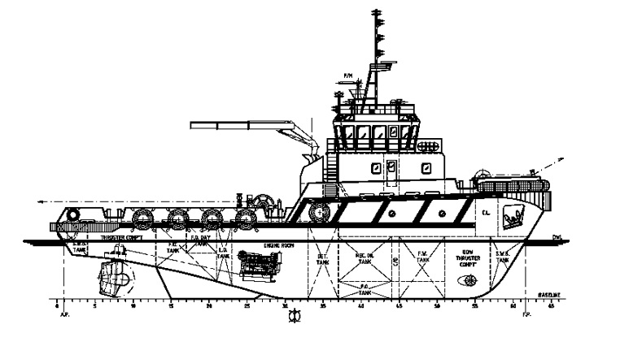

### Entries in the biofouling record book

#### Vessel maintenance

* a date and location that the vessel was removed from the water
* date that vessel was re-floated
* any hull cleaning that was performed, including areas cleaned and method used for cleaning
* any antifouling coating, including patch repairs, that was applied while dry-docked, detailing type of antifouling coating and areas applied, and surface preparation work undertaken
  + for example, complete removal of underlying antifouling coating or application of new antifouling coatings or seal coat over the top of existing antifouling coating
* details of the antifouling coating specifications applied to each area such as type, manufacturer, expected effective life, operating conditions required for coating to be effective (including any operational constraints such as not effective for long periods of lay-up), cleaning requirements and any other specifications relevant to coating performance
* name and signature of the person in charge of the activity.

#### Underwater hull area, fittings, niches and voids inspection

* date and location of dive survey and reason for survey
* area or side of the vessel surveyed
* general observations with regard to biofouling
  + extent of biofouling and predominant biofouling types such as mussels, barnacles, tubeworms, algae or slime.
* whether any suspected marine pests were found, and action taken
* name and signature of the person in charge of the activity.

#### Underwater hull area, fittings, niches and voids cleaning

* date and location of vessel when cleaning occurred
* hull areas, fittings, niches and voids cleaned and method used
* general observations with regard to biofouling
  + extent of biofouling and predominant biofouling types such as mussels, barnacles, tubeworms, algae or slime.
* whether any suspected marine pests were found, and action taken
* name and signature of the person in charge of the activity

#### Internal seawater systems inspection and cleaning/treatment

* date and location of vessel when inspection and/or cleaning occurred
* general observations with regard to biofouling of internal system
  + extent of biofouling and predominant biofouling types such as mussels, barnacles, tubeworms, algae or slime.
* any cleaning or treatment undertaken and procedures and materials used
* whether any suspected marine pests were found, and action taken
* name and signature of the person in charge of the activity

#### Levels of usage

Record any periods of time when the vessel was laid up for an extended period of time

* date and location where vessel was laid up
* maintenance action taken prior to and following period laid up
* precautions taken to prevent biofouling accumulation (such as sea chests blanked off).

#### Quarantine records

For vessels arriving internationally: details of inspection or review of vessel biofouling quarantine risk (where applicable):

* date and location of vessel when quarantine review occurred
* regulatory authority conducting the inspection/review and details of procedures followed or protocol adhered to and inspector's involved
* result of quarantine inspection/review
* name and signature of the person in charge of the activity for the vessel.

#### Additional notes

Record any additional observations and general remarks that may be relevant.

## Glossary

| Term | Definition |
| --- | --- |
| AHT/AHTSV | Anchor handling tug/anchor handling tug supply vessel |
| ALARP | As low as reasonably practicable |
| antifouling coating [AFC) | Any coating specifically designed to prevent or deter the attachment and growth of biofouling organisms on a surface: includes biocidal coatings, fouling-release coatings |
| ANZECC | Australian and New Zealand Environment and Conservation Council |
| AV | Accommodation vessel |
| bilge spaces | The lowest and typically dampest internal spaces of a hull where water can accumulate |
| biocide | A chemical substance that is poisonous to living organisms |
| biofouling | Marine organisms attached to any part of a vessel hull [including the hulls, rudders, propellers and other hull appendages) or internal seawater systems [including sea chests and pipe work), or to any equipment or equipment spaces attached to or onboard the vessel (including mooring devices, anchor wells, cable lockers, cargo spaces, bilges) |
| biofouling organism | Any species that attaches to natural or artificial substrates such as piers, navigation buoys, pilings or hulls or other organisms; including both attached organisms and mobile organisms living on or between the attached biofouling |
| biota | All biological organisms, including micro-organisms, plants and animals |
| chemical dosing | The slow and continuous injection of chemicals [can be used to eradicate a pest) |
| CGS | Concrete gravity structure |
| CTV | Crew transfer vessel |
| Dry-docking support strips (DDSS) | The areas of the hull that are covered by supporting blocks when a vessel is dry-docked, hence fresh antifouling cannot be reapplied to these areas. |
| diving support vessel (DSV) | Any offshore support vessel (OSV) with onboard control and equipment facilities for managing diving operations. The larger DSVs are typically equipped with a Class 2 Dynamic Positioning system for working in deep water areas |
| exotic marine species | Any non-native species that may or may not be present in Australia's marine environment |
| fouling release coatings | Non-biocidal coatings with surface properties that minimise the strength of adhesion of biofouling organisms resulting in detachment by vessel movement |
| FPSO | Floating production, storage and offloading vessel |
| FS0 | Floating storage and offloading vessel |
| HLV | Heavy lift vessel |
| hull | The wetted surfaces of a vessel, including its propulsion and steering gear, internal cooling circuits, sea strainers, bow thrusters, transducers, log probes, anchors, anchor chains, anchor lockers and bilge spaces |
| ICCP | Impressed current cathodic protection |
| introduce/introduction | Deliberate or unintentional human-assisted movement of a species to any location that is not part of its natural (native) range |
| invasive | Ability of an introduced species to spread across natural or semi-natural habitats by its own means and form dominant populations |
| LC/LCT/LCF | Landing craft (supply)/vehicles/freight |
| marine pest | Any exotic marine species that poses a threat to Australia's marine environment or industry, if introduced, established or translocated |
| MGPS | Marine growth prevention system |
| MODU | Mobile offshore drilling unit |
| MOF | Materials offloading facility [may be permanent or temporary) |
| National System | National System for the Prevention and Management of Marine Pest Incursions |
| niche | Protected or refuge areas on a vessel that facilitate the settlement and survival of biofouling organisms |
| OSV | Offshore support vessel |
| pathway | Route taken by vector's from point A to point B |
| propagules | Dispersal agents of organisms (includes spores, zygotes, cysts, seeds, larvae and self-regenerative fragments) |
| PSV | Platform supply vessel |
| route | A geographic track or corridor taken or formed by a vector |
| ROV | Remotely operated vessel |
| RTM | Riser turret mooring |
| SALRAM | single anchor leg rigid arm mooring |
| sea chest | A recess built into a vessel's hull covered by a coarse grill that contains one or more seawater intakes for engine cooling, ballast uptake, firefighting and other onboard functions |
| SSV | Seismic survey vessel |
| translocation | Only refers to the accidental or intentional transportation of an organism from one location to another, and does not refer to a successful introduction or incursion |
| UV/USV | Utility vessel/utility support vessel |
| vector | The physical means, agent or mechanism which facilitates the transfer of organisms or their propagules from one place to another. |
| vessel | Any ship, barge, mobile drilling unit, work boat, craft, launch, submersible, or similar |

## Contacts

For more information about marine pests and biofouling management guidelines contact your local state/territory fisheries officer or visit the [Marine Pests](http://www.marinepests.gov.au/) website.