# National biofouling management guidelines for recreational vessels

Version 1.0, 2009

© Commonwealth of Australia 2009

**Ownership of intellectual property rights**

Unless otherwise noted, copyright (and any other intellectual property rights, if any) in this publication is owned by the Commonwealth of Australia (referred to as the Commonwealth).

**Creative Commons licence**

All material in this publication is licensed under a Creative [Commons Attribution 4.0 International Licence](https://creativecommons.org/licenses/by/4.0/legalcode) except content supplied by third parties, logos and the Commonwealth Coat of Arms.

Inquiries about the licence and any use of this document should be emailed to [copyright@agriculture.gov.au](mailto:copyright@agriculture.gov.au).

C:\Documents and Settings\west merryn\Local Settings\Temporary Internet Files\Content.Word\by.png

**Cataloguing data**

This publication (and any material sourced from it) should be attributed as: Marine Pest Sectoral Committee 2018, National biofouling management guidelines for recreational vessels, Department of Agriculture and Water Resources, Canberra, November. CC BY 4.0. Document modified in 2018 to meet accessibility requirements.

This publication is available at [marinepests.gov.au/what-we-do/publications](http://www.marinepests.gov.au/Pages/map/American-slipper-limpet.aspx)

Marine Pest Sectoral Committee Secretariat

Department of Agriculture and Water Resources

GPO 858 Canberra ACT 2601

Telephone 1800 372 746 (local calls) +61 2 6272 5232 (international)

Email [mpsc@agriculture.gov.au](mailto:mpsc@agriculture.gov.au)

Web [marinepests.gov.au](http://www.marinepests.gov.au/)

**Disclaimer**

These guidelines are part of a series of documents setting out a consensus view of effective biofouling management practices.

The guidelines are made available on the understanding that the Commonwealth of Australia is not thereby engaged in rendering professional advice. The Commonwealth does not warrant the accuracy, currency or completeness of the guidelines, or their relevance for any particular purpose. In particular, it should be noted that legislation, regulations and by-laws may vary between different jurisdictions and ports in Australia. Consequently, the guidelines do not purport to state what is necessary or sufficient to comply with laws applying in any place.

Before relying on the guidelines in any important matter, users should obtain appropriate professional advice to evaluate their accuracy, currency, completeness and relevance for their purposes.

Contents

Introduction 1

1 Maintaining trailered vessels onshore 2

2 Clean your vessel and gear 3

Remove biofouling as soon as possible 3

Scrape down vessel hull 4

Wash down your vessel to remove slime layer 4

Clean underwater fittings regularly 4

Clean/treat internal seawater systems regularly 5

Inspect hulls 5

Inspect, clean and dry gear and equipment 5

Clean hull before travel 5

Report suspicious biofouling 5

Notify your local regulatory 5

3 Application of antifouling 6

Selection 6

Application 7

Frequency 7

4 Treatment of internal seawater systems 7

5 Waste and effluent disposal 8

6 Record keeping and reporting 8

Antifouling and maintenance schedules 8

Vessel movement reports and voyage plans 8

7 Declared pest management measures or areas 9

Reporting marine pests 9

Contacts 9

**Figures**

Figure 1 Niche areas where biofouling can accumulate on a small recreational vessel 2

Figure 2 Niche areas where biofouling can accumulate on a larger recreational vessel 3

**Photographs**

Photo 1 Heavily biofouled yacht undergoing cleaning and repainting 1

Photo 2 Using hydroblasting to remove biofouling on a recreational vessel 4

Photo 3 Sanding back old antifouling coating before applying a fresh coat 6

## Introduction

These guidelines have been developed to assist recreational vessel owners and operators reduce the risk of spreading marine pests by managing biofouling on your vessels.

Marine pests are great hitchhikers and readily attach themselves to hulls, internal seawater systems, and damp spaces or to boating gear such as anchors, ropes and buckets. With more than one million recreational vessels in Australia, there is huge opportunity for pests to be inadvertently spread as boats move from one place to another.

The keys to preventing marine pests from being spread by your vessel are good maintenance and having effective antifouling.

Photo 1 Heavily biofouled yacht undergoing cleaning and repainting

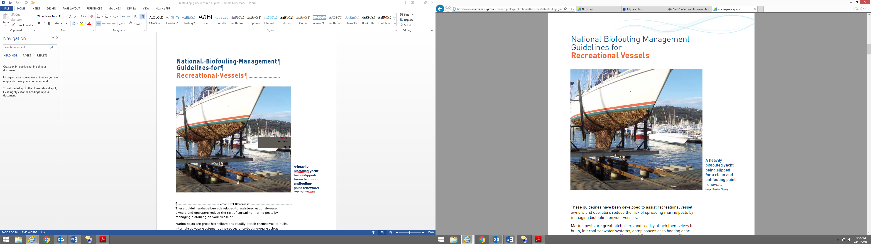

Image: Bayview Slipway.

## Maintaining trailered vessels onshore

Trailered vessels have the potential to translocate marine pests from one area to another via both the vessel and/or its trailer (Figure 1). To reduce this risk, take the following precautions after each trip:

* check for and remove entangled or attached biofouling (seaweeds) from the vessel and trailer
* check outboard and hull fixtures for water that could harbour potential marine pests (including trimming outboard down to let water out of the gearbox housing)
* rinse the boat inside and out with fresh water, drain and if possible, allow to dry for 48 hours if moving to another location
* dispose of any biofouling and waste water, including known marine pests, in bins or to landfill so that it cannot be returned to the water

Figure 1 Niche areas where biofouling can accumulate on a small recreational vessel

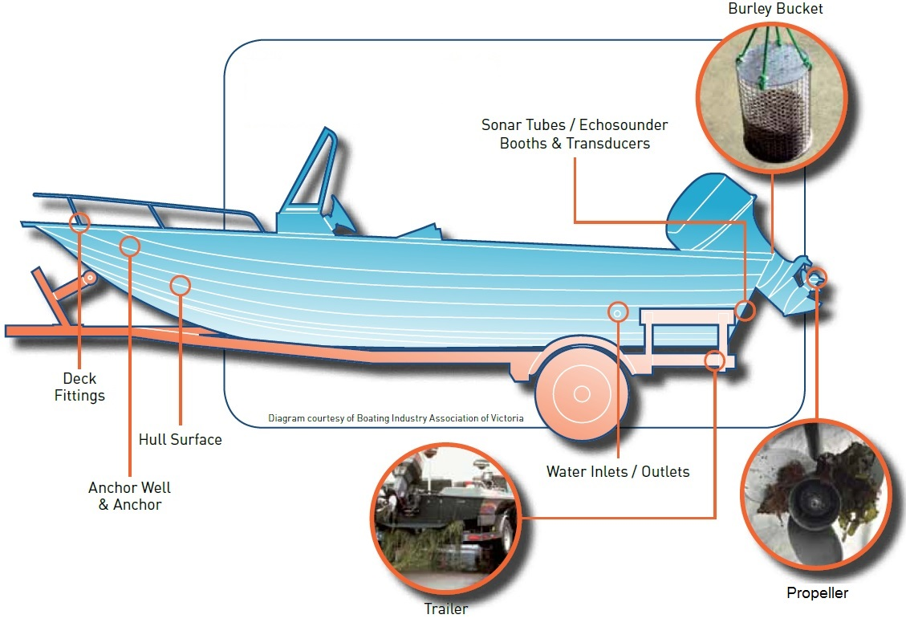

Image: Illustration adapted from a diagram provided by Mermaid Marine Australia Ltd.

## Clean your vessel and gear

Keep your vessel and gear clean to help to prevent the spread of marine pests.

### Remove biofouling as soon as possible

You should remove biofouling:

* at a licensed vessel maintenance facility if your vessel has established biofouling
* by rinsing with freshwater either once you have returned to land or in your backyard if your vessel is trailered, and allow to drain completely and air dry.

Air-drying will kill most small pest species in about 24 hours. If your vessel does become fouled, remove the biofouling on land where scrapings and wastewater cannot get back into the waterways or stormwater drains. If conducting hull servicing independently, remember to obtain the relevant permits to discard biofouling at a licensed disposal site.

If possible, collect some specimens and keep in a sealed plastic bag in the freezer for identification.

Figure 2 Niche areas where biofouling can accumulate on a larger recreational vessel

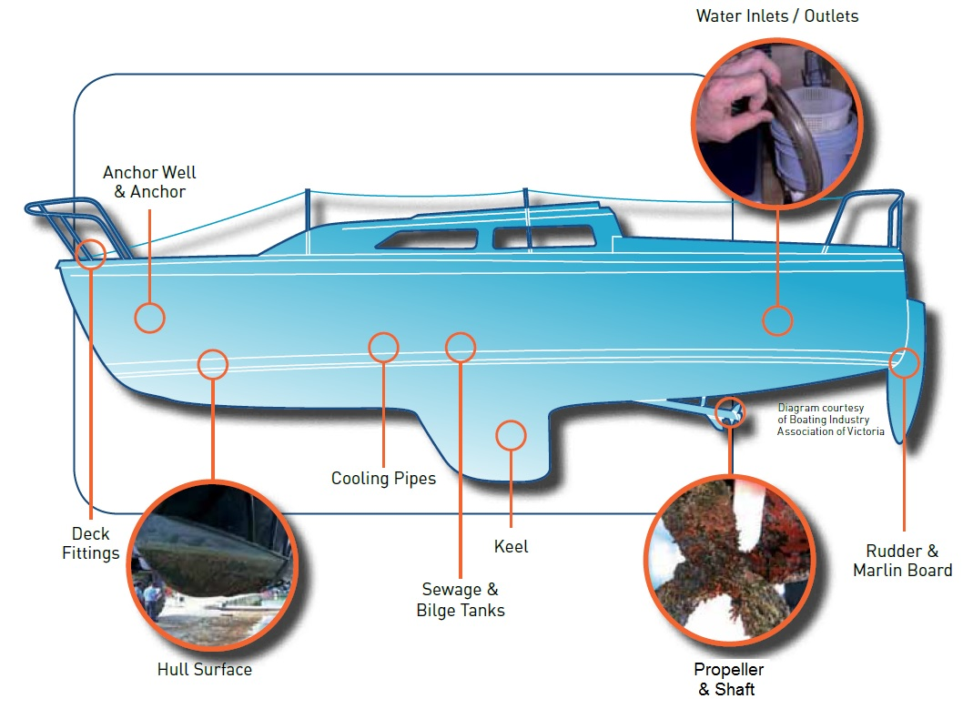

Image: Illustration adapted from a diagram provided by Mermaid Marine Australia Ltd.

### Scrape down vessel hull

Maintenance of all vessels should be undertaken at licensed vessel maintenance facilities.

* do not scrape down your vessel hull in the water
* do not scrape down your vessel hull on the shoreline
  + This applies to areas such as the beach, at boat ramps, tidal grids or careening bays where removed organisms can get back into waterways.

The ANZECC Code of Practice for Antifouling and In-Water Hull Cleaning and Maintenance (the code) is applicable in all states and the Northern Territory. Ask your maintenance facility how they manage their waste.

Under the code in-water hull scraping/cleaning is generally not allowed and permission needs to be sought to conduct any in-water cleaning. If you do wish to conduct in-water cleaning, please check with the relevant state/territory or port authority and the ANZECC [Anti-fouling and in-water cleaning guidelines](http://www.agriculture.gov.au/biosecurity/avm/vessels/biofouling/anti-fouling-and-inwater-cleaning-guidelines) for applicable exemptions.

### Wash down your vessel to remove slime layer

Using a soft cloth, wash down your vessel as often as required to prevent build-up of heavy fouling, if this is permitted in your area. Soft-cloth wipe down may not be permitted in all places depending on your vessel movements and the presence of any marine pests in your area. Check with your relevant state/territory or port authority for more information.

### Clean underwater fittings regularly

Some underwater fittings such as propellers cannot be painted and are more susceptible to biofouling. Check with the relevant state/territory or port authority for any conditions or management measures required when cleaning these.

Photo 2 Using hydroblasting to remove biofouling on a recreational vessel

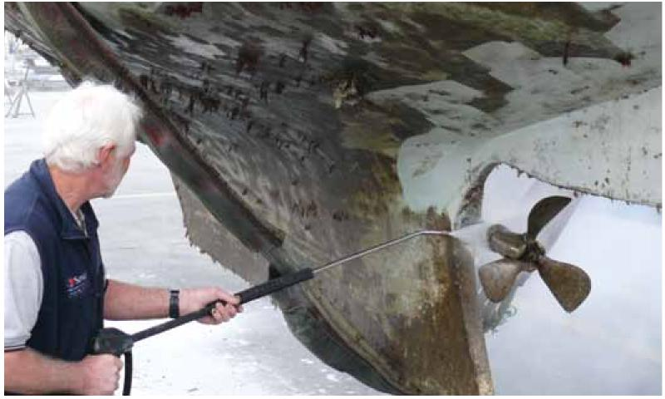

Image: Paul Gascoigne, Sandringham Yacht Club.

### Clean/treat internal seawater systems regularly

Treat by cleaning intake and outlet points and by periodically flooding with fresh water prior to moving between regions. See section 4 for more detailed directions.

### Inspect hulls

Hull should be inspected at least monthly if vessels are moored for long periods in one place, to monitor for potential biofouling, and take any necessary action such as slipping and cleaning.

### Inspect, clean and dry gear and equipment

Do this each time you change the location you are operating, moving between different waterways, bays or harbours. Include anchors, fishing gear, nets and burley buckets (as marked in Figure 1 and Figure 2). Dispose of waste in a bin.

### Clean hull before travel

Ensure your boat hull is clean before leaving its current location so that potential pests are not spread to other harbours and other vessels.

### **Report suspicious biofouling**

Notify your local regulatory agency if you think you have identified any pest species, any unknown species or any other potential pest species—so their spread can be monitored. Signs include unusually heavy biofouling, biofouling largely of the same species and species unfamiliar to the area.

## Application of antifouling

If your vessel is moored in water, apply an antifouling coating suitable for your vessel type and usage.

### Selection

Select the best antifouling coating for your vessel based on:

* vessel operating location (tropical vs temperate)
* vessel type/operating conditions
* vessel construction materials
* voyage profile (pattern of use and activity).

Consult your antifouling coating supplier for advice. Antifouling products containing tributyltin (TB71) cannot be used in Australia.

Photo 3 Sanding back old antifouling coating before applying a fresh coat

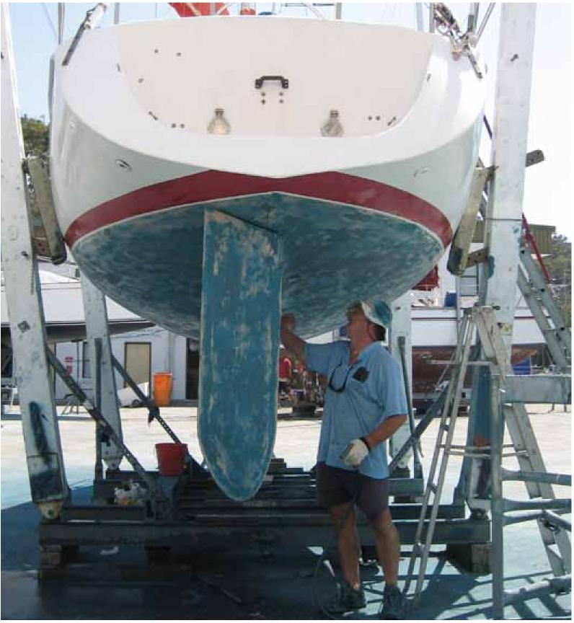

### Application

Apply and remove antifouling products at licensed vessel maintenance facilities that comply with the ANZECC Code of Practice for Antifouling and In-Water Hull Cleaning and Maintenance (1997) and follow the [Anti-fouling and in-water cleaning guidelines](http://www.agriculture.gov.au/biosecurity/avm/vessels/biofouling/anti-fouling-and-inwater-cleaning-guidelines).

### Frequency

Apply antifouling at least as often as specified by the manufacturer, and follow closely the application directions on the can, for the particular product selected for your vessel.

Antifouling coatings should be renewed towards the shorter end of its recommended life expectancy. Note that the effective life of a coating may be reduced by hull scrubbing or by knocks and collisions.

## Treatment of internal seawater systems

Clean or treat internal seawater systems, which are known to be a high-risk area for biofouling and may contain large numbers of juveniles or small species.

Treat systems with an approved treatment:

* if a vessel has remained stationary for an extended period of time
* before moving a vessel to a new location
* whenever you slip your vessel, and
* regularly flush internal seawater systems with fresh water or use an approved treatment as a preventative measure to keep the systems clean.

You will need to check with your local regulatory authority to find out what internal seawater system treatments are permitted in your area.

## Waste and effluent disposal

Dispose of all biofouling waste appropriately and ensure that it cannot get back into waterways, stormwater drains or the marine environment.

Contain, collect and treat all biofouling removed during hull cleaning and dispose of it appropriately into identified bins at a licensed vessel maintenance facility.

Contain all wash down water that may be contaminated by fouling organisms—do not allow it to run back into the waterways or stormwater drains.

Where possible, dispose of bilge water and sewage wastes at appropriate pump-out facilities provided at marinas, slipways or boat ramps. Bilge water and seawater used for toilet flushing may be contaminated with marine pests. Your marina/port authority may have guidelines for the disposal of bilge water and sewage wastes.

## Record keeping and reporting

Keep records to help in the case of marine pest emergencies, such as safety situations, declaration of marine pest management areas, quarantine areas, and for auditing and compliance monitoring.

### **Antifouling and maintenance schedules**

Retain purchase invoices for antifouling products (indicating date, brand, type and volume of paint) and receipts for application of the paint by the slipway or evidence of third party oversight. A written statement from the owner's marina or boat club representative confirming oversight of repainting is sufficient

Vessel log book should record all slipping and maintenance schedules, antifouling application schedule and products used, cleaning of hull, propeller and any other problem areas of the vessel, and treatment of internal seawater systems.

### Vessel movement reports and voyage plans

These should include destination, route and expected time of departure and return, to marina or boating club in order to track vessels in the event of a pest outbreak or other emergency.

## Declared pest management measures or areas

Comply with specific requirements as directed in the event of declared pest management measures or areas. If management measures are implemented to eradicate an outbreak of an introduced marine pest or control an existing marine pest, the relevant authority will advise you on what you need to do.

Measures may include:

* declaration of a quarantine area or a control area to quarantine vessels within an area and/or prevent vessels from entering and/or leaving the area
* your vessel may be required to undergo an inspection and/or be treated and cleaned if it is within a control area or at a specific location, to eradicate a pest or prevent its transfer to another location
* you may be required to report your vessel movements so that vessels that may be contaminated with a marine pest can be tracked
* access to certain areas or locations may be restricted to prevent your vessel from being contaminated. It is important to comply with specific requirements as directed in the event of declared pest management areas or temporary quarantined areas.

The records listed in section 6 help authorities assess the level of biofouling that may be present on your vessel and may help get your vessel cleared to leave a quarantined area.

## Reporting marine pests

Learn to identify known pests and report any new sightings of these species or any other unusual species to the relevant authority (see the [Marine Pests](http://www.marinepests.gov.au/report) website).

Be aware of pest infestations in your local area and undertake measures to minimise the risk of translocating these species.

Never release a known marine pest back into the water.

## Contacts

For more information about marine pests and biofouling management guidelines contact your local state/territory fisheries Officer or visit the [Marine Pests](http://www.marinepests.gov.au/) website.