The relative contribution of vectors to the introduction and translocation of invasive marine species

Keeping marine pests out of Australian waters

Important
The Australian Government Department of Agriculture, Fisheries and Forestry advises that the information contained in this report is based on scientific research and is intended to inform the development of public policy. Readers are advised and need to be aware that this information may be incomplete or unsuitable for use in any specific situation. Before taking any action or decision based on the information in this publication, readers should seek professional, scientific and technical advice.
To the extent permitted by law, the Australian Government and the Department of Agriculture, Fisheries and Forestry (including its employees, consultants and advisers) disclaim all liability, including liability for negligence, for any direct or consequential loss, damage, death, injury, expense, liability or cost incurred or suffered by any person (including corporate entities or bodies politic) as a result of accessing, using or relying on any of the information or data contained in this publication.

September 2010
ISBN 978-1-921575-14-3

Copyright
© Commonwealth of Australia 2010 (except where otherwise indicated)
This work is copyright. You may download, store in cache, display, print, reproduce, distribute or communicate these materials in an unaltered form only (retaining this notice) provided no monetary consideration is received in exchange and that the work is not dealt with in a manner that is misleading or deceptive. Apart from any use as permitted under the Copyright Act 1968, all other rights are reserved. Requests for further authorisation should be sent to: Commonwealth Copyright Administration, Attorney General’s Department, Robert Garran Offices, National Circuit, Barton ACT 2600 or posted at <www.ag.gov.au/cca>.
Cover image courtesy of Jan Young
Japanese seaweed image courtesy of John Lewis ES Link Services Pty Ltd
Designed by Professional Public Relations <www.ppr.com.au>

The relative contribution of vectors to the introduction and translocation of marine invasive species
Commissioned by
The Department of Agriculture, Fisheries and Forestry (DAFF)
Prepared by
The National Centre for Marine Conservation and Resource Sustainability
within the Australian Maritime College
Professor Chad Hewitt and Associate Professor Marnie Campbell

Executive summary
Whether intentional or not, humans have been responsible for the translocation of invasive marine species. The indicative representations of association suggest that biofouling has been the most prevalent mechanism contributing to such invasions across the globe.
Biofouling is one of the oldest mechanisms of human-mediated transport of marine species, beginning with early human movements on small scales and eventually leading to world explorations with the European Expansion from 1500 AD onwards.
The most common means of biofouling is marine species attaching themselves to any part of a vessel, or any equipment attached to or onboard the vessel, aquaculture equipment and mooring devices.
In contrast, ballast water is a relatively new vector of transport, with the earliest ballast water use recorded in the late 19th century. Ballast water – water (including sediment that has been contained in water) held in tanks and cargo holds of ships to increase stability and manoeuvrability during transit – represents an expansion of transport opportunity to the vast majority of the benthic species associated with biofouling.
This project assessed the relative contributions of known marine pest vectors in terms of the introduction and translocation of marine invasive species on a national basis (in Australia) through a review of the National Port Survey Database (NPSD) and on a worldwide basis through a literature review.
The information represented by the global dataset and the NPSD provide a useful tool for identification of species associations with modern vectors of transport, and the opportunity to identify likely relationships for future entry.
Analysis of the global dataset indicated that more species have life history characteristics associated with biofouling (55 per cent) than any other vector. The second highest association was with ballast water (31 per cent).
A similar relative contribution was found in the Australian context through analysis of the NPSD, with biofouling contributing 60 per cent of species association and ballast water 24 per cent.

Contents
1. Introduction 9
2. Objectives 14
2.1 Overall objective 14
2.2 Specific objectives 14
3. Global assessment 15
4. National Port Survey Database 19
5. Evaluation of broad vector categories 39
6. Discussion and conclusions 43
7. References 49
Appendix – Researchers contacted to value add information 56

List of Tables
Table 1 Specific constraints associated with identified transport mechanisms 12
Table 2 National Introduced Marine Pest Coordination Group broad vector categories 14
Table 3 Examples of regional assessments of non-indigenous species 15
Table 4 Priority sites as identified in Hewitt and Martin (2001), based on inoculation pressure and detection of introduced and cryptogenic species in port surveys 20
Table 5 Examples of surveys with estimated cost per sample (2007 US$) in relation to efficiency (% of total introduced species detection) for five sites and ten sites 21
Table 6 Number of sites of each type in the 33 ports represented in the National Port Survey Database 23
Table 7 Introduced and cryptogenic species detected in the 33 port surveys, with total number of records of occurence (ports, samples, sites) and according to site types 25
Table 8 Species X site association 38
Table 9 Summary of species associations with vectors, based on life history characteristics for the various datasets 48

List of Figures
Figure 1 An evaluation of historic marine bioinvasions according to five primary transport mechanisms 13
Figure 2 Number of recognised introduced and cryptogenic marine species on a global scale in the top 15 high-level (Phylum) taxonomic groups 18
Figure 3 Australian ports and facilities (surveyed locations noted in orange) 19
Figure 4 Numbers of unidentified species (species without binomials) detected in the 33 surveys 33
Figure 5 Numbers of introduced and cryptogenic species detected in the 33 surveys and in Port Phillip Bay for comparison 34
Figure 6 Nonparametric Multi-Dimensional Scaling plot of introduced and cryptogenic species similarity between ports, highlighting the separation between tropical and temperate port systems 35
Figure 7 Dendrogram of the hierarchical clustering of introduced and cryptogenic species in highlighting an Australian port-by-port separation of tropical and temperate ports 36
Figure 8 Nonparametric Multi-Dimensional Scaling plot of introduced and cryptogenic species similarity between environmental types, highlighting the dissimilarity between all types 37
Figure 9 Introduced and cryptogenic species association with vectors based on life history characteristics (following Table 1) 37
Figure 10 Comparison of the average percentage species association with sites compared with average frequency of site representation in the 33 surveys 38

Figure 11 Number of marine bioinvasions (introduced and cryptogenic species) in the 18 large-scale IUCN marine bioregions, according to contribution of specified transport mechanisms 40
Figure 12 Percentage of marine bioinvasions (introduced and cryptogenic species) in the 18 large-scale IUCN marine bioregions, according to contribution of specified transport mechanisms 41
Figure 13 Potential association for species to be transported by major vector categories (average across the 18 large-scale IUCN marine bioregions) 42
Figure 14 Re-evaluation of Figure 1 – evaluation of historic marine bioinvasions 42
Figure 15 Distribution and prevalence of Paracerceis sculpta in the Port of Fremantle and Cockburn Sound (reprinted from Hewitt and Campbell 2001) 47

1. Introduction
Humans have undoubtedly transported species, intentionally and accidentally, for several thousand years (diCastri 1989). However, these movements are likely to have been spatially restricted and of relatively low frequency. The modern era of European expansion (post-1500 AD) has resulted in the massive transport and inoculation of species between non-contiguous biotic provinces (Crosby 1986; diCastri 1989). The transport of species by human vectors was recognised by early workers (Ostenfeld 1908; Elton 1958; Williams et al. 1988), but it is only in the last few decades that significant progress on identifying patterns and processes has been made (e.g. Carlton 1985, 1996, 2001; Ruiz et al. 2000; Hewitt 2002; Hewitt et al. 2004; Castilla et al. 2005; Minchin 2006).
Transport mechanisms in the marine environment have largely been associated with commerce and exploration. These include:
- wooden-hulled vessel boring
- biofouling
- dry and semidry ballast
- steel-hulled vessel biofouling and the transport of planktonic organisms and fragments in ballast water
- the intentional transfer of aquaculture and mariculture organisms (specifically oyster introductions) including the unintentional movement of associated organisms (e.g. Elton 1958; Carlton 1989, 1996; Ribera and Boudouresque 1995)
- the transfer of live, frozen and dried food products and aquarium trade (e.g. Weigle et al. 2005)
- the use of biological material for packing (e.g., Ribera Siguan 2002, 2003; Miller et al. 2004)
- the explicit transport of species for scientific research.
Many of these vectors have not been limited to single species movements but have often resulted in entire assemblages or communities of tens to hundreds of species being transported between disparate bioregions. These vectors of transport typically result in the unidirectional movements of species over long periods, inoculating new individuals or propagules for multiple generations (e.g. Carlton and Geller 1993; Ruiz et al. 2000; Hewitt et al. 2004).
Most efforts have focused on the ship as a transport vector, which is comprised of several sub-vectors, such as:
- biofouling on the hull, seachests, propeller, rudder, exposed surfaces of water piping, thruster tunnels and other ‘niche’ areas
- the boring of organisms into the structure of the vessel (primarily limited to wooden-hulled vessels)
- the uptake of organisms in association with wet or dry ballast
(e.g. Carlton 1989, 1996; Ruiz et al. 2000).
Several of these ship sub-vectors are believed to have ceased to exist as significant mechanisms of transport (e.g. wooden hull boring, dry and semidry ballast, accidental acquaculture introductions). Hull boring, for example, virtually ceased to exist with the use of steel as the primary ship-building material in merchant and naval vessels. However, many pleasure boats and fishing craft are still constructed of wood (Nagabhushanam and Sarojini 1997) and therefore present an opportunity for this mechanism to continue. Similarly, dry-ballast made up of sand, gravel and rock taken from littoral environments was replaced with water ballast beginning in the late 1800s and was phased out by 1950. While it is believed that these transport mechanisms have ceased, others have become more apparent (e.g. ballast water).
None of the various transport mechanisms are species specific, with the exceptions of intentional introductions of target species for aquaculture, fisheries enhancement, or biocontrol. Several mechanisms are likely to transport entire assemblages of species. These transport mechanisms have unique sets of constraints that act as selection criteria influencing a species’ ability to successfully enter and survive the invasion process (Table 1). This suggests that suites of species with physiological and ecological characteristics may be recognised in association with specific transport vectors. For example, biofouling primarily transports species that have attached sedentary or sessile, benthic habits, or species associated with these communities (e.g. living in, between or on other organisms) (Minchin and Gollasch 2002). In contrast, ballast water transports species associated with the plankton either as holo-plankton (species that have their whole life-cycle in the water column), mero-plankton (species with a portion of their life-cycle in the water column), or tycho-plankton (species accidentally swept into the water column), and often includes pelagic species.
It is difficult to establish a firm link between an already-established introduced species and the vector (or sub-vector) by which it arrived in the new location. Nevertheless, linkages to sub-vectors based on life history modes, timing of invasions, and association between location of incursion and sub-vectors have been deduced by reasoned argument (e.g. Hewitt et al. 1999, 2004, 2007, in press; Ruiz et al. 2000). It has become apparent that assigning a species to a single vector is problematic, and perhaps inappropriate, given the opportunity for species to be inoculated multiple times through transport by a number of different vectors.
Hewitt et al. (1999, 2004) evaluated known introductions to Port Phillip Bay and identified the most probable vector(s) of transport for individual species. This was based on the biology of each life history phase (e.g. planktonic larvae for ballast water, attached benthic phase for hull fouling) and the timing of invasions (e.g. before or after the advent of ballast water use). Species assignments to vectors were not exclusive; any vector by which a life history phase could be transported (see expert author chapters in Hewitt et al. 1999), and that was operating at the time of first collection, was given equal weighting (the total for an individual species summing to 1) and a percentage of all species calculated for each vector. This evaluation resulted in a simple comparison of the five categories of transport vector used in the study (see Figure 1).

Table 1. Specific constraints associated with identified transport mechanisms
 | Uptake |  |  |  | Transport
Transport  Mechanism | Exposure (settlement/  uptake) period | PLanktonic Phase | Association with target species or habitat |  | Shear  stress | Desiccation | Darkness | Crushing  and physical  stress | Exposure  to  changing  environment
Hull boring | * |  |  |  |  |  | * |  | *
Hull fouling | * |  |  |  | * | * |  |  | *
Dry and semidry ballast |  |  | * |  |  | * | * | *
Water ballast |  | * |  |  |  |  | * | *
Ballast tank sediments |  | * |  |  |  |  | * | *
Aquaculture/mariculture |  |  | * |  |  |  |  | *
Aquarium and live seafood trade |  |  | *
Bait and packing material |  |  | * |  |  | * | * | *
Scientific research |  |  | *
Maritime equipment | * | * |  |  |  | * |  |  | *
(from Hewitt et al. 2007)

Figure 1. An evaluation of historic marine bioinvasions according to five primary transport mechanisms
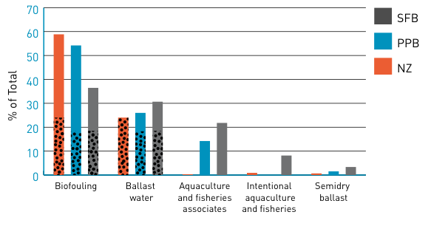
Red – New Zealand (based on Cranfield et al. 1998)
Blue – Port Phillip Bay (Hewitt et al. 1999, 2004)
Grey – San Francisco Bay (Cohen and Carlton 1995)
Stippled areas represent species that could have been introduced both by hull fouling and ballast water. (Figure adapted from Hewitt et al. 2009).

2. Objectives

2.1 Overall objective
This project assesses the relative contributions of known marine pest vectors in terms of the introduction and translocation of marine invasive species on a national basis (in Australia) through review of the NPSD and on a worldwide basis through a literature review.

2.2 Specific objectives
- A global assessment of recognised introduced marine species with assignation to broad vector categories (Table 2). Data to be derived from pre-existing materials such as published literature.
- An analysis of the NPSD to determine association of recognised Australian introductions with broad vector categories (Table 2).
- A matrix assessment of the estimated proportion that each broad vector category (Table 2) and each vector contributes to marine pest translocation.
- Development of a bibliography of the literature reviewed during the project (delivered previously).

Table 2. National Introduced Marine Pest Coordination Group broad vector categories
 | Broad Vector Category
 | Ballast water | Biofouling | Other
Specific vector | - Commercial vessels  - Defence vessels  - Miscellaneous vessels  (i.e. super-yachts,  cruise liners) | - Commercial fishing vessels  - Non-trading vessels  - Commercial vessels  - Recreational vessels  - Petroleum production and exploration industry  - Aquaculture operations | - Aquaculture  (non-biofouling transfers)  - Aquarium

3. Global assessment
Currently no single source of information provides an up-to-date repository of recognised marine invasions around the globe. Attempts to generate such a comprehensive list are fraught with difficulty, as the source information is often difficult to access or the identifications are called into question by taxonomic experts in other regions. Several regional assessments of species recognised by local experts have been undertaken, providing an opportunity to pull together these
various pieces of information into a consistently represented dataset
(Table 3; see also Campbell et al. 2007).

Table 3. Examples of regional assessments of non-indigenous species
Location | No. of  Introduced and cryptogenic species | Reference
United States | 298^{a,e} | Ruiz et al. 2000
Baltic Sea | 96a | Gollasch and Leppäkoski 1999; Leppäkoski and Olenin 2000
New Zealand | 167a | Cranfield et al. 1998
United Kingdom | 50b | Eno et al. 1997
Black Sea | 35a,^{b} | Zaitsev and Mamaev 1997
Mediterranean Sea (1997) | 240^{a,c,d} | Por 1978; Ruiz et al. 1997
Mediterranean Sea (2002) | 467 | CIESM Atlases: Golani et al. 2002;  Galil et al. 2002; Zenetos et al. 2003
Azores | 52 | Cardigos et al. 2006
South Africa | 58^{a,c} | de Moor and Burton 1988
South Atlantic (Patagonia) | 114 | Orensanz et al. 2002; this study
Southeast Pacific (Chile) | 40 | Castilla et al. 2005
Australia (1990) | 62 | Pollard and Hutchings 1990a,b
Australia (2001) | >215 | Hewitt et al. 1999, 2004; Hewitt 2002
Australia (2005) | 338 | Hayes et al. 2005
Australia (2008) | 429 | This study
Note.
a Includes marine, brackish, freshwater and salt marsh species.
b Partial evaluation of species.
c Includes all species records, not limited to establishment.
d Includes Lessepsian migration as well as human mediated introductions.
e Limited to continental United States (including Alaska).
Hayes et al. (2005) provided an assessment that reported 1582 marine and estuarine species that have been transported by human mediated activities worldwide. More recently, The Nature Conservancy published a global assessment (Molnar et al. 2008) compiling information from over 350 data sources and recording data spatially using the (Spalding et al. 2007; <www.nature.org/MEOW>) ecoregions. The dataset generated by their assessment (Spalding et al. 2007; <www.nature.org/marineinvasions>) was evaluated against the dataset generated in this assessment and was found to have numerous gaps. For example, the Bassian ecoregion in southeast Australia, which includes Port Phillip Bay, is reported to have only 42 introduced species (of which Molnar et al. deem 22 as pests), whereas the Port Phillip Bay assessment (Hewitt et al. 1999, 2004) alone has identified 99 introduced and 67 cryptogenic species.
The information presented here expands upon the work of Hewitt et al. (unpub dataset, 1999, 2004) and others (Hayes et al. 2002, 2005; Hayes and Sliwa 2003; Molnar et al. 2008). A note of caution must be made concerning the use of international datasets. Much of the overseas data was collected for other purposes than evaluation of non-native species, presence or distribution, resulting in differential sampling efforts across habitats and regions. For example, much of the biodiversity assessments used to harvest non-indigenous species (NIS) information explicitly sample in ‘pristine’ regions, thus avoiding port and marina areas that experience high NIS inoculation pressure. As a result, these assessments will likely underestimate the number of NIS.
An assessment of the primary and secondary (grey) literature, including websites and online databases, was performed to identify the known marine introduced and cryptogenic species to generate a global dataset. In addition, a number of researchers (Appendix) were approached directly to add additional information in generating the complete dataset. Wherever possible, primary literature was sought as the source information. We have compiled information from over 700 data sources.
In this evaluation, data for species presence was recorded using the 18 large-scale International Union for Conservation of Nature (IUCN) marine bioregions (Kelleher et al. 1995), as these are close representatives of widely accepted biological provinces, rather than the finer scale ecoregions. The designation and use of biogeographic boundaries has caused significant debate in the literature; however, the use of provinces with recognition of overlapping boundaries provides the basis for the Kelleher et al. (1993) designation. This system creates a sequence of ‘core’ and ‘transitional’ areas which are roughly equivalent to the Spalding et al. (2007) ecoregions by Molnar et al. (2008).
The database now includes 1781 species (see Figure 2), 43 of which are species restricted to lower salinities (< 5 ppt). The dominant groups of species in our database are:
- arthropods (444 species)
- molluscs (350)
- fish (166)
- red algae (153)
- annelids (104)
- cnidarians (101)
- brown algae (73)
- bryozoans (73)
- green algae (51).
Over 98 per cent of the 1781 species have been allocated to possible transport vectors, based on examination of life history characteristics (at the species level where available), morphological characteristics and habitat associations following the criteria and methods proposed by Hewitt and Campbell (Table 1) and similar to the evaluation of Port Phillip Bay in Hewitt et al. (1999, 2004). Where species-level information was not readily available, genus-level characteristics were used to classify morphological characteristics and habitat associations.
We followed the broad vector categories provided in Table 2; however, finer scale evaluation of association with specific vectors was not feasible for differentiating within the broad categories of ballast water or biofouling as specified in Table 2. In addition, we were able to analyse association with historic vectors (semidry ballast and wooden hull boring), intentional aquaculture and fisheries transfers, and others (e.g. canals, biocontrol, intentional plantings).

Figure 2. Number of recognised introduced and cryptogenic marine species on a global scale in the top 15 high-level (Phylum) taxonomic groups
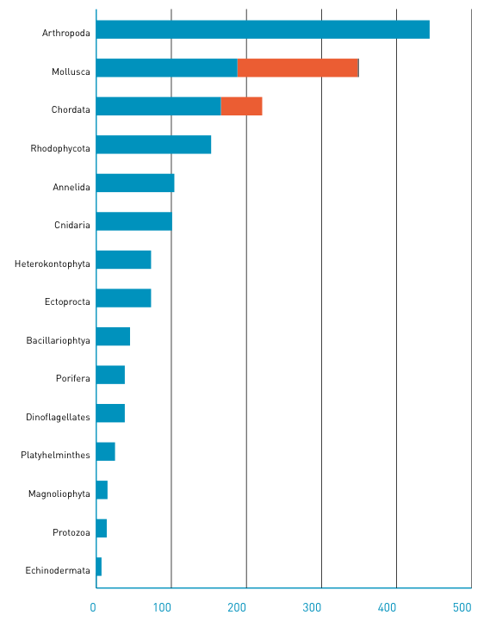
Note. Representing 98.5 per cent of the total recognised global introduced diversity.
Mollusca is divided into gastropods, bivalves and chitons (represented in blue, orange and black, respectively). Chordata is divided into fishes (blue) and ascidians (orange).

4. National Port Survey Database
Between 1995 and the present, 34 Australian locations have been surveyed using a consistent suite of standardised methods for the design and sampling of biodiversity across a range of habitats (Hewitt and Martin 1996, 2001; see also review by Campbell et al. 2007; Figure 3). The Hewitt and Martin (1996, 2001) protocols aim to detect introduced, cryptogenic and native species and determine species distributions to identify introduced species, pathways and vectors. They are designed to maximise the likelihood that introduced marine species are detected. To achieve this, sampling strategies concentrate on habitats and sites that are most likely to have been inoculated and colonised by species associated with recognised transport vectors (e.g. vessel biofouling, ballast water, aquaculture operations, recreational vessels etc) (Table 4).

Figure 3. Australian ports and facilities (surveyed locations noted in orange)
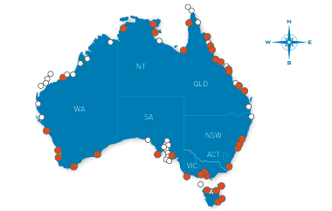
Campbell et al. (2007) evaluated methodologies used in the majority of global efforts to detect and identify introduced and cryptogenic species in marine environments. They identified five suites of survey methodologies:
- the Hewitt and Martin (1996, 2001) protocols (also known as the CRIMP protocols)
- the Rapid Assessment Survey (RAS) protocols (e.g. Cohen et al. 2001; Pedersen et al. 2003; Cohen et al. 2005)
- the Bernice P. Bishop Museum (BPBM) protocols (Coles and Eldredge 2002)
- the Chile aquaculture surveys (Hewitt et al. 2006)
- the Passive Sampling protocols (e.g. Ruiz and Hewitt 2002;
Wyatt et al. 2005; deRivera et al. 2006).
The comparison of survey types was restricted to understanding the survey constraints and benefits, specifically in relation to:
- detection efficiencies (as determined by species accumulation curves)
- the total and per-sample costs
- the cost efficiencies (Table 5).
The Bishop Museum and Hewitt and Martin protocols were determined to be most effective in detecting species.

Table 4. Priority sites as identified in Hewitt and Martin (2001), based on inoculation pressure and detection of introduced and cryptogenic species in port surveys
1 | Commercial shipping facilities in port
 | Active berths
 | Inactive/disused wharves
 | Channel markers
 | Tug and pilot vessel berths
 | Slipways
 | Breakwaters, groynes etc.
 | Spoil ground
2 | Non-commercial facilities/areas in port
 | Fishing vessel berths/moorings
 | Recreational vessel berths/moorings
 | Beaches
 | Rock jetties, breakwaters, groynes
 | Mariculture facilities
 | Marinas and boat ramps
 | Estuarine/brackish/lagoonal areas
 | Wrecks and hulks
3 | Adjacent areas outside port
 | Non-commercial shipping facilities
 | Estuarine/brackish/lagoonal areas
 | Offshore exposed areas
 | Beaches

Table 5. Examples of surveys with estimated cost per sample (2007 US$) in relation to efficiency
(% of total introduced species detection) for five sites and ten sites
Survey | Survey Method | Per  sample cost  (US$) | 5 Sites |  | 10 Sites
Survey | Survey Method | Per  sample cost  (US$) | Cost  (US$) | Effectiveness  (%) | Cost  (US$) | Effectiveness  (%)
Port of Esperance, Western Australia (Campbell et al., unpub ms) | Hewitt and Martin | 4125 | 20 625 | 62.75 | 41 250 | 83.72
Washington State Exotics Expedition (2000) | Rapid Assessment Survey | 3360 | 16 800 | 26.61 | 33 600 | 30.70
Kaneohe Bay, Oahu, Hawaii, USA (Coles et al., 2002) | Bishop Museum | NR | NR | 49.35 | NR | 80.51
Shark Bay Passive Sampling  (Wyatt et al., 2005) | Passive Sampling | 200 | 1000 | 23.12 | 2000 | 41.05
(Table modified from Campbell et al. 2007). Note. Passive Sampling does not present information for sites, but for panels

These surveys were initially undertaken to provide baseline information (providing information on the spatial aspect of invasions) with the intention, if funds existed, of subsequently resurveying sites using the same methods and intensity (providing both spatial and temporal invasion data). The frequency of resurveys should be dependent on the baseline data and the introduced species detected. In practice, resurveys have occurred infrequently, and, where they have occurred, at six-month intervals (e.g. Darwin wet and dry season surveys), three-year intervals (e.g. New Zealand port surveys) and five-year intervals (e.g. Bunbury, Western Australia, resurvey). To date, the Hewitt and Martin protocols have been used in more than 73 surveys in 12 countries and represent 66 per cent of the formal evaluations for marine invasions across the globe (Campbell et al. 2007).
The NPSD represents the formal collation of data from 33 of the baseline evaluations from ports around Australia. The database specifically excludes the Port Phillip Bay analysis undertaken by CSIRO (Hewitt et al. 1999, 2004), as this was not formally part of the NPSD and relied on a combination of port survey methods as well as museum and literature evaluations. Here we have incorporated the Port Phillip Bay data into the representative analyses to allow for comparisons with the previous information.
Australian port locations vary significantly in size (e.g. number of berths) and primary activities (commercial berths, recreational and fishing vessel marinas, defence berths or areas, aquaculture). We have analysed the recognised introduced and cryptogenic species in each of the surveys to determine the detection association with the various types of sites (commercial, recreational, fisheries, defence, historic, aquaculture and other; Table 6). Each port survey represents the accumulation of successful introductions throughout the life of the location’s (port, marine) activity.
Here, we assume that the presence of species at a site represents an indication of transport association between the primary activity of a site (e.g. commercial shipping, recreational vessels, fisheries vessels, defence estate, historic, aquaculture and other) and the species through correlation. It should be noted that sites within Australian ports are rarely exclusive. With the exception of defence and aquaculture locations which have restricted access, all other locations have a designated primary activity but are frequented by other vessel types; for example, commercial berths are frequently used by other types of vessels, including fishing vessels, recreational vessels, slow-moving barges, oil and gas platforms and exploratory rigs, in addition to commercial ships. Similarly, recreational and fishing vessels are frequently found in the same marinas or mooring locations (e.g. Francis Bay Marina in Darwin, Challenger Harbour in Fremantle and Trinity Inlet in Cairns). Consequently, the assumption of association between the primary activity and the species may be incorrect.

Table 6. Number of sites of each type in the 33 ports represented in the National Port Survey Database
 |  | Commercial | Recreational | Fisheries | Defence | Historic | Aquaculture | Otherª
WA | Albany | 5 | 4 | 1 |  | 1 | 1 | 6
WA | Bunbury | 11 | 5 |  |  | 1 |  | 9
WA | Esperance | 9 | 6 |  |  |  |  | 2
WA | Fremantle | 31 | 7 | 3 | 7 |  | 1 | 15
WA | Geraldton | 11 | 6 |  |  |  |  | 1
WA | Port Hedland | 15 | 1 |  |  |  |  | 5
QLD | Abbot Point | 4 |  |  |  |  |  | 2
QLD | Cairns | 12 | 8 | 2 |  | 1 |  | 12
QLD | Gladstone | 13 | 1 | 1 |  |  |  | 8
QLD | Hay Point | 14 |  |  |  |  |  | 11
QLD | Karumba | 2
QLD | Lucinda | 5 |  |  |  |  |  | 9
QLD | Mackay | 6 | 7 |  |  |  |  | 6
QLD | Mourilyan | 1
QLD | Townsville | 9 | 3 |  |  |  |  | 15
QLD | Weipa | 3 |  |  |  |  |  | 7
VIC | Geelong | 7 |  |  |  |  |  | 4
VIC | Hastings | 2 | 1
VIC | Melbourne | 19 |  |  |  |  |  | 9
VIC | Portland | 6 | 1 | 2 |  |  |  | 13
TAS | Burnie | 9 | 1 |  |  |  |  | 8
TAS | Devonport | 7 | 2 | 1 |  |  |  | 19
TAS | Hobart | 16 | 2 | 4 | 1 |  |  | 5
TAS | Lady Barron | 3 |  | 3 |  |  |  | 3
TAS | Launceston | 18 | 1 |  |  |  |  | 13
SA | Adelaide | 10 | 2 |  | 1 |  |  | 17

Table 6. Number of sites of each type in the 33 ports represented in the National Port Survey Database Continued
 |  | Commercial | Recreational | Fisheries | Defence | Historic | Aquaculture | OTHERª
SA | Port Lincoln | 11 | 8 | 1 |  |  |  | 2
NT | Darwin | 17 | 3 | 3 | 2 | 3 |  | 2
NT | Gove | 6 | 1 | 1 |  |  |  | 5
NSW | Botany Bay | 16 |  |  |  |  |  | 14
NSW | Eden | 8 |  |  |  |  |  | 17
NSW | Newcastle | 13 |  |  |  |  |  | 26
NSW | Port Kembla | 18 | 4 |  |  |  |  | 10
Note. a Other designation includes ‘pristine’ areas, beaches etc.

Table 7. Introduced and cryptogenic species detected in the 33 port surveys, with total number of records of occurence (ports, samples, sites) and according to site types
PHYLUM | Genus sSP | Status | Ports | Samples | Sites | Commercial | Recreational | Fisheries | Defence | Historic | Aquaculture | Other
Annelida
 | Boccardia chilensis | C | 7 | 37 | 25 | 16 | 1 | 1 | 0 | 1 | 0 | 6
 | Boccardia polybranchia | I | 1 | 1 | 1 | 1 | 0 | 0 | 0 | 0 | 0 | 0
 | Boccardia proboscidea | I | 2 | 10 | 8 | 4 | 1 | 0 | 0 | 0 | 0 | 3
 | Capitella capitata spp complex | C | 2 | 12 | 10 | 1 | 1 | 0 | 0 | 0 | 0 | 8
 | Dipolydora flava | C | 1 | 16 | 6 | 5 | 0 | 0 | 0 | 0 | 0 | 1
 | Dipolydora giardi | C | 1 | 1 | 1 | 1 | 0 | 0 | 0 | 0 | 0 | 0
 | Euchone limnicola | I | 6 | 88 | 31 | 18 | 1 | 1 | 0 | 0 | 0 | 11
 | Hydroides diramphus | I | 3 | 22 | 16 | 15 | 0 | 0 | 0 | 0 | 0 | 1
 | Hydroides elegans | C | 4 | 82 | 31 | 15 | 2 | 1 | 1 | 0 | 0 | 12
 | Hydroides ezoensis | I | 2 | 10 | 9 | 8 | 0 | 0 | 0 | 0 | 0 | 1
 | Lysidice collaris | C | 8 | 95 | 47 | 36 | 2 | 2 | 1 | 1 | 0 | 5
 | Myxicola infundibulum | I | 6 | 46 | 30 | 18 | 2 | 3 | 1 | 0 | 0 | 6
 | Polydora hoplura | C | 2 | 62 | 18 | 13 | 2 | 2 | 0 | 0 | 0 | 1
 | Pseudopolydora kempi | C | 1 | 11 | 6 | 5 | 0 | 0 | 0 | 0 | 0 | 1
 | Sabella spallanzanii | I | 9 | 295 | 79 | 53 | 9 | 1 | 0 | 1 | 1 | 14
Arthropoda
 | Amphibalanus amphitrite | C | 17 | 290 | 121 | 86 | 11 | 8 | 2 | 1 | 0 | 13
 | Apocorophium acutum | I | 2 | 8 | 7 | 5 | 2 | 0 | 0 | 0 | 0 | 0
 | Ashtoret lunaris | C | 1 | 1 | 1 | 1 | 0 | 0 | 0 | 0 | 0 | 0
 | Balanus improvisus | I | 1 | 1 | 1 | 1 | 0 | 0 | 0 | 0 | 0 | 0
Status. I – Introduced, C – Cryptogenic. Bolded species are represented in only one site type

Table 7. Introduced and cryptogenic species detected in the 33 port surveys, with total number of records of occurence (ports, samples, sites) and according to site types Continued
PHYLUM | Genus sSP | Status | Ports | Samples | Sites | Commercial | Recreational | Fisheries | Defence | Historic | Aquaculture | Other
 | Balanus reticulates | I | 5 | 30 | 15 | 9 | 0 | 0 | 0 | 1 | 0 | 5
 | Balanus trigonus | C | 13 | 888 | 162 | 118 | 9 | 3 | 5 | 1 | 0 | 26
 | Caprella acanthogaster | I | 1 | 90 | 25 | 14 | 1 | 4 | 1 | 0 | 0 | 5
 | Caprella danilevskii | C | 1 | 1 | 1 | 1 | 0 | 0 | 0 | 0 | 0 | 0
 | Caprella equilibra | C | 5 | 13 | 13 | 6 | 1 | 0 | 0 | 0 | 0 | 6
 | Caprella penantis | C | 3 | 23 | 17 | 9 | 0 | 2 | 0 | 0 | 0 | 6
 | Caprella scaura | I | 2 | 6 | 5 | 3 | 0 | 0 | 0 | 0 | 0 | 2
 | Carcinus maenas | I | 7 | 45 | 22 | 10 | 2 | 0 | 0 | 1 | 0 | 9
 | Cirolana harfordi | I | 3 | 7 | 6 | 6 | 0 | 0 | 0 | 0 | 0 | 0
 | Elasmopus rapax | I | 1 | 23 | 20 | 15 | 1 | 0 | 0 | 0 | 0 | 4
 | Halicarcinus innominatus | I | 1 | 89 | 18 | 13 | 1 | 2 | 0 | 0 | 0 | 2
 | Jassa marmorata | I | 2 | 14 | 10 | 8 | 0 | 1 | 0 | 0 | 0 | 1
 | Jassa slatteryi | C | 3 | 81 | 25 | 17 | 2 | 3 | 1 | 0 | 0 | 2
 | Leandrites stenopus | C | 1 | 1 | 1 | 1 | 0 | 0 | 0 | 0 | 0 | 0
 | Leptochelia dubia | C | 2 | 40 | 17 | 14 | 1 | 1 | 0 | 0 | 0 | 1
 | Ligia exotica | I | 1 | 1 | 1 | 0 | 0 | 0 | 0 | 0 | 0 | 1
 | Megabalanus rosa | I | 2 | 25 | 22 | 18 | 0 | 0 | 0 | 0 | 0 | 4
 | Megabalanus tintinnabulum | I | 6 | 12 | 9 | 7 | 0 | 0 | 0 | 0 | 0 | 2
 | Megabalanus zebra | I | 2 | 5 | 5 | 4 | 0 | 0 | 0 | 0 | 0 | 1
 | Metacarcinus novaezelandiae | I | 4 | 7 | 7 | 7 | 0 | 0 | 0 | 0 | 0 | 0
 | Monocorophium acherusicum | I | 5 | 142 | 38 | 21 | 3 | 3 | 1 | 1 | 0 | 9
 | Monocorophium insidiosum | I | 2 | 36 | 12 | 7 | 0 | 1 | 0 | 0 | 0 | 4
Status. I – Introduced, C – Cryptogenic. Bolded species are represented in only one site type

Table 7. Introduced and cryptogenic species detected in the 33 port surveys, with total number of records of occurence (ports, samples, sites) and according to site types Continued
PHYLUM | Genus sSP | Status | Ports | Samples | Sites | Commercial | Recreational | Fisheries | Defence | Historic | Aquaculture | Other
 | Paracerceis sculpta | I | 10 | 51 | 25 | 15 | 4 | 1 | 0 | 1 | 0 | 4
 | Paradella dianae | I | 5 | 7 | 5 | 4 | 0 | 1 | 0 | 0 | 0 | 0
 | Petrolisthes elongatus | I | 5 | 97 | 26 | 13 | 3 | 4 | 1 | 0 | 0 | 5
 | Sphaeroma serratum | I | 2 | 3 | 3 | 0 | 1 | 0 | 0 | 0 | 0 | 2
 | Sphaeroma walkeri | I | 2 | 15 | 15 | 14 | 0 | 0 | 0 | 0 | 0 | 1
 | Stenothoe valida | C | 2 | 4 | 4 | 4 | 0 | 0 | 0 | 0 | 0 | 0
 | Tanais dulongi | I | 1 | 7 | 4 | 0 | 1 | 0 | 0 | 0 | 0 | 3
Chlorophyta
 | Caulerpa filiformis | C | 2 | 4 | 4 | 1 | 1 | 0 | 0 | 0 | 0 | 2
 | Chaetomorpha linum | C | 1 | 1 | 1 | 0 | 0 | 0 | 0 | 0 | 0 | 1
 | Codium fragile ssp tomentosoides | I | 2 | 5 | 5 | 3 | 0 | 1 | 0 | 1 | 0 | 0
 | Ulva compressa | C | 1 | 14 | 7 | 4 | 2 | 1 | 0 | 0 | 0 | 0
 | Ulva intestinalis | C | 1 | 2 | 2 | 2 | 0 | 0 | 0 | 0 | 0 | 0
 | Ulva lactuca | C | 8 | 44 | 29 | 19 | 3 | 1 | 0 | 0 | 0 | 6
 | Ulva rigida | C | 3 | 21 | 13 | 8 | 1 | 0 | 0 | 0 | 0 | 4
 | Ulva stenophylla | I | 1 | 5 | 4 | 4 | 0 | 0 | 0 | 0 | 0 | 0
 | Ulva taeniata | C | 1 | 1 | 1 | 0 | 0 | 0 | 0 | 0 | 0 | 1
Chordata
 | Acentrogobius pflaumi | I | 2 | 10 | 9 | 5 | 0 | 0 | 0 | 0 | 0 | 4
 | Ascidiella aspersa | I | 7 | 176 | 61 | 38 | 8 | 4 | 0 | 0 | 0 | 11
 | Botrylloides leachi | I | 11 | 84 | 54 | 39 | 6 | 3 | 0 | 0 | 0 | 6
 | Botrylloides magnicoecum | C | 10 | 26 | 24 | 21 | 2 | 0 | 0 | 0 | 0 | 1
Status. I – Introduced, C – Cryptogenic. Bolded species are represented in only one site type

Table 7. Introduced and cryptogenic species detected in the 33 port surveys, with total number of records of occurence (ports, samples, sites) and according to site types Continued
PHYLUM | Genus sSP | Status | Ports | Samples | Sites | Commercial | Recreational | Fisheries | Defence | Historic | Aquaculture | Other
 | Botryllus schlosseri | I | 5 | 64 | 29 | 16 | 4 | 5 | 1 | 0 | 0 | 3
 | Ciona intestinalis | I | 8 | 148 | 85 | 56 | 6 | 3 | 4 | 0 | 0 | 16
 | Ciona savignyi | I | 1 | 5 | 5 | 3 | 2 | 0 | 0 | 0 | 0 | 0
 | Diplosoma listerianum | I | 4 | 63 | 25 | 20 | 2 | 3 | 0 | 0 | 0 | 0
 | Styela clava | I | 3 | 86 | 28 | 23 | 0 | 0 | 0 | 0 | 0 | 5
 | Styela plicata | I | 8 | 88 | 51 | 37 | 4 | 0 | 0 | 0 | 0 | 10
 | Tridentiger trigonocephalus | I | 3 | 9 | 9 | 7 | 1 | 0 | 0 | 0 | 0 | 1
Cnidaria
 | Antennella secundaria | I | 3 | 25 | 12 | 9 | 0 | 0 | 0 | 0 | 0 | 3
 | Bougainvillia muscus | I | 4 | 22 | 12 | 7 | 1 | 3 | 0 | 0 | 0 | 1
 | Clytia hemisphaerica | C | 11 | 62 | 39 | 27 | 6 | 3 | 0 | 1 | 0 | 2
 | Clytia paulensis | C | 5 | 10 | 8 | 5 | 1 | 1 | 0 | 0 | 0 | 1
 | Cordylophora caspia | I | 1 | 1 | 1 | 1 | 0 | 0 | 0 | 0 | 0 | 0
 | Culicia tenella | C | 3 | 29 | 23 | 22 | 1 | 0 | 0 | 0 | 0 | 0
 | Eudendrium carneum | I | 1 | 6 | 4 | 1 | 0 | 1 | 0 | 1 | 0 | 1
 | Filellum serratum | C | 2 | 6 | 4 | 3 | 0 | 0 | 1 | 0 | 0 | 0
 | Halecium  delicatulum | C | 10 | 38 | 29 | 20 | 3 | 3 | 0 | 0 | 0 | 3
 | Haliplanella lineata | I | 1 | 2 | 1 | 1 | 0 | 0 | 0 | 0 | 0 | 0
 | Obelia dichotoma | I | 10 | 63 | 39 | 25 | 3 | 3 | 0 | 1 | 1 | 6
 | Obelia geniculata | I | 3 | 4 | 4 | 2 | 0 | 0 | 0 | 0 | 0 | 2
 | Obelia longissima | C | 6 | 36 | 15 | 13 | 0 | 0 | 0 | 0 | 0 | 2
 | Pennaria disticha | I | 6 | 26 | 14 | 10 | 0 | 0 | 0 | 1 | 0 | 3
 | Phialella quadrata | I | 6 | 12 | 10 | 8 | 0 | 2 | 0 | 0 | 0 | 0
Status. I – Introduced, C – Cryptogenic. Bolded species are represented in only one site type

Table 7. Introduced and cryptogenic species detected in the 33 port surveys, with total number of records of occurence (ports, samples, sites) and according to site types Continued
PHYLUM | Genus sSP | Status | Ports | Samples | Sites | Commercial | Recreational | Fisheries | Defence | Historic | Aquaculture | Other
 | Plumularia setacea | I | 3 | 16 | 9 | 7 | 0 | 2 | 0 | 0 | 0 | 0
 | Sarsia eximia | C | 5 | 18 | 13 | 11 | 1 | 0 | 0 | 0 | 0 | 1
 | Sertularia orthogonalis | C | 1 | 3 | 3 | 2 | 0 | 0 | 0 | 0 | 0 | 1
 | Tubularia crocea | I | 5 | 43 | 25 | 18 | 0 | 1 | 1 | 0 | 0 | 5
 | Turritopsis nutricula | I | 5 | 22 | 13 | 9 | 1 | 1 | 0 | 0 | 0 | 2
Dinophyceae
 | Alexandrium catenella | I | 4 | 41 | 37 | 16 | 1 | 0 | 0 | 1 | 0 | 19
 | Alexandrium minutum | I | 5 | 61 | 54 | 23 | 4 | 0 | 0 | 1 | 0 | 26
 | Alexandrium tamarense | C | 7 | 25 | 24 | 20 | 0 | 0 | 0 | 0 | 0 | 4
 | Gymnodinium catenatum | I | 2 | 30 | 16 | 9 | 2 | 3 | 0 | 0 | 0 | 2
Echinodermata
 | Asterias amurensis | I | 2 | 166 | 37 | 22 | 2 | 2 | 1 | 0 | 0 | 10
 | Patiriella regularis | I | 1 | 151 | 19 | 12 | 1 | 2 | 1 | 0 | 0 | 3
Bryozoa
 | Acanthodesia savartii | I | 3 | 18 | 10 | 7 | 0 | 0 | 0 | 0 | 0 | 3
 | Aetea anguina | C | 3 | 5 | 5 | 3 | 0 | 0 | 0 | 0 | 0 | 2
 | Aeverrillia setigera | C | 1 | 2 | 2 | 0 | 0 | 0 | 0 | 0 | 0 | 2
 | Amathia distans | I | 11 | 87 | 33 | 24 | 2 | 0 | 0 | 0 | 0 | 7
 | Amathia tortuosa | C | 3 | 36 | 12 | 9 | 3 | 0 | 0 | 0 | 0 | 0
 | Bowerbankia gracilis | I | 2 | 8 | 5 | 4 | 1 | 0 | 0 | 0 | 0 | 0
 | Bowerbankia imbricata | I | 1 | 6 | 6 | 4 | 1 | 0 | 0 | 0 | 0 | 1
Status. I – Introduced, C – Cryptogenic. Bolded species are represented in only one site type

Table 7. Introduced and cryptogenic species detected in the 33 port surveys, with total number of records of occurence (ports, samples, sites) and according to site types Continued
PHYLUM | Genus sSP | Status | Ports | Samples | Sites | Commercial | Recreational | Fisheries | Defence | Historic | Aquaculture | Other
 | Bugula avicularia | I | 1 | 1 | 1 | 1 | 0 | 0 | 0 | 0 | 0 | 0
 | Bugula flabellata | I | 12 | 129 | 48 | 34 | 5 | 3 | 1 | 0 | 0 | 5
 | Bugula neritina | I | 20 | 209 | 92 | 70 | 0 | 5 | 2 | 1 | 0 | 14
 | Bugula stolonifera | I | 9 | 68 | 35 | 20 | 3 | 1 | 3 | 0 | 1 | 7
 | Conopeum reticulum | I | 2 | 7 | 6 | 3 | 0 | 0 | 0 | 1 | 0 | 2
 | Conopeum seurati | C | 5 | 39 | 26 | 21 | 0 | 0 | 0 | 0 | 0 | 5
 | Cryptosula pallasiana | I | 12 | 127 | 56 | 38 | 5 | 3 | 0 | 1 | 0 | 9
 | Electra tenella | C | 1 | 3 | 2 | 0 | 0 | 0 | 0 | 0 | 0 | 2
 | Jellyella tuberculata | C | 2 | 7 | 7 | 5 | 1 | 0 | 0 | 0 | 0 | 1
 | Membranipora membranacea | C | 4 | 10 | 9 | 6 | 0 | 0 | 0 | 0 | 0 | 3
 | Savignyella lafontii | C | 4 | 12 | 5 | 3 | 0 | 0 | 0 | 0 | 0 | 2
 | Schizoporella errata | I | 6 | 60 | 32 | 18 | 5 | 1 | 1 | 1 | 0 | 6
 | Schizoporella unicornis | I | 7 | 40 | 33 | 22 | 6 | 1 | 0 | 0 | 0 | 4
 | Scruparia ambigua | I | 1 | 3 | 2 | 2 | 0 | 0 | 0 | 0 | 0 | 0
 | Thalamoporella gothica | I | 1 | 1 | 1 | 1 | 0 | 0 | 0 | 0 | 0 | 0
 | Tricellaria inopinata | C | 2 | 51 | 17 | 15 | 1 | 0 | 0 | 0 | 0 | 1
 | Tricellaria occidentalis | I | 6 | 53 | 34 | 25 | 2 | 0 | 1 | 0 | 0 | 6
 | Tricellaria porteri | C | 6 | 66 | 27 | 20 | 2 | 2 | 0 | 1 | 0 | 2
 | Watersipora arcuata | I | 8 | 35 | 22 | 15 | 3 | 1 | 0 | 1 | 0 | 2
 | Watersipora subtorquata | I | 16 | 319 | 129 | 94 | 8 | 5 | 2 | 0 | 1 | 19
 | Zoobotryon verticillatum | I | 8 | 43 | 32 | 21 | 4 | 2 | 3 | 0 | 0 | 2
Status. I – Introduced, C – Cryptogenic. Bolded species are represented in only one site type

Table 7. Introduced and cryptogenic species detected in the 33 port surveys, with total number of records of occurence (ports, samples, sites) and according to site types Continued
PHYLUM | Genus sSP | Status | Ports | Samples | Sites | Commercial | Recreational | Fisheries | Defence | Historic | Aquaculture | Other
Kamptozoa
 | Barentsia gracilis | I | 1 | 1 | 1 | 1 | 0 | 0 | 0 | 0 | 0 | 0
Mollusca
 | Corbula gibba | I | 5 | 69 | 24 | 13 | 1 | 1 | 0 | 0 | 0 | 9
 | Crassostrea gigas | I | 5 | 133 | 41 | 28 | 4 | 3 | 1 | 0 | 0 | 5
 | Maoricolpus roseus | I | 4 | 32 | 14 | 9 | 1 | 2 | 0 | 0 | 0 | 2
 | Musculista senhousia | I | 9 | 138 | 59 | 36 | 4 | 0 | 0 | 0 | 0 | 19
 | Mytilopsis sallei | I | 1 | 2 | 1 | 0 | 1 | 0 | 0 | 0 | 0 | 0
 | Mytilus edulis | C | 17 | 239 | 66 | 55 | 1 | 2 | 3 | 0 | 0 | 5
 | Mytilus galloprovincialis | C | 9 | 184 | 75 | 58 | 3 | 4 | 1 | 0 | 0 | 9
 | Raeta pulchella | I | 2 | 21 | 10 | 4 | 0 | 0 | 0 | 0 | 0 | 6
 | Ruditapes largillierti | I | 2 | 6 | 5 | 5 | 0 | 0 | 0 | 0 | 0 | 0
 | Thecacera pennigera | I | 1 | 1 | 1 | 0 | 0 | 0 | 0 | 0 | 0 | 1
 | Theora lubrica | I | 7 | 161 | 41 | 25 | 2 | 3 | 0 | 0 | 0 | 11
Phaeophyta
 | Cladostephus spongiosus | C | 4 | 11 | 9 | 4 | 4 | 0 | 0 | 0 | 0 | 1
 | Colpomenia sinuosa | C | 4 | 6 | 6 | 3 | 1 | 0 | 0 | 0 | 0 | 2
 | Dictyota dichotoma | C | 5 | 16 | 14 | 10 | 1 | 1 | 0 | 0 | 0 | 2
 | Undaria pinnatifida | I | 2 | 3 | 3 | 3 | 0 | 0 | 0 | 0 | 0 | 0
Porifera
 | Aplysilla cf. rosea | I | 1 | 1 | 1 | 1 | 0 | 0 | 0 | 0 | 0 | 0
 | Dendrilla rosea | I | 2 | 5 | 3 | 3 | 0 | 0 | 0 | 0 | 0 | 0
 | Lissodendoryx isodictyalis | C | 1 | 8 | 4 | 3 | 1 | 0 | 0 | 0 | 0 | 0
Status. I – Introduced, C – Cryptogenic. Bolded species are represented in only one site type

Table 7. Introduced and cryptogenic species detected in the 33 port surveys, with total number of records of occurence (ports, samples, sites) and according to site types Continued
PHYLUM | Genus sSP | Status | Ports | Samples | Sites | Commercial | Recreational | Fisheries | Defence | Historic | Aquaculture | Other
Rhodophyta
 | Acanthophora cf. spicifera | C | 1 | 1 | 1 | 1 | 0 | 0 | 0 | 0 | 0 | 0
 | Antithamnionella ternifolia | C | 3 | 33 | 17 | 15 | 1 | 1 | 0 | 0 | 0 | 0
 | Ceramium flaccidum | C | 2 | 3 | 3 | 0 | 3 | 0 | 0 | 0 | 0 | 0
 | Ceramium virgatum | C | 3 | 4 | 4 | 2 | 0 | 0 | 0 | 0 | 0 | 2
 | Champia parvula | C | 3 | 6 | 5 | 4 | 1 | 0 | 0 | 0 | 0 | 0
 | Corallina officinalis | C | 2 | 7 | 5 | 4 | 0 | 0 | 0 | 0 | 0 | 1
 | Gracilaria  cf. salicornia | C | 1 | 1 | 1 | 0 | 0 | 0 | 0 | 0 | 0 | 1
 | Polysiphonia blandii | I | 4 | 17 | 14 | 11 | 1 | 1 | 0 | 0 | 0 | 1
 | Polysiphonia brodiei | I | 2 | 9 | 6 | 3 | 1 | 2 | 0 | 0 | 0 | 0
 | Polysiphonia constricta | C | 2 | 7 | 6 | 4 | 1 | 0 | 0 | 0 | 0 | 1
 | Polysiphonia infestans | C | 3 | 5 | 3 | 1 | 0 | 0 | 0 | 0 | 0 | 2
 | Polysiphonia senticulosa | I | 1 | 7 | 5 | 4 | 0 | 1 | 0 | 0 | 0 | 0
 | Polysiphonia subtilissima | I | 2 | 68 | 27 | 20 | 1 | 2 | 0 | 0 | 0 | 4
 | Pterocladiella capillacea | C | 1 | 1 | 1 | 1 | 0 | 0 | 0 | 0 | 0 | 0
 | Pterosiphonia bipinnata | C | 1 | 2 | 2 | 2 | 0 | 0 | 0 | 0 | 0 | 0
 | Schottera nicaeensis | I | 1 | 10 | 5 | 4 | 1 | 0 | 0 | 0 | 0 | 0
 | Solieria filiformis | I | 1 | 1 | 1 | 0 | 0 | 0 | 0 | 0 | 0 | 1
Status. I – Introduced, C – Cryptogenic. Bolded species are represented in only one site type

Results
The NPSD indicates that the surveys detected a total of 10 847 taxa, with identification of 122 introduced and 80 cryptogenic species representing more than 7300 specimens. When added to the identifications from the evaluation of Port Phillip Bay (Hewitt et al. 1999, 2004), the total number of introduced and cryptogenic species detected in Australian port surveys is 248, approximately 58 per cent of the 429 species in the Australia and New Zealand bioregion recognised from the literature, museum collections and port surveys (Table 3). Several patterns are evident from the NPSD data.
The vast majority of taxa were not identified to species level (7113 taxa; 65.6 per cent of total), with tropical locations having a higher number of unknown species (Figure 4; for raw species numbers: t_{[30]} = 45.08, p < 0.05) and a higher proportion of the total taxa collected remaining unidentified (arcsine*square root transformed: t_{[30]} = 1.57, p < 0.05).

Figure 4. Numbers of unidentified species (species without binomials) detected in the 33 surveys
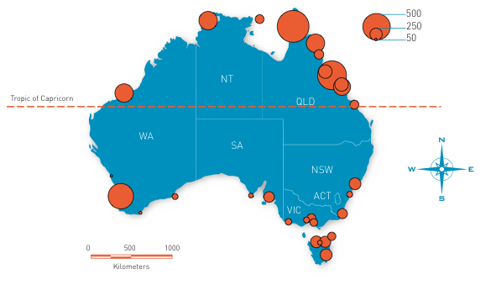
In contrast, virtually all surveys detected introduced and cryptogenic species (Figure 5), with a significant reduction in the number of introduced (t_{[30]} = 15.91, p < 0.05) and cryptogenic (t_{[30]} = 3.37, p < 0.05) species detected as latitude of surveys decreased towards the equator (Figure 5). Multivariate analyses comparing the similarity of introduced and cryptogenic assemblages between ports demonstrate a clear separation of tropical and temperate environments (Figure 6; stress 0.15). This is further illustrated by a port-by-port hierarchical cluster analysis, where assemblages of introduced and cryptogenic species form two distinct groups (tropical and temperate) at approximately 18 per cent similarity (Figure 7). Furthermore, multivariate analyses indicate that no similarity exists between site (environmental) types (Figure 8; stress 0).

Figure 5. Numbers of introduced and cryptogenic species detected
in the 33 surveys and in Port Phillip Bay for comparison
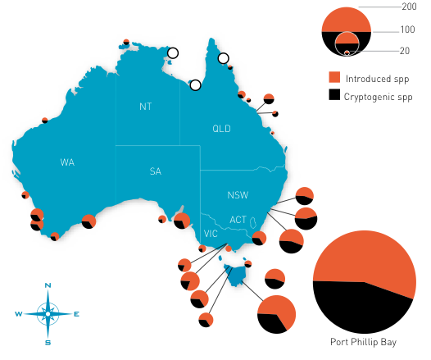
Note. Open circles represent locations for which no introduced or cryptogenic species were recorded

Figure 6. Nonparametric Multi-Dimensional Scaling plot of introduced and cryptogenic species similarity between ports, highlighting the separation between tropical and temperate port systems

Stress 0.15
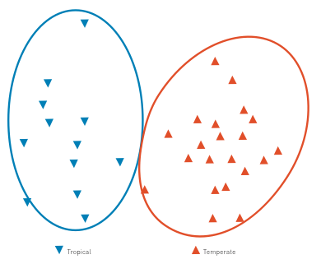

Figure 7. Dendrogram of the hierarchical clustering of introduced and cryptogenic species in highlighting an Australian port-by-port separation of tropical and temperate ports
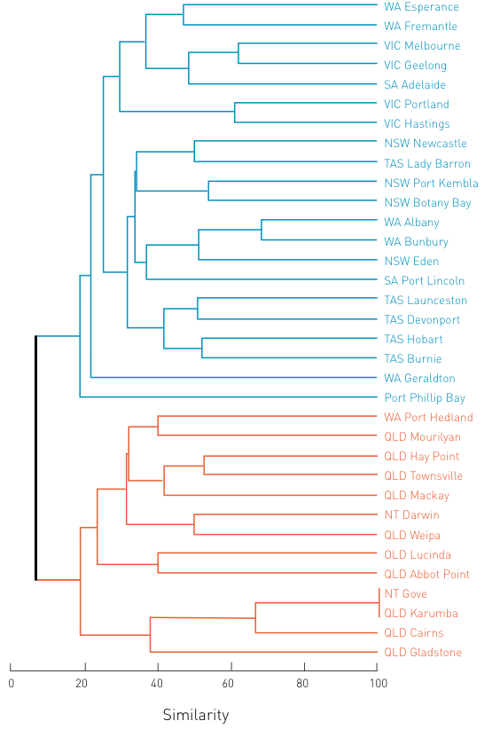
Note. Temperate ports: <22 degrees latitude
Tropical ports: >22 degrees latitude

Figure 8. Nonparametric Multi-Dimensional Scaling plot of introduced and cryptogenic species similarity between environmental types, highlighting the dissimilarity between all types
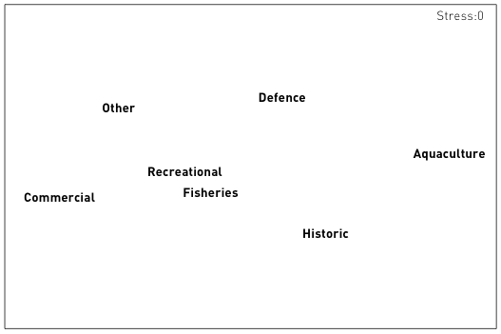
Of the 248 introduced and cryptogenic species detected in the port surveys, 59.8 per cent of introduced and cryptogenic species are associated with biofouling based on life history characteristics;24.0 per cent of introduced and cryptogenic species are associated with ballast water (Figure 9).

Figure 9. Introduced and cryptogenic species association with vectors based on life history characteristics (following Table 1)
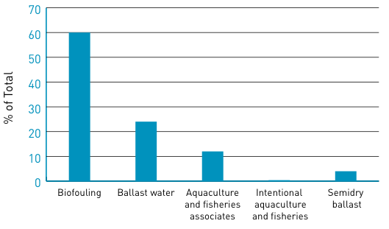
Species are most commonly associated with commercial sites, with additional representation at recreational and fisheries sites across all 33 ports (Figure 10). Introduced and cryptogenic species have a greater percentage representation at all site types than expected by site representation (Figure 10); however, the mean species association with site types is not significant except for historic sites, which are significantly higher than expected by chance alone (t_{[31 ]}= 2.79, p < 0.05; Table 8). Species associations with site type clearly separate sites through National Minimum Data Set analysis (Figure 8, Stress = 0)

Figure 10. Comparison of the average percentage species association with sites compared with average frequency of site representation in the 33 surveys
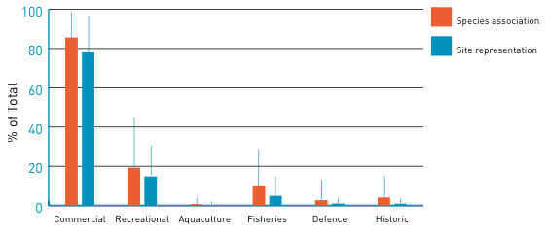

Table 8. Species X site association
Site type | Site representation |  | Species association |  | t_{[31]}
Site type | Mean % | Std Dev | Mean% | Std Dev | t_{[31]}
Commercial | 85.6 | 13.7 | 78.0 | 19.1 | 0.58
Recreational | 19.3 | 25.5 | 14.8 | 15.4 | 0.06
Aquaculture | 0.7 | 3.2 | 0.3 | 1.5 | 0.10
Fisheries | 9.8 | 19.3 | 4.9 | 10.1 | 0.40
Defence | 2.7 | 10.7 | 1.0 | 3.1 | 0.16
Historic | 4.1 | 11.3 | 0.9 | 2.6 | -2.79
Site types as a percentage representation in port surveys (standard deviation) and mean species association (standard deviation). Studentised t statistic is presented for pairwise comparisons of
arcsine* square root transformed percentages

5. Evaluation of broad vector categories
Using the information recorded from the global evaluation of introduced and cryptogenic species identified or reported from the 18 IUCN large-scale bioregions, patterns of species association with broad vector categories according to life history characteristics was carried out. Invasions within the large-scale IUCN marine bioregions have large differences in the strength of the broad vector categories (Figures 11 and 12) with high standard errors (Figure 12). Clearly the numbers of species recognised within the various regions differ, with some regions having significantly more introductions (e.g. Australia, North East Pacific, South Pacific, including Hawaii, and the Mediterranean). These regions have a longer history of marine study and investment in marine invasion ecology and have literature that is more readily accessible.
The relative importance of the vectors is more clearly observed in the per cent contribution to total (Figures 11 and 12). More species (averaged across the 18 bioregions) have life history characteristics or associations which indicate a biofouling association (55.5 per cent) than any other category, with a larger association with vessels (of all types). The high variability across bioregions for biofouling association (standard deviation 9.38 per cent) can readily be observed in Figure 13. Ballast water represents the second largest category (30.8 per cent), with a standard deviation of 7.2 per cent. A significant overlap of species associations between these two categories exists, as has been identified and discussed previously (Ruiz et al. 1997, 2000; Hewitt et al. 1999, 2004, in press; Minchin and Gollasch 2002; Minchin 2006; Figure 12).

Figure 11. Number of marine bioinvasions (introduced and cryptogenic species) in the 18 large-scale IUCN marine bioregions, according to contribution of specified transport mechanisms
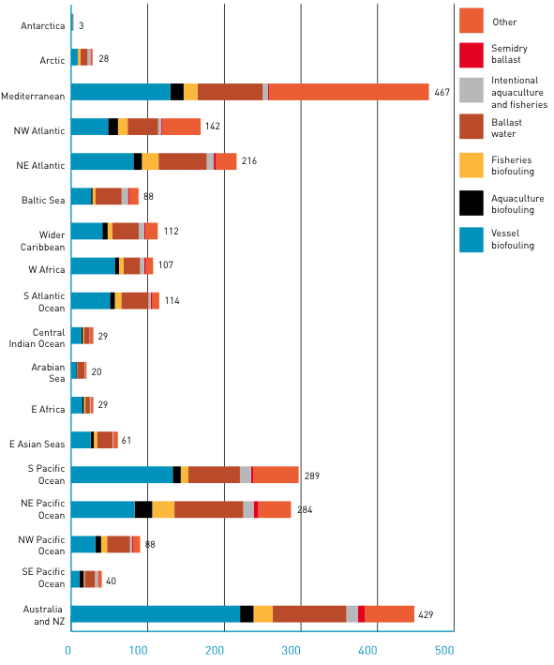
Note. Numbers at the end of bars represent total number of introduced and cryptogenic species identified from the region.
Note. Biofouling (vessels, aquaculture species and gear, fisheries gear), ballast water, intentional introductions through aquaculture and fisheries and other.

Figure 12. Percentage of marine bioinvasions (introduced and cryptogenic species) in the 18 large-scale IUCN marine bioregions, according to contribution of specified transport mechanisms
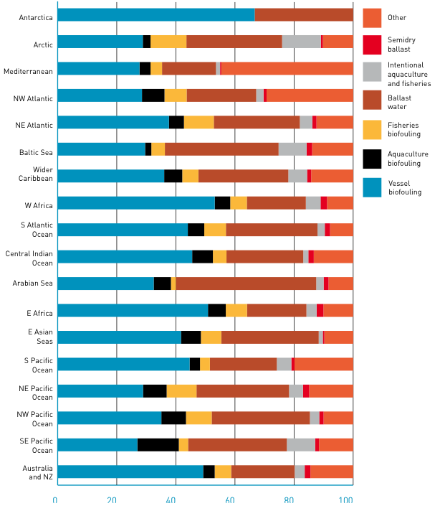
Note. Biofouling (vessels, aquaculture species and gear, fisheries gear), ballast water, intentional introductions through aquaculture and fisheries and other.

Figure 13. Potential association for species to be transported by major
vector categories (average across the 18 large-scale IUCN marine bioregions)
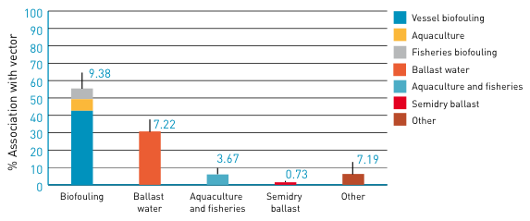
Note. Biofouling comprises of vessel biofouling, aquaculture species and gear biofouling, and fishing gear biofouling (respectively). Standard deviations of the mean for each vector are presented by error bars and numbers above the line.

Figure 14. Re-evaluation of Figure 1 – evaluation of historic marine bioinvasions
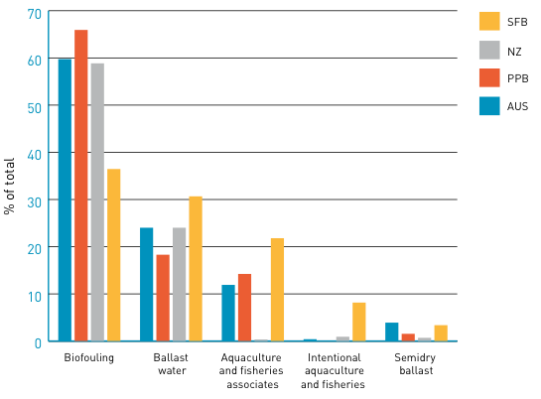
Note. Australia – this study; PPB – Port Phillip Bay (Hewitt et al. 1999, 2004); NZ – New Zealand (based on Cranfield et al. 1998); SFB – San Francisco Bay (Cohen and Carlton 1995).

6. Discussion and conclusions
This analysis has expanded upon previous attempts to collate information from the global literature, with a current representation of more than 1700 introduced and cryptogenic species from the 18 global IUCN bioregions. The list has been generated from over 700 sources and relies heavily on the accuracy of those individual assessments. While some judgements were made, these were based on subsequent literature or expert assessments from the regions. As has been discussed by others, invasion history alone is insufficient to determine future invasion potential. However, for the purposes of this retrospective assessment, the dataset provides a valuable tool in exploring species-level characteristics that provide clues to the mechanisms of species transport and establishment in new regions.
The information from the global dataset has a number of restrictions. The information extracted from the literature rarely has useful temporal information, and even where reported this is likely to represent a detection many years after the initial inoculation. As a consequence, it is not possible here to undertake a temporal reconstruction of vector associations.
While the global dataset cannot aid in identification of the specific sub-vector association, the indicative representations of association suggest that biofouling has been the most prevalent vector contributing to invasions across the globe. Biofouling is one of the oldest mechanisms of human-mediated transport of marine species, with early human movements on small scales leading to the eventual world explorations of the European Expansion (Crosby 1986). It is therefore unsurprising that the global dataset, representing the sum total of recognisable human-mediated introductions over the past millennium, has a heavy weighting towards biofouling-associated species.
Numerous examples of biofouling-related invasions have been documented in the literature (e.g. Skerman 1960; Gollasch 2002), including:
- commercial vessels (e.g. Coutts 1999; Lewis et al. 2003, 2004; Coutts and Taylor 2004)
- recreational vessels (Bax 1999; Floerl et al. 2004)
- replica sailing vessels (Lewis et al. 2006a; pers obs)
- slow moving barges (Lewis et al. 2006b; Coutts 2002)
- dredges (Clapin and Evans 1995)
- oil platforms (Carlton 1987; Page et al. 2006).
In several instances, these detections identified significant biofouling (e.g. 25 tons on the barge Steel Mariner, Coutts 2002; 90 tons on the fishing vessel Yefim Gorbenko in New Zealand, Hay and Dodgshun 1997) and/or identification of NIS in the biofouling (Page et al. 2006).
Clapin and Evans (1995) reported that the dredge Kingfisher, which had been frequently towed between Cockburn Sound and Bunbury, Western Australia, was moored in the Inner Harbour of Bunbury in 1993 and reported to have ‘many worms matching the description of S. spallanzanii on its hull’. Sabella was not officially detected in Bunbury until Clapin and Evans’ report. Hutchings et al. (1994) did not detect S. spallanzanii in their evaluation of the port.
Page et al. (2006) detected NIS on two of seven platforms they evaluated off the California coast. Species detected include Watersipora subtorquata, Diadumene sp. and Caprella mutica. They hypothesise that the association between platforms and small vessels and barges may have resulted in the transfer of species from onshore facilities to these platforms.
Ballast water in contrast is a relatively new vector of transport, with the earliest ballast water use recorded in the late 19th century. Ballast water represents an expansion of transport opportunity to the vast majority of the benthic species associated with biofouling. Many of these species have life histories with planktonic, larval dispersal, making them mero-planktonic. As a consequence, ballast water represents a significant expansion of the transport pathways. In contrast, ballast water is the first significant opportunity for the transfer of holo-planktonic species – that is, those species whose entire life history is associated with the water column. Globally there is a significant under-representation of holo-planktonic species as recognised invaders, despite the fact that one of the earliest recognised marine invasions was holo-planktonic (Ostenfeld 1908).
Several species have life history characteristics that enable transport by both biofouling and ballast water (Figure 1). This overlap suggests that many species may be inoculated through multiple means associated with vessel traffic, resulting in a stronger propagule pressure as well as greater likelihood of establishment success by creating a more genetically diverse population.
Other vectors have operated historically; however, the advent of new mechanisms of transport and trade have limited the extent to which they operate in the modern era. Semidry ballast – that is, the use of sand, cobble and rock as ballast for trim and stability of ships – was typically used in wooden vessels. With the advent of steel hulled vessels and efficient pumps, ballast water replaced semidry ballast. However, this material may have contributed to the transfer of untold species in the intertidal and near-shore rock, cobble and sand fauna and flora.
Wooden hull boring also provided significant opportunity for transport of boring and associated nestling fauna. With the development of steel-hulled vessels, this means of transport ceased to exist as a global mechanism of transfer, though it remains a local mechanism in many parts of the world today.
The inadvertent transfer of species by association with aquaculture and fisheries organisms or gear has contributed to a number of invasions globally. In most instances these have been due to the biofouling of the species or gear. The aquaculture and fisheries industries have adopted best practice guidelines that restrict or limit the likelihood of biofouling transfers in modern practice. These industries, along with the live seafood trade and the aquarium trade, do remain a risk of inadvertent transfer of parasites and pathogens.
The NPSD has provided an opportunity to assess the relationship between inoculation points within ports associated with specific target vectors (e.g. recreational vessel biofouling, commercial vessel biofouling and ballast water, defence vessel biofouling, aquaculture). As discussed above, the detection of 202 introduced and cryptogenic species in the 33 ports represented in the NPSD is largely associated with commercial wharves; however, this is not more than expected by chance alone (Table 8). This outcome suggests that the increased likelihood of delivery of species through both biofouling and ballast water provides an increased opportunity for species establishment.
Several examples of species found in a single site type across one or multiple ports are represented in the introduced and cryptogenic fauna (bold species in Table 7). The majority of these (> 90 per cent) are associated with commercial sites, and all are restricted to commercial, recreational or ‘other’ site categories.
Interestingly, the ‘other’ category represents a significant number of species detections. In most instances these represent site tags that have been lost, or designations that cannot be deciphered and may represent commercial wharves. In addition, this category explicitly includes areas identified as non-commercial, including ‘pristine’ areas (Table 4), and therefore may represent historic invasions. Further analysis is necessary to tease apart the details of this category.
The NPSD has not incorporated some of the additional identifications subsequent to the individual surveys. For example, Hewitt and Campbell (2001) evaluated the port survey specimen collection and museum collections from each of the state museums in Australia to determine the detection and representation of the isopod Paracerceis sculpta. This species had previously been detected only in Queensland; however, this species was identified in the Port Phillip Bay sampling by CRIMP and in the survey of Eden, NSW. Subsequent analysis of survey materials identified a broad distribution across Australia. Within sites, the information suggested that P. sculpta was transported in association with biofouling, based on the fact that eight of 11 sites where it is located were primarily associated with recreational vessels (Port Jackson, NSW; New Haven Marina, SA; and Peel Inlet, WA), fishing vessels (Wollongong Harbour and Eden, NSW; and Port Denison, WA) or slow-moving vessels such as tugs (Hay Point Tug Harbour, Qld), ferries (Hayles Wharf, Townsville, Qld) and barges (Hewitt and Campbell 2001). Indeed in Fremantle, the species was primarily detected in recreational and fishing areas (Figure 15). In addition, the NPSD is lacking much of the identified bryozoan fauna that was taxonomically verified by Dennis Gordon and others. While this material could potentially alter the analysis of the port survey information, it is out of the scope of this analysis; we have restricted our analysis to the official record for the purpose of this evaluation.

Figure 15. Distribution and prevalence of Paracerceis sculpta in the Port of Fremantle and Cockburn Sound, Western Australia
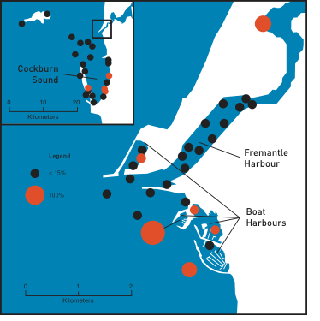
Note. Orange symbols denote presence; black symbols denote absence. Percentage representation of samples within site – represented by size of circles
(reprinted from Hewitt and Campbell 2001)
In conclusion, the information represented by the global dataset and the NPSD provides a useful tool for identification of species associations with modern vectors of transport and the opportunity to identify likely relationships for future entry. The global dataset indicates that more species have life history characteristics associated with hull fouling than any other vector (Figures 12 and 13), with vessel biofouling representing 42.6 per cent (±2.2 per cent standard deviation) and total biofouling (vessel, aquaculture and fisheries) 55.5 per cent (±9.4 per cent standard deviation). In contrast, the second highest association was with ballast water, representing 30.8 per cent (±7.2 per cent standard deviation). The majority of species in the global invasion literature have life history characteristics that associate with biofouling; however, many are also capable of transport by ballast water, meaning that there is potential for multiple inoculations. The high association with commercial sites would fit this premise.
In the Australian context, 429 species have been identified in the global dataset from the literature, specimen collections and port surveys as being introduced or cryptogenic. Using life history characteristics to determine vector associations,
58.1 per cent were associated with vessel biofouling (69.2 per cent for all biofouling; Figure 11) and 21.6 per cent were associated with ballast water.
Based on the NPSD, more than 248 introduced and cryptogenic species were detected, which is approximately 58 per cent of the 429 species identified for Australia and New Zealand. Based on life history characteristics, these detected species were 59.8 per cent of the introduced and cryptogenic species associated with biofouling, based on life history characteristics, as opposed to 24.0 per cent of introduced and cryptogenic species associated with ballast water (Table 9).
The three datasets demonstrate congruity in relative contribution to the various vectors, with a high contribution of biofouling (ranging from 55 per cent to 69 per cent) and ballast water (21 per cent to 31 per cent) (Table 9).

Table 9. Summary of species associations with vectors, based on life history characteristics for the various datasets
Data-set | Species number | Bio-fouling | Ballast water | Aquaculture and fisheries associates | Intentional aquaculture and fisheries | Semidry ballast
Global (ALL) | 1781 | 55.5% | 30.8% | 6.7% | 6.0% | 1.5%
Global (AUS) | 429 | 69.2% | 21.6% | 11.0% | 4.5% | 2.0%
NPSD | 248 | 59.8% | 24.0% | 11.9% | 0.4% | 3.9%
The greater detection of species at commercial sites overall, coupled with the detection of rare species (those found in only one site) and species detected in only one site type across single or multiple ports, are primarily associated with commercial sites. In this instance the association is much more than would be expected by chance alone. We note, however, that species association with commercial sites is not statistically significant relative to the effort expended in these regions. These outcomes suggest that the current management focus on commercial vectors, and specifically the move to redress biofouling, is appropriate and commensurate with demonstrated invasions.

7 References
Bax, NJ 1999, ‘Eradicating a dreissenid from Australia’, Dreissena! vol. 10, pp. 1–5.
Campbell, ML; Gould, B & Hewitt, L 2007, ‘Baseline survey evaluations and surveillance techniques to assess marine bioinvasions’, Marine Pollution Bulletin, vol. 55 pp. 360–378. DOI:10.1016/j.marpolbul.2007.01.015
Cardigos, F; Tempera, F; Ávila, S; Gonçalves, J; Colaço, A & Santos, RS 2006, ‘Non-indigenous marine species of the Azores’, Helgolander Marine Research, vol. 60, pp. 160–169.
Carlton, JT 1985, ‘Transoceanic and interoceanic dispersal of coastal marine organisms: the biology of ballast water’, Oceanography and Marine Biology Annual Review, vol. 23, pp. 313–371.
Carlton, JT 1987, ‘Patterns of transoceanic marine biological invasions in the Pacific Ocean’, Bulletin of Marine Science, vol. 41, pp. 452–465.
Carlton, JT 1989, ‘Man’s role in changing the face of the ocean: Biological invasions and implications for conservation of nearshore environments’, Conservation Biology, vol. 3, pp. 265–273.
Carlton, JT 1996, ‘Pattern, process, and prediction in marine invasion ecology’, Biological Conservation, vol. 78, pp. 97–106.
Carlton, JT 2001, Introduced Species in U.S. Coastal Waters: Environmental Impacts and Management Priorities, Pew Oceans Commission, Virginia, USA, p. 28.
Carlton, JT & Geller, JB 1993, ‘Ecological roulette: the global transport of nonindigenous marine organisms’, Science, vol. 261, pp. 78–82.
Castilla, JC; Uribe, M; Bahamonde, N; Clarke, M; Desqueyroux-Faúndez, R; Kong, I; Moyano, H; Rozbaczylo, N; Santilices, B; Valdovinos, C & Zavala, P 2005, ‘Down under the southeastern Pacific: marine non-indigenous species in Chile’, Biological Invasions, vol. 7, pp. 213–232.
Clapin, G & Evans, DR 1995, ‘The status of the introduced fanworm Sabella spallanzanii in Western Australia: A preliminary investigation’, CRIMP Technical Report 2, CSIRO, Hobart.
Cohen, AN & Carlton, JT 1995, Non-indigenous Aquatic Species in a United States Estuary: A Case Study of the Biological Invasions of the San Francisco Bay and Delta, prepared for the US Fish and Wildlife Service, Washington D.C. p. 246.
Cohen, AN; Berry, H; Mills, C; Milne, D; Britton-Simmons, K; Wonham, M; Secord, D; Barkas, JA; Bingham, B; Bookheim, B; Byers, J; Chapman, JW; Cordell, J; Dumbauld, B; Fukuyama, A; Harris, LH; Kohn, A; Li, K; Mumford, T; Radashevsky, V; Sewell, A & Welch, K 2001, Report of the Washington State Exotics Expedition 2000: A Rapid Assessment Survey of Exotic Species in the Shallow Waters of Elliot Bay, Totten and Eld Inlets, and Willapa Bay, Nearshore Habitat Program, Washington State Department of Natural Resources, Olympia, p. 47.
Cohen, AN; Harris, LH; Bingham, BL; Carlton, JT; Chapman, W; Lambert, CC; Lambert, G; Ljubenkov, JC; Murray, SN; Rao, LC; Reardon, K & Schwindt, E 2005, ‘Rapid assessment survey for exotic organisms in southern California bays and harbours, and abundance in port and non-port areas’, Biological Invasions, vol. 7, pp. 995–1002.
Coles, SL & Eldredge, LG 2002, ‘Nonindigenous species introductions on coral reefs: A need for information’, Pacific Science, vol. 56, pp. 191–209.
Coutts, ADM 1999, ‘Hull fouling as a modern vector for marine biological invasions: investigation of merchant vessels visiting northern Tasmania’, Masters Thesis, Australian Maritime College, Launceston.
Coutts, ADM 2002, A Biosecurity Investigation of a Barge in the Marlborough Sounds, Cawthron Report No. 744, p. 59.
Coutts, ADM & Taylor, MD 2004, ‘A preliminary investigation of biosecurity risks associated with biofouling on merchant vessels in New Zealand’, New Zealand Journal of Marine and Freshwater Research, vol. 38, pp. 215–219.
Cranfield, HJ; Gordon, DP; Willan, RC; Marshall, BA; Battershill, CN; Francis, MP; Nelson, WA; Glasby, CJ & Read, GB 1998, Adventive Marine Species in New Zealand, NIWA Technical Report 34, National Institute of Water and Atmospheric Research, Wellington, p. 48.
Crosby, AW 1986, Ecological Imperialism: The Biological Expansion of Europe, 900–1900, Cambridge University Press, Cambridge, p. 368.
di Castri, F 1989, History of biological invasions with special emphasis on the Old World, in: (JA Drake, HA Mooney, F di Castri, RH Groves, FJ Kruger, M Rejmánek & M Williamson, eds.), Biological Invasions: A Global Perspective, SCOPE 37, John Wiley and Sons, New York, pp. 1–30.
Elton, C 1958, The Ecology of Invasions by Plants and Animals, Methuen and Co., London, p. 181.
Eno, CN; Clark, RA & Sanderson, WG 1997, ‘Non-native marine species in British waters: a review and directory’, Joint Nature Conservation Committee, Peterborough, p. 152.
Floerl, O; Inglis, GJ & Marsh, HM 2004, ‘Selectivity in vector management: an investigation of the effectiveness of measures used to prevent transport of non-indigenous species’, Biological Invasions, vol. 7, pp. 459–475.
Galil, BS; Froglia, C & Noel, PY 2002, CIESM Atlas of Exotic Species in the Mediterranean – vol. 2, Crustaceans: decapods and stomatopods, Briand, F (Ed.), Monaco, CIESM Publishers, p. 192.
Golani, D; Orsi-Relini, L; Massutí, E & Quingnard, JP 2002, CIESM Atlas of Exotic Species in the Mediterranean – vol. 1, Fishes, Briand, F (Ed.), Monaco, CIESM Publishers, p. 256.
Gollasch, S 2002, The importance of ship hull fouling as a vector of species introductions into the North Sea, Biofouling, vol. 18, pp. 105–212.
Gollasch, S & Leppakoski, E (eds.) 1999, Initial Risk Assessment of Alien Species in Nordic Coastal Waters, Nordic Council of Ministers, Copenhagen.
Hay, CH & Dodgshun, T 1997, ‘Ecosystem transplant? The case of the Yefim Gorbenko’, Seafood New Zealand, May 1997, pp. 13–14.
Hayes, KL & Sliwa, C 2003, ‘Identifying potential marine pests—a deductive approach applied to Australia’, Marine Pollution Bulletin,
vol. 46, pp. 91–98.
Hayes, KR; McEnnulty, FR & Sliwa, C 2002, Identifying Potential Marine Pests – An Inductive Approach, CSIRO Division of Marine Research, Hobart, p. 40.
Hayes, KL; Sliwa, C; Migus, S; McEnnulty, F & Dunstan, P 2005, National priority pests: Part II. Ranking of Australian marine pests, CSIRO Division of Marine Research, Hobart, p. 94.
Hewitt, CL 2002, ‘The distribution and diversity of Australian tropical marine bio-invasions’, Pacific Science, vol. 56, pp. 213–222.
Hewitt, CL & Campbell, ML 2001, ‘The Australian distribution of the introduced sphaeromatid isopod, Paracerceis sculpta’, Crustaceana, vol. 74, pp. 925–936.
Hewitt, CL & Martin, RB 1996, Port Surveys for Introduced Marine Species – Background considerations and sampling protocols, CRIMP Technical Report 4, CSIRO Division of Fisheries, Hobart, p. 40.
Hewitt, CL & Martin, RB 2001, Revised protocols for baseline port surveys for introduced marine species – design considerations, sampling protocols and taxonomic sufficiency, CRIMP Technical Report 22, CSIRO Marine Research, Hobart, p. 46.
Hewitt, CL; Campbell, ML & Gollasch, S 2006, Alien Species in Aquaculture, Considerations for Responsible Use, International Union for Conservation of Nature, Gland, viii, p. 32.
Hewitt, CL; Campbell, ML & Schaffelke, B 2007, ‘Introductions of marine macroalgae – accidental transfer pathways and mechanisms’, Botanica Marina, vol. 50, pp. 326–337.
Hewitt, CL; Campbell, ML; Thresher, RE & Martin, RB 1999, Marine Biological Invasions of Port Phillip Bay, Victoria, Centre for Research on Introduced Marine Pests, Technical Report 20, CSIRO Marine Research, Hobart, p. 344.
Hewitt, CL; Campbell, ML; Thresher, RE; Martin, RB; Boyd, S; Cohen, BF; Currie, DR; Gomon, MF; Keogh, MJ; Lewis, JA; Lockett, MM; Mays, N; McArthur, MA; O’Hara, TD; Poore, GCB; Ross, DJ; Storey, MJ; Watson, JE & Wilson, RS 2004, ‘Introduced and cryptogenic species in Port Phillip Bay, Victoria, Australia’, Marine Biology, vol. 144, pp. 183–202.
Hewitt, CL; Gollasch, S & Minchin, D 2009, Ballast water, sediments and hull fouling in: (G Rilov & J Crooks eds.), Biological Invasions in Marine Ecosystems: Ecology, Conservation and Management Perspectives, Springer, Heidelberg, pp. 117–129.
Kelleher, G; Bleakeley, C & Wells, S 1995, A global representative system of marine protected areas, vol. 1. The Great Barrier Reef Marine Park Authority, The World Bank and The World Conservation Union, Washington, DC.
Leppäkoski, E & Olenin, S 2000, ‘Non-native species and rates of spread: lessons from the brackish Baltic Sea’, Biological Invasions, vol. 2, pp. 151–163.
Lewis, JA; Watson, C & ten Hove, HA 2006a, ‘Establishment of the Caribbean serpulid tubeworm Hydroides sanctaecrucis Krøyer [in] Mörch, 1863, in northern Australia’, Biological Invasions, vol. 8, pp. 665–671.
Lewis, PN; Hewitt, CL; Riddle, M & McMinn, A 2003, ‘Marine introductions in the Southern Ocean: an unrecognised hazard to biodiversity’, Marine Pollution Bulletin, vol. 46, pp. 213–223.
Lewis, PN; Riddle, M and Hewitt, CL 2004, ‘Management of exogenous threats to Antarctica and the sub-Antarctic Islands: balancing risks from TBT and non-indigenous marine organisms’, Marine Pollution Bulletin, vol. 49, pp. 999–1005.
Lewis, PN; Bergstrom, DM & Whinam, J 2006b, ‘Barging in: A temperate marine community travels to the subantarctic’, Biological Invasions, vol. 8, pp. 787–795.
Miller, WA; Chang, AL; Cosentino-Manning, N & Ruiz, GM 2004, ‘A new record and eradication of the northern Atlantic alga Ascophyllum nodosum (Phaeophyceae) from San Francisco Bay, California, USA’, Journal of Phycology, vol. 40, pp. 1028–1031.
Minchin, D 2006, The transport and the spread of living aquatic species in: (J Davenport & JL Davenport, eds.) The Ecology of Transportation: Managing Mobility for the Environment, Springer, pp. 77–97.
Minchin, D & Gollasch, S 2002, Vectors – how exotics get around, in: (E Leppäkoski, S Gollasch & S Olenin, eds.), Invasive Aquatic Species of Europe Distribution, Impact and Management, Kluwer Academic Publishers, The Netherlands, pp. 183–192.
Molnar, JL; Gamboa, RL; Revenga, C & Spalding, MD 2008, ‘Assessing the global threat of invasive species to marine biodiversity’, Frontiers in Ecology and Evolution, vol. 6, doi:10.1890/070064.
de Moor, IJ & Burton, MN 1988, ‘Atlas of alien and translocated indigenous aquatic animals in southern Africa’, South African National Scientific Programmes Report No. 144.
Nagabhushanam, R & Sarojini, R 1997, An overview of Indian research efforts on marine wood-boring and fouling organisms, in: (R Nagabhushanam & MF Thompson eds.), Fouling organisms of the Indian Ocean, biology and control technology, A.A. Balkema, Rotterdam, p. 538.
Oresanz, JM; Schwindt, E; Pastorino, G; Bortolus, A; Casas, G; Darrigran, G; Elı´as, R; López Gappa, JJ; Obenat, S; Pascual, M; Penchaszadeh, P; Piriz, ML; Scarabino, F; Spivak, ED & Vallarino, EA 2002, ‘No longer the pristine confines of the world ocean: a survey of exotic marine species in the southwestern Atlantic’, Biological Invasions, vol. 4, pp. 115–143.
Ostenfeld, CH 1908, Meddelelser Fra Kommissionen Fur Danmarks Fiskeri-og Havundersogelser, Serie Plankton 1: No. 6.
Page, HM; Dugan, JE; Culver, CS & Hoesterey, JC 2006, ‘Exotic invertebrate species on offshore platforms’, Marine Ecology Progress Series, vol. 325, pp. 101–107.
Pedersen, J; Bullock, R; Carlton, J; Dijkstra, J; Dobrroski, N; Dyrynda, P; Fisher, R; Harris, L; Hobbs, N; Lambert, G; Lazo-Wasem, E; Mathieson, A; Miglietta, M; Smith, J; Smith, J & Tyrrell, M 2003, Marine Invaders in the Northeast. Rapid Assessment Survey of Non-native and Native Marine Species of Floating Dock Communities, MIT Sea Grant College Program Publication No. 05-3, pp. 41, <http://massbay.mit.edu/exoticspecies/exoticmaps/RAS-report11.pdf>.
Pollard, DA & Hutchings, PA 1990a, ‘A review of exotic marine organisms introduced to the Australian Region, I. Fishes’, Asian Fisheries Science, vol. 3,
pp. 205–221.
Pollard, DA & Hutchings, PA 1990b, ‘A review of exotic marine organisms introduced to the Australian Region, II. Invertebrates and algae’, Asian Fisheries Science, vol. 3, pp. 223–250.
Por, FD 1978, Lessepsian Migration – The Influx of Red Sea Biota into the Mediterranean by way of the Suez Canal, Ecological Studies 23, Springer-Verlag, Berlin-Heidelberg-New York, pp. 228.
Ribera Siguan, MA 2002, Review of non-native marine plants in the Mediterranean Sea, in: (E Leppäkoski, S Gollasch & S Olenin, eds.), Invasive Aquatic Species of Europe Distribution, Impact and Management, Kluwer Academic Publishers, The Netherlands, pp. 291–310.
Ribera Siguan, MA 2003, Pathways of biological invasions of marine plants, in: (GM Ruiz & JT Carlton, eds.), Invasive species: Vectors and management strategies, Island Press, Washington, D.C., pp. 183–226.
Ribera, MA & Boudouresque, CF 1995, ‘Introduced marine plants with special reference to macroalgae: mechanisms and impact’, Progress in Phycological Research, vol. 11, pp. 187–268.
deRivera, CE; Ruiz, GM; Crooks, JA; Wasson, K; Lonhart, SI; Fofonoff, P; Steves, BP; Rumrill, SS; Brancato, MS; Pegau, WS; Bulthuis, DA; Preisler, RK; Schoch, GC; Bowlby, E; DeVogelaere, A; Crawford, MK; Gittings, SR; Hines, AH; Takata, L; Larson, K; Huber, T; Leyman, AM; Collinetti, E; Pasco, T; Shull, S; Anderson, M & Powell, S 2006, Broad-Scale Nonindigenous Species Monitoring along the West Coast in National Marine Sanctuaries and National Estuarine Research Reserves, Report to National Fish and Wildlife Foundation, Smithsonian Environmental Research Centre, viewed 26 November, 2006, <www.sanctuaries.nos.noaa.gov/library/national/invasives_report.pdf>
Ruiz ,GM & Hewitt, CL 2002, Toward understanding patterns of coastal marine invasions: a prospectus, in: (E Leppäkoski, S Gollasch & S Olenin, eds.), Invasive Aquatic Species of Europe - Distribution, Impact and Management, Kluwer Academic Publishers, The Netherlands, pp. 529–547.
Ruiz, GM; Carlton, JT; Grosholz, ED & Hines, AH 1997, ‘Global invasions of marine and estuarine habitats by non indigenous species: mechanisms, extent and consequences’, American Zoologist, vol. 37, pp. 621–632.
Ruiz, GM; Fofonoff, PW; Carlton, JT; Wonham, MJ & Hines, AH 2000, ‘Invasion of coastal marine communities in North America: apparent patterns, processes, and biases’, Annual Review of Ecology and Systematics, vol. 31, pp. 481–531.
Skerman, TM 1960, ‘Ship-fouling in New Zealand waters: a survey of marine fouling organisms from vessels of the coastal and overseas trade’, New Zealand Journal of Science, vol. 3, pp. 620–648.
Spalding, MD; Fox, HE; Allen, GR; Davidson, N; Ferdaña, ZA; Finlayson, M; Halpern, BS; Jorge, MA; Lombana, A; Lourie, SA; Martin, KD; McManus, E; Molnar, J; Recchia, CA & Robertson, J 2007, Marine Ecoregions of the World: a bioregionalization of coast and shelf areas, BioScience 57, pp. 573–583.
Weigle, SM; Smith, LD; Carlton, JT & Pederson, J 2005, ‘Assessing the risk of introducing exotic species via the live marine species trade’, Conservation Biology, vol. 19, pp. 213–223.
Williams, RJ; Griffiths, FB; Van der Wal, EJ & Kelly, J 1988, ‘Cargo vessel ballast water as a vector for the transport of non-indigenous marine species’, Estuarine, Coastal and Shelf Science, vol. 26, pp. 409–420.
Wyatt, ASJ; Hewitt, C; Walker, DI & Ward, TJ 2005, ‘Marine introductions in the Shark Bay World Heritage Property, Western Australia: a preliminary assessment’, Diversity and Distributions, vol. 11, pp. 33–44.
Zaitsev, Y & Mameav, V 1997, Marine Biological Diversity in the Black Sea: a Study of Challenge and Decline, United Nations Publications, New York.
Zenetos, A; Gofas, S; Russo, G & Templado, J 2003, CIESM Atlas of Exotic Species in the Mediterranean – Vol. 1. Fishes. CIESM Publications, p. 256.

Appendix –
Researchers contacted to value add information
Dr Greg Ruiz
Smithsonian Environmental Research Centre, USA
Dr Mark Torchin
Smithsonian Tropical Research Institute, Panama
Dr Dan Minchin
Marine Organism Impacts, Ireland
Dr Stephan Gollasch
GoConsult, Germany
Dr Anna Occipinti
Padua University, Italy
Dr Mark Sytsma
Portland State University, USA

