# Response manual for invasive marine crabs

Version 1.0, June 2022

© Commonwealth of Australia 2022

**Ownership of intellectual property rights**

Unless otherwise noted, copyright (and any other intellectual property rights, if any) in this publication is owned by the Commonwealth of Australia (referred to as the Commonwealth).

**Creative Commons licence**

All material in this publication is licensed under a [Creative Commons Attribution 4.0 International Licence](https://creativecommons.org/licenses/by/4.0/legalcode) except content supplied by third parties, logos and the Commonwealth Coat of Arms.

Inquiries about the licence and any use of this document should be emailed to [copyright@agriculture.gov.au](mailto:copyright@agriculture.gov.au).



**Cataloguing data**

This publication (and any material sourced from it) should be attributed as: Marine Pest Sectoral Committee 2022, Response manual for marine invasive crabs, Department of Agriculture, Fisheries and Forestry, Canberra, June 2022. CC BY 4.0. Document modified to meet accessibility requirements.

This publication is available at [marinepests.gov.au/what-we-do/publications](https://www.marinepests.gov.au/what-we-do/publications)

Marine Pest Sectoral Committee Secretariat  
Department of Agriculture, Fisheries and Forestry  
GPO 858 Canberra ACT 2601  
Email [mpsc@agriculture.gov.au](mailto:mpsc@agriculture.gov.au)  
Web [marinepests.gov.au](http://www.marinepests.gov.au/)

**Disclaimer**

These manuals are part of a series of documents providing detailed information and guidance for emergency response to key marine pest species or groups of pest species.

The manuals are made available on the understanding that the Commonwealth of Australia is not thereby engaged in rendering professional advice. The Commonwealth does not warrant the accuracy, currency or completeness of the guidelines, or their relevance for any particular purpose. In particular it should be noted that legislation, regulations and by-laws may vary between different jurisdictions and ports in Australia. Consequently, the guidelines do not purport to state what is necessary or sufficient to comply with laws applying in any place.

Before relying on the manuals in any important matter, users should obtain appropriate professional advice to evaluate their accuracy, currency, completeness and relevance for their purposes.

**Note**

Response manuals provide guidance for Australian responses. They provide detailed information and guidance for emergency response to a marine pest incident. The guidance is based on sound analysis and links policy, strategies, implementation, coordination and emergency management plans.

## Preface

The Australian Government Department of Agriculture, Fisheries and Forestry maintains a series of response[1] manuals to ensure national coordination of emergency responses to incursions by exotic pests and diseases or significant range expansions of established pests and endemic diseases. The Response Manuals for marine pests provide detailed information and guidance for emergency response to key marine pest species or groups of pest species of national significance.

The Response Manuals are adapted from the Australian emergency plans for terrestrial and aquatic animal diseases—the Australian Veterinary Emergency Plan (AUSVETPLAN) and the Australian Aquatic Veterinary Emergency Plan (AQUAVETPLAN). The format and content have been kept as similar as possible to those documents to enable emergency response personnel trained in their use to work efficiently with these manuals in the event of a marine pest emergency.

This manual describes the principles for an emergency response to an incident caused by the suspicion or confirmation of incursion by a marine invasive crab.

The National Institute of Water and Atmospheric Research, New Zealand were commissioned to draft this manual. It has gone through an extensive process of editing and comment from MPSC and relevant experts. The Marine Pest Sectoral Committee endorsed this manual on 18 May 2022.

The manual will be reviewed at least every five years to incorporate new information and experience gained with incursion management of these or similar marine pests. Amended versions will be published on the [marine pest website](https://www.marinepests.gov.au/what-we-do/emergency).

### Recommendations for amendments

To recommend changes or corrections to this document, forward your suggestions to:

Marine Pest Sectoral Committee Secretariat

Department of Agriculture, Fisheries and Forestry

GPO 858 Canberra City ACT 2601

Email [mpsc@agriculture.gov.au](mailto:mpsc@agriculture.gov.au)

Proposed changes will be considered by the MPSC before being incorporated into the manual.

Contents

Response manual for invasive marine crabs i

Preface iii

Recommendations for amendments iv

Introduction 1

Manual purpose 1

Manual format 1

Manual scope 2

General crab biology 4

Reproduction and growth 5

Diseases 6

Vectors 7

Management of invasive marine crabs 7

1 Policy and rationale for incursion response 8

1.1 Policies for management and financing marine pest responses in Australian waters 8

1.2 Control and eradication strategy for invasive marine crabs 9

1.3 Policy on decision points 9

1.4 Policy on funding of operations and compensation 10

2 Pest pathways and vectors 12

2.1 Biofouling 12

2.2 Ballast 13

2.3 Fisheries, aquaculture and the ornamental trade 14

2.4 Natural dispersal 15

2.5 Debris and flotsam 15

3 Principles for preventing and monitoring spread 17

3.1 Methods for preventing spread 17

3.2 Tracing an incursion 32

4 Containment, eradication and control of established populations 34

4.1 Containment and control 34

4.2 Public information and engagement 35

4.3 Eradication 35

4.4 Guidelines for delimiting surveys 36

4.5 Design of a delimiting survey 37

5 Methods for treating established populations 46

5.1 Open coastal environments 46

5.2 Closed or semi-enclosed coastal environments 46

5.3 Monitoring and ongoing surveillance 52

Appendix A: Species specific information for six high priority invasive marine crabs to Australia 53

Links to recent publications and tests can be found at: www.marinepests.gov.au/what-we-do/research/compendium-marine-pest-studies. 53

Family Panopeidae 53

Family Carcinidae 60

Family Portunidae 68

Family Varunidae 75

Appendix B: Some diseases of crustaceans carried by crabs and considered significant to Australia 91

*Aphanomyces astaci* 91

White spot syndrome virus 92

Appendix C: Using the *Biosecurity Act 2015* during an emergency response 95

Appendix D: State and territory legislative powers of intervention and enforcement 97

Appendix E: Using plankton samples to detect crab larvae 99

References 100

**Tables**

Table 1 Summary of known vectors and pathways for six high priority invasive marine crab species into and within Australia 16

Table 2 Management recommendations for different types of vectors 25

Table 3 Sampling methods for six high priority invasive marine crabs 45

Table 4 Methods that have been tried to control the six invasive marine crabs that are a high priority to Australia 50

Table 5 Taxonomy of *Rhithropanopeus harrisii* 54

Table 6 Taxonomy of *Carcinus maenas* 61

Table 7 Taxonomy of *Charybdis japonica* 69

Table 8 Taxonomy of *Eriocheir sinensis* 75

Table 9 Taxonomy of *Hemigrapsus sanguineus and Hemigrapsus takanoi* 83

**Figures**

Figure 1 Schematic of general brachyuran crab anatomy. 4

Figure 2 Lifecycle of brachyuran crabs 6

Figure 3 Areas that may be designated during an aquatic animal disease emergency 19

Figure 4 High-risk niche areas for inspection of biofouling on vessels less than 25 metres 23

Figure 5 Schematic diagram showing the high-risk niche areas for inspection of biofouling on vessels greater than 25 metres. Vessel and its components are not to scale. 24

Figure 6 Baited box traps 39

Figure 7 Crab condos 40

Figure 8 Diver search 41

Figure 9 Epibenthic sled 42

**Photographs**

Photo 1 Adult *Rhithropanopeus harrisii* 55

Photo 2 Distinguishing carapace features of *Rhithropanopeus harrisii* showing the four visible anterolateral teeth on either side of the carapace 55

Photo 3 Different colour variant of adult *Rhithropanopeus harrisii* 56

Photo 4 Adult *Carcinus maenas* 62

Photo 5 Distinguishing carapace features of *Carcinus maenas* showing the five visible anterolateral teeth on either side of the carapace 62

Photo 6 Common green colour variant of adult *Carcinus maenas* (top) and variable colour and pattern morphology of *C. maenas* (bottom) 63

Photo 7 Adult *Charybdis japonica* 70

Photo 8 Distinguishing carapace features of *Charybdis japonica* showing the six visible anterolateral teeth on either side of the carapace 71

Photo 9 Colour variation of adult *Charybdis japonica* 71

Photo 10 Adult *Eriocheir sinensis* 76

Photo 11 Distinguishing carapace features of *Eriocheir sinensis* showing the four visible anterolateral teeth on either side of the carapace 77

Photo 12 Ventral view of male *Eriocheir sinensis* showing typical narrow abdominal flap 77

Photo 13 Adult *Hemigrapsus sanguineus* 84

Photo 14 Adult *Hemigrapsus takanoi* 84

Photo 15 Distinguishing carapace features of *Hemigrapsus sanguineus* and *H. takanoi* showing the three visible anterolateral teeth on either side of the carapace 85

Photo 16 Variation in spot distribution of *Hemigrapsus takanoi* and *Hemigrapsus penicillatus* 85

**Maps**

Map 1 Global distribution of *Rhithropanopeus harrisii* 59

Map 2 Global distribution of *Carcinus maenas* 68

Map 3 Global distribution of *Charybdis japonica* 74

Map 4 Global distribution of *Eriocheir sinensis* 81

Map 5 Global distribution of *Hemigrapsus sanguineus* 89

Map 6 Global distribution of *Hemigrapsus takanoi* 89

## Introduction

### Manual purpose

Emergency response operations are most effective if they are based on detailed knowledge of the pest’s life history, biology and ecology, ability to introduce or carry pathogens, and susceptibility to control measures or eradication. The purpose of this document is to serve as a reference of technical information required on invasive marine crabs, and to provide guidance in a response.

During an emergency response, detailed technical information must be collected in the investigation phase of the response. At a minimum information will be needed on:

* the nature of the pest, including its:
  + taxonomy
  + known distribution (global/Australia, native/non-native)
  + life history and ecology
  + environmental tolerances
  + potential impacts (economic, environmental, social)
  + diseases that could be co-introduced
* pathways and vectors by which the species might be spread
* methods to prevent the spread of the organism
* methods for undertaking surveys to:
  + delimit established populations
  + trace an incursion
  + monitor the effectiveness of management measures
* methods to control or eradicate pest populations in different marine environments
* federal, state and territory legislation and policy relevant to emergency responses.

The Marine Pest Response Plan is a series of guidance documents that provide information on marine pest emergency response. This manual is part of the Response Manuals and is intended to be used in conjunction with other manuals to support marine pest response activities.

The [National Introduced Marine Pest Information System (NIMPIS)](https://nimpis.marinepests.gov.au/) is a central repository of information on the biology, ecology and the Australian distribution of over 100 marine pest species. NIMPIS is a primary source of accurate up-to-date summary information on introduced and exotic marine pest species of relevance to Australia.

### Manual format

This response manual for invasive marine crabs is consistent with previous species-specific response manuals. It is intended to be used in conjunction with appropriate existing Australian Veterinary Emergency Plan ([AQUAVETPLAN](https://www.agriculture.gov.au/animal/aquatic/aquavetplan)) manuals, which detail the disposal, destruction and decontamination for disease control if disease is co-introduced with a marine crab.

There are five main chapters within this manual, including information on Australian State and Federal policy relevant to responding to an invasive crab, pathways and vectors for the spread of marine invasive crabs, sampling methods, and methods for control and treatment of established crab populations. Within the appendices is species-specific information on the six high-priority crab species listed and information on two disease agents that could be introduced with brachyuran crabs: white spot syndrome virus (WSSV) and the oomycete Aphanomyces astaci. [AQUAVETPLANS](https://www.agriculture.gov.au/animal/aquatic/aquavetplan) exist for WSSV and A. astaci and this manual does not intend to replace them but draws linkages between marine pest management and aquatic disease management. ‘Aquatic’ for the purposes of this manual and the AQUAVETPLAN disease manuals includes marine, freshwater, estuarine and hypersaline waters.

### Manual scope

Marine crabs belong to two different major groups (infraorders) of decapod crustaceans: the Brachyura and Anomura. Although some anomurans, such as king crabs (Lithodidae), and porcelain crabs (Porcellanidae) have a crab-like body form, they are technically not considered ‘true crabs’. Brachyuran crabs are true crabs. Brachyuran crabs are characterised by a hard exoskeleton, a very short tail that is usually entirely hidden under its body, and by ten visible legs—two of which are formed into claw-like pincers (chelae) (Figure 1). This manual provides guidance for emergency response to incursions by brachyuran crabs that are not native to Australia.

There are more than 100 families and more than 6,500 species of brachyuran crabs worldwide (Ng et al. 2008). They inhabit a broad range of inland waterways, brackish and marine habitats from the deep sea to high tide level, including rocky shores, sandy shores, mudflats and estuarine areas. Some marine crabs spend portions of their lives in freshwater rivers and streams. Brockerhoff and McLay (2011) reported that 73 species of brachyuran crabs across 26 families have been introduced to areas outside their natural geographic range, of which 48 species are established. McLay (2015) later reported additional records, bringing the number of established marine crabs to 52 species, meanwhile Swart et al. (2018) identified 56 established marine crab species. The families with the largest number of representatives that have spread beyond their native ranges include the Portunidae (14), Grapsidae (6), Pilumnidae (6) and Epialtidae (5) (Brockerhoff & McLay 2011). At least 48 (65.8%) of the 73 species of crabs that have established populations in new geographic regions, have established as a result of human activities (Brockerhoff & McLay 2011). Of these, most belong to the families Portunidae (9), Grapsidae (5), Panopeidae (4), and Varunidae (3) (Brockerhoff & McLay 2011). *Carcinus maenas* and *C. aestuarii* were formerly included in the Portunidae family but have since been reclassified into the Carcinidae family.

This response manual includes information on how to respond to the introduction of an invasive marine crab. The information contained in this manual is designed to facilitate emergency responses to any brachyuran crab species. We use six invasive marine crab species that have been identified as high priority to Australia as examples of how technical information can be used to inform a response to an incursion. These six species represent four different families: Carcinidae, Portunidae, Panopeidae, and Varunidae. The species are:

* Rhithropanopeus harrisii (Panopeidae)
* Carcinus maenas (Carcinidae)
* Charybdis japonica (Portunidae)
* Eriocheir sinensis, Hemigrapsus sanguineus and Hemigrapsus takanoi (Varunidae).

Species-specific information on these species is detailed in Appendix A with further information in [NIMPIS](https://nimpis.marinepests.gov.au/). These six crabs were selected based on the [Australian Priority Marine Pest List](https://www.marinepests.gov.au/what-we-do/apmpl) (APMPL), the [Exotic Environmental Pest List](https://www.agriculture.gov.au/biosecurity/environmental/priority-list) (EEPL) and the [Consultative Committee on Introduced Marine Pest Emergencies](https://www.marinepests.gov.au/what-we-do/emergency) (CCIMPE) trigger list (now superseded by other lists). They have been identified as having the potential to cause significant environmental, economic and social impacts should they arrive, or in the case of those already established, there is national interest to limit their spread and impact within Australia. Two of the crabs, the Chinese mitten crab E. sinensis (Varunidae) and the European green crab C. maenas (Carcinidae) are listed in the [world’s 100 worst invasive alien species](http://www.iucngisd.org/gisd/100_worst.php). Carcinus maenas and H. sanguineus are both established in Australia. Carcinus maenas was first recorded in Victoria in the late 1800s and today has a regional distribution in Australia that includes South Australia, Victoria, Tasmania and New South Wales (Ahyong 2005; NIMPIS 2020c). Hemigrapsus sanguineus was detected in Port Phillip Bay in 2020 and to date has not been found at other locations in Australia (NIMPIS 2020b). A few C. japonica individuals have been reported from South Australia and Western Australia, but it is uncertain if self-sustaining populations are present in either location (Hourston et al. 2015; NIMPIS 2020a). Rhithropanopeus harrisii, H. takanoi and E. sinensis have never been reported from Australia apart from at-border detections of E. sinensis.

In total five introduced marine brachyuran crab species are recorded and established from Australia: C. maenas, Pyromaia tuberculata (Inachoididae), Metacarcinus novaezelandiae (Cancridae), Halicarcinus innominatus (Hymenosomatridae), and H. sanguineus (Varunidae) (Sliwa et al. 2009; Department of Agriculture, Fisheries and Forestry 2020).

Figure 1 Schematic of general brachyuran crab anatomy.

The entire claw is the cheliped. The swimming paddle on the last leg shown in the ventral view is only present in some species (particularly the Portunidae which includes the Asian paddle crab and the native blue swimmer crabs).

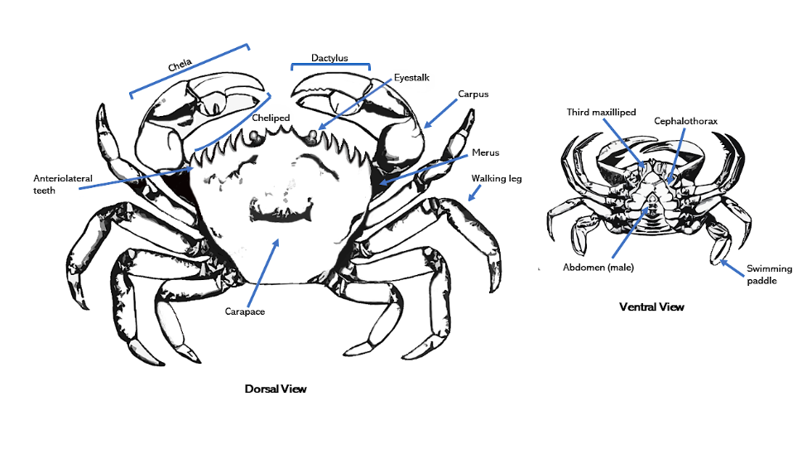 Source: Kimberley Seaward, NIWA

### General crab biology

There are several life-history traits in brachyuran crabs that appear to facilitate marine invasions. Although invasive marine crabs live at depths ranging from the intertidal to 1,400 metres in their native range, most of the records occur in the intertidal or shallow subtidal (<40 metres) (Brockerhoff & McLay 2011). Invasive marine crabs can tolerate wide ranges of salinities and temperatures. Crabs that can withstand large changes in salinity often move between freshwater and saline environments but may be classified as ‘marine crabs’. Eriocheir sinensis spend a significant portion of their life in freshwater and only return to higher salinity waters to reproduce. Rhithropanopeus harrisii has been reported from inland freshwater tributaries many kilometres from the marine environments they typically inhabit. Understanding these aspects of their life history is critical for effective management and understanding of potential spread.

Crab larvae are generally more environmentally sensitive than the adults. For example, survival of Carcinus maenas larvae require salinity >20 ‰ and 9 to 22 °C water temperature, whereas the adults can withstand salinity 4 to 52 ‰ and –2 to 36 °C (Audet et al., 2008; Rangeley & Thomas, 1987). Introductions of C. maenas are more likely to occur during the more environmentally tolerant adult life stages. The adults of some marine crabs can remain out of water for several hours or days without mortality. For instance, live E. sinensis are sold in vending machines in some Asian cities where they may be out of the water for many hours. Carcinus maenas can also survive out of water for days if kept moist and at a constant moderate temperature (Crothers 1968). These traits facilitate translocation via fishing bait packaged with seaweed or other damp products, as live product intended for consumption, aquaculture equipment, dry ballast, and other above water infrastructure.

Crabs tend to be omnivorous or generalist predators and can be aggressive and competitive (but not always, for example, Pyromaia species). They are fecund, capable of producing several thousand eggs per clutch and/or several clutches per year. They are often abundant and common in their native range, thereby giving them greater chance of being translocated by human pathways. Crab species that can withstand wide fluctuations in environmental conditions have greater likelihood of becoming established once introduced.

### Reproduction and growth

The general lifecycle of brachyuran crabs involves courtship, copulation, external brooding of fertilised eggs, hatching, planktonic larval development (zoeae and megalopae), then settlement into the habitats on the seabed before developing into a juvenile crab (Figure 2). Fertilisation in brachyuran crabs typically includes copulation that in some taxa occurs immediately after the female has moulted (for example, Eriocheir sinensis) and in other taxa occurs after the carapace of the female has hardened (for example, in Hemigrapsus sanguineus) (see Dittel & Epifanio 2009). In both cases, the male deposits sperm packets into seminal receptacles of the female, providing her with the potential to fertilise more than one batch of eggs. Clusters of fertilised eggs are eventually extruded onto the abdominal appendages known as pleopods and are brooded externally before hatching and being released as free-living larvae. The duration of brooding and timing of hatching and release varies widely between species, ranging from a few days to several months. It can be strongly influenced by seasonal, tidal and lunar cycles. Larval periods vary between species and longer periods can facilitate transport via a ballast water vector. Hemigrapsus species spend several weeks as larvae enabling them to be carried long distances via ballast water to naturally disperse (for example, on currents) between locations.

Larval development includes several free-swimming stages (zoea) and a final post-larval stage (the megalopa) that more closely resembles the adult form. Each stage is separated by a moult, in which the hard exoskeleton is shed to allow the animal to grow. There are often five zoeal stages that are characterised by different morphologies that allow discrimination between zoeal stages and among species (Dittel & Epifanio 2009). The time spent as planktonic larvae is related to egg size (Brockerhoff & McLay 2011) and environmental conditions. Species that produce clutches with numerous small eggs tend to have longer planktonic phases than those that produce broods with fewer relatively large eggs (Brockerhoff & McLay 2011). Larval development under optimal conditions may be only a couple of weeks but could be up to a couple of months if the conditions are not suitable (Dittel & Epifanio 2009). Long planktonic larval durations increase the likelihood of dispersal by water currents and also increase the potential for transport and discharge within ballast water. Brooding female crabs may also be transported in sea chests and in well-developed biofouling (Coutts et al. 2003). The zoeal and megalopal stages generally have narrower environmental tolerance than adult crabs. Planktonic larval stages are active swimmers that can change their vertical position in the water column to avoid adverse conditions or to take advantage of water currents for directional dispersal (Forward Jr. 2009).

Figure 2 Lifecycle of brachyuran crabs

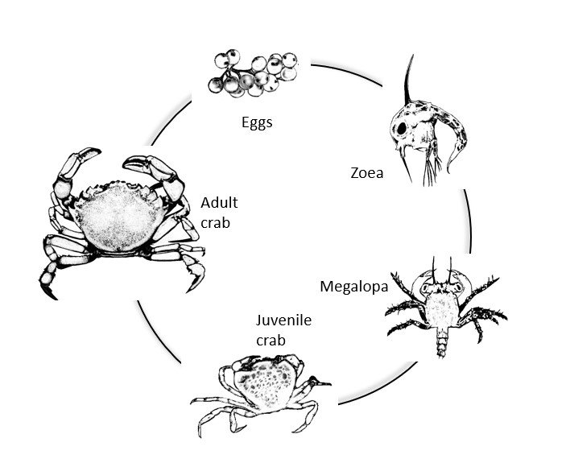

Source: Kimberley Seaward, NIWA

### Diseases

Invasive marine crabs can introduce pathogens that can cause severe disease, compromising commercial seafood production and impacting natural ecosystems. Two diseases that are high priority risks to Australia and are capable of being introduced with marine crabs are white spot disease (WSD) caused by WSSV and the crayfish plague caused by the oomycete Aphanomyces astaci (see Appendix B). [AQUAVETPLANS](https://www.agriculture.gov.au/animal/aquatic/aquavetplan) contain detailed information on these diseases and are a primary resource during a disease incursion. Appendix B provides a general overview of these diseases and other information relevant to marine crabs. WSSV and A. astaci are notifiable to the World Organisation for Animal Health (OIE). Aphanomyces astaci has never been recorded from Australia and is restricted to fresh water. WSSV has been detected in Australia only within the movement regulated area in southeast Queensland surrounding Moreton Bay and the Logan River, after WSSV was found in wild prawns and crabs in this area in late 2016. Movement restrictions are in place on all crustacean material from this area to control spread of WSSV.

Some pathogens potentially introduced by marine crabs may also have impacts on human health. Eriocheir sinensis is a host for the lung fluke Paragonimus westermani. Humans can become infected with this parasite when infected crabs are consumed undercooked. Infections in humans can cause serious respiratory and neurological illness.

### Vectors

The global transport, introduction and spread of invasive species has been associated with a range of human pathways and vectors. These include vessel biofouling (including of vessel hulls, sea chests and other niche areas), ballast (solid and water, although solid ballast is no longer used it was a historically important vector), co-transfer with aquaculture stock (particularly molluscs) or fishing operations, and intentional live release (Brockerhoff & McLay 2011). Vectors responsible for introducing marine crabs to Australia are similar to the aforementioned globally important vectors for marine crabs. Reports of crabs introduced into Australia have occurred via hull-fouling, ballast (both solid and wet) and co-transfer with importations of oysters. Because of Australia’s geographic isolation, natural dispersal events—either as adults or larvae—are unlikely to result in an introduction into the country, although these might be an important secondary vector for domestic spread within Australia following an introduction. Similarly, strict importation requirements mean that the intentional introduction of crabs for ornamental or seafood industries is unlikely. However, intentional import of live crabs for human consumption as luggage with travellers or via mail order provides another vector. Refer to section 2 for more detail on vectors and pathways for introductions of marine crabs to Australia.

### Management of invasive marine crabs

Management actions proposed for invasive marine crabs include physical removal (by trapping or fishing, including removal by hand), the use of chemical biocides, biological and ecological methods (Thresher & Kuris 2004). The utility of different control methods depends on the context of their use, including the size of the incursion (that is, area infested and size of population), its location and the species involved. Often the most appropriate management approaches require a combination of several techniques targeting different life stages. Physical removal and biocides are efficient control methods for small-scale incursions but there are no adequate control methods for large-scale marine crab incursions. No program has successfully eradicated an invasive marine crab species (Brockerhoff & McLay 2011) and management of population numbers may be a more realistic response objective in many cases. Refer to sections 3, 4, 5 for further information on methods to sample marine crabs and methods to control invasive marine crab populations.

## Policy and rationale for incursion response

### Policies for management and financing marine pest responses in Australian waters

Every biosecurity incident is unique, as is the response to the incident. Management actions taken in marine pest responses will differ based on variables such as the:

* pest specific traits and their taxonomic or functional characteristics
* significance (environmental, economic and social impacts)
* extent of the incursion
* value and location of the receiving environment
* likelihood of eradication.

National policies guide and support marine pest responses by providing a biosecurity response framework, operational guidance, and potential financial arrangements that can be tailored to meet the needs of each unique incident.

The [Biosecurity Incident Management System: Marine pest version](https://www.marinepests.gov.au/what-we-do/emergency/biosecurity-incident-management-system) manual provides guidance on policies and procedures for the management of biosecurity incident responses, including responses to marine pest emergencies within Australian waters.

The National Environmental Biosecurity Response Agreement (NEBRA) establishes national arrangements for responses to nationally significant biosecurity incidents when they are predominately environmental or public benefit. The NEBRA provides a mechanism to share responsibilities and costs for a response when eradication is considered feasible, the pest is considered to be of national significance, and other criteria are met.

Marine pest biosecurity incidents that do not meet the criteria for cost-sharing under the NEBRA will predominately be the responsibility of the lead agencies, however *ad hoc* resourcing (for example, financial, human and physical) may be available through national biosecurity support programs such as the [National Biosecurity Response Team](https://portal.biosecurityportal.org.au/Pages/NBRT-landing.aspx).

#### Commonwealth, state and territory authority responsibilities

Lead agencies in a response to a marine pest emergency should collaborate with and keep the Consultative Committee on Introduced Marine Pest Emergencies (CCIMPE) informed.

For incidents that are contained to a single jurisdiction, state coordination centres and local control centres may be established depending on the scale of the response. A national coordination centre is established to help manage concurrent incursions in more than one jurisdiction. National coordination operations will work in consultation with the CCIMPE representatives and relevant industry and community sector organisations. For further information on local, state and national control and coordination centres refer to the [Biosecurity Incident Management System: Marine pest version](https://www.marinepests.gov.au/what-we-do/emergency/biosecurity-incident-management-system).

##### Consultative Committee on Introduced Marine Pest Emergencies (CCIMPE)

CCIMPE provides national technical coordination for managing marine pest emergencies and comprises biosecurity representatives from each Australian jurisdiction with coastal borders (the Australian Capital Territory is not represented).

CCIMPE is a national technical body that advises the National Biosecurity Management Group (NBMG) on marine pest incidents and whether they meet the criteria for national cost-sharing under the NEBRA.

CCIMPE provides response advice to lead agencies and assists in developing and implementing response actions such as a National Biosecurity Incident Response Plan (NBIRP). CCIMPE may also act as an information sharing forum to provide national biosecurity agencies with updates on marine pest responses that are not cost shared under the NEBRA.

#### Stages in an emergency response to a marine pest of national significance

Management of a marine pest emergency of national significance has three phases of activation:

1. investigation and alert phase
2. operational phase
3. stand-down phase

Further details can be found in the [Biosecurity Incident Management System: Marine pest version](https://www.marinepests.gov.au/what-we-do/emergency/biosecurity-incident-management-system). It is important to note that not all detections of marine pests will initiate a response involving all three phases, whereas other detections such as a detection of marine pests on vessels may involve truncated responses.

### Control and eradication strategy for invasive marine crabs

The methods used to control a marine pest incursion and/or eradicate a marine pest will depend on the location and nature of the outbreak. Specific methods for the control of marine pests are covered in section 4. Guidance is provided on general policy decision points that can be used either to stand-down eradication or control operations and transition to management, or declare proof of eradication.

Detection of any marine crab not known to occur in Australia should initiate an investigation phase. This phase will likely be run concurrently with the initial control actions if initial indications are that the infestation is limited. If the emergency investigation revealed that the incursion was potentially eradicable then the Incident Manager will prepare a NBIRP and forward to the CCIMPE for urgent consideration.

Refer to section 4 and section 5 for options for controlling an invasive marine crab in Australian waters.

### Policy on decision points

The policy on decision points includes decisions to stand down eradication or control operations and proof of freedom.

#### **1.3.1 Calculating optimal sample numbers and when to stand down a response**

Quantification of response sampling numbers and the best time to stand down a response are technical assessments. Advice from statisticians, ecologists, economists or other relevant experts should be sought.

Information for calculating the optimal number of surveys to conduct after freedom is assumed to have been achieved is available from Regan et al. (2006). Guidance on undertaking a benefit-cost analysis (BCA) for marine pest responses is available from [Summerson et al. (2018)](https://cebra.unimelb.edu.au/research/data-and-information/response-to-a-marine-pest-incursion). Demonstrating that the benefits of a response outweigh the costs is required when seeking cost-sharing under the NEBRA.

In many cases a decision on a surveillance program to meet the requirements of the situation may be discussed and agreed by CCIMPE. This will take into account the context of the situation and the issues around conducting a surveillance program. This simpler approach was adopted for a response to Asian Green mussel on Cape York Peninsula.

#### 1.3.2 Proof of freedom

Proof of freedom aims to demonstrate to an agreed level of confidence that a pest, if present, is at a low enough abundance that it can be regarded as effectively eradicated. It requires a robust and intensive surveillance program during the operations phase of the response. The purpose for proof of freedom will be to inform future decisions, mainly whether a response can be stood down once the proof of freedom surveillance is complete, or whether further ongoing management is required. The outcome of proof of freedom surveillance may influence management actions such as movement restrictions, ballast water and biofouling management.

[Epitools](https://epitools.ausvet.com.au/riskbasedsstwostage) offers several tools to assist in decision making for sampling numbers and is freely available and easy to use. SARDI has developed a sample number calculator for surveillance using plankton samples tested with quantitative polymerase chain reaction (qPCR) assays (<https://sardi-mar-biosec.shinyapps.io/surveydesign/>). Both tools require estimates of survey confidence, target abundance and test performance to calculate the number of samples required.

Responses that are cost-shared under the National Environmental Biosecurity Response Agreement (NEBRA) require a proof of freedom phase if eradication is thought to have been achieved. The [NEBRA custodian](mailto:nebra@agriculture.gov.au) can provide guidance on developing proof of freedom surveillance programs on request.

Ultimately proof of freedom surveillance will depend upon the context and requirement. CCIMPE can provide advice and connection to expertise to assist in developing a proof of freedom surveillance plan.

### Policy on funding of operations and compensation

CCIMPE will help determine whether an incursion is likely to be eradicable and when national cost-shared funding under [NEBRA](https://www.agriculture.gov.au/biosecurity/emergency/nebra) should be sought. Species on the APMPL and EEPL are already pre-considered to be of national significance. Cost sharing must be agreed to by NBMG and the eligible costs of emergence eradication responses shared as follows:

* a 50% share from the federal Australian Government
* a 50% share collectively from the states and Northern Territory
  + this is calculated for each jurisdiction based on the length of coastline potentially affected by the marine pest as well as their respective human populations
  + only jurisdictions affected or potentially affected by the pest or disease are required to contribute.

NBMG may commit up to $5 million in annual aggregate towards the eligible costs associated with an agreed national biosecurity incident response. If this $5 million is exceeded in any one financial year, the NBMG must seek ministerial approval from all parties to continue activities and/or begin new emergency responses.

Private beneficiary contributions to a response will be considered by NBMG on a case-by-case basis where there is one or more private beneficiary and no existing arrangements.

Please refer to the current version of the NEBRA or contact the NEBRA custodian [nebra@agriculture.gov.au](mailto:nebra@agriculture.gov.au)

for more information as the NEBRA may be periodically revised.

## Pest pathways and vectors

Crabs can be transported over great distances and introduced into new areas as larval stages or as adults. It can be unclear what the specific vector is for an introduction unless the crab was observed being introduced by that vector. For example, it is difficult to separate an introduction via biofouling from ballast water. Brockerhoff and McLay (2011) summarise the vectors and pathways that have facilitated the global spread of invasive marine crabs. Introduction pathways can be either primary or secondary: a primary pathway moves species to new regions across biogeographic barriers, such as oceanic, landmass or climatic barriers, whereas a secondary pathway is the spread and dispersal of introduced species between points within or between neighbouring regions (Harrower et al. 2018). The most common vectors for marine crabs are ballast water and biofouling, associated with vessel movements. Introductions have also occurred via man-made canals such as the Suez Canal and co-transfer with shellfish movements for aquaculture purposes. Other minor vectors include intentional release for aquaculture or fisheries purposes and movement as live seafood/bait. These latter minor vectors are not as likely for introduction of crabs into Australia because there are strict import requirements for aquaculture stock (reducing the chance of co-transfer with shellfish), live crab imports, and Australia is a geographically isolated restricting natural dispersal events either as larvae or adults from overseas jurisdictions. Nevertheless, illegal importations of live Eriocheir sinensis have been intercepted at the border.

Once introduced into Australia, marine crabs may subsequently spread to new locations by the same vectors that introduced them, or another secondary pathway. DNA sequencing of invasive crabs can enable the provenance to be more easily identified and the vector inferred (Blakeslee et al. 2017).

Some crabs have lifestyles that make them more prone to introductions, including long-lived larval stages, occupation of shallow water habitats where they are more likely to encounter ships, or by being part of a fouling community that colonises vessels. Members of the crab families Portunoidea (swimming crabs: including high priority species such as Carcinus maenas and Charybdis japonica) and Grapsoidea (shore crabs: including high priority species such as E. sinensis, Hemigrapsus sanguineus and Hemigrapsus takanoi) all have ecological characteristics that increase the likelihood of invasions. The crab family Majoidea (spider crabs) also possess similar traits and have been introduced into Australia: the American spider crab Pyromaia tuberculata is established in Australia, having been introduced into Western Australia and Victoria in 1978 and 1990, respectively, by ballast water (Morgan 1990).

Table 1 presents a summary of known pathways and vectors for the six high priority marine crabs to Australia. These same vectors and pathways for introductions are likely modes of transport for other crab species from different families. Details of vectors and pathways for the introduction and spread of marine crabs in Australia are provided in subsequent sections in order of significance.

### Biofouling

International and domestic shipping has facilitated the spread of marine crabs more than any other vector, as a result of transport in ballast water and biofouling assemblages (Brockerhoff & McLay 2011). Potential vectors include a diverse range of craft, including commercial ships, such as tankers and container ships, fishing vessels, recreational vessels, passenger vessels, barges, dredges, and research vessels. Biofouling on the hull of vessels or in their internal seawater systems is one of two main ways that vessels can act as vectors for crabs (the second is ballast water, see section 2.2). Fouling communities typically comprise sessile and encrusting organisms, but if the fouling layer is dense enough then it can support the translocation of mobile species within the shelter provided by attached species. Species within biofouling assemblages can be introduced by: (1) spawning of a fouling species present on a vessel while in port followed by its successful settlement and establishment of a reproductive population, (2) the dislodgment of fouling species from a vessel in port (for example, through hull cleaning or abrasion with wharf piles), and (3) the sinking of a fouled vessel.

Fouling communities are not only found on the hull of a vessel, but can occur on any wet surface, such as anchor wells, sea chests, bow thrusters, internal piping and propeller shafts; collectively referred to as niche areas (Figure 4 and Figure 5). Niche areas may be more susceptible to biofouling because they are sheltered from water shear and may be free of antifouling paint. Sea chests are particularly capable of translocating diverse and abundant marine communities, including crabs. For example, Coutts et al. (2003) found three adult and egg-bearing Carcinus maenas in the sea chests of a passenger ferry operating between Tasmania and Melbourne. There are numerous other records of crabs being introduced via biofouling, such as the introduction of Hemigrapsus sanguineus into Europe. The introductions of Charybdis japonica into New Zealand and Australia were also likely from biofouling or ballast.

Biofouling can occur on all fixed or mobile structures immersed or exposed to the water. Marine aquaculture equipment such as buoys, ropes, nets and cages, could contribute to the spread of invasive marine crabs if they become heavily fouled. For example, multi-filament netting can be heavily colonised by biofouling with growths of up to 8.5 kg per m² (Braithwaite et al. 2007). Biofouling of aquaculture equipment and structures is more likely to be a greater secondary pathway within Australia as opposed to a primary pathway into Australia. Measures are in place for imported second-hand aquaculture equipment because sometimes such equipment becomes available after disease outbreaks or other biosecurity threats than can cause closures and emergency sale of equipment.

Fixed marine structures such as pontoons, moorings, piles do not represent a risk for translocation of invasive marine crabs unless they are moved while still heavily fouled.

### Ballast

Ballast water is water taken on-board a vessel to adjust the overall weight of the vessel and the internal distribution of weight to keep the ship safe, upright and stable. Sediments are also inadvertently taken up along with the ballast water and can accumulate in the ballast tank. Ballast water is used mainly by large merchant vessels, some cruise ships and certain types of fishing vessels and ferries. A vessel arriving in a port unladen will usually be ballasted and will need to discharge some of its ballast water in proportion to the weight increase caused by cargo loading. Ships can unintentionally transport diverse assemblages of marine species, including crabs of varying life stages, when seawater is pumped on board for ballast. These species can then be carried and introduced when the ballast is discharged. Discharging untreated ballast water is now prohibited in Australia (see the section on treatment methods for decontaminating infested vectors). Ballast water is also managed by the [International Convention for the Control and Management of Ships' Ballast Water and Sediments (International Ballast Water Management Convention)](https://www.imo.org/en/MediaCentre/HotTopics/Pages/Implementing-the-BWM-Convention.aspx) although there are still considerable areas of refinement needed before these measures can be regarded as being effective at meeting the defined standards.

The number and frequency of species introductions has increased since ballast water replaced solid ballast around the 1880s (Cariton & Geller 1993). Around 20% of introduced marine species into Port Phillip Bay are thought to have arrived in ballast water (Hewitt et al. 2004). Ballast water is a relatively non-selective dispersal mechanism as it can potentially carry larvae of all crab species present in the site where ballast was taken up, and provide a means for the introduction of larval stages of crabs in addition to introductions of juvenile and adult stages. Juvenile and adult life stages can also be transferred in the sediment that accumulates at the bottom of the ballast tanks. Crab species with relatively long larval durations, such as Hemigrapsus sanguineus (which has a larval duration of more than three weeks), are more likely to survive within ballast water than crabs with shorter larval stages and therefore more likely to be introduced to new areas, especially over longer distances.

### Fisheries, aquaculture and the ornamental trade

Fishing and aquaculture operations and the ornamental trade can translocate crabs accidentally with aquaculture stock (particularly shellfish), or bait, or deliberately by illegal importation of live crabs. Aquaculture is a minor pathway for crab species following biofouling and ballast water (Brockerhoff & McLay 2011). Some crab species are more likely to be transferred by aquaculture and fisheries operations. For instance, crab species like Rhithropanopeus harrisii that are commonly found in oyster reefs are more likely to be transferred by this vector than deeper water crabs, such as spider crabs in the superfamily Majoidea. High priority species like Carcinus maenas, R. harrisii and Hemigrapsus sanguineus have been accidentally introduced into new areas along with shellfish aquaculture operations, most likely through importation of stock carrying the crabs as hitch hikers. An example of a co-transfer with intentional shellfish movements was the introduction of the New Zealand native crab Metacarcinus novaezelandiae to Tasmania with transhipment of oysters in the late 1800s (Dartnall 1969).

The risk of introduction of a marine crab into Australia via importing aquaculture stock is lower than biofouling and ballast because there are now strict regulations of live animal imports (see [list of species suitable for live import](https://www.legislation.gov.au/Details/F2020C01012)) and any imported aquaculture stock already processed for human consumption would have met purification and sanitation requirements. However, this vector could be a significant secondary pathway for domestic spread following the introduction of a marine crab into Australia (Roche & Torchin 2007). The accidental introduction of crabs associated with fishing operations such as bait can also occur. A classic example is the introduction of C. maenas to the North American Pacific coast from the Atlantic coast in seaweed-wrapped bait worms.

Some crab species are economically valuable as a human food item or as ornamental species in the aquarium trade. For instance, Eriocheir sinensis are highly regarded as a food so there is an incentive to move these crabs around for fisheries or aquaculture purposes. Intentional illegal importations are a possible global vector for the introduction of E. sinensis (see Cohen and Carlton 1995). Several interceptions of adult E. sinensis have been made at the Australian border, although none have been detected in Australia. Because of strict import requirements this vector is less likely in an Australian context (see [list of species suitable for live import](https://www.legislation.gov.au/Details/F2020C01012)). However, sale of ‘live rocks’ are common among the aquarium trade. Live rock is a rock from the ocean that has been introduced into an aquarium. The rock is often inhabited by a multitude of marine organisms, including crabs. Live rock is sold in Australia with Queensland, Western Australia, Northern Territory and Victoria common places of origin (Morrissey et al. 2011). Although internet sales data shows that live rock sales are mainly within state it is a potentially important vector, particularly for domestic spread of crabs that inhabit rocks and other complex structures. Import conditions prevent importation of live rock with viable invertebrates, and ban import of viable crustaceans (see [BICON](https://bicon.agriculture.gov.au/BiconWeb4.0)).

### Natural dispersal

Although human-mediated dispersal is undoubtedly the most common vector for crab dispersal, once a crab has been introduced into an area it can disperse naturally. Control of natural dispersal from established populations is likely to be impractical or impossible, which is why response actions need to be taken before a population can establish. A single female crab can lay hundreds of thousands of eggs each year and in multiple broods depending on species. Once hatched, larvae can then spread over several hundred kilometres (Shanks et al. 2003) making it difficult to contain the population. The introduction of Carcinus maenas into New South Wales estuaries is most likely to be a consequence of natural dispersal (Burden et al. 2014). Further, Eriocheir sinensis is known to move large distances inland through freshwater networks. Natural dispersal of adult crabs could be an important secondary vector if this was introduced into Australia.

### Debris and flotsam

Some species of crabs, such as grapsid shore crabs, have evolved semi-terrestrial air-breathing, whereas other species like Planes spp. are free-swimming, capable of clinging to floating objects. Both mechanisms enable some crabs to be carried over long distances by rafting. Debris from the 2011 Japanese earthquake and tsunami drifted by currents across the Pacific and washed-up on the west coast of North America bringing with it a diverse range of introduced species, including the crab Hemigrapsus sanguineus (see Therriault et al. 2018). *Plagusia* species crabs were recently found on a ghost net floating off Norfolk Island, and these are a well-known rafting species (Schubart et al 2001). Although introductions via this vector are rare, it can be an important pathway under certain circumstances, such as following a large natural disaster or shipwrecks.

Table 1 Summary of known vectors and pathways for six high priority invasive marine crab species into and within Australia

| **Pathway** | **Description** | **Carcinus maenas**  **(Carcinidae)** | **Charybdis japonica**  **(Portunidae)** | **Eriocheir sinensis**  **(Varunidae)** | **Hemigrapsus sanguineus**  **(Varunidae)** | **Hemigrapsus takanoi**  **(Varunidae)** | **Rhithropanopeus harrisii**  **(Panopeidae)** |
| --- | --- | --- | --- | --- | --- | --- | --- |
| Vessels | Biofouling | Yes | Yes | Yes | Yes | Yes | Yes |
| Ballast | Yes | Yes | Yes | Yes | Yes | Yes |
| Sea chests and other niche areas | Yes | Yes | Yes | Yes | Yes | Yes |
| Fisheries, aquaculture, and ornamentals | Accidental translocation with aquaculture stock movement | Yes | No | Yes | Yes | Yes | Yes |
| Accidental translocation with fishing products, for example bait | Yes | No | Yes | Yes | Yes | Yes |
| Illegal intentional introduction | Yes | Yes | Yes | No | No | No |
| Ornamental aquarium trade | No | No | No | No | No | No |
| Natural dispersal | Natural range extension through larvae | Yes | Yes | Yes | Yes | Yes | Yes |
| Natural range extension through juvenile/adults | No | Yes | Yes | No | No | No |
| Debris and flotsam | Dispersal associated with debris and flotsam | Yes | No | No | Yes | Yes | No |

## Principles for preventing and monitoring spread

Potential for eradication of an incursion by a marine crab depends on early detection and rapid action. Eradication is most likely to be successful in shallow and/or partially or fully enclosed waterways where the incursion can naturally be contained and natural dispersal is limited. In open coastal waters with moderate to high water exchange, emergency containment is likely to be limited to those crabs with limited adult and larval dispersal. Where surveys indicate that an incursion is widespread, eradication action is unlikely to be successful and management to prevent or minimise further spread or reduce populations may be more appropriate. In all cases intensive public consultation and education is essential to ensure support and/or compliance with response actions.

### Methods for preventing spread

Methods used to prevent the spread of the organism are quarantine, movement control and treatment to reduce effectiveness of vectors.

#### Quarantine and movement controls

Quarantine and movement controls can be implemented during the investigation phase, alert phase and operations phase, and are best implemented early, where possible, and refined when investigative work has provided additional information. They may end up being permanently implemented to minimise risk of spread in a long-term management program.

##### Investigation phase

When a suspected pest crab is detected in an area, but a marine pest emergency has not yet been confirmed, the notifying party should, when feasible, take steps to limit the spread of the suspected pest from the investigation site or area by initiating voluntary restrictions on movements of potential vectors or release of water where this may contain propagules (in suitable sites). The investigation phase should attempt to identify all potential vectors present at their site. A list of potential vectors for each crab covered in this response manual are shown in Table 1. This will likely involve notifying relevant parties about the investigation into a marine pest emergency, for example port authorities, marina operators, vessel owners and aquaculture facilities in the relevant area. Cooperation from stakeholders is important to stop, restrict or inform the notifying party of the risks associated with movement of vectors from the site. Compliance with voluntary movement controls may be enhanced by distribution of appropriate public awareness materials about the pest. Care needs to be taken when transporting specimens to avoid any chance of accidental escape, particularly of crabs in berry. In this phase appropriate local authorities need to be contacted to obtain permission for relevant surveillance and sampling activities in specified areas (for example, marine parks, conservation areas, and nature reserves).

##### Alert phase

If the initial investigation finds that an invasive crab is likely to be present, the findings should be communicated to the Consultative Committee on Introduced Marine Pest Emergencies ([CCIMPE](mailto:ccimpe@awe.gov.au)) for consideration of the appropriate course of action recommended by the affected jurisdiction to manage the risk of spread from affected sites. The incident management team must ensure appropriate measures are implemented. These could include:

* restrictions on movement of potential vectors, such as vessels, fishing gear, and aquaculture equipment into and out of suspect sites
* controlling the movement of people, such as property owners, tourists, scientists, into or out of suspect sites, as appropriate. This may require police involvement
* awareness of methods to report sightings of the pest and access general information
* tracing potential vectors that have left the affected site
* hydrodynamic modelling to determine potential spread of larval stages
* redirecting vessels that have already left the site to appropriate sites for inspection and/or decontamination if appropriate
* notifying relevant experts when appropriate.

##### Operations phase

The operations phase will be guided by whether eradication of the marine pest of national concern is determined to be feasible or not feasible.

###### Eradication not feasible

If an investigation reveals an incursion of a marine crab is unlikely to be eradicable, then interim containment measures to prevent translocation of it from any infested waterway should be implemented to minimise the risk of the pest being spread from the affected area. A stand-down phase for NBMG involvement may be entered either directly from the alert phase or from the operations phase when CCIMPE and NBMG agree there is no need to initiate a national biosecurity incident response. The stand down of NBMG does not mean that actions and consultation within CCIMPE cease. This consultation and communication through CCIMPE will continue as long as the affected jurisdiction/s and/or the Chair of CCIMPE deem it necessary. Longer term management options should be formulated and agreed on, and resourcing for longer term management determined. In some cases delimitation may take over one year to capture seasonal appearance of pests.

###### Eradication feasible

If an investigation reveals a potentially eradicable incursion from an invasive marine crab, then movement restrictions implemented in the investigation phase should remain in place.

Quarantine restrictions require establishing specified areas (Figure 3):

* An infested area including all or part of a waterway in which a marine pest emergency is known or deemed to exist, pending confirmation of pest identification.
* Dangerous contact area(s) including an area close to an infested area in which a pest has not been detected but due to its potential for infestation will be subject to the same movement restrictions as an infested area.
* Suspect area is an area identified as ‘at-risk’ and subject to the same movement restrictions as an infested area, pending further investigation.
* Restricted area is an area around an infested area that is subject to intensive surveillance and movement controls on potential vectors[2].
* Control area is an area surrounding a restricted area in which biosecurity conditions apply to the entry or exit of potential vectors or specific risk items.

Similar terminology is applied to potentially infested vectors within each area. For example, a vessel within a dangerous contact area would be classified as a ‘dangerous contact vessel’ and a vessel within an infested area would be classified as an ‘infested vessel’. For more information on response area classifications, see the [BIMS Marine Pest Version](https://www.marinepests.gov.au/what-we-do/emergency/biosecurity-incident-management-system).

Figure 3 Areas that may be designated during an aquatic animal disease emergency

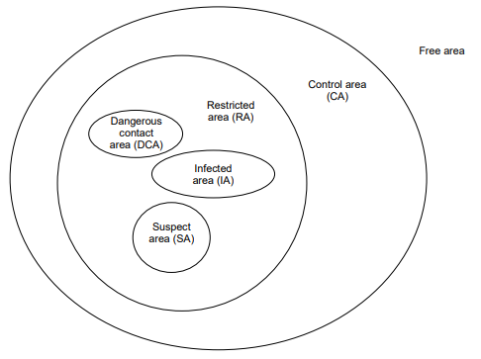

Source: BIMS Marine Pest Version 2020

The extent of each specified area should be determined by:

* an initial delimiting survey of the area (see guidelines on designing a delimiting survey)
* an evaluation of the length of time the species has been present and whether it is likely to have reproduced. This could be calculated by the size and distribution of the animals in the affected area, the number of cohorts apparent and, when possible, examination of the reproductive status (for example, evidence of berried females)
* mobility of the species
* the strength and distribution of directional or tidal currents
* expert advice.

It is important to recognise that in aquatic situations a simple radius around a detection is inadequate. Hydrodynamics and geography of the area and ecology of the target species need to be considered to determine the specified areas.

Movement restrictions may include limiting:

* the movement of vessels, other equipment exposed to the pest, aquaculture stock or equipment and vectors for biofouling. Exposed equipment will vary depending on the target species. For example, some crabs are intertidal and can remain out of the water for long periods of time so above water assets will need to be considered
* access within certain areas
* the uptake or movement of ballast water or other water within the control areas where appropriate controls are not in place.

Implementation of restrictions will be a dynamic process, determined by the location and extent of infestation and whether the aim is to eradicate the pest or to control its spread. Some restrictions may be deemed impractical or unnecessary in a circumstance, but others will be critically important for eradication or control. Effective communication and accurate information dissemination are critical to ensure compliance and acceptance of restrictions.

###### Restricted Area Movement and Security Unit

The Restricted Area Movements Unit of the Operations Centre is responsible for controlling movement of goods, submersible equipment, vessels, water and other vectors including people, into, within and out of the restricted area as appropriate to minimise the potential for pest spread.

The main duties of this unit are to:

* issue movement permits to the public
* establish and operate road and water checkpoints in the restricted area, including liaison with state transport authorities, port authorities, water authorities, police and local government
* coordinate movement and security activities across affected sites
* maintain registers of all movements in restricted and affected areas, permits issued and staff deployed.

###### The Commonwealth of Australia Biosecurity Act 2015

The Biosecurity Act 2015 can be used in the absence of appropriate State or Territory legislative powers and may be used in circumstances, including directing conveyances[3] (Appendix C):

* + into port
  + to not enter a port and to obey further instruction
  + to undergo a treatment action the Incident Manager deemed necessary.

The Australian Director of Biosecurity (or their delegate) can authorise state and territory officers as biosecurity officers under the Biosecurity Act, which will enable certain actions to be undertaken in a biosecurity response. All actions taken against a conveyance should only be taken in relation to those identified as being at risk of spreading the invasive species (Ferguson 2000). The Biosecurity Act is only intended to be used if there is no State or Territory legislation that provides appropriate powers necessary for the response, aside from ballast water which is entirely covered by the Biosecurity Act. A provisional list of other Commonwealth and State powers for intervention and detention of vessels is in Appendix D.

Each state and territory should consider enacting relevant fisheries or other legislation to prevent or control fishing within a control area, and prevent or control translocation of stock and equipment from within it. Any requested movement of fishing gear or aquaculture stock or equipment should be subject to risk assessment consistent with procedures outlined in the [National Policy Guidelines for the Translocation of Live Aquatic Animals](https://www.agriculture.gov.au/sites/default/files/documents/national_policy_guidelines_for_the_translocation_of_live_aquatic_animals.pdf) (Department of Agriculture, Fisheries and Forestry 2020). All potentially infested fishing gear, aquaculture equipment or stock should be treated and inspected before removal from the control area.

Refer to the sections on biofouling and ballast water for relevant information.

For additional information on using the Biosecurity Act 2015 during an emergency response see Appendix C.

#### Surveillance for high-risk vectors

In the event of an emergency marine pest response, movement controls on potential vectors and pathways will be easier to manage if efforts can be targeted at vectors that pose the greatest risk of spread of invasive crab species.

All vessels and other recognised vectors (see Table 1) that have been within an infested area or dangerous contact area during the time the pest is known or suspected to have been present could be considered as a high risk of transporting the pest. A risk assessment based on the specific circumstances of the incursion would be required. Vectors that have been present in suspect, restricted or control areas should also be treated as high risk. The risk status of vectors may change if inspections or surveys discover no pests.

Vessels that have not been within the infested or dangerous contact areas but have been near a high-risk vessel that has departed infested or dangerous contact areas, or the control area could also be considered a high-risk vessel. All high-risk vessels should be assessed to determine if required to proceed to an approved inspection and treatment facility, for example if the vessel is heading overseas then there may be no Australian requirements for management of the vessel. Risk assessment may determine whether this is necessary. For example, a recently cleaned vessel with be at lower risk of picking up crabs than one with heavily fouled niches.

All vessels and potential vectors within the control area should be assessed where resources allow and inspected for signs of the pests were determined necessary. Medium-risk vectors should be assessed and required to remain within the control area until they can be inspected and declared free of the pest as determined appropriate.

All high-risk and medium-risk vessels that have recently left a control area should be contacted immediately if their itinerary indicates that they present a risk for spread of the pest in Australia. If the itinerary indicates visitation to another country with biosecurity requirements on ships (for example New Zealand) the appropriate contact in that country should be notified. If these vessels have not entered another port or marina, they should be encouraged to remain at sea, no closer than 1.5 nautical miles to the nearest land until inspection and/or quarantine arrangements can be made. Biosecurity risks detected before or during this inspection must be dealt with before the vessel can be brought further inshore. A vessel that has entered another port or coastal area should be inspected immediately. If signs of the pest are discovered, then the vessel should be directed for treatment and a back tracing of the vessel’s itinerary be done and surveys undertaken of the anchorages it has visited.

##### Vessel inspection

Crabs can be transported in heavy growths of biofouling or within the internal seawater systems of vessels, therefore, divers or other appropriate means (such as remote operated vehicles (ROVs) should carry out in-water inspection of vessels using a standardised search protocol. Refer to [anti-fouling and in-water cleaning guidelines](https://www.agriculture.gov.au/sites/default/files/sitecollectiondocuments/animal-plant/pests-diseases/marine-pests/antifouling-consultation/antifouling-guidelines.pdf). If water visibility or hazards make diving unfeasible then alternative approaches to examining the communities should be considered. These can include removing the vessel from the water or the use of ROVs. Biofouling is likely to be greatest in wetted areas of the vessel that are protected from drag when the vessel is underway and/or where the antifouling paint is worn, damaged or not applied. Divers can inspect interior spaces and crevices, such as sea chests, water intakes or outlets using endoscopes. Moist places such as anchor wells will require inspection for crabs. Areas such as the bow and keel are unlikely to transport crabs unless they are heavily fouled.

Critical inspection areas for vessels less than 25 metres long (Figure 4) include:

* rudder, rudder stock and post
* propellers, shaft, bosses and skeg
* seawater inlets and outlets
* stern frame, stern seal and rope guard
* sacrificial anode and earthing plate
* rope storage areas and anchor chain lockers
* ropes, chains or fenders that are in water or have been used recently
* keel and keel bottom if they are heavily fouled (these areas are unlikely to transport crabs unless they are heavily fouled).
* sounder and speed log fairings.

Figure 4 High-risk niche areas for inspection of biofouling on vessels less than 25 metres

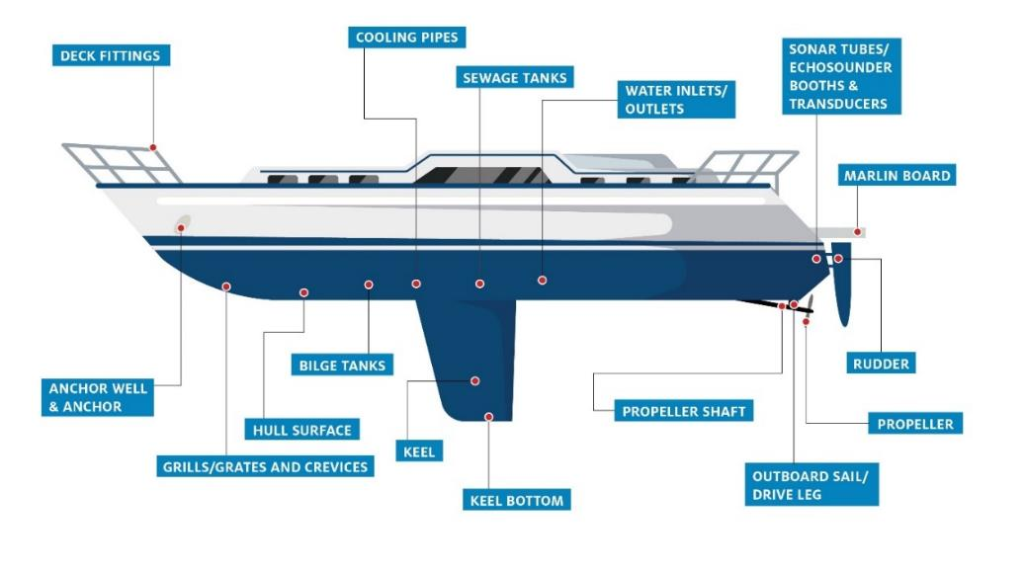

Source: Floerl, 2004

Critical areas are similar for vessels longer than 25 metres (Figure 5), except for some additional areas (Figure 5), including:

* sea chests and gratings
* ballast tanks and internal systems
* dry-docking support strips (DDSS)
* sonar tubes
* bow thrusters
* keel and bilge keels
* other niches and cavities in the ship’s wet water side.

Figure 5 Schematic diagram showing the high-risk niche areas for inspection of biofouling on vessels greater than 25 metres. Vessel and its components are not to scale.

**ANCHOR, ANCHOR CHAIN & WELLS**

**BOW THRUSTERS**

**ANODES**

**DRY-DOCK SUPPORT STRIPS**

**BILGE KEEL**

**SEA CHESTS & GRATINGS**

**INTAKE & OUTFLOW OPENINGS**

**PROPELLOR, SHAFT & STERN TUBE**

**RUDDER, SHAFT & HINGE**

**SUPERSTRUCTURE/BRIDGE**

**INTERNAL SEAWATER PIPES & SYSTEMS**

**ANTIFOULING PAINT**

**BULBOUS BOW**

**WATERLINE**

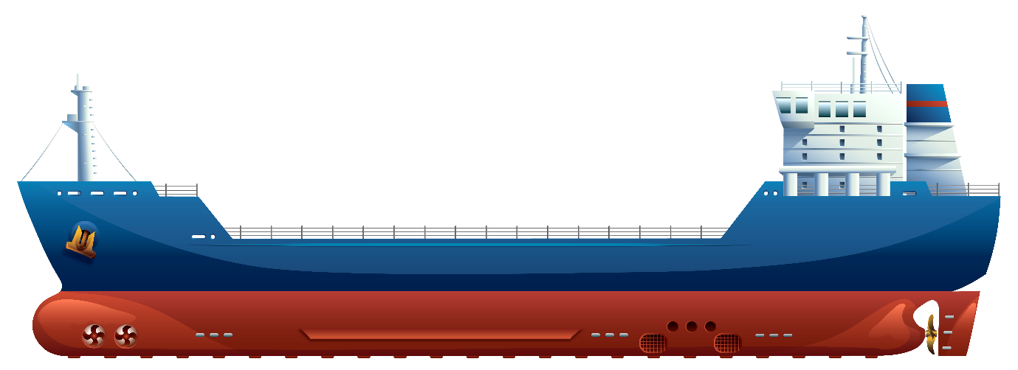

Source: René Campbell – Department of Agriculture, Fisheries and Forestry.

#### Treatment methods for decontaminating infested vectors

Treatment methods will be different depending on the type of area where an infestation occurred. Table 2 summarises management recommendations for different types of vectors. These recommendations are generic and can be applied to all marine invasive crabs.

Table 2 Management recommendations for different types of vectors

| **Vector** | **Management** |
| --- | --- |
| International and domestic yachts < 25 m | Clean external submerged surfaces |
| Treat internal seawater systems |
| Manage ballast water |
| Remove from the control area once cleaned |
| Domestic fishing vessels, ferries, tugs, naval vessels | Clean external submerged surfaces |
| Treat internal seawater systems |
| Manage ballast water |
| Domestic merchant vessels > 25 m | Inspect and clean (if possible) external submerged surfaces |
| Treat or seal internal seawater systems |
| Manage ballast water |
| International merchant vessels >25 m | Inspect and clean (if possible) external submerged surfaces |
| Treat or seal internal seawater systems |
| Manage ballast water |
| Recreational craft, for example, jet-skis, kayaks. | Clean external submerged surfaces |
| Clean and dry internal seawater systems |
| Educate users and service agents of risk |
| Fishing gear and nets | Clean and dry on removal from area |
| Educate users of risk |
| Fouled aquaculture stock | Remove from infested area or use an effective method for decontamination |
| Fouled aquaculture equipment | Removed from infested area |
| Clean thoroughly by high pressure water blast, for example > 2,000 psi, capturing cleaned material for safe disposal |
| Immerse in copper sulphate solution (4 mg/L) or liquid sodium hypochlorite (200 to 400 ppm) for 48 hours |
|  | Rinse in seawater and air dry, preferably in sunlight |
| Buoys, pots, floats | Restrict movement from the control area |
| Clean and dry |
| Educate users on risks |
| Water, shells, organisms, for example, for bait or aquaria | Restrict movement from the control area |
| Educate users on risks |
| Flotsam and jetsam | Remove from water/shoreline |
| Dry prior to onshore disposal |
| If possible, use barriers to prevent escape from infested area |
| Fauna, for example, birds | No vector recorded |
| Stormwater pipes and intakes | Clean and remove fouling |
|  | Where possible, seal until stand down of emergency response |

Source: Bax et al. 2002

##### Vessels operating between Australian domestic locations

Vessels intending to discharge ballast water sourced in an Australian port in another Australian port are required to manage their ballast water using one of the approved ballast water management options. These options are available in the [Australian Ballast Water Management Requirements](http://www.agriculture.gov.au/abwmr). The Biosecurity Act 2015 prohibits the discharge of high-risk ballast water within Australian seas (within 12 nautical miles).

Same Risk Areas (SRA) are the waters where ballast water may be taken up and discharged within these areas without undertaking ballast water exchange as defined under the Biosecurity (Ballast Water Same Risk Area) Instrument 2017. For vessels that have been required to phase out the use of ballast water exchange, ballast water must be managed utilising an alternative method within these areas:

* Queensland—The Great Barrier Reef Marine Park SRA
* South Australia—Gulf St Vincent and the Spencer Gulf SRA
* Victoria—Port Phillip Bay SRA
* Northern Territory—Northern Territory SRA—excluding international ports of Darwin, Gove and Milner Bay.

The operation of the SRA applies only to vessels utilising ballast water exchange as their primary method of ballast water management. If the vessel is fitted with an approved Ballast Water Management System (BWMS) and has met its compliance date, then the BWMS will be required to be used in a SRA.

Additional measures may be applied to vessels which operate exclusively within a SRA in the event of an emergency response.

Vessels operating between Australian domestic ports may be eligible for exemptions from managing Australian sourced ballast water between specific ports, where the ballast transfer has been determined to be low risk. The [Australian Sourced Ballast Application](https://www.agriculture.gov.au/sites/default/files/sitecollectiondocuments/ballast-application-QRG19.pdf) is a risk assessment tool that assesses the risk posed by the translocation of marine pest species through movement of ballast water based on the uptake port and date, and the intended discharge port and date. This tool is relevant for the known distribution of introduced crabs in Australia and may not be relevant for a new incursion of a marine crab. Nevertheless, the outcome for an intended discharge will be either high risk or low risk.

* High Risk ballast water must be managed prior to discharge at the intended port. Management must be in accordance with Australian Ballast Water Management Requirements.
* Low Risk ballast water does not need to be managed prior to discharge at the intended port if an exemption has been granted. Using this tool, a vessel with low risk ballast water may be issued a discharge management exemption under Section 280 of the Biosecurity Act 2015.

Alterations to the domestic ballast water risk tables may be required in the event of an emergency response. The domestic ballast water risk tables inform the Australian Sourced Ballast Application in MARS which reflects the risk status of port waters.

##### Vessels departing for international destinations

Vessels leaving a control area for destinations outside of Australia’s territorial water should be notified of the risk and be required to manage ballast water as specified by the International Maritime Organization (IMO) [International Convention for the Control and Management of Ships’ Ballast Water and Sediments, 2004 (Ballast Water Management Convention)](https://www.imo.org/en/About/Conventions/Pages/International-Convention-for-the-Control-and-Management-of-Ships%27-Ballast-Water-and-Sediments-(BWM).aspx). They also need to be aware of any requirements in destination countries (for example, New Zealand).

##### Biofouling of vessels

Removal of biofouling on vessels includes land-based treatment, treatment of biofouling in internal seawater systems and various in-water treatments.

###### Land-based treatment

All crabs may inhabit internal piping and water intakes that are not easily inspected or cleaned. Therefore, haul-out of vessels and other non-permanent structures, such as moorings, pontoons and ropes, for inspection and treatment on land is the preferred option for inspection and decontamination. This is most easily achieved for vessels <25 metres in length and where suitable haul-out or dry-dock facilities are available near the control area. Larger vessels may need to be inspected and treated in water or suitably treated in dry dock where this is possible.

There is a risk that any crab dislodged during haul-out or vessel cleaning may remain viable and could start a new population if returned to the sea. Some crab species are intertidal and move readily across open, dry spaces so this may need to be accounted for. The Incident Manager must approve haul-out facilities used for decontamination. Such facilities should be fully contained so that material from vessel hulls cannot accidentally or intentionally be returned to the marine environment. All macro (>1 mm) particles removed from vessels cleaned out of water should be retained and disposed of in landfill (or as biohazard material in secure landfill if appropriate). All liquid effluent (runoff) from out-of-water vessel water blasting or cleaning should be collected for treatment in a liquid effluent treatment system or disposal in a secure landfill/seepage system that does not connect with waterways.

Guidance for identifying and selecting approved vessel cleaning facilities suitable for removing marine pests are given by Woods et al. (2007). Approved facilities should comply with relevant jurisdictional requirements for waste containment and disposal from slipways, boat repair and maintenance facilities.

High-pressure water blasting followed by prolonged (>5 days) aerial exposure (preferably to the sun) may also be used to treat other fouled structures removed from an infested area, such as mooring blocks, pontoons, floats and fenders. Consideration needs to be given if using this method for crab species that can survive for extended periods out of the water, particularly intertidal species.

###### Internal seawater systems

Internal seawater systems of vessels should be cleaned to the greatest extent possible with:

* 5% v/v industrial detergent (quaternary ammonium disinfectants) in water (preferably freshwater) for 14 hours (Lewis and Dimas 2007)
* chlorine at a concentration of 24 mg/L for 90 hours (Bax et al. 2002)
* hot water 60 °C for 1 hour (Growcott et al. 2016)
* copper sulphate solution at a concentration of 1 mg/L for 38 hours (Bax et al. 2002).

Bear in mind that concentrations will need checking at intervals to ensure they are maintained, particularly for chlorine which degrades rapidly in the presence of organic matter.

###### In-water cleaning

The [antifouling and in-water cleaning guidelines](https://www.agriculture.gov.au/sites/default/files/sitecollectiondocuments/animal-plant/pests-diseases/marine-pests/antifouling-consultation/antifouling-guidelines.pdf) state that where practical, vessels and moveable structures should be removed from the water for cleaning, in preference to in-water operations. When removal is not economically or practically viable, the guidelines accept in-water cleaning as a management option for removing biofouling, provided risks are appropriately managed.

Applicants who wish to perform in-water cleaning in Australian waters should familiarise themselves with the principles and recommendations contained in the guidelines. Applicants in Commonwealth waters should first check their obligations under the [Environment Protection and Biodiversity Conservation Act 1999](https://www.environment.gov.au/epbc). If the activity does not need to be referred under the Act then applicants should self-assess their activity using the decision support tool in Appendix 1 of the [antifouling and in-water cleaning guidelines](https://www.agriculture.gov.au/sites/default/files/sitecollectiondocuments/animal-plant/pests-diseases/marine-pests/antifouling-consultation/antifouling-guidelines.pdf). Applicants who wish to perform in-water cleaning in state or territory waters must first contact the relevant agency in each state or territory jurisdiction for approval.

###### Sea chests and other niche areas

Sea chests and internal seawater systems of vessels can accumulate biofouling and are structurally complex, making access for inspection and treatment difficult. Mobile species like crabs are frequently found in these areas (Coutts et al. 2003). Fouling communities that include dense patches of bivalve shellfish are particularly attractive habitats for small crabs. Biofouling of sea chests, internal pipework and other niche areas can be independent to biofouling on the hull and a clean hull does not necessarily imply clean niche areas.

There are considerations for effective in-water cleaning. For instance, a key element of in-water cleaning of sea chests is being able to seal off the confined spaces so that the treatment can be administered effectively. This can be achieved by sealing off external gratings using commercially available [magnetic tarpaulins](https://mikomarine.com/underwater-blanking-tools/magnetic-miko-plaster/) or bespoke sealing units. Sealing off confined spaces can also assist in preventing mobile crab species from avoiding the treatment.

Treatments of these areas for marine crabs include chemical and non-chemical methods.

For most chemical treatments, such as chlorine, chlorine dioxide, bromine, hydrogen peroxide, ferrate and peracetic acid there are insufficient information to accurately assess their efficacy in removing crabs (Cahill et al. 2019). There are published reports demonstrating that acetic acid and commercial descaler formulations, Rydlyme®, can be effective against intact fouling assemblages within 48 hours (Cahill et al. 2019). These preparations effectively clean attached molluscs and would be expected to attack calcareous shells of crustaceans, therefore killing crabs. An important consideration for chemical treatments is its risk to the environment and operator against its efficacy. Acetic acid and chlorine are considered safe to use within the marine environment; however, their efficacy needs to be determined. Maintaining active concentrations of these chemicals requires careful monitoring. Local authorities should be contacted for requirements around use of chemicals in natural waterbodies.

For non-chemical treatments, only thermal stress can feasibly be applied to pipework and niche areas and be effective within 48 hours. The application of thermal stress does need to be considered against which crab species is being targeted as it may be more effective on temperate species than tropical species. For instance, Carcinus maenas has a higher heat tolerance than other intertidal and subtidal crabs (Tepolt & Somero 2014). However, the use of heated water between 50 to 60 °C can render taxa non-viable in under two hours. It is also safe for the operator and the environment.

Physical removal is not feasible for many niche spaces. There is risk of inadvertently releasing the biofouling organisms into the environment without significant measures to ensure that no viable material can escape. Deoxygenation and osmotic shock could take many days to several weeks to kill resilient crabs (Cahill et al. 2019), meaning they are unsuitable for response actions.

###### Wrapping and encapsulation

Wrapping and encapsulation of the submerged surfaces of vessels using impermeable barriers, such as polyethylene plastic, have been used to treat fouling on vessels up to 113 metres long (Mitchell 2007b). The wrapping deprives fouling species of light and food, while continued respiration and decomposition of organisms within the barrier depletes dissolved oxygen in the water, therefore, creating an anoxic environment that is eventually lethal to all enclosed organisms. Speed of effectiveness of wrapping and encapsulation can be improved through the addition of biocides such as chlorine or acetic acid (Ammon et al. 2019). Chlorine is a biocide commonly used in wrapping and encapsulation that is generally used at >200 ppm for at least 24 hours (Ammon et al. 2019). Concentrations must be measured regularly to ensure that active concentration is maintained as active chlorine levels drop dramatically in presence of large amounts of organic matter.

Polyethylene silage plastic wrap (15 x 300 metres, 125 µm thick) is cut to size to suit the vessel type and is deployed by divers in association with a topside support team. The plastic is passed from one side of the vessel to the other, overlapped and secured tightly using PVC tape or ropes to create a dark watertight environment. Sharp objects on the hull, such as propeller blades, should be wrapped separately or covered with tubing or cloth before encapsulation to prevent tears in the plastic. Commercial encapsulation tools are available which can be applied to a vessel arriving in port, or to a vessel at anchor, alongside a wharf or in a marina berth.

[Commercially available](https://fabdock.com/) floating boat docks up to 30 metres have been shown to be useful for emergency treatment of biofouling on small vessels. The addition of chlorine (for example, ‘dichlor’) at an initial concentration of 200 mg/l killed all fouling organisms on a vessel within 6 days and was effective for 90% of the study’s target organisms (Morrisey et al. 2016). The invasive polychaete worm *Sabella spallanzanii* was rendered non-viable within 4 hours of exposure (ibid). These types of floating docks could be a good alternative to wrapping for treating small vessels during an emergency response.

If properly deployed, the wrap should contain the pest species and its larvae. Extreme care should be taken to ensure that biofouling is not dislodged when the wrap is deployed. The wrap must remain in place for at least 7 days if no biocide is used to achieve the desired effect (Inglis et al. 2012). Wrapping of vessels >25 metres is labour intensive and may take up to two days to deploy. The time needed for effective treatment is around 7 days, which may be too long when rapid treatment and vessel turnaround time is crucial.

Wrapping is most effective in sheltered environments with low currents because strong currents can make deploying the wrap difficult and increase the risk of tearing the wrap. Wrapping also produces large amounts of plastic waste. This waste must be disposed of in landfill or an approved solid waste treatment facility.

With any wrapping method it must be noted that some crab species can leave the water to respire and feed, so wrapping techniques should ensure that this cannot happen for species that are capable of survival out of water, such as *Eriocheir sinensis* or *Hemigrapsus sanguineus*.

Relevant state or territory agencies should be consulted about the suitability of wrapping and encapsulation method for a vessel or moveable structure.

##### Aquaculture stock and equipment

###### Chemical treatment

Treatments used to remove fouling of marine pests from ropes, aquaculture nets and lines and equipment include:

* acetic acid
* hydrated lime
* sodium hypochlorite (bleach)
* alkaline ammonia.

The efficacy will vary depending on the organism being targeted, the concentration and contact time (Inglis et al. 2013). As with all chemical treatments local conditions on use may apply.

###### Desiccation (air-drying)

Marine crabs have a range of tolerances to aerial exposure, for instance intertidal crabs can survive for extended periods of time out of the water. The recommended length of time required for equipment to be fully dried to ensure all biofouling is killed will be ~21 days (Hilliard et al. 2006). Because crabs are mobile organisms airdrying should be carried out in a contained area. Sun exposure increases the efficacy of drying. Material being desiccated needs to be well spread out and weather needs to be considered as wet weather may prolong the period required.

###### High-pressure water blasting

High-pressure water blasting is a feasible, low-cost method of treating some forms of biofouling on infrastructure that should remove all mobile biofouling species, such as crabs (Inglis et al. 2013). High pressure (>2000 psi for 2 seconds at 100 mm distance) may be required to dislodge biofouling from fissures and crevices. Water blasting could promote release of gametes, so high-pressure cleaning may best be combined with additional treatments such as chemical treatment, heat or desiccation. Containment of the waste is also necessary.

###### Heat treatment

The efficacy of heat treatment is dependent on the temperature achieved, fouling mass and exposure time. Generally, heat treatment is a favourable treatment option because of its efficacy and low risk to environment and operations. Crabs and other organisms with hard shells require hotter treatments (50 to 70 °C) than soft-shelled organisms. The use of heated water between 50 to 60 °C can render taxa non-viable in under two hours (Cahill et al. 2019).

###### Freshwater treatment

Freshwater has been recommended as an effective marine biofouling treatment option for biofouling species that are susceptible to changes in salinity (Georgiades et al. 2016). Freshwater may only be effective on larval life stages of marine crabs covered in this manual. The adult life stages are tolerant of wide ranges of salinity. Further, the adult stages of some crabs such as *Eriocheir sinensis* are found predominantly in freshwater rendering this treatment ineffective for these crabs and similar species with tolerance to freshwater conditions.

###### Ropes and equipment

The protocols recommended for treatment of ropes and aquaculture equipment, such as buoys, floats, nets and traps are:

1. Remove to land taking care not to dislodge crabs when removing structures from the water.
2. Clean thoroughly by high pressure water blasting (> 2000 psi at distance of 100 mm).
3. Immerse in 2% liquid sodium hypochlorite (200 to 400 ppm) for >4 hours, or 2% detergent (for example, DECON 90) solution for >8 hours, or hot water (>50 °C) for >1 hour.
4. Rinse in seawater and air dry for >48 hours.

###### Aquaculture stock

Some farmed species such as oysters or seaweed can provide habitats that support the accidental co-transfer of invasive marine crabs. For instance, small intertidal crabs such as Rhithropanopeus harrisii are known to have been introduced into new areas via transhipments of oysters. Utility of methods used to decontaminate aquaculture stock will depend on the robustness of the cultured stock to the treatment as well as the efficacy of the treatment for the crab.

Disinfection of bivalves and other aquaculture stock for external hitchhikers is not always effective and must be weighed against potential environmental impacts of any treatment and its effect on the saleability of the stock. Where the treatment cannot be effective, it may be precautionary to either destroy potentially contaminated stock and dispose of it to landfill, or harvest and process stock for human consumption.

Gunthorpe et al. 2001 recommends the following treatments based on laboratory experimentation:

* Declump stock then immerse in 2% detergent (e.g DECON 90) for >8 hours.
* Rinse in sterile seawater and hold in quarantine facilities before redeployment into marine environment.

Further trials should be carried out to determine rates of mortality of the treatment on shellfish stock and on the target crabs. These methods are also likely to be cost-effective ways to treat other fishing, aquaculture or boating equipment for marine crabs.

Import of aquaculture stock is strongly regulated and most jurisdictions have conditions on movements of aquaculture stock to manage biosecurity and other risks.

### Tracing an incursion

Tracing is used to discover the method and pattern of the spread of the pests and may include trace-forward and trace-back. Tracing is crucial to defining and modifying the dimensions of the specified areas. Tracing and surveillance within the control area is managed by the Local Control Centre. Tracing requires investigations into:

* the length of time the species has been present
* the initial source and location of infestation
* whether the pest is likely to have reproduced
* the possible movement of water, vessels, animals, submersible equipment and other potential vectors for the pest
* the existence and location of other potentially infested areas.

Elements of demography of the pest populations may be inferred from the size or age distribution within the population and reproductive state of animals collected during investigations. A population that contains individuals that vary widely in size, are reproductively active (that is, berried females or presence of eggs/larvae), or contain two or more distinct size cohorts could be indicative of successful local reproduction and multiple recruitment events. Single crabs have been reported from parts of Australia for Charybdis japonica and Carcinus maenas with no further detection of other crabs despite sampling efforts. This represents a population that has not established.

#### Data sources for tracing vectors

##### Vessels

Tracing the movements of vessels to and from an incursion is made difficult by the lack of a consolidated system for reporting or managing data on vessel movements in Australian waters. Some potentially useful data sources on movements of large, registered commercial vessels are:

* The [Lloyd’s List Intelligence](https://www.seasearcher.com/) maintains real-time and archived data on movements of more than 120,000 commercial vessels worldwide. It contains arrival and departure details of all vessels larger than 99 gross tonnes from all major Australian and international ports. The database contains a searchable archive that includes movement histories of boats since December 1997. Searches can be purchased for specific ports, vessels or sequences of vessel movements.
* [MarineTraffic](https://www.marinetraffic.com/) provides real-time data on the movements of more than 550,000 vessels. It maintains archived data going back to 2009. Searches can be purchased for specific ports, vessels, areas or periods of time.
* Local port authorities keep records of all vessel movements at their port berths and associated anchorage points.
* The [Australian Fisheries Management Authority manages](https://www.afma.gov.au/) data on the locations of all fishing vessels that have Commonwealth fishing concessions. All Commonwealth fishing concession holders must have installed and be operating an integrated computer vessel monitoring system. The system is also required for some fisheries managed by state and territory fisheries management agencies (such as Queensland East Coast Otter Trawl Fishery).
* The [Bureau of Infrastructure, Transport and Regional Economics](https://www.bitre.gov.au/) maintains statistics on maritime trade, markets, shipping lanes, key trade routes, traded commodities and passenger services throughout Australia.
* The [Australian Government Department of Agriculture, Fisheries](https://www.agriculture.gov.au/) and Forestry, and the [Australian Border Force](https://www.abf.gov.au/) maintain data on all vessels arriving in Australian waters from overseas. These data are for proclaimed first ports of entry into Australia.
* The [Australian Maritime Safety Authority](https://www.amsa.gov.au/) deals with maritime safety, protection of the marine environment and maritime and aviation search and rescue services. It also coordinates a vessel tracking program, which works as an umbrella for managing related vessel information from the Modernised Australian Ship Tracking and Reporting System (MASTREP), the Great Barrier Reef and Torres Strait Vessel Traffic Service, the Automatic Identification System, the Long Range Information and Tracking System, and the Australian Maritime Identification System.

Specific industries operating in marine environments may have information on movement of vessels and equipment such as aquaculture, natural resource extractors, maritime transport and logistics industries. There are no consolidated data on domestic movements of smaller coastal vessels within Australian waters. Ports and some marina operators keep records of vessels that have been used in their facilities. Local industry groups, such as fishing groups, may provide point-of-contact for vessels and the movements of their respective industry sectors. Logged vessel trip reports held by the Australian Volunteer Coast Guard may also provide some data on vessel movements.

Some states and territories have developed vessel-tracking systems for a range of vessel types. For example, during the operational period of the black-striped mussel Mytilopsis sallei incursion in Darwin, the Northern Territory Police and the Australian Government Department of Agriculture, Fisheries and Forestry, with support and input from the Darwin Port Authority, Australian Border Force, the Northern Territory Fisheries Division Licensing Branch, the Australian Fisheries Management Authority and Coastwatch, developed an access database that contained vessel names and contacts, current location, history of individual vessel movements and the risk status of the vessel.

##### Ocean current modelling

Ocean current modelling may be an effective forward and back tracing method for estimating the source and sink locations as part of an invasive marine crab response. It was used following the 2020 detection of Hemigrapsus sanguineus in Victoria. Some tools that can assist with modelling current movements include:

* [Connie3](https://connie.csiro.au/) uses archived currents from oceanographic models and particle tracking techniques to estimate connectivity statistics from use-specific source or sink regions. A range of physical and biological behaviours can be specific including vertical migration, horizontal propulsion, swimming, flotation, or surface slick formation.
* [Regional Ocean Modelling System (ROMS)](https://www.myroms.org/) is an ocean model used for a diverse range of applications. ROMS has a pre-processing and post-processing software for data preparation, analysis, plotting and visualisation.

## Containment, eradication and control of established populations

Methods of controlling a marine invasive crab species include physical removal (including commercial exploitation), chemicals, biocontrol, and environmental remediation. The acceptability of control methods depends on their feasibility, effectiveness and their side effects. For example, physical removal may only be appropriate for incursions that occupy relatively small areas and inappropriate for large scale control. The biology and ecology of marine invasive crabs also needs to be considered when selecting appropriate control methods. The efficacy of the control method can be impacted by the crab’s life history (that is, control efficacy for adult crabs will likely differ to controls for larvae/juveniles) and ecology (that is, controls for subtidal species will likely differ to controls for intertidal species). Public information and engagement to key stakeholder groups must also be considered as a high priority.

The feasibility of controlling a marine invasive crab infestation in Australian waters depends on the nature and location of the incursion and the management strategy adopted. Two control options are available:

* containing the species to the infested areas and preventing further spread this option has ongoing costs and efforts, which could mean it has higher long-term costs

or

* eradication of an invasive marine crab from an infested area; this option demands the highest initial control measure and cost.

### Containment and control

If a decision is made to not attempt eradication but to implement containment and control, then the Incident Manager will recommend that interim containment measures be implemented to minimise the risk of pest translocation from the infested waterway. This may include movement controls on potential vectors, public information campaigns, policies and practices for vessel and equipment sanitation and surveillance (in consultation with stakeholders), and control of secondary infestations outside the infested waterway.

To reduce populations commercial or targeted harvesting has been suggested to reduce numbers of crabs. Some invasive crab species (for example, *Callinectes sapidus* and *Charybdis japonica*) have commercial value. Any consideration of commercial harvest must bear in mind that often harvesters will aim to maintain stocks rather than reduce them to non-viable levels, which may not be consistent with management aims. Additionally, transfer of valued species of new areas is common and difficult to manage so this must be considered. Community removal of highly abundant pest species can reduce numbers in the short term, but there is a degree of ‘collateral damage’ of misidentified other species, and sustained pressure needs to be maintained at appropriate times.

[National Control Plans](https://www.marinepests.gov.au/what-we-do/emergency/national-control-plans) (NCP) have been developed for several marine pests that are already established in Australia and are having significant impacts on the marine environment or marine industries. The purpose of the NCP is to deliver an agreed national response to reduce impacts and minimise spread of agreed pests of concern. A NCP exists for [Carcinus maenas](https://www.marinepests.gov.au/sites/default/files/Documents/national-control-plan-european-green-shore-crab-carcinus-maenas.pdf) and includes:

* practical management actions and cost-effective approaches to control or reduce the impact of the marine pest
* recommendations for future research and development, including cost-benefit analysis and planning tools
* links to the National System monitoring strategy
* recommendations for additional public information and education strategies
* an implementation strategy.

### Public information and engagement

Communication and engagement with interest groups, local residents and recreational users are critical to gain acceptance of management or eradication attempts, compliance with any regulations, and to encourage participation in surveillance activities and reporting.

Communication and engagement should occur early in any marine pest response, and should be maintained during recovery efforts, and into the management phase.

In response to an exotic marine pest the combat state may establish an Incident Management Team in which a Public Information function will be activated. The Public Information function covers the overall strategic communication approach to the incident including specific activities: media, social media, website content, community and stakeholder engagement, as well as the development of collateral such as flyers, signage and similar communication materials.

The public information function works with the National Biosecurity Communication and Engagement Network (NBCEN) to develop nationally consistent messaging, particularly where the pest has economic or social impacts or affects more than one jurisdiction. The NBCEN consists of a communication representative from each jurisdiction including other relevant organisations which can provide technical expertise. A member from NBCEN (usually the Commonwealth representative) attends CCIMPE meetings and develops national talking points in conjunction with the combat jurisdiction to facilitate the delivery of consistent messaging that can be agreed to and used by all jurisdictions.

The NBCEN is guided by the [Biosecurity Incident Public Information Manual (BIPIM).](https://www.animalhealthaustralia.com.au/our-publications/ausvetplan-manuals-and-documents/) More on the national arrangements, including NBCEN can be found on the [Outbreak website](https://www.outbreak.gov.au/how-we-respond-to-outbreaks).

### Eradication

Eradication of any invasive marine crab requires its complete elimination from the infested area. No program has successfully eradicated an invasive marine crab, but there are virtually no examples of well-designed, well-resourced eradication programs that have been initiated early enough to enable eradication (Brockerhoff & McLay 2011). Eradication is unlikely to be successful or feasible if initial investigations determine that the species is widespread, cannot be contained, is difficult to detect, or is present or potentially present in open coastal environments.

Marine crabs have high fecundity and planktonic larval durations that can spread over large distances by tides and currents. Because of this, eradication may not be possible in open coastal waters where there is high movement of water. Eradication is most likely to be feasible when:

* the area inhabited is small, that is, <1,000 m2
* the infestation occurs within an area of minimal flushing or exchange of water
* the available habitat occurs in relative shallow water, such as <15 m
* the population is relatively aggregated and has not yet reached reproductive maturity (Crombie et al. 2008)
* the infestation is detected and controlled before spawning can occur.

See section 5 on methods for treating established populations.

Progress towards eradication at time $t$, ${Ex}_{t}$, can be represented separately by the difference between the time it takes to conclude that a population has been extirpated (for example, based on the longevity of dormant life stages), $E_{max}$, and the mean of the frequency distribution of the time since the most recent detection for all populations, :

The values of $D_{t}^{'}$ and ${Ex}_{t}$ can be plotted against the total area that has been infested to show the progress of eradication efforts. Declines in both $D_{t}^{'}$ and ${Ex}_{t}$ reflect good management.

Extensions to these metrics to include weightings for the differential detectability of the pest in different habitats and its probability of occurrence within them are described by Burgman et al. 2013.

### Guidelines for delimiting surveys

A delimiting survey establishes the boundary of an area considered to be infested by, or free from, a pest. The survey should be conducted to establish the area considered to be infested by the pest during the emergency response and to assist deciding if eradication is feasible. The State or Local Control Centre will plan a delimitation survey strategy with reference to appropriate confidence limits based on:

* the location where the pest was initially detected
* pest biology, such as survival reproductive rate, spread, dispersal and influence from environmental factors
* pest habitat, such as distribution and suitability of potential habitats around restricted areas and control areas
* survey design sensitivity (factoring detection method sensitivity), sampling logistics and operator safety.

### Design of a delimiting survey

The geographic extent of an incursion will be determined by:

* how long the pest has been present at the site before it was detected
* the dispersal characteristics of the pest including
  + the frequency and quantity of reproductive output from the population since the initial incursion
  + the effects of environmental and human factors on the spread of dispersal stages.

Local knowledge and site inspections as well as satellite imagery, habitat suitability maps or risk maps, hydrographic charts and online databases such as [Seamap Australia](https://seamapaustralia.org/) can be useful for identifying areas that may contain habitat suitable for the pest. Where they exist, habitat suitability maps and hydrodynamic models such as [Connie3](https://connie.csiro.au/), may also be useful to simulate the likely directions of current flow and the possible rate and extent of spread of planktonic larvae from the known area of infestation (Inglis et al. 2006). Trace-forward techniques should be used to identify locations outside the infested area that may have been exposed to the pests transported by human vectors that have departed the known infested area (van Havre & Whittle 2015).

Trace-back information can also be used to determine the possible extent of an incursion, particularly for a primary incursion where a single size or age class is present. Working backwards from the estimated age of the specimens and the known settlement biology and larval lifecycle of the species, ocean current modelling can estimate the source of a spawning event. This source information can be used to determine where else in the area the prevailing currents could have spread the larvae (Burgman et al. 2013; Hauser et al. 2016). The use of DNA-based methods can help identify both source and connected populations and areas of provenance (Roux et al. 2020).

Allocating surveys along perpendicular transects can rapidly lead surveyors to the outer reaches of an invasion, particularly at times when infestations are dense at the point of introduction and decline with distance (Hauser et al. 2016). Alternatively, survey effort should be made at the margins of the known infestation. Adaptive sampling designs with sample points located on systematic grids or gradients away from the site of known infestation are the most useful to ensure the greatest possible area is covered, while providing the best chance of detecting established and founding populations.

Knowledge of habitat requirements may assist in targeting surveillance to habitats likely to harbour the invasive species. Habitat suitability models and particle dispersion models may also assist in identify survey locations (see Inglis et al 2006). For example, shore crabs tend to inhabit areas with rocks and temperate mangroves in intertidal zones rather than bare, sandy areas where as many swimming crabs prefer open habitats at subtidal depth ranges. Absence of rocky shores in southern North Carolina may have restricted southward movement of invasive *Hemigrapsus sanguineus* in the eastern seaboard of the United States (Epifanio, 2013).

Graphical summaries that plot the areal extent of new detections relative to the area searched can be used to evaluate the progress of delimitation and control of the pest (Panetta & Lawes 2005).

#### Sampling methods

The type of sampling method chosen should be based specifically on the species being targeted and its life stage, the habitat being searched and the conditions at the time of sampling. Trapping methods, both baited and unbaited, are typically the most effective means of catching adult and sub-adult marine crabs. Baited traps typically attract scavenging and predatory adult crabs, whereas unbaited traps such as crab condos are effective at trapping younger life stages and omnivorous crabs. If the crab is reliably identifiable then visual shore searches are very effective at sampling intertidal crab species. It is important to note that several sampling methods can be run simultaneously providing greater detection ability (Zalota et al. 2016).

It is also important to note that when using baiting methods relevant animal welfare legislation should be considered as part of the trapping activities.

We provide an overview of the different sampling methods for marine crabs in descending order of general effectiveness. Further, Table 3 presents a summary of the utility of these sampling methods for the six high priority crab species to Australia for juvenile and adult life stages. Note in some cases that a sampling method is not necessarily consistent across life stages, for instance a method that is effective for trapping juvenile stages may be ineffective at trapping adult life stages.

Use of any traps in fresh waters (for example, for mitten crabs) must account for accidental capture of platypus or turtles. If deployed in areas inhabited by platypus or turtles, access to air is essential to prevent drowning. Traps may be destroyed or dislodged when deployed in areas of crocodile habitat, high swells, or large tidal movements. Traps placed in areas with public access such as popular beaches can be at risk from human theft and tampering.

Use of and type of traps is governed by local regulations, so appropriate permissions may need to be sought before use.

##### Baited traps

Baited traps are often the most effective and efficient way to trap adult crab species. Swimming crabs are commonly caught by this method. Baited traps are attractive to aggressive or active predators and scavengers but can miss omnivorous crabs, such as Hemigrapsus spp. and egg-bearing females that forage less. Smaller crab species are less likely to be attracted inside baited traps or may not be detected since cannibalism and predation inside traps are common.

Baited box traps are logistically convenient because they are relatively small, lightweight and collapsible, meaning they can be carried in large numbers onboard small boats, whereas commercial crab pots are larger and may require specialist boats to deploy. Baited traps can usually be deployed over a relatively short duration (24-hour soak time) enabling a large area to be sampled (Mabin et al. 2020). Crab traps can be deployed in a variety of locations, often near habitats where crabs are commonly found such as near intertidal rocky shores, wharf pilings, break walls and other habitat with complex physical structure, such as seagrass meadows, temperate mangrove channels, saltmarshes, and shellfish beds.

There are many different types of baited traps used to catch invasive marine crabs such as box traps, trapezoid traps, Blanchard cylindrical traps, Fukui folding traps, minnow traps, and opera-house traps (Duncombe & Therriault 2017; Young et al. 2017). The collapsible baited box trap (Figure 6) is commonly used. These are lightweight, commercially available traps (size: 63 cm x 42 cm x 20 cm, with a 1.3 cm mesh netting). Crabs enter the traps through slits in inward sloping panels at each end with bait contained within an internal mesh bag secured to the upper frame. These traps have been effectively used in sampling several important invasive crab species such as Carcinus maenas (Mabin et al. 2020) and Charybdis japonica (Gust and Inglis 2006). The baited box trap has fewer crab escapees compared to other trap designs because the slits at the end provide a more secure trap than traps with open-ended funnels; traps with open-ended funnels allow more crabs to enter a trap, but actually retain far fewer crabs than box traps (Vazques Archdale et al. 2007). These traps are less effective at catching smaller omnivorous/herbivorous crabs because they can either escape the trap if they enter, will not enter if predatory species are already present, or are not attracted to the bait.

The important part of any baited trap is the bait: this is the lure for the target species (Favaro et al. 2020). Bait fish such as sardines are commonly used and typically considered the most effective bait (Dittmann et al. 2017; Favaro et al. 2020). Sardines and pilchards are commercially available and can be purchased in bulk, making them a cost-effective bait choice. Squid and cod are not as effective, or in the case of mussels completely ineffective, at attracting crabs (Favaro et al. 2020).

In some jurisdictions used of specific designs of crab traps is regulated and permission may need to be sought prior to deployment.

Figure 6 Baited box traps

Colour photograph showing a typical box trap used to attract and capture scavenging marine pests. Colour photograph showing a typical box trap used to attract and capture scavenging marine pests.

Source: Chris Woods, NIWA

##### Unbaited traps

Unbaited traps include a variety of traps including pitfall traps, plastic crates filled with bivalve shells, and crab condos. These types of traps are engineered to attract crabs by providing shelter. Experimentation has shown that some crabs select habitat based on habitat structure rather than food available in that habitat, which explains why some crabs are more likely to be caught in unbaited traps than baited traps (Riipinen et al. 2017). These types of traps are much better at catching and attracting different crab life-stages, from new settling megalopae to reproducing adults (Fowler et al. 2013a).

Crab condos were developed to target Eriocheir sinensis by imitating the burrows juvenile E. sinensis typically inhabit and are significantly more effective at capturing E. sinensis than baited traps (Veldhuizen 1999). Crab condos are made of 9 vertical PVC pipes (15 cm long, 5 cm diameter) held together by plastic mesh basket (Figure 7). Crab condos can be deployed (48 hours to 3, 5, 9 days) in almost any environment relevant to the species being targeted (Veldhuizen 1999). Crab condos are effective at catching a range of crab species (Hewitt & McDonald 2013). A total of 332 crabs were caught during a sampling regime using crab condos in Western Australia (Hewitt & McDonald 2013). Most crabs caught (n=294) were hermit crabs, with the remaining representative from the brachyuran crab families Portunidae, Hymenosomatidae, Majidae and Pilumnidae (Hewitt & McDonald 2013).

Crates filled with dead oyster shells have been used to capture Rhithropanopeus harrisii for monitoring invasive populations in Panama and Europe (Fowler et al. 2013a, Roche et al. 2009). Plastic crates (30 cm x 30 cm x 30 cm) filled with dead, sterile oyster shells provide suitable habitat for natural recruitment of juvenile and adult R. harrisii. These crates probably act as suitable habitat for several other crab species that use shelter such as Hemigrapsus spp., but this has not been tested. Although these crates are effective at capturing crabs, they typically need to be deployed for 1.5 to 2 months to allow adequate time for recruitment (Fowler et al. 2013a), making them unsuitable for rapid surveillance.

Pitfall traps can be constructed in intertidal soft sediments by sinking buckets (~20 L) filled with seawater into the substrate so the rim is flush with the sediment surface. Foraging crabs fall into the buckets and are unable to escape. Pitfall traps can be effective to sample small or young crabs (Behrens Yamada et al. 2015) but are less commonly used than other unbaited traps.

Unbaited traps that extend across stream and river channels have effectively been used to trap one million E. sinensis over two years in Belgium (Schoelynck et al. 2020). The migratory habit of E. sinensis was used as an advantage to trap these invasive crabs as they migrated up and down the river channel. Although Schoelynck et al. (2020) were working with an established population of E. sinensis, it may be a useful method to contain smaller populations to one river system before it can establish more widely. Use of barrier systems like this will need to account for the other wildlife, particularly platypus and turtles.

Figure 7 Crab condos

Colour photograph showing a typical 'crab condos' used to attract invasive crustacean species. Condos are constructed using sections of PVC pipe and attached together with zip ties and gutter-guard mesh. Colour photograph showing a typical 'crab condos' used to attract invasive crustacean species. Condos are constructed using sections of PVC pipe and attached together with zip ties and gutter-guard mesh.

Source: Chris Woods, NIWA

##### Shore searches

Shore searches can be an effective way to observe and catch live intertidal crabs. They can also detect exuviae of moulted crabs. Once searchers are familiar with the identity of the target crab then many searchers can be deployed, covering large areas. A standard shore search may involve 10-minute timed searches along a transect or be based on the number of rocks/boulders overturned. In Port Phillip Bay, Victoria it was reported that *Hemigrapsus sanguineus* were found to occur in very discrete patches roughly 5 m2 where up to 15 individuals could be found in 2 minutes. Between patches up to 100 rocks could be turned over before another patch was found (DJPR 2021, pers. comm.).

For crab species that burrow into banks, such as Eriocheir sinensis, shore searches can be an effective detection tool. Shore searches have been effective at locating burrowing *Carcinus maenas* sheltering under rocks during low tide, or juveniles and berried females that tend to avoid baited traps (Dittmann et al. 2017). Shore searches are less effective at sampling cryptogenic species because they are hard to identify and for species that are subtidal. Complex or inaccessible habitats such as mangroves, steep limestone cliffs/rocks and areas with high boat traffic or swell can impede shore searches. Often shore searches are used to augment other sampling regimes of baited or unbaited traps.

##### Divers and remote operated vehicles

Divers carry out subtidal surveys around wharf piles, floating pontoons and other artificial structures in port and marine environments (Figure 8). They can also perform surveys on intertidal and shallow subtidal reefs. They can be effective at detecting large marine crabs as crabs tend to aggregate around complex structures such as wharf piles. However, the ability to observe a crab while diving relies heavily on water visibility, identification training and search techniques. If visibility is less than one metre, then visual surveys will be compromised. These same visibility limitations apply to ROVs. ROVs can be used in place of divers, particularly when hazards are present (for example crocodiles, sharks, stinging cnidarians), but their full use in surveillance or pest detection is still being optimised and few data are available on their effectiveness. Like shore searches, divers are good additions to other sampling regimes.

Figure 8 Diver search

Colour photograph of a SCUBA diver underwater and inspecting the underside of a floating pontoon covered in European fan worms.

Source: Chris Woods, NIWA

##### Netting

Nets, including seines, midwater trawl nets, gill nets or fyke nets can be used to catch active species and dipnets can be used in the shallow subtidal. Netting can be effective at capturing large numbers of adult crabs but can be ineffective at capturing juveniles and small crab species, such as Hemigrapsus sanguineus and Rhithropanopeus harrisii because they can escape through the mesh. An environmental and logistical drawback of netting is the amount of bycatch. For example, fyke nets caught significantly more Carcinus maenas than baited box traps but also caught significantly more bycatch than the baited traps (Poirier et al. 2017). Similar results were found when the same trapping methods were used to catch Eriocheir sinensis (Clark et al. 2017). Nets can be difficult to operate in areas where crabs usually occur, for instance in complex habitats such as rock areas and seagrass meadows. Also, nets are usually prohibited in port areas where surveillance operations are commonly undertaken, or in sanctuary zones and some marine park areas.

##### Epibenthic sled

Benthic sled tows effectively sample epibenthic assemblages over large areas (Figure 9). Because most crab species prefer complex habitats that provide shelter, benthic sleds can be unsuitable for sampling many crab species in many locations. Although benthic dredging has been used to sample marine crabs such as Rhithropanopeus harrisii in its native range (Hegele-Drywa et al. 2014), it is not usually used for sampling marine crabs. Epibenthic sleds could be used to augment other sampling regimes but are not recommended as a single survey method

Figure 9 Epibenthic sled

Colour photograph showing a typical epibenthic sled used to collected marine organisms from the sediment surface. Colour photograph showing a typical epibenthic sled used to collected marine organisms from the sediment surface. The epibenthic sled has been deployed and is being towed along the sandy bottom underwater.

Source: Chris Woods, NIWA

##### Molecular delimitation surveillance

Molecular detection techniques can be rapid and cost-effective tools for marine pest surveillance. These techniques are highly sensitive and can assist in detecting target species, even at low abundances. Molecular methods can also be used to confirm identification of sample specimens when morphological identification is difficult or unresolved. A range of tools and resources exist to support molecular surveillance and are referenced throughout this section. For molecular techniques to effectively support marine pest management, issues such as assay validation, sampling procedures, marker/DNA probe selection and interpretation of molecular surveillance results should be considered.

Delimitation surveillance involves identifying the spatial population boundaries of a target species. The species may be present at low population densities and have a heterogenous distribution, which can increase the time and resources required to undertake comprehensive delimitation (Bott et al. 2010; Darling & Mahon 2011; Darling et al. 2017; Darling & Frederick 2018; Goldberg et al. 2016; Hauser et al. 2016; Trebitz et al. 2017; Zaiko et al. 2018). In aquatic environments, detection probability is influenced by the decay rate of genetic material and passive dispersal from the source under local hydrodynamic conditions (Darling & Frederick 2018; Ellis et al. 2021). The high sensitivity and low costs of molecular techniques make them an effective tool for delimitation surveillance (Goldberg et al.2016) and the ability to test historic environmental samples can improve temporal surveillance resolution and assist in trace-back activities. Other benefits of molecular surveillance included the ability to detect life stages that lack diagnostic morphological characteristics such as eggs and larvae, cryptic or morphologically ambiguous taxa, and viable but non-culturable microorganisms (Darling & Frederick 2018).

Molecular methods for detection of marine pest species have been developed using primarily either a polymerase chain reaction (PCR) approach generally targeting specific species, or a high throughput sequencing (HTS) approach that attempts to identify sequences to the lowest taxonomic level in a community, but may lack the specificity to identify sequences to a species level. In delimitation surveillance, usually one species or taxon will be targeted, therefore the PCR or quantitative PCR (qPCR) approaches are recommended. Targeted species approaches aim to determine the presence or absence of a species in a sample, the abundance of the target species in a sample, and whether the sample complies with a standard. For community-based approaches, HTS metabarcoding or next-generation sequencing may be used to identify multiple species in a complex sample to infer species richness and biodiversity (Darling & Frederick 2018).

Validated assays should be used where possible to maximise detection probability and so that assay performance (sensitivity and specificity) can be quantified. PCR assays for all high priority crab species in Australia have either been validated, or partially validated, to provide a degree of confidence in the results. PCR assays developed overseas should still be validated for Australian conditions because of the potential for cross-reaction with native species (the majority of which have not been sequenced) that could affect test performance. See the [Marine pest molecular studies relevant to Australia](https://www.marinepests.gov.au/what-we-do/research/compendium-marine-pest-studies) for species-specific information including validated assays.

Molecular sampling methods for crabs include plankton tows and filtered water samples. Plankton tows use a fine mesh (~50-100 µm) plankton net pulled through the water column either vertically, horizontally, or obliquely to collect planktonic organisms including crab larvae. Sensitivity levels of PCR tests are high, allowing detection even where target DNA is present at very low concentrations. However, where the target organism is rare, DNA may not be present in every sample. Sample quality and DNA quantity, inhibition, false positive or negative errors and seasonal variability in DNA presence in the water can influence results (Goldberg et al.2016). Use of validated assays enables calculation of the optimal sample number as part of surveillance program design. SARDI have developed a [sample number calculator](https://sardi-mar-biosec.shinyapps.io/surveydesign/) for surveys using plankton tow samples and qPCR assays.

Molecular surveillance results should be interpreted in conjunction with other surveillance tools, methods and considerations to best inform management. Positive molecular detections of target DNA do not guarantee target organisms are present at the location and may be due to false positive results (DNA probe specificity or sample contamination) or translocation of target DNA (for example, through ballast water or hydrodynamic dispersal). Positive detections using molecular methods should be confirmed using traditional surveillance methods where possible. Shipping databases and local port authorities can help in tracing vessel movement and ballast water discharge. Ocean current modelling can be used to predict planktonic dispersal rates to help identify source populations.

Molecular methods for detection of pest DNA are advancing. For example, an assay using recombinase polymerase amplification has been developed for *Carcinus maenas* with a similar assay being developed for *Hemigrapsus sanguineus.* These field-based tests can be cheap and easy to use, requiring simple one tube reactions. While validation and refinement are required, these tools do work for some marine species and may be a useful tool in the future as molecular technology and bioinformatic workflows are, advanced, refined and standardised (Darling & Frederick 2018).

Refer to Appendix E for an example method of how to collect environmental samples for molecular analysis of invasive crabs, one method of which is by plankton tows.

Table 3 Sampling methods for six high priority invasive marine crabs

| **Method** | **Carcinus maenas**  **(Carcinidae)** | | **Charybdis japonica**  **(Portunidae)** | | **Eriocheir sinensis**  **(Varunidae)** | | **Hemigrapsus sanguineus**  **(Varunidae)** | | **Hemigrapsus takanoi**  **(Varunidae)** | | **Rhithropanopeus harrisii**  **(Panopeidae)** | |
| --- | --- | --- | --- | --- | --- | --- | --- | --- | --- | --- | --- | --- |
| Life stage | Juveniles | Adults | Juveniles | Adults | Juveniles | Adults | Juveniles | Adults | Juveniles | Adults | Juveniles | Adults |
| Crab condos | + | + | + | + | ++ | + | - | - | - | - | - | - |
| Baited traps | ++ | ++ | ++ | ++ | - | + | - | + | - | + | + | - |
| Unbaited trapsa | + | + | + | + | + | + | + | + | + | + | ++ | ++ |
| Netting | - | + | +b | + | + | ++ | - | - | - | - | - | - |
| Epibenthic sled | - | - | - | - | - | - | - | - | - | - | + | + |
| Shore searches | ++ | ++ | + | + | ++ | ++ | ++ | ++ | ++ | ++ | ++ | ++ |
| Dive searches | ++ | ++ | - | + | - | - | - | - | - | - | + | + |
| DNA sequencing | ++ | ++ | + | + | + | + | + | + | + | + | + | + |

**a** Includes all unbaited traps, such as pitfall traps but excludes crab condos which are presented separately. **b** Beach seines and beam trawls are likely to catch Charybdis japonica. **c** Although where possible, validated assays for target species should be used in eDNA surveillance.

**++** recommended sampling method. **+** The method has some application but cost, method assessment, validation of efficiency limits its use. **-** The method is not recommended

## Methods for treating established populations

Methods used to treat established populations of invasive marine crabs will vary in efficacy according to the size and location of the incursion. This chapter summarises treatment options for open coastal environments and closed or semi-enclosed coastal environments.

### Open coastal environments

There are limited emergency eradication response options available for marine pests in open coast environments, particularly on high energy coastlines or water >10 metres deep. Many treatment options described in the following sections may be applied to small-scale incursions in the open ocean environment, but the primary difficulties are containing the wide dispersal of larvae if reproduction is occurring and maintaining treatment conditions at a lethal level for enough time to be effective. For instance, the application of chemicals will require the deployment of structures or technologies to ensure that will account for the effects of currents and wave action. Most chemical treatments also cause impacts on non-target species, and may have environmental effects, which requires consideration.

Successful eradication of small incursions may be possible using simple methods, such as physical removal, smothering, small-scale containment and chemical treatment if the incursion is detected early or where site-specific conditions allow removal or containment of the crab species. Successful eradication usually combines a range of methods, some of which may be based on factors such as population distribution and density (Green & Grosholz 2020).

### Closed or semi-enclosed coastal environments

Eradication is most achievable in closed or semi-enclosed coastal environments, such as marinas and coastal lakes, because the crab population can be more easily contained, and it is possible to maintain conditions necessary to achieve mortality for longer. Various treatment options are possible in these circumstances, including draining, de-oxygenation and/or flushing of the waterway with freshwater, application of chemical biocides, physical removal and ecological control. Timeliness is essential, because if crabs have spawned and the larvae have settled then control will be far more difficult.

If the infestation is confined to a relatively small, enclosed or semi-enclosed waterway, it may be possible to treat the entire water body and all aquatic habitats within it. If this is not possible then the management success will depend more heavily on the ability of monitoring and delimitation surveys to locate and treat all clusters of the population.

The wide range of physical tolerance of invasive marine crabs presents many challenges for their control. In areas where crabs have successfully invaded, complete eradication may not be achievable. It may be more feasible to focus on control where the goals are to reduce population densities down to levels where they reduce the impact on ecological functioning of the system (‘suppression’) and to minimise the spread to other areas (‘containment’). Control will require continued coordination and communication between affected parties.

Treatment methods can be grouped into three general categories: physical, biological or ecological, and chemical. We summarise each of these three broad categories in descending order of effective methods to control invasive marine crab populations. A summary table of examples of each control method used for six high-priority crab species to Australia is presented in Table 4.

#### Physical treatments

Physical removal is the most socially and environmentally acceptable way of removing unwanted crabs from a system. Crabs are easily physically removed and traps can remove large numbers; the highest catch of Carcinus maenas in a single trap in Tasmania was 428 (Proctor & Thresher 1997). Deploying traps that target specific species, life stages and both males and females is the most effective way to control a population. Baited traps are often biased towards capture of adult male crabs. Egg-bearing females and juveniles may avoid traps and/or forage less frequently than males (refer to sampling methods for further information). Moreover, some omnivorous adult crabs are not attracted to baited traps, so trapping methods need to be specific to the species being targeted. It is also important to know that methods used to trap populations may not be effective at controlling and reducing population numbers. For instance, unbaited shell-filled-crates are used to catch Rhithropanopeus harrisii but whether they remove sufficient numbers to reduce its population density is unknown (Roche et al. 2009).

Overall, trapping has its largest effect on population control in a small population and may only have minor effect or no effect in areas of high abundance. Catch records of C. maenas in the USA showed that trapping did not decrease the catch per unit effort (CPUE) or a change in population structure despite high catch rates (Walton 1997). One example where trapping has been effective on a small scale was the trapping effort following the detection of Charybdis japonica in Western Australia: all four crabs were caught by recreational and commercial fishers between 2010 and 2013 despite extensive delimiting surveys (Hourston et al. 2015). Long-term trapping programs for control of widely established populations can, however, be expensive and labour-intensive (Mabin et al. 2020).

Physical removal by divers is only effective as a control method in small areas, such as in areas around new incursions. It is logistically impossible to remove all crabs manually over large areas. The same is true for physical removal from physical habitats. This method of collection may also be complicated further due to the cryptic or highly mobile habits of some adult and juvenile stages, such that it is unlikely that all individuals will be located and removed. Any residual populations nearby could act as a source for future invasions.

Some crabs serve as useful food items. For instance, C. maenas and Eriocheir sinensis are valuable commercial species in their native range. Recreational and commercial harvesting can be a potential control option, but it is important to disincentivise movement of animals outside the area of infestation through education, regulation and enforcement. Attempts to market C. maenas caught in a trial fishery in the USA were unsuccessful and trapping of E. sinensis has not been effective in controlling the effects the introduced crabs have had on its recipient environment (Gollasch 1999). Some species will have highly specific markets and may not be marketable outside their long-term distribution. *C. maenas* is too small for food markets in Australia.

Physical barriers are not able to control population numbers but may be used to contain adult crabs on a local scale. For example, exclusion barriers have been used around mollusc aquaculture facilities in the USA to exclude predatory crabs such as Callinectes sapidus and C. maenas with varying success (Cristini et al. 1993). Other barriers such as bubble curtains and chemical barriers were ineffective to the movement of highly mobile crab species (Browne & Jones 2006).

#### Biological and ecological treatments

Biological control is an established method for population suppression for plant and insect pests but is relatively untested for marine pest populations. Biological control is also not a rapid response operation as an extensive review process must occur before a biological control agent can be released into the environment. This includes work across a range of different areas, including consulting publicly on the plan and working through the legislative approvals processes, primarily the Environmental Protection and Biodiversity Conservation Act 1999, Biological Control Act 1984, Biosecurity Act 2015 and various other state and territory legislation.

Natural predation on established populations of invasive crab may be effective but is not amenable to control by response personnel. Some top-down control of Carcinus maenas from predation in southeast Australia suggests that natural predation may assist in population suppression (de Rivera et al. 2005). Predation by fish has previously been shown to significantly reduce the population density of other introduced crustaceans in freshwater systems (Hein et al. 2007). Sacculinid barnacles have sometimes been suggested as potential control agents for crabs as they parasitically castrate their hosts. However not enough is known about host specificity in novel environments or actual impacts on populations to consider them as a viable method of control.

#### Chemical treatments

There are major constraints on the use of chemical treatments in water bodies, including the volume of water that needs to be treated (a function of the area, depth and degree of flushing of the waterway), the presence and susceptibility and value of non-target organisms that may also be affected, residual effects of any toxicants on the surrounding environment and human health, and safety management when handling large volumes of chemicals. The dynamic nature of marine environments means that any biocides or chemical agents, such as chlorine, salt, herbicides or pesticides released into them are rapidly diluted and dispersed. This is problematic when the agent must be above a threshold level to be lethal. Very large concentrations may need to be released (Ferguson 2000) or the area may need to be enclosed for the treatment to be effective (Anderson 2005). Similar challenges are faced with heat dissipation when thermal stress is applied to treat marine pests (Hunt et al. 2009). Conversely, where the agent is effective at very low concentrations rapid dispersion by water may achieve broad dispersal.

The [Australian Pesticides and Veterinary Medicines Authority](https://apvma.gov.au/) (APVMA) is the Commonwealth authority responsible for assessment and the registration of all agricultural and veterinary chemical products in the Australian marketplace. APVMA used to be known as the National Registration Authority (NRA). The primary legislative acts the APVMA operates under are the Agricultural and Veterinary Chemicals (Administration) Act 1992 and the Agricultural and Veterinary Chemicals Code Act 1994. The APVMA contains a list of all approved chemical products that are available in Australia: the list can be found at this [link](https://portal.apvma.gov.au/pubcris?p_auth=Y91N7San&p_p_id=pubcrisportlet_WAR_pubcrisportlet&p_p_lifecycle=1&p_p_state=normal&p_p_mode=view&p_p_col_id=column-1&p_p_col_pos=2&p_p_col_count=4&_pubcrisportlet_WAR_pubcrisportlet_javax.portlet.action=search). Any variations required to be made to these chemicals must be approved by APVMA.

In most states and territories, registered chemical products must only be used for the purposes specified on the label. Any use of chemical for the control of invasive marine crabs is likely to differ from that specified on the label. In these cases, permits need to be sought from APVMA to use chemicals in a different way. APVMA can also consider applications for permits allowing limited use of an unregistered chemical product.

In addition to seeking APVMA approval for use of chemicals to control marine invasive crabs, there will often be other stakeholders that need to be consulted and consent sought for their use, such as port authorities, local governments and national parks.

Chemical treatments have been proposed but have never been tested in Australia to control invasive marine crab populations. They were, however, used to disinfect prawn farms following the WSSV incursion in Queensland, where chlorine was used effectively to eliminate prawns and WSSV in prawn ponds. Grapsid crabs were less affected as they were on the shores of ponds rather than in the water. The ability of crabs to evade treatments is an important consideration. Overall, chlorine is the most used biocide in aquatic systems because of its economy, availability and minimal long-term effects on the environment. Chlorine also has the advantage that it breaks down rapidly in ponds and lack of residues, although the sheer volumes required presented logistical challenges.

Carbaryl is a broad-spectrum pesticide that is widely used for insect control, toxic to crabs (Cox 2005) and is registered in Australia, although not for the control of crab populations. Carbaryl-soaked baits were proposed for the control of Carcinus maenas in the USA (Carr & Dumbauld 1999) and Charybdis japonica in New Zealand (Browne & Jones 2006), however, because of public opposition to the method and risks to non-target organisms the method was not investigated beyond laboratory trials (MAF 2008).

Ammonium sulphate is a common fertiliser component and has been applied successfully to kill bivalve molluscs in the USA. Some ammonium sulphate fertilisers are registered in Australia but not for use for crab control. The use of ammonia has caused the acute toxicity and death to megalopae and juveniles of Eriocheir sinsensis during laboratory trials (Zhao et al. 1998; Zhao et al. 1997). Ammonia is toxic to a variety of other marine species however and it cannot be used without the prior approvals mentioned above.

The use of the pesticide Dimlin (active ingredient diflubenzuron) has been shown to be lethal to the invasive crab Rhithropanopeus harrisii larvae when administered to brackish waters (Christiansen et al. 1978). Dimlin inhibits chitin synthesis of crab larvae so may be applicable to larvae of several crab species, but also probably affects other crustacea.

Table 4 Methods that have been tried to control the six invasive marine crabs that are a high priority to Australia

| **Crab species** | **Physical removal** | **Biological/ecological control** | **Chemical control** |
| --- | --- | --- | --- |
| Carcinus maenas | Baited traps are the most effective methods for removing C. maenas from an infested site (Mabin et al. 2020); C. maenas observed a significant decline in crab abundance and ecological effects such as cultured bivalve predation and native crab survival from trapping operations in North America (deRivera et al. 2007). | Foraging activity is reduced during artificially elevated noise levels, however, for those crabs that do aggregate, eating activity was not reduced. Acoustic control is probably ineffective at controlling C. maenas populations (Hubert et al. 2018); Biological control from infection with parasitic barnacles Sacculina carcini may assist in reducing host numbers but will not eradicate a population. The parasite may affect other native non-target species (Bateman et al. 2017; Goddard et al. 2005). | Calcium oxide (CaO) does not affect mortality of C. maenas and therefore could not be a reliable chemical control option (McEnnulty et al. 2001); Two commonly found active molecules of antidepressants did not affect the morbidity or mortality of juvenile C. maenas, however, prolonged exposure did alter behaviour that may impact the long-term survival of the species (Chabenat et al. 2019). |
| Charybdis japonica | A trial fish-down method using opera-house crab traps was not successful in reducing introduced C. japonica populations in New Zealand, although catch and removal efficiency will likely be increased if paired with insecticides (MAF 2008). | The rhizocephalan barnacle Heterosaccus papillosis castrates infected C. japonica and may significantly reduce its population, however, it may impact native non-target species (Kobayashi & Vazquez-Archdale 2018). | Insecticide Carbaryl-laced baited traps were identified as a potential control option for C. japonica in New Zealand, however, was never implemented because of consenting issues and social opposition (Mitchell 2007a). |
| Eriocheir sinensis | Physical barriers and traps deployed during migration of E. sinensis can lower population densities, however, they may not be effective in large waterbodies with high degree of connectivity between tributaries (Schoelynck et al. 2020); E. sinensis is a valuable seafood and commercial harvest may assist in population control, however, it may also promote spread and reduce understanding for their need to control. No fishery exists yet in order to control population, and critical to a viable fishery is the ability to trap enough crabs (Clark et al. 2008). | No biological controls known specific to E. sinensis. | No data currently available |
| Hemigrapsus sanguineus | Shore based surveys and physical removal were used in Victoria in a recent outbreak though significant effort is required (DJPR 2021, pers. comm.). | Little research has been done on the Asian shore crab for food by native species as a potential biocontrol. One overseas study found some predation of an invasive population of shore crabs by native fish (Brousseau, et al. 2008). | No data currently available |
| Hemigrapsus takanoi | No data are currently available | No data currently available | No data currently available |
| Rhithropanopeus harrisii | No data are currently available | No data currently available | Diflubezuron, the active chemical in the pesticide Dimilin, is lethal on hatching R. harrisii larvae at 7 to 10 ppb, but lacks specificity and may take several weeks to degrade in brackish waters (Christiansen & Costlow 1982); Fenoxycarb an insecticide caused 100% mortality of R. harrisii zoeae after 2 to 3 days of exposure to 240 µg fenoxycarb/L and in megalopae exposed to 48 µg/L (Cripe et al. 2003). |

### Monitoring and ongoing surveillance

Once the initial response phase is completed and next steps have been decided, design of appropriate surveillance to manage the infestation or to prove that eradication has been successful is required. These methods are detailed in Chapter 4.

Active surveillance for any marine invasive crab in restricted and control areas should continue until the incursion is declared eradicated or until the emergency response is stood down. If a zoning program is implemented, then it will be necessary to implement targeted active surveillance for the species outside the restricted and control areas to support declaration of zones free from the crab under surveillance. The [Australian marine pest monitoring manual and guidelines](https://www.marinepests.gov.au/what-we-do/surveillance/monitoring-manual) can be used to help determine appropriate sampling intensity for ongoing surveillance.

For information on appropriate surveillance methods see chapter 4.

## Appendix A: Species specific information for six high priority invasive marine crabs to Australia

### Links to recent publications and tests can be found at: [www.marinepests.gov.au/what-we-do/research/compendium-marine-pest-studies](http://www.marinepests.gov.au/what-we-do/research/compendium-marine-pest-studies).

### Family Panopeidae

#### Rhithropanopeus harrisii (Panopeidae)

The Harris mud crab, [Rhithropanopeus harrisii](https://nimpis.marinepests.gov.au/species/species/68) (Gould, 1841), is a small crab (up to 26 mm across) native to the Atlantic coastline of North America and the Gulf of Mexico. Rhithropanopeus harrisii is commonly found in brackish waters and has recently been reported from freshwater inland lakes of North America. It has been introduced to the Pacific coastline of North America, is widespread throughout Europe and is established in parts of Central America, South America and Japan (Iseda et al. 2007; Roche & Torchin 2007). Rhithropanopeus harrisii can occupy different habitats (muddy sediments, sandy/shelly/stony shore), but the presence of shelter (plants, shells, rocks) is critical to habitat selection (Zalota, Spiridonov & Kolyuchkina 2016). Likely introduction pathways include ballast water, vessel fouling, and co-transfer with oyster translocations. Rhithropanopeus harrisii is probably susceptible to WSSV.

The optimum temperature range of the species is reported between 15 °C and 25 °C (Hegele‑Drywa & Normant 2014), and the salinity range is between 0.4 ppt and 40 ppt (reproductive range is 2.5 ppt to 40 ppt) (NIMPIS 2017), therefore, it is likely it could establish in temperate and tropical areas of Australia.

Rhithropanopeus harrisii is listed on the [Australian Priority Marine Pest List](https://www.marinepests.gov.au/what-we-do/apmpl) and on the [National Priority List of Exotic Environmental Pests, Weeds and Diseases (EEPL)](https://www.agriculture.gov.au/biosecurity/environmental/priority-list). Refer to the [NIMPIS *R. harrisii* page](https://nimpis.marinepests.gov.au/species/species/68) for further information on this species.

Table 5 Taxonomy of *Rhithropanopeus harrisii*

| **Classification** | Rhithropanopeus harrisii |
| --- | --- |
| Phylum | Arthropoda |
| Subphylum | Crustacea |
| Class | Malacostraca |
| Subclass | Eumalacostraca |
| Superorder | Eucarida |
| Order | Decapoda |
| Suborder | Pleocyemata |
| Infraorder | Brachyrua |
| Superfamily | Xanthoidea |
| Family | Panopeidae |
| Genus | Rhithropanopeus |

##### Diagnostic features for identification

Rhithropanopeus harrisii can be identified in the field and in the laboratory.

###### Field identification

Rhithropanopeus harrisii is a small, olive green-brown crab. The maximum carapace width (CW) is approximately 20 mm. The front of the carapace is straight. Five marginal teeth border the carapace from the eyestalk to the widest point on the carapace (Photo 1 and Photo 2). The first two marginal teeth may be fused presenting only four visually distinguishable marginal teeth (Photo 1 and Photo 2). The frontal margin of the carapace is transversely grooved, appearing doubled when viewed from the front (Grosner 1978) and with an indented small notch between the eyes when viewed from above (Photo 2). The carapace displays prominent horizontal dorsal ridges. The two white-tipped claws (chelae) are unequal in size and dissimilar. The major claw has a short, fixed finger and a strongly curved dactyl. The minor chela has a proportionately longer fixed finger and long, straight dactyl (Photo 1). The walking legs are slender and can be hairy. The males are larger than females. Individuals can vary in colour (Photo 1 and 3), although the colour presented in Photo 1 is the most usual. Colour is pale white ventrally.

The features distinguishing this species from similar crabs are the four lobes/teeth on the side of the carapace, which are readily seen but need to be checked with a hand-lens for confirmation. *Rhithropanopeus harrisii* is visually similar to some other native crab species of Australia, primarily hairy shore crabs (*Pilumnus* spp.), smooth-handed crabs (*Pilumnopeus* *serratifrons*), black-fingered crabs (*Ozius truncatus*) and members of the Grapsoidea and Xanthoidea superfamilies. *Rhithropanopeus harrisii* contains a small, median notch on the frontal margin of the carapace and prominent horizontal dorsal ridges on the carapace that can also distinguish it from some native species.

Photo 1 Adult Rhithropanopeus harrisii

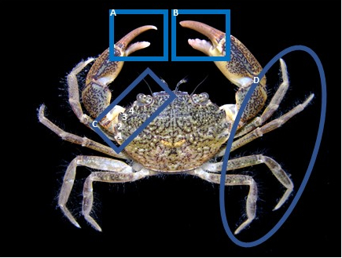

**a** Minor chela demonstrating proportionately longer fixed finger and long, straight dactyl. **b** Major chela demonstrating short, fixed finger and a dactyl. **c** Five marginal teeth bordering the carapace, however only four marginal teeth are visually distinguishable as two teeth are fused. **d** Long, slender, slightly hairy walking legs

Source: Marine Pest Photo album, ID confirmed by P. Davie, Qld Museum

Photo 2 Distinguishing carapace features of Rhithropanopeus harrisii showing the four visible anterolateral teeth on either side of the carapace

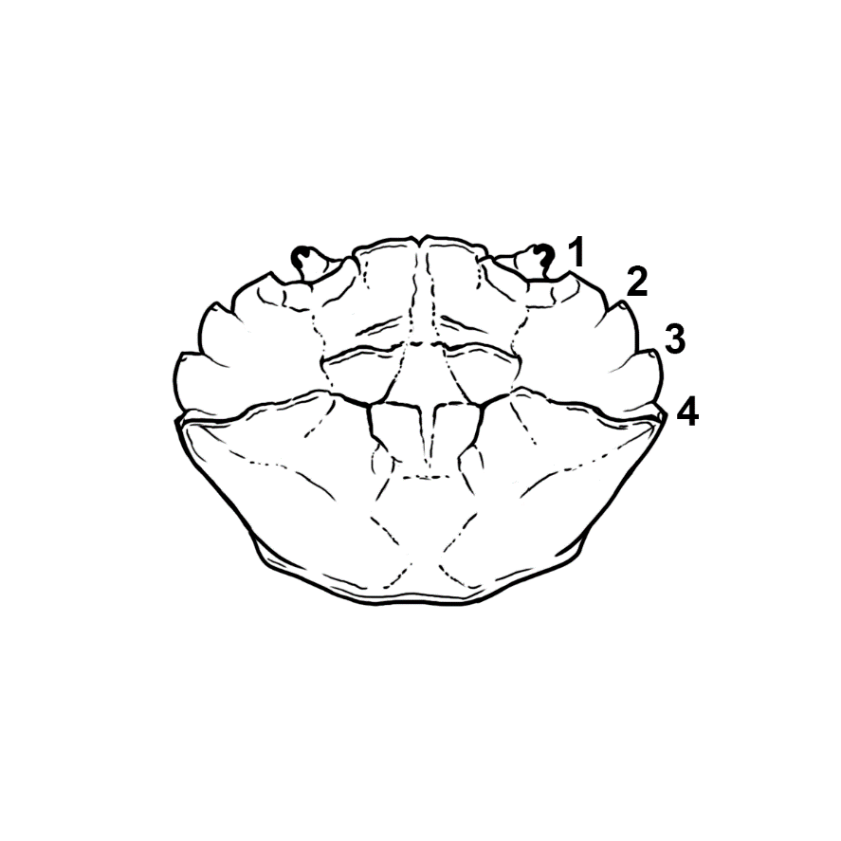

Source: René Campbell – Department of Agriculture, Fisheries and Forestry.

Photo 3 Different colour variant of adult Rhithropanopeus harrisii

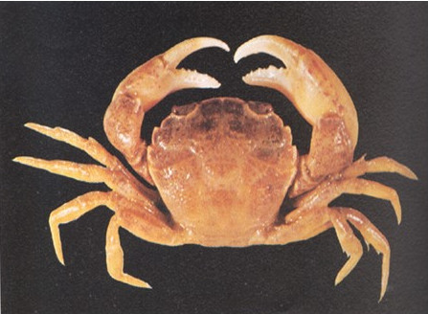

Source: Copyright Notice: Rhithropanopeus harrisii © Morris et al. 1980.

###### Laboratory identification

The most recent comprehensive work to establish a reliable test for *Rhithropanopeus harrisii* is by Knudsen and Andersen 2020. The validation of this test was done for eDNA in Danish waters so may need to be treated with some caution in Australian waters (Simpson et al 2018).

Partial validation of tests for *R. harrisii* was done under Australian conditions. Small volumes and sample limitations meant that full validation was not possible at that time but validation will be improved in 2023. Primers and molecular probes were designed for this study and evaluated *in silico*. Sequences of re-designed *Rhithropanopeus harrisii* primers and TaqMan-MGB probe are provided. The assay performed well for detection of synthetic oligonucleotides but performed poorly with spiked DNA and tissue samples (most likely caused by poor quality DNA and poorly preserved tissue used for DNA spiking). Sequences of re-designed *Rhithropanopeus harrisii* primers and TaqMan-MGB probe are available. Details on that research can be sourced from DAFF.

Refer to the [guidelines for development and validation of assays for marine pests](https://www.marinepests.gov.au/what-we-do/research/development-validation-assays) for further information and [Compendium of introduced marine pest molecular studies relevant to Australia](https://www.marinepests.gov.au/what-we-do/research/compendium-marine-pest-studies).

##### Life history and ecology

###### Life habit

Rhithropanopeus harrisii inhabits brackish water in its native range, usually at lower salinities (< 18 ‰), but can tolerate marine salinities. Eight reproductively active populations evidenced by gravid females, abundant juveniles and the presence of zoeae in the plankton were observed in freshwater lakes in Texas—salinities recorded during this study were 0.5 ‰, which is much lower than previously known for larval survival (Boyle Jr et al. 2010). This crab is typically found in shallow waters with muddy or sandy substrates associated with shelter, such as vegetation or oyster reefs. In non-native ranges, R. harrisii is found under stones and woody debris or among pieces of wood or vegetation (Roche & Torchin 2007). They are also found in seagrass (Zostera spp.) meadows and narrow bands of reed roots along the river estuaries (Zalota et al. 2016). The primary requirement for R. harrisii in habitat selection is the presence of shelter (Riipinen et al. 2017).

Smaller crabs of both sexes and most ovigerous females hide in burrows (Zalota et al. 2016). The burrows can be crevices and burrows created by other organisms or natural formations, as in under stones and shells or plant roots (Zalota et al. 2016). A survey of foraging R. harrisii from the Black Sea showed temporal separation of size and sex, probably reducing the chance of antagonistic encounters (Zalota et al. 2016). It was observed that males were more active during the morning and evening, whereas non-ovigerous females were more active during the day and hide towards evening. Ovigerous females tend to seek shelter.

Rhithropanopeus harrisii is associated with estuaries and lagoons or artificial lagoons such as harbours along the Black Sea coast of Romania and Bulgaria. This distribution is consistent with observations in other non-native areas such as North Sea and Atlantic Europe and Pacific coast North America (Zalota et al. 2016). Rhithropanopeus harrisii is commonly found in shallower depths between 8 to 15 metres but has been observed at 30 metres (Hegele-Drywa et al. 2014).

Rhithropanopeus harrisii can withstand a large range of temperature and has been observed to survive winter temperatures below 1 °C in its introduced range in Europe (Turoboyski 1973). The maximum temperature for larval R. harrisii is 35 °C (Forward Jr. 2009), with some adult crabs able to survive for two days at 37 °C (Turoboyski 1973).

Rhithropanopeus harrisii is an opportunistic omnivore, consuming algae, detritus and small invertebrates, although it does become increasingly carnivorous at larger sizes (carapace width > 12 mm) (Aarnio et al. 2015).

###### Reproduction and growth

Mating usually occurs over the summer months. Sexual maturity can be reached within one year. The size of sexual maturity for males is ~4.5 mm CW and 4.4 to 5.5 mm CW for females. The female remains in situ for around three to four days after copulation where it burrows into the benthos to extrude the eggs it will carry until they hatch. Females usually lay between 1,200 and 4,800 eggs, and the egg carrying capacity is proportional to size (Turoboyski 1973). Rhithropanopeus harrisii has four zoeal stages and one megalopal stage. Larvae are usually released in low-salinity estuarine areas where the salinity, temperature and oxygen saturation can widely fluctuate. The average time to development is 16 days (Cripe et al. 2003), although it can be around a week under optimum conditions of 20 to 25 °C and 15 to 20 ‰ (Forward Jr. 2009). The larvae display active swimming and can vertically migrate to avoid adverse conditions. Larval zoeae are about 1 mm long and eventually moult into postlarval megalopa at about ~2 mm long (Fofonoff et al. 2018).

Reproduction of R. harrisii can be limited by the presence of the rhizocephalan parasite Loxothylacus panopaei. The parasite larva settles on R. harrisii megalopae (Walker et al. 1992) and eventually causes parasitic castration of the crab. Rhithropanopeus harrisii has a reproductive infection refuge below 10 ‰ because larvae of L. panopaei survive poorly at salinities below 10 ‰ (Reisser & Forward 1991). A gradient of ovigerous females have been observed with increasing salinity that correlated with prevalence of L. panopei. The parasitic barnacle has been considered as a biological control agent for R. harrisii outside of its native range but has never been used in a natural setting (Fowler et al. 2013a) and the host specificity of this parasite is untested. Biological control in the marine environment has been viewed as too risky by some experts (Secord 2003).

###### Pathways and vectors

Rhithropanopeus harrisii is a small crab easily concealed in transhipments of oysters and other aquaculture stock. Transfer of R. harrisii into Australia via this mode is unlikely due to biosecurity regulations that prevent import of viable molluscs and conditions that ensure accompanying fouling has been removed. However, if *R. harrisii* were to enter Australia, transhipment via translocations is a real possibility if the National Guidelines for Translocations are not observed. Rhithropanopeus harrisii was likely introduced to California from Chesapeake Bay between 1907 and 1920s via translocations of the American oyster Crassostrea virginica (Petersen 2006). The introduction of R. harrisii into Italy is believed to be from a similar mechanism (Mizzan & Zanella 1996). In Texas, Keith (2008) suspected that the fish stocking programmes may be responsible for the introduction of R. harrisii into freshwater lakes, but this remains unconfirmed.

Accidental transport of larvae and adults in the ballast water and ship fouling is likely a major vector. The introduction of R. harrisii in the Panama Canal certainly resulted from shipping. A gravid female R. harrisii was detected in a ballast tank in Canada (Briski et al. 2012). Some individuals may be ensconced in biofouling of niches (such as sea chests) and enter via that pathway.

Natural dispersal of planktonic R. harrisii is possible but requires specific conditions. Rhithropanopeus harrisii larvae, like many crab larvae, use vertical migration to avoid adverse environments and maintain their spatial location near the home estuary (Forward Jr. 2009). Flood events or ephemeral climatic events could promote greater dispersal of R. harrisii. Petersen (2006) proposed that the range extension of R. harrisii along west coast North America from central California to Oregon resulted from a strong El Niño event producing high velocity nearshore currents, enabling wider planktonic larvae dispersal. The origins of R. harrisii in the estuarine water of the Vulan River, which leads into the Black Sea, is hypothesised to be from natural larval dispersal from a founding Black Sea population introduced via shipping (Zalota et al. 2016).

###### Potential impact

Rhithropanopeus harrisii is an aggressive predator and is known to compete with and displace native crabs and other benthic fauna. It can negatively affect prey species richness, diversity and size structure (Forsström et al. 2015). Rhithropanopeus harrisii is an effective predator of littoral grazers, readily consuming sessile fauna and mobile species such as amphipods under laboratory conditions (Forsström et al. 2015). Predation of the native faunal community associated with the alga Fucus vesiculosus impacted the snail Theodoxus fluviatilis under natural field conditions, but impacts on other species were not observed (Forsström et al. 2015).

R. harrisii is known to foul plumbing of lakeside homes within its introduced range of the freshwater lakes in Texas, USA (Boyle Jr et al. 2010).

R. harrisii may carry viruses that could affect other crustacean species, for instance WSSV (see section on white spot syndrome virus) (Payen & Bonami 1979).

##### Global and Australian distribution

Rhithropanopeus harrisii has not been reported from Australia.

The native range of R. harrisii is the fresh to estuarine waters along the east coast of North America from New Brunswick, Canada, to Veracruz, Gulf of Mexico (Williams 1984) (Map 1).

R. harrisii has been introduced to the Pacific coast of North America, including California and Oregon in the USA and British Columbia, Canada (Map 1). It has also been reported from the Panama Canal, in areas between 0 and 4 ‰, where it is now considered to be established (Roche & Torchin 2007). Other established populations exist in the Black Sea and the Sea of Azov, the North Sea and Atlantic Europe, the Mediterranean and Japan. The reports of R. harrisii from Brazil do not represent an established population (Fofonoff et al. 2018).

Map 1 Global distribution of Rhithropanopeus harrisii

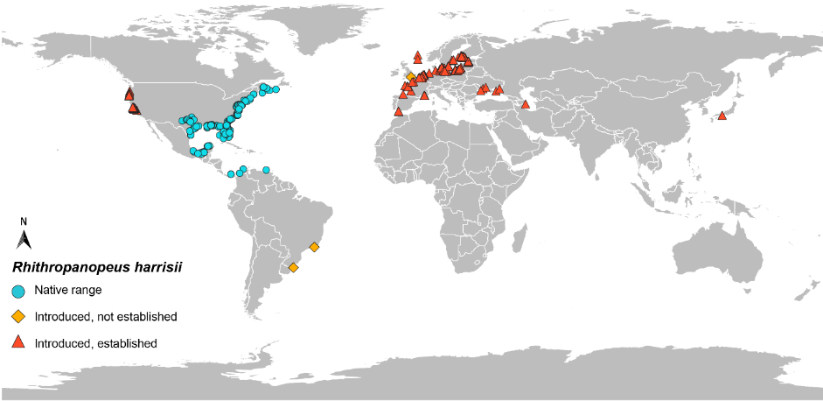

Data source: GBIF.org (18 January 2022) GBIF Occurrence Download [https://doi.org/10.15468/dl.f7m53b](https://doi.org/10.15468/dl.qmkr44)

##### Invasion history

Rhithropanopeus harrisii was introduced to the Pacific coast of North America in California in 1937 via vessels and is now abundant in the brackish waters around San Francisco, California. It then spread north into Oregon probably via currents during the larval stage (Perry 2018). Rhithropanopeus harrisii is native to the Texan estuaries along the Gulf Coast but has recently extended its range into the freshwater inland lakes of Texas and Oklahoma, where the high mineral content of the water is believed to allow its survival (Boyle Jr et al. 2010). The mechanisms of introduction into the North American inland lakes are uncertain, but could include the transfer of crabs and/or zoeae with fish-stocking activities or by fishermen via live wells or bait buckets from coastal populations where R. harrisii naturally occurs (Boyle Jr et al. 2010). Rhithropanopeus harrisii is established in the Panama Canal (Roche & Torchin 2007; Roche et al. 2009) and an established population is believed to occur in Nakagawa Canal on the southeast coast of Honshu, Japan (Iseda et al. 2007). There is an established population of R. harrisii in Venezuela (Fofonoff et al. 2018).

Rhithropanopeus harrisii has been introduced to many European countries, either via fouling of vessels, ballast water or oyster shipments. It was first recorded in the Netherlands in 1874 and has now spread to the United Kingdom in the west through to eastern European countries of Russia, Romania and Bulgaria. Rhithropanopeus harrisii spread east from Netherlands into Germany and into the Baltic Sea (Williams 1984). It has been reported from inland lagoons in Lithuania where it does not seem to be established, although in Polish lagoons the abundance is increasing (Grabowski 2007). In 2009, R. harrisii was observed in Finland with its abundance increasing rapidly (Fowler et al. 2013a). Rhithropanopeus harrisii spread west from Netherlands into Belgium (Wouters 2002), the Atlantic Coast of France (Goulletquer et al. 2002), and the United Kingdom (Eno et al. 1997), and is also found along the Atlantic coast of Europe, including the Bay of Biscay and the Iberian Peninsula of Spain. Reappearance of *R. harrisii* was recorded in the River Thames, London UK, however current status is unknown (Jarvis & Clark 2021). The abundance of R. harrisii in the Mediterranean Sea is low and has only been reported from a few rivers and lagoons from France and Italy (Galil et al. 2002). Rhithropanopeus harrisii is also known from the Black Sea, the Sea of Azov, the Caspian Sea and the saline parts of the Aral Sea.

##### Diseases

While WSSV has not been confirmed in Rhithropanopeus harrisii, the OIE recognises that all decapods are susceptible to WSSV infection. It is unknown whether R. harrisii can become infected with Aphanomyces astaci.

The rhizocephalan barnacle Loxothylacus panopaei is often reported infecting R. harrisii. This parasite can cause parasitic castration and growth reduction of the crab. The host specificity of this parasite is untested, so it may prove to be a threat to native Australian crabs. Biological control in the marine environment has been viewed as too risky by some (Secord, 2003).

There are no human health relevant pathogens associated with R. harrisii.

### Family Carcinidae

#### Carcinus maenas

The European green crab (or European shore crab), Carcinus maenas (Linnaeus, 1758), is native to Atlantic Europe, the western Baltic and north-west Africa. It is the most widespread intertidal crab in the world and has been introduced into the Pacific and Atlantic coasts of North America, south-eastern Australia, South Africa, South America and East Asia. Carcinus maenas is considered one of the worst global marine invaders by the [International Union for the Conservation of Nature](https://www.iucn.org/) (IUCN). Carcinus maenas is a generalist omnivore, can tolerate wide salinities, is extremely fecund and can successfully outcompete native fauna (Grosholz & Ruiz 1996). Outside of its native range, *C. maenas* has impacted aquaculture operations, particularly of bivalve molluscs (Campbell et al. 2019; Tummon Flynn et al. 2019). Several vectors have been identified including ballast water, hull-fouling and co-transfer with fish bait (see section on pest pathways and vectors).

C. maenas is listed on the [APMPL](https://www.marinepests.gov.au/what-we-do/apmpl). Refer to the [NIMPIS *C. maenas* page](https://nimpis.marinepests.gov.au/species/species/84) for further information on this species.

Table 6 Taxonomy of Carcinus maenas

| **Classification** | **Carcinus maenas** |
| --- | --- |
| Phylum | Arthropoda |
| Subphylum | Crustacea |
| Class | Malacostraca |
| Subclass | Eumalacostraca |
| Superorder | Eucarida |
| Order | Decapoda |
| Suborder | Pleocyemata |
| Infraorder | Brachyrua |
| Superfamily | Portunoidea |
| Family | Carcinidae |
| Subfamily | Carcininae |
| Genus | Carcinus |

##### Diagnostic features for identification

Carcinus maenas can be identified in the field and in the laboratory.

###### Field identification

Key distinguishing features of Carcinus maenas include a distinct triangular carapace, three rounded ‘teeth’ or lobes between the eyes and five marginal teeth (spines) along each side of the carapace (Photo 4 and Photo 5). Unlike most members of the Portunoidea superfamily the fourth walking leg on C. maenas is not flattened into a swimming paddle (Photo 4 and Photo 5). Individuals vary extensively in pattern and colour depending on the stage of moult cycle and life stage: the patterns can be plain, striped or mottled and the colour can vary from green (newly moulted) to orange and red (intermoult) (Photo 6). The juveniles are generally lighter in colour with extensive colour and pattern variation used for camouflage. Adults tend to be darker with green, brown or black hues and have less pattern variation. Carcinus maenas can range from 10-20 mm to 90-100 mm maximum CW and are wider than they are long.

A sister species, Carcinus aestuarii, is native in areas of the Mediterranean Sea and introduced into areas of Japan and South Africa. It is morphologically like C. maenas. Dittmann et al. (2017) summarises characters to assist in the differentiation between C. maenas and C. aestuarii. Carcinus maenas has a wider CW to carapace length ratio for crabs >20 mm: 1.29 to 1.36 for C. maenas compared to 1.22 to 1.27 for C. aestuarii. Carcinus maenas has three distinct lobes between the eyes, whereas C. aestuarii has a scalloped shape between the eyes (Yamada & Hauck 2001). There is molecular evidence that hybridisation of these two species occur in Japan and South Africa, however the population in Australia is C. maenas (Campbell 2022, per. comm.; Frederich & Logan 2018; Rius & Darling 2014).

*Carcinus maenas* is visually similar to some other native crab species of Australia, primarily reef crabs (*Nectocarcinus integrifrons*), red velvet crabs (*Nectocarcinus tuberculosus*), juvenile blue swimmer crabs (*Portunus armatus*), juvenile sand crabs (*Ovalipes australiensis*), and *Liocarcinus* spp.

Photo 4 Adult Carcinus maenas

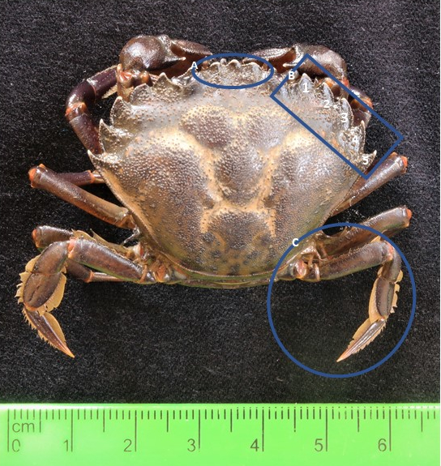

**a** Three rounded lobes between the eyes. **b** Five prominent spines along the side of the carapace. **c** Fourth walking leg flattened into a paddle.

Source: Marine Pest Photo album, ID confirmed by P. Davie, Qld Museum.

Photo 5 Distinguishing carapace features of Carcinus maenas showing the five visible anterolateral teeth on either side of the carapace

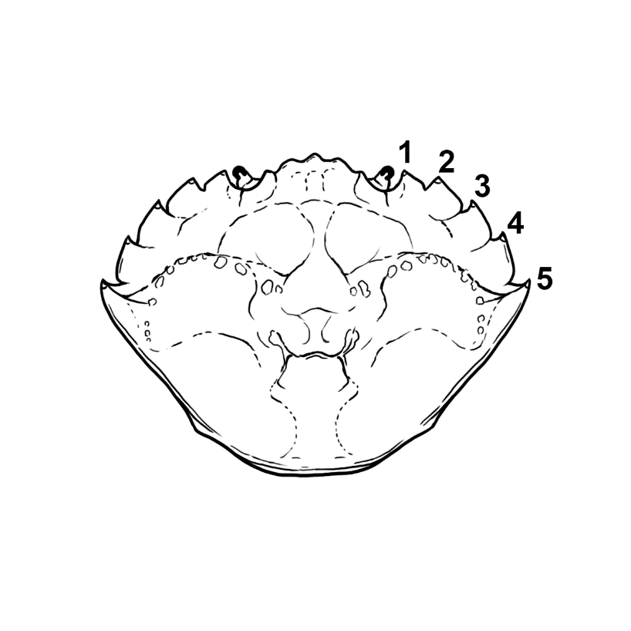

Source: René Campbell – Department of Agriculture, Fisheries and Forestry.

Photo 6 Common green colour variant of adult *Carcinus maenas* (top) and variable colour and pattern morphology of *C. maenas* (bottom)

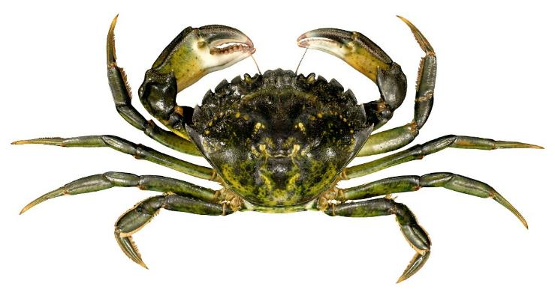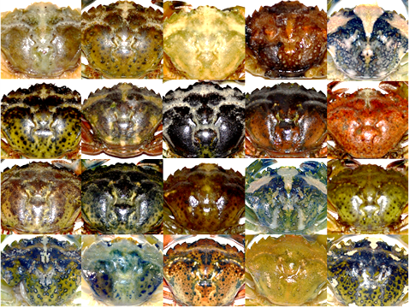

Source: René Campbell – Flinders University; Dittmann et al. 2017.

###### Laboratory Identification

A qPCR assay has been developed for Carcinus maenas, targeting the mitochondrial CO1 gene (Bott et al. 2010).

Refer to the [guidelines for development and validation of assays for marine pests](https://www.marinepests.gov.au/what-we-do/research/development-validation-assays) for further information and [Compendium of introduced marine pest molecular studies relevant to Australia](https://www.marinepests.gov.au/what-we-do/research/compendium-marine-pest-studies).

##### Life history and ecology

###### Life habit

Carcinus maenas is a habitat generalist that can survive in soft and hard substrates in marine and brackish waters. It is most abundant in intertidal to shallow subtidal (~6 metres) habitats, preferring sandy and rocky bottoms, and sheltered areas such as estuaries and harbours. It has however been observed to depths of 60 metres (Crothers 1968). The habitat C. maenas occupies varies between localities. For example, C. maenas does not often occur in rocky habitats in the Pacific coast North American range, but it has colonised the rocky shores of South Africa, Atlantic North America and occurs in these habitats in its native range in Europe (Grosholz & Ruiz 1996). Carcinus maenas are more often found in mangrove forests than unvegetated adjacent zones in south-eastern Australia (Garside & Bishop 2014). In Tasmanian waters, it has been found in a wide range of habitat types within estuaries and bays, occupying heavily sea-grassed areas through to non-vegetated areas with a clean sandy bottom. Carcinus maenas can also be found on and near man-made structures such as docks and aquaculture structures.

Several studies (Abello et al. 1997; Van Der Meeren 1994) suggest aggregation or clustering of pre-moult or ovigerous female C. maenas in particular regions of the shoreline, raising the possibility of a lek-type mating system or specific spawning sites. Ovigerous females are often found together under boulders or other structures in intertidal environments (McDonald et al. 2004). Pre-moult females release pheromones in their urine that elicit increased search and mating-specific behaviours in male C. maenas, such as posing, posing search, cradle carrying and stroking (Ekerholm & Hallberg 2005). Males compete for receptive females; larger males typically dominate smaller males and achieve greater mating success.

Carcinus maenas is a euryhaline and eurythermal species and can withstand short periods of low dissolved oxygen levels (Legeay & Massabuau 2000). Adults can tolerate salinities from 4 ‰ to 52 ‰ (Cohen et al. 1995) and water temperatures from –2 °C to 35 °C (Cohen, Carlton & Fountain 1995). The optimum salinity and temperature range is between 20 to 35 ‰ and 3 to 26 °C. Larvae are less tolerant than adults and require salinities of >20 ‰ and water temperatures between 9 to 22 °C to complete development. Because of the wide food range and environmental tolerance of adults, the environmental requirements of larvae are probably the largest limiting factor of distribution for C. maenas, and possibly predators (deRivera et al. 2005).

Juvenile C. maenas feed primarily on detritus and become more carnivorous with age. Adult crabs are predominantly predatory but can feed on a wide range of taxa. The most common prey items are shellfish, including mussels and clams, gastropods and worms. Carcinus maenas can be cannibalistic.

Few known predators effectively control C. maenas abundance in invaded habitats, although predation by the blue crab (*Callinectes sapidus*) limits abundance and geographic range in North America.

Putative and recorded predators in southeast Australia that feed on C. maenas include octopus, blue swimmer crab, mud crab, eastern fiddler ray, stingaree, different species of eel, including moray eel, various fish species, including yellowfin bream, leatherjacket, eastern blue groper, and snapper. Juvenile crabs have the same predators as adults.

###### Reproduction and growth

Carcinus maenas live from 4 to 7 years, with females typically living 3 years and males 5 years. The lifespan of C. maenas varies between localities. On the Atlantic coast North America it can be 5 to 7 years, whereas on the Pacific coast North America it can be 3 to 4 years (Klassen & Locke 2007; Yamada & Hauck 2001). The moulting cycle for C. maenas consists of an intermoult period during which the crab actively feeds before undergoing moulting. The intermoult period is recognised by the orange-red coloured carapace. Newly moulted crabs are green in colour. The timing of moult can vary depending on region, but generally occurs when the water is at its warmest (usually summer and autumn) (Vinuesa 2007). Mating in C. maenas can take place only after the female has moulted, although males can mate without moulting (Broekhuysen 1937). Mating usually occurs in the shallow water close to the shore. Males locate females by sensing pheromones. The seasonality of mating varies among populations and locations, although appears to occur around mid-summer, coinciding with the moulting period of the female crab. Carcinus maenas can survive in temperatures ranging from 0 to 35 °C but need temperatures between 18 and 26 °C to reproduce.

Female C. maenas can store male spermatophores for 4 months or longer until optimum spawning conditions occur, therefore, there is little link between mating time and egg bearing (Broekhuysen 1937). Ovigerous females do not actively feed and remain in burrows, so are rarely caught during trapping operations. When females have been caught it has typically been in winter and spring and more so by physical collection than trapping (Dittmann et al. 2017).

Carcinus maenas can reproduce up to three times a year and mature at between two and three years of age under suitable conditions. In South Australia, average size of sexual maturity for females is 50 mm CW, however ovigorous females as small as 22 mm CW have been observed (Campbell 2022 pers. comm). Females begin to mature when their carapace width reaches 40 mm in Argentina, but in Maine, USA, the minimum carapace width at sexual maturity is 34 mm (Vinuesa 2007). Although Carcinus maenas can reach sexual maturity within a year, this appears to vary among geographic regions, but typically it reaches sexual maturity between 2 to 3 years.

Females lay on average 185,000 – 210,000 eggs per clutch; but in South Australia, females with a CW between 60 mm to 75 mm produced between 400,000 to 500,000 eggs per clutch, and the average was 210,000 eggs per clutch (Campbell 2022 pers. comm.). The average size of an egg clutch from non-indigenous C. maenas from Canada was 75,577 ± 37,808 (Griffen 2014). The greatest recruitment occurs in late winter and spring in Australia (Garside et al. 2015), with the greater number of recruits in areas that contain live oyster shells compared to areas without oyster shells, artificial turf or that are devoid of structure (Garside et al. 2015).

The larval stages include a protozoea, four zoeal stages and the megalopa. Larvae can tolerate salinities between 20 to 40 ‰, (Anger 1991). An experiment using combinations of temperature (10, 15, 20, 25 °C) and salinity (20, 25, 30, 35 ‰) showed greatest larval survival at the highest salinity (35 ‰) and lower temperature (10 °C) (Nagaraj 1993). Ovigerous females tend to release eggs at the mouth of an estuary, allowing the larvae to develop in high-salinity coastal waters before returning to the estuary as megalopae. Larvae are temperature-sensitive: in controlled laboratory conditions, all five stages can be completed in 18 days in 25 °C water but larval duration can be as long as 66 days at 12 °C.

###### Pathways and vectors

Carcinus maenas is established in parts of Australia and there is management in place to limit further spread. The primary anthropogenic vectors for C. maenas are vessel ballast and co-transfer with aquaculture stock, such as oysters. Dry ballast has historically been a high-risk vector for C. maenas because of the crabs’ ability to withstand extended periods out of water. Solid ballast is likely the vector for the introduction of C. maenas into Australia in the late 1800s (Thresher 1997). Dry ballast is no longer used, but has been replaced by ballast water, which presents similar high risk of transferring C. maenas. Other known vectors are co-transfer with aquaculture stock, live food and bait. The introduction to the Pacific coast of North America was the result of an accidental co-transfer in seaweed used to pack baitworms or live seafood such as American lobsters during transport (Carlton & Cohen 2003; Cohen et al. 1995).

The typical larval planktonic duration of C. maenas is 30 to ­50 days so natural spread from an established population is likely, however, it is highly influenced by oceanographic factors. The spread within areas where it is currently known, such as between Australian states of South Australia, Victoria, Tasmania and New South Wales, is likely to occur via natural dispersal. The first arrival of C. maenas to the north and northeast coast of Tasmania appears to be from one dispersal event or through a secondary introduction from the mainland (Burden et al. 2014; Thresher et al. 2003). Unpublished population genomic analysis of South Australian *C. maenas* revealed that the population is likely a result of multiple introduction events from southeast Australia and Europe (Campbell 2022 pers. comm.). Carcinus maenas is not present in Western Australia and natural larval dispersal to Western Australia from established populations on the south and east coasts of Australia is unlikely. Carcinus maenas is unlikely to survive in the tropical climates of the northern coast of Australia (Richmond et al. 2010). It has not spread from southern NSW to northern NSW to date (NIMPIS, accessed 2021).

Oceanographic phenomena like El Niño events can provide large dispersal events. Carcinus maenas spread from northern California, USA, to Vancouver Island, Canada, in a single year, which correlated with unusually strong north-flowing coastal currents associated with a strong El Niño of 1997–1998 (Yamada et al. 2005).

There are no reports of intentional introductions of C. maenas.

###### Potential impacts

The ecological and economic damage caused by the introduction of Carcinus maenas has been well documented in several regions (Campbell et al. 2019; Matheson et al. 2016). These crabs are highly effective predators with cosmopolitan feeding habits. They can occur in large numbers and their presence can severely affect the native biota in invaded regions (Tanner 2007).

The preference of C. maenas to predate on shellfish can disrupt aquaculture operations. For instance, C. maenas has had negative impacts on ecologically important mussels and commercially harvested cockles in Australia (Campbell et al. 2019; Poirier et al. 2017; Walton et al. 2002). Matheson et al. (2016) demonstrated that seagrass decline was correlated with the presence of C. maenas and the degree of seagrass loss was proportional to the population density of C. maenas.

Carcinus maenas interacts with both native and other alien species, such as Hemigrapsus sanguineus and Hemigrapsus takanoi in its North American and European range. Carcinus maenas selected similar prey (mussels) to H. sanguineus and H. takanoi highlighting interspecific competition that could further affect local mussel populations (Bouwmeester et al. 2020).

##### Global and Australian distribution

Carcinus maenas is restricted to temperate areas of Australia, including the states of New South Wales, Victoria, Tasmania and South Australia.

Carcinus maenas is native to Atlantic Europe, from northwest Africa through to Norway, the North Sea and the Baltic Sea (Map 2). Introduced populations exist on the Atlantic and Pacific coasts of North America, South Africa, Argentina and Australia (Map 2). Records of C. maenas exist in many other places around the world, including Brazil, Panama, Hawaii, the Red Sea, Black Sea, Sri Lanka, Madagascar, Myanmar, Pakistan and India, although they are not reported as being established (Carlton & Cohen 2003; Young & Elliott 2019).

##### Invasion history

Carcinus maenas was introduced into mid-Atlantic United States of America in 1817, presumably in New Jersey or New York, and has now extended as far south as Chincoteague Bay, Virginia, USA, and northwards into Canada (Carlton & Cohen 2003). In 2007, C. maenas was found in Newfoundland, Canada (Klassen & Locke 2007). Carcinus maenas was discovered on the Pacific coastline of USA in 1989–1990, where it was found in San Francisco Bay, California. Molecular data identified that the source of the Pacific coast North American population was the introduced Atlantic North American population. Like the Atlantic coastline introduction, most of the spread along the Pacific coast has been northwards into Canada. Carcinus maenas was found in mainland British Columbia in 2015. The southernmost range extension was Elkhorn Slough in Monterey Bay, California. Substantial non-indigenous populations have become established in the waters of south-eastern Australia (1900), South Africa (1983), Japan (1984), and Argentina (1999–2000) (Young & Elliott 2019).

There are many countries across the world that have reported single sightings of C. maenas but where the crab is not classified as established. The first incidence occurred from the Red Sea before 1817. Other collections have been made in Rio de Janeiro and Pernambuco, Brazil (1857 and before 1899, respectively), the Bay of Panama, Panama (1866), Sri Lanka (1866–1867), Hawaii (1873), Madagascar (1922), Myanmar (1933), Perth, Australia (1965), and Pakistan (1971) and Indonesia (2018).

C. maenas was first reported from Australia in 1900 from Port Philip Bay, Victoria (Fulton and Grant 1902). It subsequently spread west to the Gulf of St Vincent, South Australia in 1973 and to Tasmania in 1993. *Carcinus maenas* has also spread northward to Port Jackson in New South Wales. It is now established in temperate estuaries and embayments in these four states. Specific areas where C. maenas has been confirmed in each of these four states can be found in [NIMPIS](https://nimpis.marinepests.gov.au/species/species/84). Genetic analyses of Atlantic and Mediterranean types of the genus Carcinus revealed that the mainland Australian populations likely originated from Europe and the Tasmanian population from mainland Australia (Thresher 1997).

A single C. maenas was reported from Western Australia in 1965 but no further specimens have since been detected (Thresher et al. 2003). Southern Western Australia provides suitable habitat for C. maenas. Other potentially suitable habitat for C. maenas in Australia, based on temperature tolerance and sea surface temperatures, includes the entire coastline of Tasmania, the entire southern coast of mainland Australia, as far north as Jurien Bay on the west coast of Western Australia, and up the coast of eastern Australia as far north as southern Queensland (Hayes et al. 2007). These regions are associated with temperate shelf fauna and conditions (Carlton & Cohen 2003).

Map 2 Global distribution of Carcinus maenas

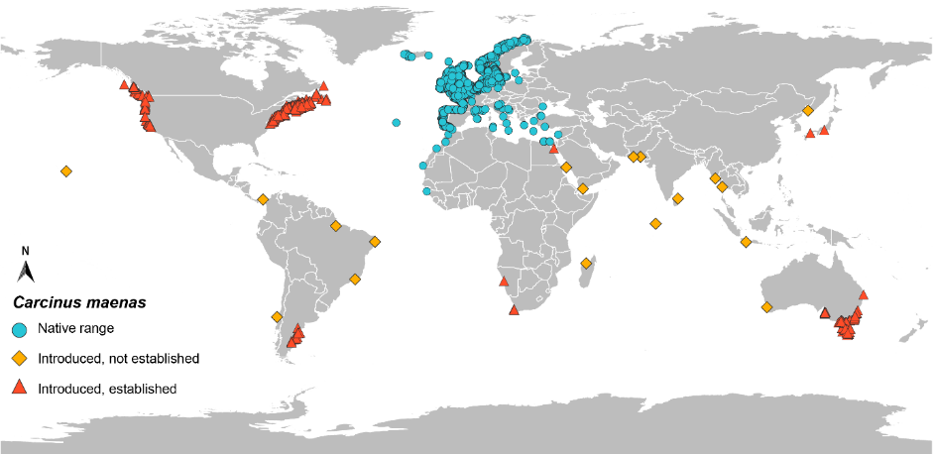

Data source: GBIF.org (18 January 2022) GBIF Occurrence Download https://doi.org/10.15468/dl.5pq7nb

##### Diseases

Carcinus maenas can be infected with WSSV but show little pathology and low mortality. It is not known to carry Aphanomyces astaci with no reports of infection.

Carcinus maenas was demonstrated to be susceptible to WSSV without presenting clinical disease through consuming infected feed or direct injection under laboratory conditions (Bateman et al. 2012). Very little pathology was observed for WSSV-infected C. maenas compared to other decapod crustaceans (including other crabs) included in the study (Bateman et al. 2012). Although little pathology was observed, C. maenas can carry WSSV infections under laboratory conditions and could be able to introduce and transmit virus to other decapods.

Carcinus maenas has been demonstrated as being able to carry the oyster virus Ostreid herpesvirus 1 microvariant (OsHV-1 µvar) and transmit it to naïve Pacific oysters Magallana gigas (see Bookelaar et al. 2018).

A baseline health study of C. maenas from its native and non-indigenous ranges showed that it can carry many bacteria, viruses and parasites (Bojko et al. 2018). The most well-known biologically consequential parasite to C. maenas is the rhizocephalan barnacle, Sacculina carcini (see Rowley et al. 2020). Rhizocephalans attach to the surface of the crab and extends branches into most of the crab’s tissue. Infected crabs are parasitically castrated and cease moulting (Mouritsen & Jensen 2006). Other potentially important parasites include the dinoflagellate parasite, Hematodinium species that could affect saleability or increase mortality of other shellfish occupying the same area following an incursion (Davies et al. 2019).

### Family Portunidae

#### Charybdis japonica

The Asian paddle crab Charybdis japonica (A. Milne-Edwards, 1861) is a swimming crab that is native to the north-western Pacific. A population of this crab was detected in New Zealand in 2000 and it has now established in estuaries throughout a large area of northern New Zealand, from the Manukau Harbour on the west coast of the North Island to Ohiwa Harbour on the east coast. Charybdis japonica has been reported from South Australia and Western Australia, but it does not appear to have established in either state. As an opportunistic predator it can impact estuarine faunal assemblages and can be an aggressive competitor to native crabs. It is also a known carrier of WSSV.

C. japonica is included on the [EEPL.](https://www.agriculture.gov.au/biosecurity/environmental/priority-list) Refer to the [NIMPIS *C. japonica* page](https://nimpis.marinepests.gov.au/species/species/108) for further information on this species.

Table 7 Taxonomy of Charybdis japonica

| **Classification** | **Charybdis japonica** |
| --- | --- |
| Phylum | Arthropoda |
| Subphylum | Crustacea |
| Class | Malacostraca |
| Subclass | Eumalacostraca |
| Superorder | Eucarida |
| Order | Decapoda |
| Suborder | Pleocyemata |
| Infraorder | Brachyrua |
| Superfamily | Portunoidea |
| Family | Portunidae |
| Subfamily | Thalamitinae |
| Genus | Charybdis |
| Subgenus | Charybdis (Charybdis) |

##### Diagnostic features for identification

Charybdis japonica can be identified in the laboratory but difficult to differentiate in the field from native species. In particular, C. japonica is similar in appearance to the Australian blue swimmer crab (Portunus armatus) and the mud crab (Scylla serrata). Charybdis japonica is smaller than both crabs.

###### Field identification

Charybdis japonica is a paddle crab, with flattened back legs that act as swimming paddles. It is a large crab, with males reaching 110 mm CW and females ~95 mm CW in both its native and introduced range (Miller et al. 2006). Key morphological features include six prominent anterolateral teeth (spines) on each side of the carapace and five prominent spines on the upper surface of each claw. *Charybdis japonica* has eight small spines on the margin between the eyes (Photo 7 and Photo 8). The colour ranges from off-white and pale green, through olive-green to a deep chestnut brown with purplish markings (Photo 9).

Sixteen native species from the genus Charybdis are known from Australia (OZCAM 2020; Stephenson et al. 1957). Most native species of Charybdis have a tropical distribution across northern Australia and onto the north-western and north-eastern coasts. Some species, such as Charybdis miles, Charybdis helleri, Charybdis feriata and Charybdis (Gonioneptunus) bimaculata extend further south on the east coast, into New South Wales. It can be difficult for a non-expert to distinguish C. japonica in the field from these native species and from native species in the related Indo-Pacific genera Thalamita and Thranita. Specialist morphological and molecular identification may be required. Key distinguishing features of C. japonica are the six prominent spines along each side of the carapace (Photo 7 and Photo 8) and five well-developed spines on the foreclaw (manus of the cheliped) (Photo 7).

Charybdis japonica has only been detected in cooler waters of South Australia and southern Western Australia to date and is sufficiently different from local species in these temperate areas to be differentiated by professional fishers. Diagnostic characters for the native Australian species of Charybdis are given in Stephenson, Hudson and Campbell (1957) and Wee and Ng (1995). Refer to the [Australian marine pest page for *C. japonica*](https://www.marinepests.gov.au/pests/identify/asian-paddle-crab) for morphological features to assist in differentiating between it and native crabs.

Photo 7 Adult Charybdis japonica

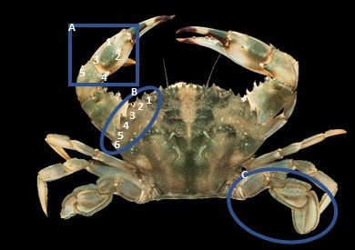

**a** Five spines on the foreclaw. **b** Six prominent spines along the side of the carapace. **c** Fourth walking leg flattened into a paddle.

Source: Richard Taylor – University of Auckland

Photo 8 Distinguishing carapace features of Charybdis japonica showing the six visible anterolateral teeth on either side of the carapace

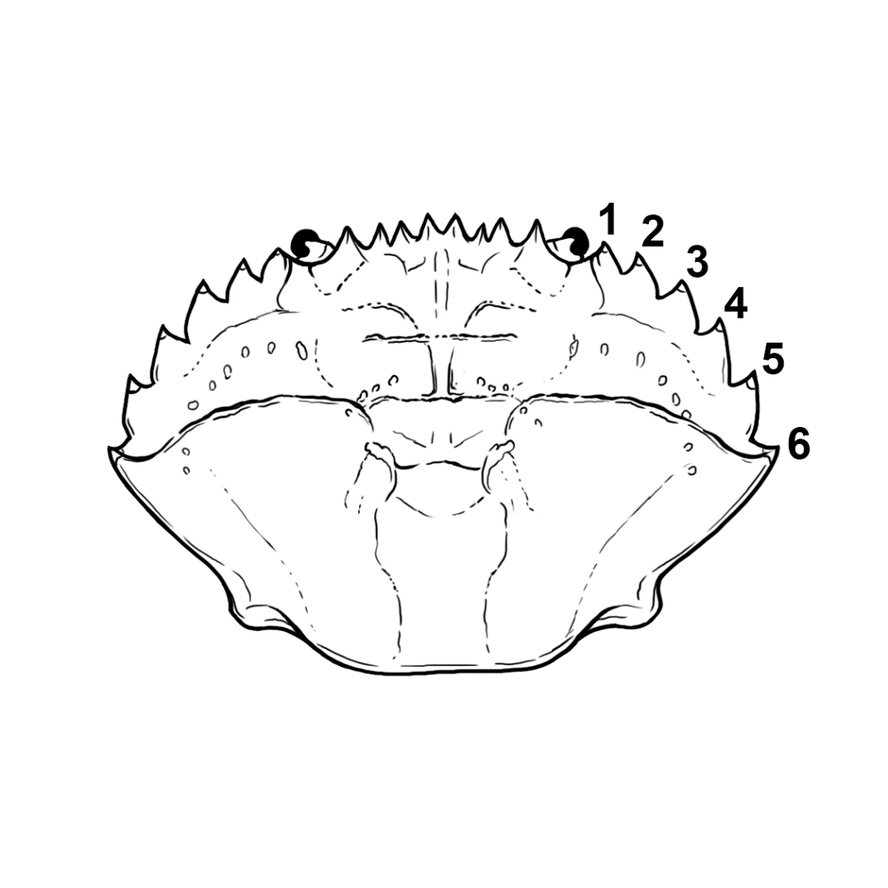

Source: René Campbell – Department of Agriculture, Fisheries and Forestry.

Photo 9 Colour variation of adult Charybdis japonica

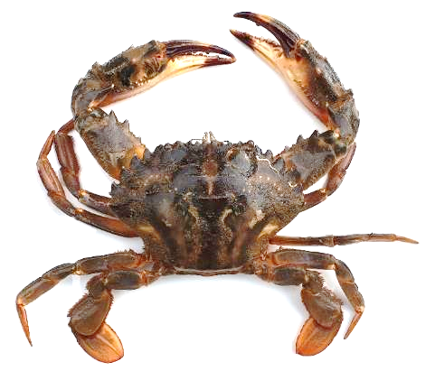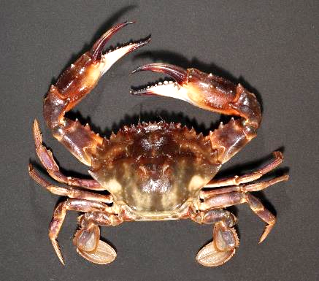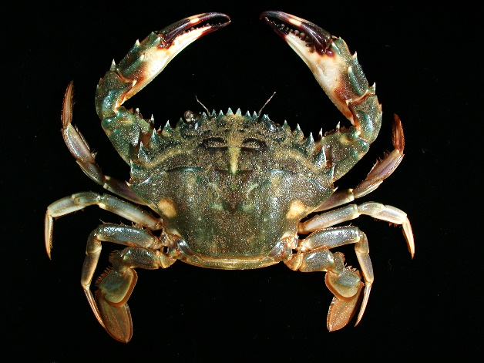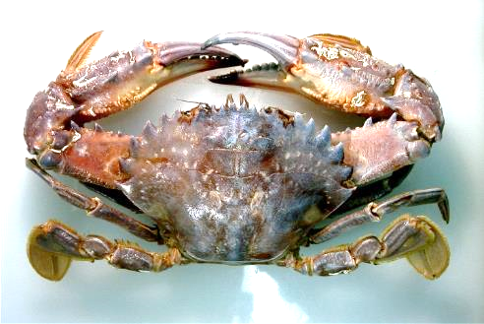

Source: Alex Chalupa – Primary Industries and Regions (PIRSA) (top-left); Wallace Richard (Rick) Webber – Museum of New Zealand, Te Papa Tongarewa (top-right, bottom-left); Peter Davie – Queensland Museum (bottom-right).

###### Laboratory identification

Interspecific identification of species belonging to the genus Charybdis can be challenging because some key morphological features overlap.

A laboratory validated test and partially field validated test have been tested under Australian conditions. See Simpson et al. 2018 for details. DNA sequencing of the mitochondrial CO1 gene has been used to reliably identify Charybdis japonica from New Zealand (Smith et al. 2003).

##### Life history and ecology

###### Life habit

Charybdis japonica is a generalist predator that consumes bivalves, crustaceans, fish and cephalopods. Charybdis japonica behave aggressively towards the native New Zealand paddle crab Ovalipes catharus under laboratory conditions when competing for a food item, often winning the antagonistic encounters (Fowler et al. 2013b). Although breeding appears to be limited to water >20 °C, C. japonica is found in water temperatures ranging from –1 to 34 °C. Adults can tolerate a salinity range of 14 to 33 ‰. Charybdis japonica zoeae can also tolerate a wide range of temperature and salinities with optimal conditions between 12 to 33 °C and 18 to 35 ‰ (Fowler et al. 2010).

Charybdis japonica occupies intertidal and subtidal habitats to depths up to 45 m in its native range (Wee & Ng 1995). Young crabs of both sexes (12 to 40 mm) are more commonly found within structurally complex intertidal habitats such as boulder shores with thick algal vegetation or seagrass meadows (Hu & An 1998; Kobayashi & Vazquez-Archdale 2018). It is believed they stay in this nursery area for close to a year (Kobayashi & Archdale 2018). Adults tend to be more widespread ranging over a variety of subtidal habitats such as reefs, mussel beds, soft sediment, piers in harbours, inland bays and open coasts (Kobayashi & Vazquez-Archdale 2018). During the early stages of its establishment in New Zealand, C. japonica was found predominantly in muddy estuarine habitats from 1 to 14 m deep but was recorded from several different habitats suggesting a habitat generalist or a propensity to forage widely (Gust & Inglis 2006).

###### Reproduction and growth

Female Charybdis japonica can mate in the hard-shell condition with no pre-copulatory or post-copulatory guarding observed, which is uncommon among portunid (swimming) crabs (Baker et al. 2018a).

Charybdis japonica in its native range release larvae in late summer when the sea temperature is at its warmest (Kobayashi & Vazquez-Archdale 2018; Kolpakov & Kolpakov 2011). Breeding may be limited to water temperatures around 18 to 20 °C (Kobayashi & Vazquez-Archdale 2018), and may restrict breeding periods in its introduced range such as Waitemata Harbour, New Zealand, that rarely exceed 21 °C mean summer water temperatures (Gust & Inglis 2006). However, breeding C. japonica in Peter the Great Bay, Russia, have been observed when the water temperature has been around 9 to 15 °C (Kolpakov & Kolpakov 2011). Reproductively active males are observed all year round but female crabs do not undergo gametogenesis until the late austral autumn/winter and spring ready for mating in late spring and summer (Wong & Sewell 2015).

Ovigerous females (43.7 to 79 mm CW) can spawn multiple broods between 200,000 to 500,000 eggs on average per year (Fowler, Taylor & Muirhead 2013b; Kolpakov & Kolpakov 2011). Females can mate with more than one male, accumulating larger amounts of semen than needed to fertilise one brood; they can then use the excess semen to fertilise additional broods (Baker et al. 2018b; Kobayashi & Archdale 2018). Wong (2014) found that sperm were present within female spermathecae year-round, likely from multiple mates, however the length of time the sperm are viable for is unknown. Crabs that hatch early in the reproductive season (early austral summer) recruit to estuaries in the following austral autumn (April and May). Individuals hatched later in the season continue to recruit to estuaries through the austral winter and into spring.

###### Pathways and vectors

Anthropogenic vectors including vessel biofouling and ballast water are the most likely means of spreading Charybdis japonica. Charybdis japonica was first discovered in New Zealand by commercial fishermen in Waitemata Harbour, Auckland. The busy port of Auckland located in the Waitemata Harbour is the likely source of introduction with commercial shipping the most likely vector. The detection of a single specimen in the Mediterranean was likely as a passenger on the hull of a ship.

The larval duration for C. japonica is ~17 days, so natural dispersal within its introduced range is likely once it became established (Gust and Inglis 2006). The relatively long larval period for C. japonica makes its dispersal via ballast water more likely.

###### Potential impacts

Experimental trials demonstrated that Charybdis japonica outcompetes the New Zealand native Ovalipes catharus for native Greenshell mussels (Perna canaliculus). Anecdotal evidence of declined catch rate of the native O. catharus during marine pest surveillance suggests C. japonica may be outcompeting this native paddle crab, but a survey of commercial crab fishers in New Zealand did not detect a change in the O. catharus fishery as a result of the introduction of C. japonica (Weaver 2017).

##### Global and Australian distribution

Charybdis japonica is not established in Australia, but it has been reported intermittently from South Australia and Western Australia.

Charybdis japonica is native to western Pacific, including Japan, Korea, Malaysia and Taiwan (Map 3). It is established in northern New Zealand (Map 3). The report from Malaysia is disputed and it could be a report of another portunid. Two preserved specimens of *C. japonica* are also known from the Red Sea (Froglia 2012). A first record of *C. japonica* was observed in the Mediterranean Sea on the Adriatic Coast of Italy in 2006, and was classified as a non-established introduction as no further individuals were subsequently found (Froglia 2012). *Charybdis japonica* was recently confirmed in the Bay of Bengal, Bangladesh, using both morphometric and genetic approaches, but is currently being regarded as native in this region (Ahmed et al. 2021).

##### Invasion history

The first occurrence of Charybdis japonica in Australia was a single male specimen caught in the Port River, South Australia in 2000 (Hooper 2001). No other specimens were found despite a 5000-trap delimiting survey. Further detections were made in South Australia in 2017 and 2020, with some molecular detections made separately. In 2010, a single male C. japonica was found in the Peel-Harvey Estuary, Western Australia (Hourston et al. 2015), with no further specimens detected. In 2012, C. japonica was found in the nearby Swan River (Hourston et al. 2015). In both Western Australia and the recent South Australian instances, public engagement campaigns were launched to assist with delimitation surveillance and management. In response, two further specimens were found from the Swan River in 2012 (Hourston et al. 2015). In 2018, one *C. japonica* was caught by a recreational fisher in the Swan River, WA. However, subsequent annual trapping surveillance and communications campaigns have not detected any *C. japonica* since (as of April 2021) (DPIRD 2021, pers. comm.). It is thought that a flood in winter lowered salinity to an unfavourable level in the Swan River limiting the ability for the crab to establish. Overall, although occasional specimens have been reported, C. japonica is not considered to be established in Australia.

Charybdis japonica has established non-indigenous populations in New Zealand. It was first detected in Auckland in 2000 where it is established in Waitematā Harbour (Gust & Inglis 2006). It is now abundant in the Waitematā Harbour. It has been detected on several occasions in two other nearby harbours, Mahurangi Harbour and Tāmaki Estuary, respectively 40 km north and 10 km south of Waitemata Harbour. In 2003, a single specimen was collected from Whangārei Harbour and is now reported in the Bay of Islands. It has also been reported from the Kaipara Harbour and Manukau Harbour on the west coast of the Auckland isthmus. The Kaipara population has recently exploded, with many juveniles observed in a single survey. The west coast population now extends as far north as Hokianga Harbour. Specimens have also been caught from Ohiwi Bay in the Bay of Plenty. The crab is restricted to northern New Zealand but it has the environmental and biological potential to establish in many parts of New Zealand, with less suitable conditions found in southern New Zealand (Crafton 2015; Rijkenberg et al. 2012).

Map 3 Global distribution of Charybdis japonica

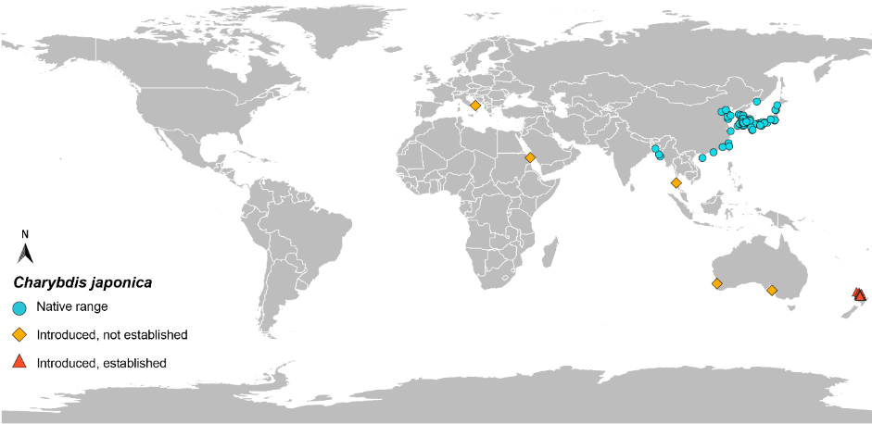

Data source: GBIF.org (18 January 2022) GBIF Occurrence Download https://doi.org/10.15468/dl.peyvhn

##### Diseases

Charybdis japonica can be infected with the WSSV (Maeda et al. 1998) and likely to transmit the virus. It is not known to be infected by Aphanomyces astaci.

Charybdis japonica in its native range in Korea is host to the parasitic rhizocephalan barnacle Heterosaccus papillosus which parasitically castrates the crab and can cause growth retardation. A survey for parasites of C. japonica following its introduction into New Zealand did not report H. papillosus or WSSV, or any other important pathogens (Miller, Inglis & Poulin 2006).

### Family Varunidae

#### Eriocheir sinensis

Eriocheir sinensis (H. Milne Edwards, 1853), is native to eastern Asia but has spread throughout Europe, and the Atlantic and Pacific coasts of North America. As a migratory species, it lives in freshwater and migrates to high-salinity marine waters to reproduce. Juvenile crabs migrate upstream to live in freshwater environments. Eriocheir sinensis can cause several impacts where it occurs outside of its native range. These include destabilising riverbanks through burrowing, disruption of local fisheries through high population abundances, competing with native species for food and other resources, and transmission of diseases that can threaten aquaculture, fisheries and human health. In its native range it is a valued and favoured delicacy, farmed in large quantities. The other species of *Eriocheir* in Asia have very similar characteristics, and E. japonica has been confirmed in parts of Europe via genetic analysis after previously being thought to be *E. sinensis* (Hayer et al. 2019b).

E. sinensis is included on the [APMPL](https://www.marinepests.gov.au/what-we-do/apmpl). Refer to the [NIMPIS *E. sinensis* page](https://nimpis.marinepests.gov.au/species/species/74) for further information on this species.

Table 8 Taxonomy of Eriocheir sinensis

| **Classification** | **Eriocheir sinensis** |
| --- | --- |
| Phylum | Arthropoda |
| Subphylum | Crustacea |
| Class | Malacostraca |
| Subclass | Eumalacostraca |
| Superorder | Eucarida |
| Order | Decapoda |
| Suborder | Pleocyemata |
| Infraorder | Brachyura |
| Superfamily | Grapsoidea |
| Family | Varunidae |
| Subfamily | Varuninae |
| Genus | Eriocheir |

##### Diagnostic features for identification

Eriocheir sinensis can be identified in the field and in the laboratory.

###### Field identification

The most distinguishing morphological feature for adult Eriocheir sinensis are large dense patches of brown setae or bristles on their claws that resemble mittens (Photo 10). Juvenile crabs develop ‘mittens’ at around 25 mm CW. Other morphological features for E. sinensis include a notch between their eyes, bordered by two distinct spines either side of the notch and four lateral spines along the margin of the carapace, the fourth (posterior) spine being the smallest (Photo 10 and Photo 11). Juveniles that do not yet have mittens are best identified by the notch and lateral carapace spines. Both claws and chelipeds are equal in size. The length of each leg is generally twice the length of the carapace. Adults are green-brown and sometimes purple in colour, whereas the juveniles are a brown orange to green-brown.

Males and females are distinguished by the shape of their abdomen: males have a narrow abdominal flap (Photo 12), whereas the female’s is much wider; once the females have undergone their ‘puberty moult’, just prior to mating, the abdominal flap extends all of the way to the edge of the carapace (Dittel & Epifanio 2009). Male crabs also tend to have a denser mat of setae, although there is no sexual dimorphism in claw size.

The genus Eriocheir is indigenous to China, the Korean Peninsula and Japan. Four species are recognised within the genus: E. sinensis, Eriocheir hepuensis (Dai, 1991), Eriocheir japonica (De Haan, 1835 [in De Haan, 1833-1850]), and Eriocheir ogasawaraensis (Komai et al. 2006). Three of these species—E. sinensis, E. japonica and E. hepuensis—have been recorded outside their native range of the northwest Pacific. Hybridisation between species of Eriocheir is known (Naser et al. 2012), which can make identification to species level challenging. There are no native species in Australia that belong to the genus so identification to genus level is easy.

The red rock crab Guinusia chabrus is the only crab native to Australia that is similar in appearance to E. sinensis. The red rock crab is coloured red with setae on its carapace. Notably it is found only on exposed rocky shores, never in estuaries or rivers where E. sinensis would be expected (Poore 2004). The shiny bait crab *Davusia glabra* has a similar carapace shape to *E. sinensis* but far shorter legs, a coastal distribution, striped colouration, and no setae mittens on the claws. Australia has few freshwater crabs that look similar to *E. sinensis.*

Photo 10 Adult Eriocheir sinensis

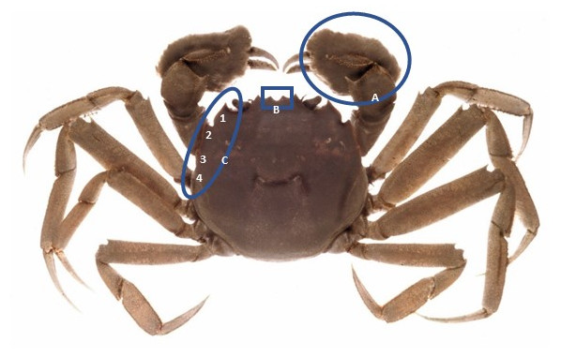

**a** Dense patches of setae on the chelae resembling mittens **b** Notch between the eyes. **c** Four prominent spines along the side of the carapace.

Source: Pedro Anastácio via [www.nrc.govt.nz/environment/weed-and-pest-control/pest-control-hub/?pwsystem=true&pwid=15](http://www.nrc.govt.nz/environment/weed-and-pest-control/pest-control-hub/?pwsystem=true&pwid=15)

Photo 11 Distinguishing carapace features of Eriocheir sinensis showing the four visible anterolateral teeth on either side of the carapace

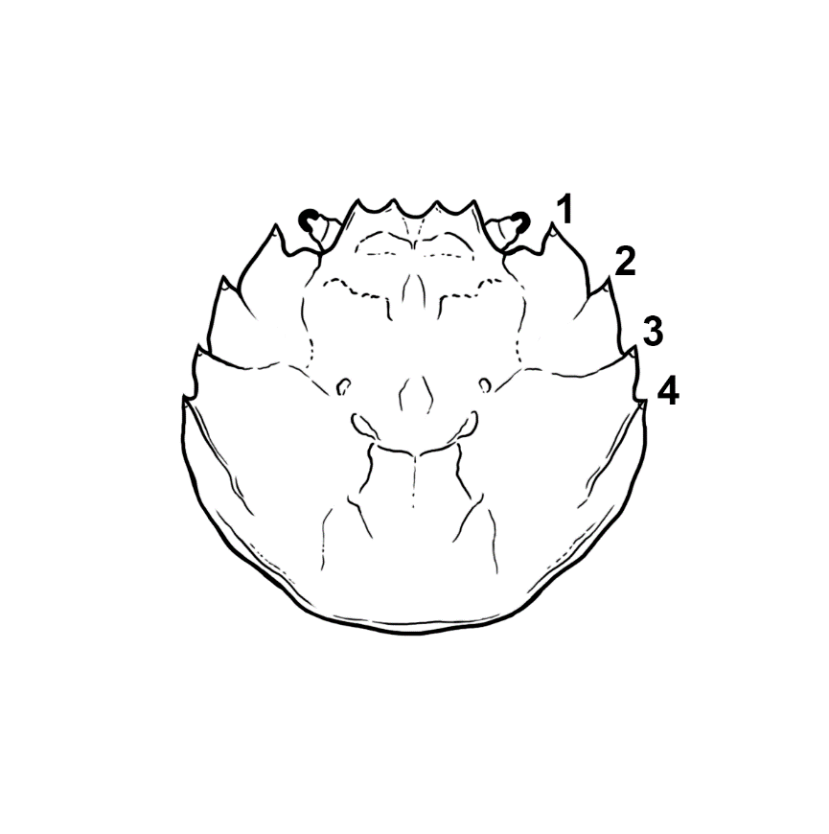

Source: René Campbell – Department of Agriculture, Fisheries and Forestry.

Photo 12 Ventral view of male Eriocheir sinensis showing typical narrow abdominal flap

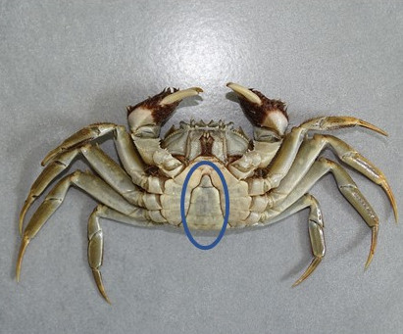

Source: Pedro Anastácio

###### Laboratory identification

Laboratory and field assessment of a qPCR of Eriocheir sinensis has a limit of detection of 0.005 ng/µl (Robinson et al. 2019). eDNA from water and surface sediment in three river catchments in Great Britain detected E. sinensis.

Refer to the [guidelines for development and validation of assays for marine pests](https://www.marinepests.gov.au/what-we-do/research/development-validation-assays) for further information and [Compendium of introduced marine pest molecular studies relevant to Australia](https://www.marinepests.gov.au/what-we-do/research/compendium-marine-pest-studies).

##### Life history and ecology

###### Life habit

Habitats that support E. sinensis have summer sea surface temperatures between 18 to 30 °C, with crab survival declining above 31 °C (Eberhardt et al. 2016).

The planktonic zoeae and megalopae are the most environmentally sensitive parts of the crabs’ life history. Their survival is influenced by temperature and salinity. Therefore, not all estuarine systems are suitable for the invasion by E. sinensis. The optimal range of growth and survival is 7 to 30 °C and 15 to 25 ‰.

One distinctive feature of E. sinensis is their propensity to burrow. Juvenile crabs create burrows in streambanks after they migrate into brackish channels and creeks. The soft sediment burrows can destabilise riverbanks causing erosion and elevated suspended sediments in waterways. Burrows are generally built between the high and low tide lines in tidally influenced streams. Burrows average 7 cm in length and are orientated downward from the entrance, allowing water into the burrow to prevent desiccation (Rudnick et al. 2000). In general, smaller juveniles construct and inhabit the burrows: Rudnick, Halat and Resh (2000) observed the average size of crabs in burrows approximately 20 mm CW. In areas where crabs are abundant, the burrows become tightly packed and are often interconnected. The large amount of sediment removed during burrowing weakens the riverbanks, accelerating erosion and can cause the riverbank to collapse (Rudnick et al. 2000). This can also increase the risk of flooding in levee systems.

Eriocheir sinensis is omnivorous and consumes both plants and small invertebrates. Feeding habits shift during the lifecycle with larvae feeding on phytoplankton and zooplankton, juveniles on aquatic plants, and adults with a greater carnivorous diet that includes worms and clams (ISSG 2016). Eriocheir sinensis normally feed at night, but when close to sexual maturity they can also be found to forage and feed during the daytime. There are few data on predators of E. sinensis although juveniles are likely to be consumed by larger birds, fish and crustaceans.

In Australia likely predators of adult crabs will be large aquatic birds, such as gulls, and fish will likely predate on juvenile crabs. Water rats would prey on all stages in fresh waters.

###### Reproduction and growth

Eriocheir sinensis have life stages in freshwater and marine habitats. They are catadromous as adults migrate from freshwaters to marine environments to spawn. Larval and juvenile crabs are present in estuaries and marine habitats and then as they age will migrate into brackish and freshwater habitats. They may leave the water during migration but do not spend much time on land.

The planktonic larvae (zoeae) occur primarily in the lower estuary and near-ocean habitats. There are five zoeal stages before metamorphosis into a megalopae. The megalopae then metamorphose into benthic juveniles before beginning their move into brackish and fresh water as adults for 1 to 5 years. Sexually mature adults synchronously migrate downstream during late summer to mate in marine water. Adults die after mating.

There is some variability in life-history aspects of various life stages of E. sinensis from its native range and in its introduced range (summarised by Dittel & Epifanio 2009). Mating of E. sinensis generally occurs around spring and occurs after the females have completed the ‘puberty moult’ and have hardened (Dittel & Epifanio 2009). Females are highly fecund, producing between 100,000 and 1 million eggs per brood (Cohen et al. 1995; Panning 1938). Eggs are extruded within 24 hours of mating and may be brooded by the female for as long as two months before hatching (Panning 1938; Rudnick et al. 2005). Female crabs are thought to continue seaward after mating, overwintering in deeper water before returning to shallower water in spring to hatch their eggs. Settlement of the planktonic larvae generally happens around summer. It is hypothesised that this coincides when the river is running at its lowest enabling easier migration upstream as juveniles. Females can produce multiple broods during a season (Panning 1938), however, adults only have one breeding season and will die soon after the release of larvae from the last batch of eggs.

Although the juvenile and adult E. sinensis live in fresh water, it is a marine species that requires brackish or marine salinities for successful larval development (Anger 1991). Sexually mature crabs mate in a high-salinity marine environment, but mating does not occur in temperatures over 18 to 20 °C (Eberhardt et al. 2016). The eggs need salinity of >20 to 25 ‰ to develop into larvae (Rudnick et al. 2005). The larvae appear to be the most environmentally sensitive stage of their lifecycle. Under optimal conditions larvae may spend 30 to 100 days in the plankton before metamorphosing into megalopae. Development time is inversely proportional to water temperature: at 15 °C larvae need 62 to 72 days to develop into a megalopae and then ~3 to 30 days into juveniles, whereas at 18 °C larvae require 37 to 44 days to develop into megalopae and then ~19 to 20 days into juveniles (Eberhardt et al. 2016). Under experimental conditions, larvae died below 9 to 10 °C water temperature, however, water temperatures in the introduced range in Europe can fall below this (Anger 1991), suggesting that crabs likely have a larval period when water temperatures are warmer. For metamorphosis into megalopae, salinity of at least 25 ‰ is required (Rudnick et al. 2005). After approximately 20 to 30 days megalopae migrate into brackish waters and metamorphose into benthic juveniles. Migrations upstream generally occur around spring to summer, although have been observed year-round in the North American introduced range (Dittel & Epifanio 2009).

Established adults are found in freshwater rivers and tributaries where they may travel several hundred kilometres upstream before migrating downstream into the marine environment to reproduce. Adult crabs are capable of limited overland travel, usually associated with circumventing human infrastructure obstacles during migration (Marques et al. 2014). Downstream migration generally occurs in mid-late autumn, peaking around September, with mating occurring during late autumn and through winter.

###### Pathways and vectors

The introductions of Eriocheir sinensis have occurred by anthropogenic vectors, most probably by discharge of ballast water and intentional illegal importation (Therriault et al. 2008). Eriocheir sinensis is a desirable seafood and is often sold live in seafood markets in Asia. Because they are a highly desired seafood there is an economic incentive to establish new populations of E. sinensis for wild harvest or aquaculture operations (refer to section 4 regarding harvesting as a population control method). DNA sequencing of E. sinensis collected from California showed a closer relationship to European populations than Asian populations, suggesting these crabs were introduced from Europe (Hänfling et al. 2002).

Eriocheir sinensis survives well in cool, moist conditions (even being sold live from vending machines overseas) and can be transported live by travellers. Several intercepts of live mitten crabs have been made at Australian airports.

Secondary vectors for E. sinensis include ballast water, aquaculture movements and recreational, commercial and small craft traffic (Therriault et al. 2008). Natural dispersal through larvae is also an important secondary vector, however, the environment will influence the likelihood of this vector. Salinities must be around 20 to 25 ‰ for development of the early planktonic stages and above 25 ‰ for megalopa. Therefore, the sensitives of the larval stages may prohibit wide-range natural dispersal. Salinities in nearshore environments may only reach those salinities after periods of heavy rainfall and then only around mouths of individual estuaries.

Adults can move across land, particularly around barriers during migrations. Adult crabs have been found hundreds of kilometres upstream in estuarine and river systems and is an important factor when managing an incursion in these systems.

###### Potential impacts

The burrowing activity of large numbers of juvenile crabs accelerates erosion of riverbanks, levees and dykes. Eriocheir sinensis have affected commercial and recreational fishing when they occur in high abundances (equipment damage and reduced catch). Crabs caught in the nets can damage the nets and kill netted species. They can also clog water intakes and other infrastructure during migrations. When E. sinensis reach high abundances, they can negatively affect estuarine and freshwater biodiversity (Therriault et al. 2008). Eriocheir sinensis can reduce the total amount of vegetation within a system reducing habitat availability for other species and reducing riverbank stability.

They also can carry and transmit aquatic animal and human pathogens, including the trematode lung fluke Paragonimus westermani, Aphanomyces astaci and WSSV. The fluke causes a tuberculosis-like condition of the upper lung. Aphanomyces astaci, the aetiological agent of crayfish plague, has caused significant mortalities and has eliminated native freshwater crayfish from many river systems in Europe (FAO 2007; OIE 2019). The ability of *E. sinensis* to carry crayfish plague and to migrate hundreds of kilometres would make it a vector and reservoir for crayfish plague if it were ever introduced into Australia.

##### Global and Australian distribution

No species from the genus Eriocheir have been recorded from Australia.

Eriocheir sinensis is native to eastern Asia, mainly from China and northwards into Korea and Russia. Most Chinese provinces have populations of E. sinensis. In its native range, E. sinensis is a commercially and culturally valuable aquaculture and fisheries species. Currently, the market value of E. sinensis aquaculture is much higher than that of freshwater fish, and its production is as high as 0.8 million tons and is worth 10 billion dollars in economic benefits per year (Huang et al. 2020). The gonads are regarded as a delicacy and a whole crab can cost around ~US$40 in Asian restaurants.

Eriocheir sinensis has been introduced into other temperate Northern Hemisphere localities, including the Pacific and Atlantic coasts of North America, Atlantic Europe, including the United Kingdom, Italy (Map 4). It is also introduced into Japan and Iran; Singapore is the only tropical location where it is reported (Map 4) (Crocetta et al. 2020; Hayer et al. 2019a; Low et al. 2013). However, the Singapore detection was a single individual believed to have been released or escaped from the tonnes of mitten crabs imported into Singapore (Low et al. 2013).

##### Invasion history

The first record of E. sinensis into Europe was reported in 1912 from Germany (Panning 1938). The crab has since dispersed throughout most of Europe, including northern Europe and in western Baltic and North Sea estuaries (Herborg et al. 2002; Ojaveer et al. 2006). Its current invasive European range includes Finland through Sweden, Russia, Poland, Germany, the Czech Republic, Netherlands, Belgium, the United Kingdom, France and Italy.

Eriocheir sinensis was first reported from North America from the Detroit River in 1965, in Lake Erie in commercial gillnets in 1973 (Nepszy & Leach 1973) and then in the surrounding Great Lakes area (Veldhuizen & Stanish 1999). In 1987, crabs were found in the Mississippi River Delta (Cohen & Carlton 1995). It was first reported from the west coast in 1992, then in 1998 the crab population increased to hundreds of thousands (Siegfried 1999). More recently, it has been reported from the Atlantic coastline of North America in the Chesapeake and Delaware Bays, the Hudson River and its tributaries and the tributaries of the Raritan Bat (Schmidt et al. 2009).

There are reports of E. sinensis in Japan (Doi et al. 2011), Singapore (Low, Ng & Yeo 2013), and Iran (Robbins et al. 2006).

Map 4 Global distribution of Eriocheir sinensis

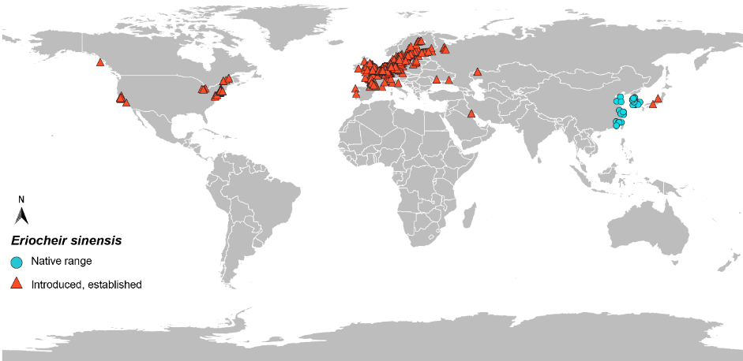

Data source: GBIF.org (18 January 2022) GBIF Occurrence Download [https://doi.org/10.15468/dl.ekrnae](https://doi.org/10.15468/dl.hjcg3s)

##### Diseases

Eriocheir sinensis is a known carrier of WSSV and Aphanomyces astaci.

WSSV has caused significant impact in aquaculture populations of E. sinensis in China (Ding et al. 2017; Ding et al. 2015). WSSV has not been detected in introduced populations, however, E. sinensis can carry and transmit the virus to naïve animals, and it can also cause high mortality in this species.

Eriocheir sinensis is known to be susceptible to, and a carrier of, Aphanomyces astaci, a pathogen only found in freshwater. Aphanomyces astaci is the causative agent of the crayfish plague and has been reported from E. sinensis introduced in Europe (Tilmans et al. 2014). *Eriocheir sinensis* can transmit A. astaci to naïve crayfish species (Schrimpf 2014).

Eriocheir sinensis serves as the secondary host for the Asian lung fluke Paragonimus westermani which is a human health risk (Yang et al. 2000). Infections of humans likely occur through ingestion of raw or undercooked crab (drunken crab is one means), or the transfer of the fluke via utensils that were in contact with infected crabs (Marquardt & Demaree 1985). The lung fluke has not yet been reported in the European range of E. sinensis (Gollasch 1999). The life cycle of the trematode requires a first intermediate molluscan host belonging to a genus not occurring in Australia, suggesting risk to human infection in Australia is lower, but is unknown (Bentley 2011)

The bacterium Vibrio parahaemolyticus is an important human-health pathogen and it has been detected in all samples of E. sinensis collected during a survey from the River Thames Estuary, England (Wagley et al. 2009).

Other important aquatic animal parasites reported from E. sinensis that may impact native Australia fauna include Spiroplasma eriocheiris (Wang et al. 2011) and Metschnikowia bicuspidate (Bao et al. 2020).

#### Hemigrapsus sanguineus and Hemigrapsus takanoi

Hemigrapsus sanguineus and Hemigrapsus takanoi are presented together because of their similar life history and biology. Distinguishing morphological differences are presented in Photo 13, Photo 14, Photo 15 and Photo 16.

The Asian shore crab H. sanguineus (De Haan, 1853) is a relatively small intertidal shore crab native to the rocky coastlines of the western Pacific Ocean from Hong Kong to Sakhalin Island, Russia. Hemigrapsus sanguineus was first reported in Australia from eastern Port Philip Bay in late 2020 and is considered established in this area. It was first reported from New Jersey, USA, in 1988 and has since spread north to Maine and south to North Carolina. Hemigrapsus sanguineus has been introduced into Europe, including from France to Sweden and Russia. In its non-native range it has the potential to cause significant changes to the marine and estuarine communities through predation and displacement of native species. WSSV has been detected from wild caught H. sanguineus.

Hemigrapsus takanoi (Asakura and Watanabe 2005), also known as the brush-clawed crab, has only been recently described as a new species (Asakura and Watanabe 2005). It is now recognised as a distinct species from Hemigrapsus pencillatus. Hemigrapsus takanoi was first recorded in Europe in 1994 as H. penicillatus, but all records of H. penicillatus in Europe are now identified as H. takanoi. Hemigrapsus takanoi is a small crab native to the northwest Pacific. It is established in Europe where it outcompetes the native Carcinus maenas when at high population densities. Hemigrapsus takanoi is commonly found in sheltered bays and estuaries that experience wide temperature and salinity ranges and can reach population densities of up to 80 m2 (van den Brink et al. 2012). Known vectors of spread include vessel biofouling, ballast water and co-transfer with oyster transhipments.

Refer to the [NIMPIS *H. sanguineus* page](https://nimpis.marinepests.gov.au/species/species/25) for further information on this species.

Table 9 Taxonomy of Hemigrapsus sanguineus and Hemigrapsus takanoi

| **Classification** | **Hemigrapsus species** |
| --- | --- |
| Phylum | Arthropoda |
| Subphylum | Crustacea |
| Class | Malacostraca |
| Subclass | Eumalacostraca |
| Superorder | Eucarida |
| Order | Decapoda |
| Suborder | Pleocyemata |
| Infraorder | Brachyrua |
| Superfamily | Grapsoidea |
| Family | Varunidae |
| Subfamily | Varuninae |
| Genus | Hemigrapsus |

##### Diagnostic features for identification

Hemigrapsus sanguineus and Hemigrapsus takanoi can be identified in the laboratory although field identification and differentiation can be challenging.

###### Field identification

Hemigrapsus sanguineus walking legs have alternating light and dark bands and a square-shaped carapace with three distinct spines on the side of the carapace (Photo 13 and Photo 15). The colour is dark, and can include green, brown, orange or purple with a light green or yellow colour in between the striped bands. The cheliped can have red spots. Males have a small fleshy swelling at the base of the cheliped, whereas females do not. Males are generally larger than females, reaching a maximum CW of >40 mm, whereas females rarely exceed 35 mm CW (Epifanio 2013).

Hemigrapsus takanoi is similarly small with a square carapace. The presence of setal patches on the chelae distinguishes H. takanoi from H. sanguineus (Photo 14). Differentiating H. takanoi and Hemigrapsus penicillatus relies on the presence and distribution of spots on the crab’s carapace. Spots are present on the ventral surface of the cephalothorax, third maxillipeds, outer faces of chelipeds and sometimes on the eyestalks but never on the abdominal segments for H. takanoi (Photo 16). The size of spots tends to be smaller on H. takanoi than H. penicillatus.

Rapid discrimination of H. sanguineus from native Australian grapsid crabs can be difficult. Although there are no Australian native *Hemigrapsus*, native grapsids such as Cyclograpsus spp., Leptograpsusspp., *Brachynotus spinosus*, *Pachygrapsus* spp., *Metopograpsus messor*, *Grapsus* spp., and Paragrapsus spp. will look similar in the field. The native mottled shore crab *Paragrapsus laevis*, also has three spines on the sides of the eyes and can have mottled purple-yellow stripes and spots. However, *P. laevis* has a mat of felt on the carpus of the first pair of walking legs. This native species does have a decent indent between the eyes which can help to distinguish it from *H. sanguineus*. The distinguishing feature of H. sanguineus from similar crabs is the purple-yellow banded pattern on the legs. Refer to [NIMPIS](https://nimpis.marinepests.gov.au/species/species/25) for more details on identifying H. sanguineus.

Photo 13 Adult Hemigrapsus sanguineus

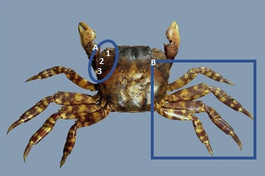

**a** Three distinct spines along the side of the carapace. **b** Banded walking legs.

Source: Frank Reiser – Shutterstock

Photo 14 Adult Hemigrapsus takanoi

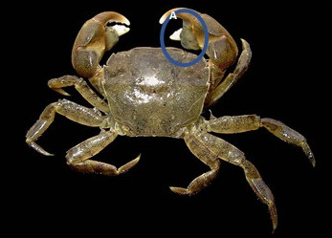

**a** Setal patches on the chelae

Source: [Hans](https://upload.wikimedia.org/wikipedia/commons/2/20/Hemigrapsus_takanoi.jpg) Hillewaert – Wikimedia Commons: https://commons.wikimedia.org/wiki/File:Hemigrapsus_takanoi.jpg

Photo 15 Distinguishing carapace features of Hemigrapsus sanguineus and H. takanoi showing the three visible anterolateral teeth on either side of the carapace

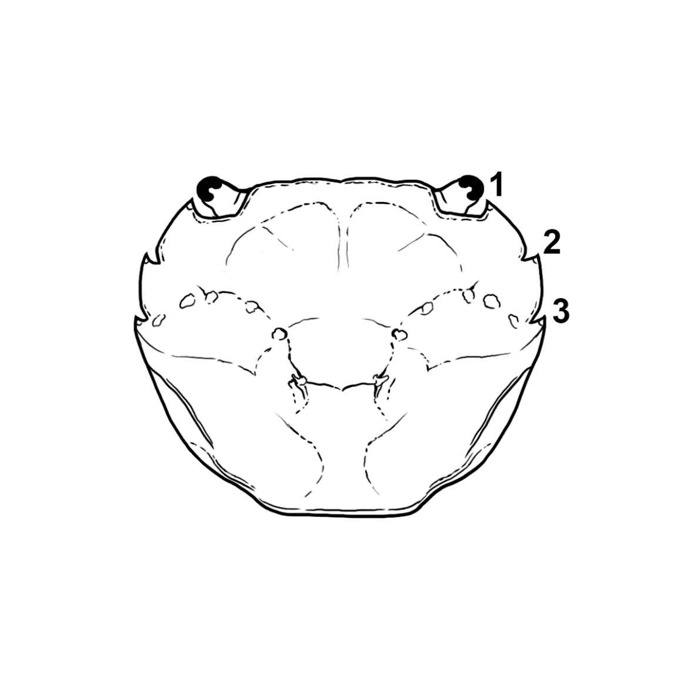

Source: René Campbell – Department of Agriculture, Fisheries and Forestry.

Photo 16 Variation in spot distribution of Hemigrapsus takanoi and Hemigrapsus penicillatus

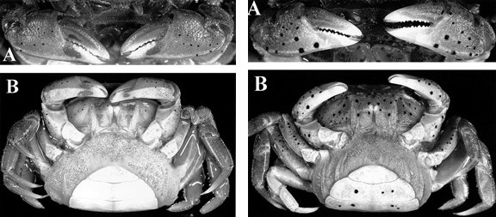

**a** Note the smaller and fewer spots visible presence of setal patches on the chelipeds of Hemigrapsus takanoi (left-hand-side) than Hemigrapsus penicillatus (right-hand-side). **b** Note the absence of spots on the ventral abdomen of Hemigrapsus takanoi (left-hand-side) than Hemigrapsus penicillatus(right-hand-side). Note also that both specimens are gravid females and are carrying egg broods in the abdominal flaps.

Source: Asakura & Watanabe 2005.

###### Laboratory identification

Polymorphic microsatellite loci have been developed and characterised for Hemigrapsus sanguineus that could be useful for inferring invasion provenance and population genetics (Blakeslee et al. 2017; Poux et al. 2015).

Refer to the [guidelines for development and validation of assays for marine pests](https://www.marinepests.gov.au/what-we-do/research/development-validation-assays) for further information and [Compendium of introduced marine pest molecular studies relevant to Australia](https://www.marinepests.gov.au/what-we-do/research/compendium-marine-pest-studies).

##### Life history and ecology

###### Life habit

Both species are opportunistic omnivores and will feed on a range of small invertebrates as well as graze benthic algae (Depledge 1984). When given the choice, H. sanguineus showed a strong preference of animals over algae as food (Brousseau & Baglivo 2005).

Hemigrapsus sanguineus can tolerate a wide range of water temperatures (5 to 30 °C) and salinities, although prefers salinity 25 to 35 ‰. It occupies estuarine and marine habitats, occurring predominantly in the middle and lower intertidal and occasionally in the subtidal. They are commonly found on rocky/cobble shores or other complex hard structures like mussel and oyster reefs. Hemigrapsus sanguineus rarely occurs in muddy places whereas H. takanoi is commonly found on mudflats (Asakura & Watanabe 2005).

###### Reproduction and growth

Hemigrapsus sanguineus typically exhibit the following mating behaviours: (1) apparent absence of courtship; (2) mating initiation by males; (3) relatively long copulation of around 30 minutes, occasionally over 60 minutes (Anderson and Epifanio 2010); (4) vertical copulation, and (5) mate in the open during diurnal and nocturnal hours. The vertical copulation is unique among the Hemigrapsus species. The copulation position is perpendicular to the substratum with the male and female facing each other. H. sanguineus mate when in the hard-shell.

Brooding in H. sanguineus follows a typical pattern for brachyuran crabs. Copulation allows deposition and storage of sperm packets in the seminal receptacles of the female for fertilisation. A single copulation can produce enough sperm for two separate broods of eggs. Time from fertilisation to extrusion of fertilised eggs is typically < 24 hours, which are then brooded between 16 days at 25 °C to 22 days at 20 °C (Anderson & Epifanio 2010). Females often extrude a second batch of eggs for brooding a few days after the initial batch (Epifanio 2013). Approximately 44,000 eggs are produced with each brood (McDermott 1998). Females can copulate multiple times during the reproductive season (Anderson & Epifanio 2010). The reproductive season can occur over several months and the length of time is proportional to water temperature. For example, the breeding season of H. sanguineus in southern Japan (warmer water) is 8 months long whereas in northern Japan (colder water) it is 3 months long (McDermott 1998). Brooding females were found in Victoria from November to at least March.

Hemigrapsus sanguineus are highly fecund and rapidly sexually mature. A sexually mature female crab can be a few months to one year old (~15 mm CW). A female crab may live to around 3 years and in that time could have produced several hundred thousand larvae (Epifanio 2013). The eggs hatch into larvae which transition through five zoeal stages to become megalopae. Like many other crabs, H. sanguineus release larvae in estuaries; larvae are then transported offshore before returning to the estuaries to settle (Epifanio 2013). Larvae remain in the water column for up to one month, encouraging wide dispersal from prevailing currents: for instance, zoeae have been collected as far offshore as 25 km (Park 2005). This is an important consideration for spread following an introduction. The time from egg hatching to metamorphosis to the first instar varies with environmental conditions. Under optimal laboratory conditions (high salinity and warm water) the full planktonic stage may take > 25 days (Epifanio et al. 1998).

The highest survival of megalopae occurs at relatively warm water temperature (> 20 °C) and at salinity >25 ‰. The average duration of megalopae before they undergo their first moult and transition into a juvenile crab is nine days. The size of the crab after metamorphosis into a juvenile crab is usually between 1.6 to 2.0 mm (Epifanio et al. 1998).

Settlement and metamorphosis of the megalopae is induced only by a cue found in the exudate from conspecific adults and cues associated with biofilm-covered substratum from natural rocky

intertidal habitat (Kopin et al. 2001). Once established, adult crabs produce cues that promote

gregarious settlement (Kopin et al. 2001). The cue is highly species-specific (Steinberg et al. 2007).

Megalopae accelerate metamorphosis in the presence of conspecific adults. This appears to be a

highly specific chemical response because the megalopae do not respond to closely related species

from the west coast of the United States or Japan.

This may have an influence on why *H. sanguineus* is in discrete patches in Port Phillip Bay (DJPR 2021, pers. comm.).

Hemigrapsus takanoi is native to Japan and may also occur in other areas of Asia where Hemigrapsus penicillatus is known to occur, such as Korea, China and Taiwan. Because of the recent description of H. takanoi and the sympatry with H. penicillatus its specific life-history is not yet fully known.

###### Pathways and vectors

The release of ballast water or fouling of the sea chest or hull is the likely cause for the introduction of Hemigrapsus sanguineus from Asia into Atlantic coast North America (Cariton & Geller 1993). The source of the introduction into Port Philip Bay is not known. The introduction of H. sanguineus into Europe was probably due to larval introduction in ballast water (Breton et al. 2002). Natural dispersal of larvae has been identified as an important secondary vector for H. sanguineus (Dauvin 2009). The larval duration is approximately 20 days at 25 °C and could be longer at cooler temperatures. The larvae can withstand temperatures from 15 to 30 °C (Epifanio et al. 1998), so if conditions are favourable then transport of larvae is likely. For example, the population extension of H. sanguineus in Atlantic Europe was supported by the permanent gyre in the Bay of Seine (Dauvin 2009).

Long-distance dispersal of H. sanguineus associated with debris was reported following the 2011 tsunami in Japan when it was transported from Japan to Oregon, USA, on floating debris (CABI).

The likely pathway for the introduction of Hemigrapsus takanoi into Europe in the early 1990s was from the release of ballast water or the translocation of Pacific oysters (Noél et al. 1997). Following the initial introduction of H. takanoi in France it spread rapidly north and south possible from natural larval dispersal (Noél, Tardy & d'Udekem d'Acoz 1997). The population in France served as a source population for other European populations either by ballast water discharge or oyster translocations. The populations of the North Sea probably resulted from secondary spread from larvae of the established French population (Gothland et al. 2014).

###### Potential impact

Hemigrapsus sanguineus occurs in the same habitat as other crabs, both native and introduced. For instance, H. sanguineus, H. takanoi and Carcinus maenas occupy the same habitat in France (Breton et al. 2002). In some locations H. sanguineus has displaced C. maenas from the intertidal habitat and has been shown to be highly competitive for food and space under experimental laboratory conditions (Brousseau et al. 2001). Hemigrapsus sanguineus is a strong competitor that will negatively impact native marine fauna and communities. It is expected that H. takanoi will also compete for food and shelter with native crabs on rocky shore habitat, especially when they occur in large abundances.

##### Global and Australian distribution

Hemigrapsus sanguineus is now recorded from Port Phillip Bay, Victoria, Australia. Hemigrapsus takanoi has not been recorded from Australia.

The native range of H. sanguineus is the east coast of Asia, from Hong Kong to Russia (Epifanio 2013) (Map 5). Hemigrapsus sanguineus and the closely related crab species H. takanoi are found in similar habitat, although H. sanguineus is more common on moderate-energy, coarse sediment habitats compared to the lower-energy finer-sediment habitats favoured by H. takanoi (Dauvin et al. 2009).

Hemigrapsus takanoi is native to Japan and may also occur in other areas of Asia where Hemigrapsus penicillatus is known to occur, such as the Korean Peninsula, China and Taiwan (Map 6). The full native range of these species is not known because of its recent description and sympatry with H. penicillatus.

##### Invasion history

Hemigrapsus sanguineus was reported from Port Philip Bay in Victoria in November 2020 (Map 5). The species is now widely distributed across the eastern and northern part of the Bay. Hemigrapsus sanguineus has also been introduced into North America and Europe (Map 5). Hemigrapsus sanguineus was first reported from the Atlantic coastline of the USA in Delaware Bay, in 1988 (Epifanio 2013). Subsequent sampling showed the presence of an established breeding population (McDermott 1991). Since then, H. sanguineus has consistently spread north and south. It is now found at Schoodic Peninsula, Maine, USA (Delaney et al. 2007) and Cape Hatteras, North Carolina, USA, to the south (Epifanio 2013). Further northward extension into Canada is probably restricted by cold ambient temperatures (Stephenson et al. 2009) and further southward extension may be limited by the fine sandy sediment of North Carolina’s Outerbanks, as well as oceanographic processes limiting larval transportation (Epifanio 2013).

Hemigrapsus sanguineus was first recorded from Europe in 1999 from Netherlands and France (Breton et al. 2002) and then in 2002 in the Mediterranean (Schubart 2007). Hemigrapsus sanguineus is now recorded from most of Atlantic Europe including in the Swedish Skagerrack (Map 5). Hemigrapsus sanguineus is recorded from Istra Peninsula, Adriatic Sea and from Constanta, Romania in the Black Sea but there is no evidence that breeding populations have been established at these locations (Micu et al. 2010; Schubart 2007; Schubart 2003).

Map 5 Global distribution of Hemigrapsus sanguineus

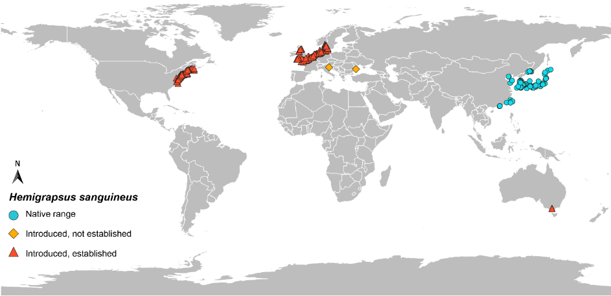

Data source: GBIF.org (18 January 2022) GBIF Occurrence Download [https://doi.org/10.15468/dl.d7fkdc](https://doi.org/10.15468/dl.j7qwzr)

Map 6 Global distribution of Hemigrapsus takanoi

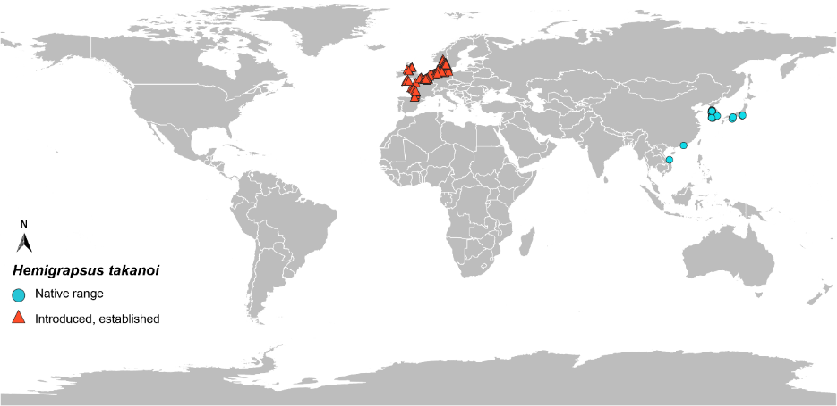

Data source: GBIF.org (18 January 2022) GBIF Occurrence Download https://doi.org/10.15468/dl.ypbjt2

**Diseases**

Hemigrapsus sanguineus can become infected with WSSV but it is not known how well they can transmit the virus (Takahashi et al. 2003). No serious pathogens have been recorded from Hemigrapsus takanoi but considering the wide host range of WSSV it is likely that H. takanoi could carry the virus. Neither species is known to carry Aphanomyces astaci, because they are largely marine.

Several other parasites have been recorded from H. sanguineus in its native range, the most consequential being rhizocephalan barnacles. Rhizocephalans cause feminisation of males and ovarian castration of females (McDermott 2011). No other parasites or ectosymbionts have been reported from introduced H. sanguineus (McDermott 2011). Other parasites described from H. takanoi, such as nematode and digenean trematodes, are likely to be of low significance (McDermott 2011).

## Appendix B: Some diseases of crustaceans carried by crabs and considered significant to Australia

Crabs are susceptible to, or can act as carriers of, a range of crustacean diseases considered significant to Australia. Two crustacean diseases are provided as examples in this manual. [Australia’s National List of Reportable Diseases of Aquatic Animals](https://www.agriculture.gov.au/animal/aquatic/reporting/reportable-diseases#crustaceans) identifies additional crustacean diseases that may be spread by invasive crabs. [The Aquatic Animal Diseases Significant to Australia: Identification Field Guide](https://www.agriculture.gov.au/animal/aquatic/guidelines-and-resources/aquatic_animal_diseases_significant_to_australia_identification_field_guide#viral-diseases-of-crustaceans) provides information on crustacean diseases considered significant to Australia.

### Aphanomyces astaci

Aphanomyces astaci is an oomycete and the causative agent of crayfish plague, a disease of freshwater crayfish. The disease has the potential to cause widespread mortality events in susceptible species which include all Australian freshwater crayfish species. Crayfish occur in all environments across all mainland and Tasmanian habitats and are a keystone species in many areas. Crayfish plague has eliminated native freshwater crayfish from many river systems in Europe. The disease does not occur in Australia. Commercially produced Australian species such as the redclaw, yabby and marron are highly susceptible to the disease. *Aphanomyces astaci* is a pathogen of fresh waters only, so would not be harboured by crab species that do not penetrate fresh waters.

Aphanomyces astaci is listed as a disease notifiable to the OIE (OIE 2020) and is on Australia’s National list of reportable diseases of aquatic animals (AHC 2018), and on the [EEPL](https://www.agriculture.gov.au/biosecurity/environmental/priority-list). An [AQUAVETPLAN](https://www.agriculture.gov.au/sites/default/files/documents/aquavetplan-crayfish-plague.pdf) exists for A. astaci that includes information on the pathobiology, epidemiology diagnostic methods and methods to control and eradicate the pathogen from Australia.

Eriocheir sinensis can become infected and transmit the pathogen to other susceptible species. The establishment of marine crab species that lives in freshwater (such as E. sinensis) would provide reservoirs of the disease which would then be impossible to eradicate. The migration habits of *E. sinensis* could allow transport of the disease over long distances against prevailing river currents.

#### Susceptible crabs

Eriocheir sinensis is susceptible to infection with Aphanomyces astaci (Tilmans et al. 2014). Eriocheir sinensis have been demonstrated to carry and transmit A. astaci to naïve crayfish (Schrimpf 2014). The river crab Potamon potamios (in Europe) is also known to be susceptible to infection with A. astaci.

Aphanomyces astaci is a freshwater pathogen that is sensitive to high salinities. Therefore, marine crabs that do not spend any time in freshwater are unlikely to be infected. Adult E. sinensis reproduce in marine waters, releasing their larvae into high salinity environments. Because A. astaci does not survive in marine or brackish water (Unestam 1969), the crab’s planktonic larvae should not become infected. However, juvenile crabs can become infected as they move into freshwater containing infected crayfish (or crabs). Direct transmission of the spores through the water column is the main route of spread of A. astaci and they can persist in the environment for a long time. The ability for E. sinensis to migrate hundreds of kilometres in river systems could spread the pathogen faster and farther than just crayfish alone.

Infected crabs have been reported to show no sign of disease other than melanised tissues (Svoboda et al. 2014). In highly susceptible species of crayfish, the first sign of an epizootic may be the observation of crayfish during daylight (crayfish are normally nocturnal), some of which may show loss of co-ordination, falling onto their backs and remaining unable to right themselves. Often, however, the first sign of an outbreak may be the presence of large numbers of deceased crayfish in a river or lake (OIE 2019). In North American crayfish species, a melanised cuticle has been suggested as a sign of infections with A. astaci (OIE 2019).

#### Global and Australian distribution

Aphanomyces astaci has never been reported from Australia despite targeted and passive surveillance.

Aphanomyces astaci naturally occurs in crayfish populations in North America and was introduced into Europe with the introduction of American crayfish. The first reports of large mortalities go back to 1860 in Italy and soon after at the France-Germany border region. Since then, *A. astaci* has spread to the Black Sea, Russia, Sweden and Finland, Turkey, Greece, Spain and the United Kingdom and is now reported in over 30 European countries.

Other locations where outbreaks of disease have occurred include Israel (2013), Taiwan (2013), Japan (2014) and Ireland (2017). The Taiwan outbreak was in cultured Australian freshwater crayfish (Hsieh et al. 2016).

#### Likelihood of introduction and transmission

Aphanomyces astaci is present throughout Europe and has been reported from Israel, Japan and Taiwan. In Europe, Eriocheir sinensis that were living in the same environment with A. astaci-infected crayfish were also found to be positive for A. astaci (Tilmans et al. 2014). Eriocheir sinensis is one of only two crab species known to become infected and transmit A. astaci. Considering A. astaci is a freshwater pathogen then the chance of introduction with E. sinensis is possible. Most marine crabs spend most of their life in marine and brackish salinities, except for Rhithropanopeus harrisii which is known from freshwater lakes in North America. The higher salinities of marine and brackish waters inhibit the release of spores from sporangia and cause spore mortality (Unestam 1969). Mycelial growth and sporulation of A. astaci was inactive at 10 ‰ and 20 ‰. The introduction of an invasive marine crab to a location that experiences marine and brackish salinities is less likely to introduce viable A. astaci.

### White spot syndrome virus

WSSV is the causative agent for WSD, a highly infectious and lethal viral disease particularly of farmed penaeid prawns. WSSV can infect all decapod crustaceans, including brachyuran crabs. In Australia, WSSV was first detected in cultured and wild crabs and prawns from Darwin in 2000, after being introduced through infected Indonesian bait prawns. A response was mounted and the infected areas were surveyed and considered white spot free around a month later. WSSV was later detected in Queensland in 2016 in farmed prawns and later in the wild populations of prawns and crabs in Moreton Bay. Active management of WSSV in southern Queensland has prevented this infection spreading to other areas. National targeted surveillance has not detected WSSV elsewhere in Australia.

Eriocheir sinensis has suffered large mortality events from WSSV and WSSV DNA has been detected in many other crabs.

WSSV is listed as a disease notifiable to the OIE (OIE 2020) and is on the [EEPL](https://www.agriculture.gov.au/biosecurity/environmental/priority-list). An [AQUAVETPLAN](https://www.agriculture.gov.au/animal/aquatic/aquavetplan/white-spot) exists for WSSV that includes information on the pathobiology, epidemiology diagnostic methods and methods to control and eradicate the pathogen from Australia.

#### Susceptible crabs

WSSV has been detected in many different crab species. Different degrees of susceptibility have been observed in infected crabs. For example, experimental infection of Carcinus maenas produced little pathology suggesting low susceptibility to disease (Bateman et al. 2017), whereas farmed populations of Eriocheir sinensis have experienced high levels of mortality following infection with WSSV (Ding et al. 2017). WSSV has been detected in Charybdis japonica and Hemigrapsus sanguineus but it is unknown how susceptible these species are and whether they can transmit the virus. The virus has not been detected in Rhithropanopeus harrisii and Hemigrapsus takanoi but considering the generalist decapod crustacean host range of WSSV, these species are likely to be susceptible to some degree. Other crabs such as the mud crabs (Scylla spp.) have also been demonstrated as being susceptible to infection.

Clinical signs of infection in decapod crustaceans other than prawns (for example, brachyuran crabs) are not well described or may be absent. Lethal infections from WSSV in the E. sinensis displayed no clinical signs, despite high viral loads (Ding et al. 2017).

Transmission of the disease can occur through the consumption of infected tissues or water-borne routes. Transmission of WSSV can occur from apparently healthy animals in the absence of disease, as well as from deceased and moribund animals. Therefore, wild decapods can act as reservoir for the disease making it very difficult to eradicate and allowing long-term persistence of the disease in an area. WSSV can persist in fresh, estuarine and marine environments, infecting crustaceans in all environments.

#### Global and Australian distribution

WSSV is present within the Movement Regulated Area (MRA) of southeast Queensland. The rest of Australia is free from WSSV.

WSSV is present throughout Asia and North, Central and South America. The virus has also been detected in farmed prawns from Europe, including Greece, Italy and Spain, and Iran and in parts of Africa. The spread of WSSV overseas is strongly linked to the importation of live prawns for aquaculture.

#### Likelihood of introduction and transmission

The wide-spread geographic range of WSSV overlaps with many crab species. A wide range of decapod crustaceans from fresh, brackish and marine water can become infected, although the susceptibility can vary among crab species. Therefore, the introduction of any invasive marine crab could simultaneously introduce WSSV and provide a reservoir of infection. Refer to the [AQUAVETPLAN](https://www.agriculture.gov.au/animal/aquatic/aquavetplan/white-spot) for WSD and the OIE (2019) manual for diagnostic methods.

## Appendix C: Using the Biosecurity Act 2015 during an emergency response

The following is an interim process for using the Biosecurity Act 2015 (the Act) for action on vessels to treat contaminations by a marine pest of national significance. The Act may be used in certain circumstances, including where a biosecurity officer suspects on reasonable grounds that the level of biosecurity risk associated with the vessel is unacceptable. Under these circumstances, a biosecurity officer may, in relation to a vessel that is under biosecurity control, direct:

* the person in charge or operator of a vessel not to move, interfere with or deal with the vessel
* the person in charge or operator of a vessel to move the vessel to a specified place, including a place outside of Australian territory
* a vessel to undergo treatment action deemed necessary by the biosecurity officer
* that other biosecurity measures which may be prescribed by regulations be undertaken.

In addition, biosecurity officers may exercise certain powers, such as taking samples of ballast water from vessels, for the purpose of monitoring compliance with provisions for the management of ballast water at a port or offshore terminal within the outer limits of the EEZ of Australia. Where the Director of Biosecurity (or delegate) is satisfied that a sample of the vessel’s ballast water indicates that the vessel poses an unacceptable level of biosecurity risk, then the Director may give a direction to the vessel not to discharge ballast water until conditions specified in the direction are met.

The conditions of using the Act are:

* the Australian Government Department of Agriculture, Fisheries and Forestry is to be contacted before taking the proposed action to determine the appropriate provisions of the Act that apply
* directions to act under the Act are to be given by a biosecurity officer. Officers of a state or territory government must be authorised as biosecurity officers under the Act to be able to give directions under the Act
* actions under the Act should only be taken for vessels currently identified as at a risk of spreading a marine pest of national significance.

Responsibility for directing and approving action under the Commonwealth Biosecurity Act rests with the biosecurity officer, but the actual vessel control and treatment actions are handled by the Local or State Control Centre. As a matter of policy, the following information should be provided to the Australian Government Department of Agriculture, Fisheries and Forestry to help determine appropriate application of the Act:

* the proposed course of action
* the location of proposed action
* details to identify the vessel involved in the proposed action
* contact details of local management agencies that will be managing the vessel control and treatment.

## Appendix D: State and territory legislative powers of intervention and enforcement

The Intergovernmental Agreement on Biosecurity (IGAB) is an agreement between the Australian, state and territory governments. It came into effect in January 2019 and replaced the previous IGAB which commenced in 2012. The agreement was developed to improve the national biosecurity system by identifying the roles and responsibilities of governments and outlining the priority areas for collaboration to minimise the impact of pests and disease on Australia’s economy, environment and community. The [National Environmental Biosecurity Response Agreement](https://www.coag.gov.au/about-coag/agreements/national-environmental-biosecurity-response-agreement-nebra) was the first deliverable of the IGAB and sets out emergency response arrangements, including cost-sharing arrangements, for responding to biosecurity incidents primarily affecting the environment and/or social amenity and when the response is for the public good. In combination with the IGAB, Commonwealth state and territory governments are responsible under their principal fisheries management legislation to respond consistently and cost-effectively to a marine pest incursion.

Table D1 Commonwealth, state and territory legislation covering emergency response arrangements

| **Jurisdiction** | **Agency** | **Principle fisheries management acts covering emergency response arrangements** | **Marine pest contact website** |
| --- | --- | --- | --- |
| Commonwealth | Department of Agriculture, Fisheries and Forestry | Fisheries Management Act 1991  Biosecurity Act 2015 | [agriculture.gov.au/fisheries](http://www.agriculture.gov.au/fisheries) |
| New South Wales | NSW Department of Primary Industries | Fisheries Management Act 1995  Fisheries Management (General) Biosecurity Regulation 2017  Fisheries Management (Aquaculture) Regulation 2012  Ports and Maritime Administration Act 1995  Marine Parks Regulation 1997  Marine Safety Act 1998 | [dpi.nsw.gov.au/fishing/pests-diseases](https://www.dpi.nsw.gov.au/fishing/pests-diseases) |
| Victoria | Department of Jobs, Precincts and Regions (Agriculture Victoria) | Fisheries Act 1995  Environment Protection Act 1970  Marine and Coastal Act 2018  Marine Safety Act 2010  Port Management Act 1995 | [www.vic.gov.au./marine-pests](http://www.vic.gov.au./marine-pests) |
| Queensland | Department of Agriculture and Fisheries | Fisheries Act 1994  Biosecurity Act 2014 | [daff.qld.gov.au/fisheries/](http://www.daff.qld.gov.au/fisheries/)  [qld.gov.au/environment/coasts-waterways/marine-pests](http://www.qld.gov.au/environment/coasts-waterways/marine-pests) |
| South Australia | Primary Industries and Regions SA | Fisheries Management Act 2007 | [pir.sa.gov.au/biosecurity/aquatics](http://www.pir.sa.gov.au/biosecurity/aquatics) |
| Western Australia | Department of Fisheries | Fish Resources Management Act 1994 (under review) | [fish.wa.gov.au/Sustainability-and-Environment/Aquatic-Biosecurity/Pages/default.aspx](http://www.fish.wa.gov.au/Sustainability-and-Environment/Aquatic-Biosecurity/Pages/default.aspx) |
| Tasmania | Department of Primary Industries, Parks, Water and Environment | Living Marine Resources Management Act 1995 | [dpipwe.tas.gov.au/biosecurity-tasmania/aquatic-pests-and-diseases](http://www.dpipwe.tas.gov.au/biosecurity-tasmania/aquatic-pests-and-diseases) |
| Northern Territory | NT Department of Primary Industry and Resources | Fisheries Act 1988 | [nt.gov.au/marine/for-all-harbour-and-boat-users/biosecurity/aquatic-pests-marine-and-freshwater](https://nt.gov.au/marine/for-all-harbour-and-boat-users/biosecurity/aquatic-pests-marine-and-freshwater)  [nt.gov.au/d/Fisheries/index.cfm?header=Aquatic%20Biosecurity](http://www.nt.gov.au/d/Fisheries/index.cfm?header=Aquatic%20Biosecurity) |

## Appendix E: Using plankton samples to detect crab larvae

Example method for collecting and preserving plankton samples to detect and quantify crab larvae, which can also be used for molecular eDNA surveillance.

Plankton samples can be collected using a 70 cm diameter, 100 µm mesh bongo net. To gather samples, tow the bongo net behind a vessel obliquely from the sea floor (if shallower than 10 metres depth) to the water surface. Tow duration may vary between 2 and 10 minutes, depending on the biomass obtained in the samples. A mechanical flow meter should be fitted to the net frame and used to estimate the volume of water filtered for each tow. After each deployment, the net should be rinsed using a bilge pump and the sample from each net washed in separate small 100 µm mesh net sieves to remove as much seawater as possible.

Alternatively, plankton samples may be obtained using a centrifugal, motor-driven pump with a throughput of about 0.5 m3/minute (Queiroga et al. 1994). Pump output should be measured and kept approximately constant for all samples. Samples should be taken throughout the top 20 metres of the water column at 1 metre depth intervals or greater, but no closer than 0.5 metres from the bottom. Water retrieved by the pump should be passed through a 500 µm net to retain the larvae. After each deployment, the net should be rinsed using a bilge pump and the sample from each net washed in separate small 100 µm mesh net sieves to remove as much seawater as possible.

Samples that are intended to be sorted visually should be preserved in 4% buffered formaldehyde immediately after collection.

Samples that will be analysed using the molecular probe should not be put into formalin. Instead, they should be rinsed into sample jars with SET-buffered, reagent-grade ethanol, ensuring that the ratio of biomass to SET buffered ethanol is no more than 1 to 3.

Each sample should be labelled with:

* details of the location in which it was collected (latitude and longitude)
* the method used to collect the sample (plankton tow or pump)
* the sample identifier (such as number in sequence of samples or sample code)
* the date and time collected
* the name of the collector.

Additional information collected with the sample (such as environmental variables, tow speed and duration, depth of collection) should be recorded separately and should also include details of the date of collection, the sample identifier, the method used and location details.

## References

Aarnio, K, Törnroos, A, Björklund, C & Bonsdorff, E 2015, 'Food web positioning of a recent coloniser: the North American Harris mud crab Rhithropanopeus harrisii (Gould, 1841) in the northern Baltic Sea', Aquatic Invasions, vol. 10, no. 4, pp. 399–413.

Abello, P, Aagaard, A, Warman, CG & Depledge, MH 1997, 'Spatial variability in the population structure of the shore crab Carcinus maenas (Crustacea: Brachyura) in a shallow-water, weakly tidal fjord', Marine Ecology Progress Series, vol. 147, pp. 97–103.

Ahmed, MS, Afrin, T & Barua, A 2021, ‘New distributional record of *Charybdis japonica, Coenobita violascens, Galene bispinosa,* and *Portunus reticulatus* (Crustacea: Decapoda) from Bangladesh waters of the Bay of Bengal’, *Regional Studies in Marine Science*, vol. 44, pp. 101785Ahyong, ST 2005, 'Range extension of two invasive crab species in eastern Australia: Carcinus maenas (Linnaeus) and Pyromaia tuberculata (Lockington)', Marine Pollution Bulletin, vol. 50, pp. 460–62.

Ammon, U, Swift, L, Brand, S, Jeffs, A & Swift, S 2019, Review of in-water hull encapsulation and enclosure treatments for eliminating marine biofouling, Ministry of Primary Industries, p. 63.

Anderson, JA & Epifanio, CE 2010, 'Mating and sperm storage of the Asian shore crab Hemigrapsus sanguineus', Journal of Shellfish Research, vol. 29, no. 2, pp. 497–501.

Anderson, L 2005, ‘California’s reaction to *Caulerpa taxifolia*: a model for invasive species rapid response’, *Biological Invasions*, vol. 7, pp. 1003-16.

Anger, K 1991, 'Effects of temperature and salinity on the larval development of the Chinese mitten crab Eriocheir sinensis (Decapoda: Grapsidae)', Marine Ecology Progress Series, vol. 72, pp. 103–10.

Asakura, A & Watanabe, S 2005, 'Hemigrapsus takanoi, new species, a sibling species of the common Japanese intertidal crab H. penicillatus (Decapoda: Brachyura: Grapsoidea)', Journal of Crustacean Biology, vol. 25, no. 2, pp. 279–92.

Audet, D Miron, G, &Moriyasu, M2008, ‘Biological characteristics of a newly established green crab (Carcinus maenas) population in the southern Gulf of St. Lawrence, Canada’, *Journal of Shellfish Research*, vol. 27, pp. 427-441.

Baker, CF, Gublin, Y & Reeve, KA 2018a, 'Observations of hard-shell mating in the portunid crab Charybdis japonica (A. Milne-Edwards, 1861) (Decapoda: Brachyura)', Journal of Crustacean Biology, vol. 38, no. 4, pp. 504–8.

Baker, CF, Gublin, Y & Reeve, KA 2018b, 'Observations of hard-shell mating in the portunid crab Charybdis japonica (A. Milne-Edwards, 1861)(Decapoda: Brachyura)', Journal of Crustacean Biology, vol. 38, no. 4, pp. 504–8.

Bao, J, Jiang, H, Shen, H, Xing, Y, Feng, C, Li, X & Chen, Q 2020, 'First description of milky disease in the Chinese mitten crab Eriocheir sinensis caused by the yeast Metschnikowia bicuspidata', Aquaculture, vol. 532, p. 735984.

Bateman, AW, Buttenschon, A, Erickson, KD & Marculis, NG 2017, 'Barnacles vs bullies: modelling biocontrol of the invasive European green crab using a castrating barnacle parasite', Theoretical Ecology, vol. 10, no. 3, pp. 305-18.

Bateman, KS, Tew, I, French, C, Hicks, RJ, Martin, P, Munro, J & Stentiford, GD 2012, 'Susceptibility to infection and pathogenicity of White Spot Disease (WSD) in non-model crustacean host taxa from temperate regions', Journal of Invertebrate Pathology, vol. 110, no. 3, pp. 340-51.

Bax, N, Hayes, K, Marshall, A, Parry, D & Thresher, R 2002, 'Man-made marinas as sheltered islands for alien marine organisms: establishment and eradication of an alien invasive marine species', Turning the tide: the eradication of invasive species, pp. 26-39.

Behrens Yamada, S, Peterson, WT, Kosro, PM, 2015, ‘Biological and physical ocean indicators predict the success of an invasive crab, *Carcinus maenas*, in the northern California Current’, *Marine Ecology Progress Series*, vol. 537, pp. 175-89.

Bentley, MG 2011, 'The global spread of the Chinese mitten crab Eriocheir sinensis', in: In the Wrong Place-Alien Marine Crustaceans: Distribution, Biology and Impacts, Springer, pp. 107-27.

Blakeslee, AMH, Kamakura, Y, Onufrey, J, Makino, W, Urabe, J, Park, S, Keogh, CL, Miller, AW, Minton, MS, Carlton, JT & Miura, O 2017, ‘Reconstructing the invasion history of the Asian shorecrab, Hemigrapsus sanguineus (De Haan 1835) in the western Atlantic’, Marine Biology, vol. 164, no. 3, p. 47.

Bojko, J, Stebbing, PD, Dunn, AM, Bateman, KS, Clark, F, Kerr, RC, Stewart-Clark, S, Johannesen, A & Stentiford, GD 2018, ‘Green crab Carcinus maenas symbiont profiles along a North Atlantic invasion route’, Disease of Aquatic Organisms, vol. 128, no. 2, pp. 147-68.

Bookelaar, BE, O’Reilly, AJ, Lynch, SA & Culloty, SC 2018, ‘Role of the intertidal predatory shore crab Carcinus maenas in transmission dynamics of ostreid herpesvirus-1 microvariant’, Diseases of Aquatic Organisms, vol. 130, no. 3, pp. 221-33.

Bott, NJ, Giblot-Ducray, D & Deveney, MR 2010, Molecular tools for detection of marine pests: Development of putative diagnostic PCR assays for the detection of significant marine pests: Asterias amurensis, Carcinus maenas, Undaria pinnatifida and Ciona intestinalis, Report prepared for Adelaide & Mt Lofty Ranges Natural Resources Management Board. South Australian Research and Development Institute (Aquatic Sciences), Adelaide. SARDI Publication No. F2011/000503-1. SARDI Research Report Series No. 587. 24pp.

Bott, NJ, Ophel-Keller, KM, Sierp, MT, Herdina, Rowling, KP, McKay, AC, Loo, MGK, Tanner, JE & Deveney, MR 2010, ‘Toward routine, DNA-based detection methods for marine pests’, *Biotechnology Advances*, vol. 28, pp. 706-714

Bouwmeester, MM, Waser, AM, van der Meer, J & Thieltges, DW 2020, ‘Prey size selection in invasive (Hemigrapsus sanguineus and H. takanoi) compared with native (Carcinus maenas) marine crabs’, Journal of the Marine Biological Association of the United Kingdom, vol. 100, no. 1, pp. 73-7.

Boyle Jr, T, Keith, D & Pfau, R 2010, ‘Occurrence, reproduction, and population genetics of the estuarine mud crab, Rhithropanopeus harrisii (Gould) (Decapoda, Panopidae) in Texas freshwater reservoirs’, Crustaceana, vol. 83, no. 4, pp. 493-505.

Braithwaite, RA, Cadavid, C, Mcevoy, L 2007, ‘Biofouling of salmon cage netting and the efficacy of a typical copper-based antifoulant’, *Aquaculture*, vol. 262 no. 2-4, pp. 219-26.

Breton, G, Faasse, M, Noël, P & Vincent, T 2002, ‘A new alien crab in Europe: Hemigrapsus sanguineus (Decapoda: Brachyura: Grapsidae)’, Journal of Crustacean Biology, vol. 22, no. 1, pp. 184-9.

Brockerhoff, A & McLay, C 2011, ‘Human-Mediated Spread of Alien Crabs’, in: In the wrong place - alien marine crustaceans: distribution, biology and impacts, pp. 27-106.

Broekhuysen, GJ 1937, 'On development, growth and distribution of Carcinides Maenas (L.)', Archives Néerlandaises de Zoologie, vol. 2, no. 1, p. 257.

Brousseau, DJ & Baglivo, JA 2005, 'Laboratory investigations of food selection by the asian shore crab, Hemigrapsus sanguineus: Algal versus animal preference', Journal of Crustacean Biology, vol. 25, no. 1, pp. 130-4.

Brousseau, DJ, Filipowicz, A & Baglivo, JA 2001, 'Laboratory investigations of the effects of predator sex and size on prey selection by the Asian crab, Hemigrapsus sanguineus', Journal of Experimental Marine Biology and Ecology, vol. 262, no. 2, pp. 199-210.

Brousseau, DJ, Murphy, AE, Enriquez, NP, & Gibbons, K2008,‘Foraging by two estuarine fishes, *Fundulus heteroclitus* and *Fundulus majalis*, on juvenile Asian shore crabs (*Hemigrapsus sanguineus)* in Western Long Island Sound’, *Estuaries and coasts*, vol. 31, no. 1, pp. 144-151.

Browne, G & Jones, E 2006, Review of methods for the control of the invasive swimming crab Charybdis japonica in New Zealand, Research Report, Kingett Mitchell Limited, Auckland, New Zealand, p. 37.

Burden, CT, Stow, AJ, Hoggard, SJ, Coleman, MA & Bishop, MJ 2014, 'Genetic structure of Carcinus maenas in southeast Australia', Marine Ecology Progress Series, vol. 500, pp. 139-47.

Burgman, MA, McCarthy, MA, Robinson, AJ, Hester, SM, McBride, MF, Elith, J & Dane Panetta, F 2013, 'Improving decisions for invasive species management: reformulation and extensions of the Panetta–Lawes eradication graph', Diversity and Distributions, vol. 19, no. 5-6, pp. 603-7.

Cahill, P, Hickey, C, Lewis, P, Tait, L & Floerl, O 2019, Treatment agents for biofouling in internal pipework of recreational vessels, MPI Technical Paper No: 2019/03, Wellington, New Zealand, p. 68.

Campbell, RT, Baring, RJ & Dittmann, S 2019, 'Cracking the cuisine: Invasive European shore crabs (Carcinus maenas) select a menu of soft-shelled mussels over cockles', Journal of Experimental Marine Biology and Ecology, vol. 517, pp. 25-33.

Cariton, JT & Geller, JB 1993, 'Ecological roulette: the global transport of nonindigenous marine organisms', Science, vol. 261, no. 5117, pp. 78-82.

Carlton, JT & Cohen, AN 2003, 'Episodic global dispersal in shallow water marine organisms: the case history of the European shore crabs Carcinus maenas and C. aestuarii’, Journal of Biogeography, vol. 30, no. 12, pp. 1809-20.

Carr, L & Dumbauld, B 1999, Monitoring and control plans for Carcinus maenas in Willapa Bay and Grays Harbour, Washington, Washington Department of Fish and Wildlife Report. Washington, USA.

Chabenat, A, Bellanger, C, Jozet-Alves, C & Knigge, T 2019, 'Hidden in the sand: Alteration of burying behaviour in shore crabs and cuttlefish by antidepressant exposure', Ecotoxicology and Environmental Safety, vol. 186, p. 14.

Christiansen, ME & Costlow, JD 1982, 'Ultrastructural study of the exoskeleton of the estuarine crab Rhithropanopeus harrisii: Effect of the insect growth regulator Dimilin® (diflubenzuron) on the formation of the larval cuticle', Marine Biology, vol. 66, no. 3, pp. 217-26.

Chu, KH, Tong, J & Chan, T-Y 1999, 'Mitochondrial cytochrome oxidase I sequence divergence in some Chinese species of Charybdis (Crustacea: Decapoda: Portunidae)', Biochemical Systematics and Ecology, vol. 27, no. 5, pp. 461-8.

Clark, PF, Campbell, P, Smith, B, Rainbow, PS, Pearce, D & Miguez, RP 2008, The commercial exploitation of Thames mitten crabs: a feasibility study., The Natural History Museum, Cromwell Road, London SW7 5 BD, England.

Clark, PF, Stefanoudis, PV, Crimmen, OA, Pearce, D, Cliftion-Dey, D & Morritt, D 2017, ‘Catching invasive Chinese mitten crabs whilst releasing the endangered European eel and other fish by-catch: the implications of fyke net design’, *Aquatic Conservation: Marine and Freshwater Ecosystems*, vol. 27, pp. 1101-15.

Cohen, AN & Carlton, JT 1995, Nonindigenous aquatic species in a United States estuary: a case study of the biological invasions of the San Francisco Bay and delta, US Fish and Wildlife Service, report number PB96-199525, U.S. Fish and Wildlife Serve, Washington D.C.

Cohen, AN, Carlton, JT & Fountain, MC 1995, 'Introduction, dispersal and potential impacts of the green crab Carcinus maenas in San Francisco Bay, California', Marine Biology, vol. 122, no. 2, pp. 225-37.

Coutts, AD, Moore, KM & Hewitt, CL 2003, 'Ships’ sea-chests: an overlooked transfer mechanism for non-indigenous marine species?', Marine Pollution Bulletin, vol. 46, no. 11, pp. 1510-3.

Cox, C 2005, ‘Carbaryl’, *Pest Reform*, vol. 25, pp. 10-15.

Crafton, RE 2015, 'Modeling invasion risk for coastal marine species utilizing environmental and transport vector data', Hydrobiologia, vol. 746, no. 1, pp. 349-62.

Cripe, GM, McKenney, CL, Hoglund, MD & Harris, PS 2003, 'Effects of fenoxycarb exposure on complete larval development of the xanthid crab, Rhithropanopeus harrisii', Environmental Pollution, vol. 125, no. 2, pp. 295-9.

Cristini, A, Anderson, P & Halpern, T 1993, 'Pest control techniques in bivalve aquaculture: the effects of sound on the control of predation by decapod crustaceans on cultured clams', in World Aquaculture, Baton Rouge, USA, vol. 24, pp. 52-52.

Crocetta, F, Tanduo, V, Osca, D & Turolla, E 2020, 'The Chinese mitten crab Eriocheir sinensis H. Milne Edwards, 1853 (Crustacea: Decapoda: Varunidae) reappears in the northern Adriatic Sea: Another intrusion attempt or the trace of an overlooked population?', Marine Pollution Bulletin, vol. 156, p. 111221.

Crombie, J, Knight, E & Barry, S 2008, Marine Pest Incursions--a Tool to Predict the Cost of Eradication Based on Expert Assessments, Australian Government, Bureau of Rural Sciences, p. 62.

Crothers, JH 1968, ‘Biology of the shore crab Carcinus maenas’, Field Studies Council, vol. 2, pp. 579-614.

Darling, JA & Mahon, AR 2011, ‘From molecules to management: adopting DNA-based methods for monitoring biological invasions in aquatic environments’, *Environmental Research*, vol. 111, pp. 978-988.

Darling, JA, Galil, BS, Carvalho, GR, Rius, M, Viard, F & Piraino S 2017, ‘Recommendations for developing and applying genetic tools to assess and manage biological invasions in marine ecosystems’, *Marine Policy,* vol. 85, pp. 54-64/

Darling, JA & Frederick, RM 2018, ‘Nucleic acids-based tools for ballast water surveillance, monitoring, and research’, *Journal of Sea Research*, vol. 133, pp. 43-52.

Dartnall, AJ 1969, ‘a viviparous species of Patiriella (Asteroidea, Asterinidae) from Tasmania’*, Proceedings of The Linnean Society of New South Wales,* vol. 93, pp. 294-96.

Dauvin, J-C 2009, 'Asian shore crabs Hemigrapsus spp. (Crustacea: Brachyura: Grapsoidea) continue their invasion around the Cotentin Peninsula, Normandy, France: Status of the Hemigrapsus population in 2009', Aquatic Invasions, vol. 4, no. 4, pp. 605-11.

Dauvin, J-C, Tous Rius, A & Ruellet, T 2009, 'Recent expansion of two invasive crabs species Hemigrapsus sanguineus (de Haan, 1835) and H. takanoi Asakura and Watanabe 2005 along the Opal Coast, France', Aquatic Invasions, vol. 4, no. 3, pp. 451-65.

Davies, CE, Batista, FM, Malkin, SH, Thomas, JE, Bryan, CC, Crocombe, P, Coates, CJ & Rowley, AF 2019, 'Spatial and temporal disease dynamics of the parasite Hematodinium sp. in shore crabs, Carcinus maenas', Parasites and Vectors, vol. 12, no. 1, p. 472.

Delaney, DG, Sperling, CD, Adams, CS & Leung, B 2007, 'Marine invasive species: validation of citizen science and implications for national monitoring networks', Biological Invasions, vol. 10, no. 1, pp. 117-28.

Department of Agriculture, Fisheries and Forestry 2020, [Marine Pests – Asian shore crab](https://www.marinepests.gov.au/pests/identify/asian-shore-crab), Canberra, accessed 10 August 2021.

Depledge, MH 1984, 'Cardiac activity in the intertidal crab Hemigrapsus sanguineus (De Haan)', Asian Marine Biology, vol. 1, pp. 115-23.

deRivera, CE, Ruiz, GM, Hines, AH & Jivoff, P 2005, 'Biotic resistance to invasion: native predator limits abundance and distribution of an introduced crab', Ecology, vol. 86, no. 12, pp. 3364-76.

Diggles, B 2020, Survey for WSSV vectors in the Moreton Bay White Spot Biosecurity Area. DigsFish Services Report DF20-04 for Fisheries Research and Development Corporation, December 2020, CC BY 3.0.

Ding, Z, Wang, S, Zhu, X, Pan, J & Xue, H 2017, 'Temporal and spatial dynamics of white spot syndrome virus in the Chinese mitten crab, Eriocheir sinensis', Aquaculture Research, vol. 48, no. 5, pp. 2528-37.

Ding, Z, Yao, Y, Zhang, F, Wan, J, Sun, M, Liu, H, Zhou, G, Tang, J, Pan, J, Xue, H & Zhao, Z 2015, 'The first detection of white spot syndrome virus in naturally infected cultured Chinese mitten crabs, Eriocheir sinensis in China', Journal of Virological Methods, vol. 220, pp. 49-54.

Dittel, AI & Epifanio, CE 2009, 'Invasion biology of the Chinese mitten crab Eriochier sinensis: A brief review', Journal of Experimental Marine Biology and Ecology, vol. 374, no. 2, pp. 79-92.

Dittmann, S, Baring, R, Jessup-Case, H & Campbell, R 2017, Monitoring and morphometric studies of the European shore crab (Carcinus maenas) in Gulf St Vincent, Report for the Adelaide & Mount Lofty Ranges NRM Board, Flinders University, Adelaide, p. 68.

Doi, W, Watanabe, S & Carlton, JT 2011, 'Alien marine crustaceans of Japan: a preliminary assessment', in In the Wrong Place-Alien Marine Crustaceans: Distribution, Biology and Impacts, Springer, pp. 419-49.

Duncombe, LG & Therriault, TW 2017, ‘Evaluating trapping as a method to control the European green crab, *Carcinus maenas*, population at Pipestem Inlet, British Columbia’, *Management of Biological Invasions*, vol. 8, no. 2, pp. 235-46.

Eberhardt, A, Pederson, J & Bisson, B 2016, Rapid response plan for management and control of the Chinese Mitten Crab, Northeast United States and Atlantic Canada. Maine Sea Grant Publications p. 119.

Ekerholm, M & Hallberg, E 2005, 'Primer and short-range releaser pheromone properties of premolt female urine from the shore crab Carcinus maenas', Journal of Chemical Ecology, vol. 31, no. 8, pp. 1845-64.

Eno, NC, Sanderson, WG & Conservation, JN 1997, Non-native marine species in British waters: a review and directory, Joint Nature Conservation Committee, Peterborough, UK.

Epifanio, CE 2013, 'Invasion biology of the Asian shore crab Hemigrapsus sanguineus: A review', Journal of Experimental Marine Biology and Ecology, vol. 441, pp. 33-49.

Epifanio, CE, Dittel, AI, Park, S, Schwalm, S & Fouts, A 1998, 'Early life history of Hemigrapsus sanguineus, a non-indigenous crab in the Middle Atlantic Bight (USA)', Marine Ecology Progress Series, vol. 170, pp. 231-8.

Favaro, B, Butt, MA & Bergshoeff, JA 2020, 'Comparison of catch per unit effort of invasive European green crab (Carcinus maenas) across four bait types', Fisheries Research, vol. 225, p. 5.

Ferguson, R 2000, The effectiveness of Australia’s response to the black striped mussel incursion in Darwin, Australia, a report of the marine pest incursion management workshop 27–28 August 1999, Department of Environment and Energy, Canberra.

Floerl, O 2004, Protocol to quantify the level of fouling (LoF) on vessel hulls using an ordinal rank scale, unpublished report for New Zealand Ministry of Fisheries project ZBS2004-03, Wellington, New Zealand.

Fofonoff, PW, Ruiz, GM, Steves, B, Simkanin, C & Carlton, JT 2018, Rhithropanopeus harrisii, Smithsonian Environmental Research Center, Edgewater, Maryland.

Folmer, O, Black, M, Hoeh, W, Lutz, R & Vrijenhoek, R 1994, 'DNA primers for amplification of mitochondrial cytochrome c oxidase subunit I from diverse metazoan invertebrates', Molecular Marine Biology and Biotechnology, vol. 3, pp. 294-9.

Forsström, T, Fowler, AE, Manninen, I & Vesakoski, O 2015, 'An introduced species meets the local fauna: predatory behavior of the crab Rhithropanopeus harrisii in the Northern Baltic Sea', Biological Invasions, vol. 17, no. 9, pp. 2729-41.

Forsström, T & Vasemägi, A 2016, 'Can environmental DNA (eDNA) be used for detection and monitoring of introduced crab species in the Baltic Sea?', Marine Pollution Bulletin, vol. 109, no. 1, pp. 350-5.

Forward Jr., RB 2009, 'Larval biology of the crab Rhithropanopeus harrisii (Gould): A synthesis', Biological Bulletin, vol. 216, pp. 243-56.

Fowler, A, Forsström, T, von Numers, M & Vesakoski, O 2013a, 'The North American mud crab Rhithropanopeus harrisii (Gould, 1841) in newly colonized Northern Baltic Sea: distribution and ecology', Aquatic Invasions, vol. 8, no. 1, pp. 89-96.

Fowler, AE, Gerner, NV & Sewell, MA 2010, 'Temperature and salinity tolerances of Stage 1 zoeae predict possible range expansion of an introduced portunid crab, Charybdis japonica, in New Zealand', Biological Invasions, vol. 13, no. 3, pp. 691-9.

Fowler, AE, Forsström, T, von Numers, M, Vesakoski, O 2013a, The North American mud crab Rhithropanopeus harrisii (Gould, 1841) in newly colonized Northern Baltic Sea: distribution and ecology’, *Aquatic Invasions*, vol. 8, pp. 89-96

Fowler, AE, Taylor, RB & Muirhead, JR 2013b, 'Early stages of a New Zealand invasion by Charybdis japonica (A. Milne-Edwards, 1861) (Brachyura: Portunidae) from Asia: behavioral interactions with a native crab species', Journal of Crustacean Biology, vol. 33, no. 5, pp. 672-80.

Frederich, M & Logan, L 2018, 'Population-specific morphology, behavior, and stress tolerance in the invasive green crab, Carcinus maenas', Integrative and Comparative Biology, vol. 58, pp. E68-E.

Froglia, C 2012, ‘First record of *Charybdis japonica* (Crustacea: Decapoda: Portunidae) in the Mediterranean Sea’, *Marine Biodiversity Records*, vol. 5, no. 33, pp. 1-3.Galil, B, Froglia, C & Noël, P 2002, CIESM atlas of exotic species in the Mediterranean, vol. 2, CIESM Publishers.

Garside, CJ & Bishop, MJ 2014, 'The distribution of the European shore crab, Carcinus maenas, with respect to mangrove forests in southeastern Australia', Journal of Experimental Marine Biology and Ecology, vol. 461, pp. 173-8.

Garside, CJ, Glasby, TM, Stone, LJ & Bishop, MJ 2015, 'The timing of Carcinus maenas recruitment to a south-east Australian estuary differs to that of native crabs', Hydrobiologia, vol. 762, no. 1, pp. 41-53.

Georgiades, E, Fraser, R & Jones, B 2016, Options to strengthen on-farm biosecurity management for commercial and non-commercial aquaculture, Prepared for the Aquaculture Unit, Ministry for Primary Industries, Technical Paper No: 2016/47.

Goddard, JHR, Torchin, ME, Kuris, AM & Lafferty, KD 2005, 'Host specificity of Sacculina carcini, a potential biological control agent of the introduced European green crab Carcinus maenas in California', Biological Invasions, vol. 7, no. 6, pp. 895-912.

Goldberg, CS, Turner, CR, Deiner, K, Klymus, KE, Thomsen, PF, Murphy, MA, Spear, SF, McKee, A, Oyler-McCance, SJ, Cornman, RS, Laramie, MB, Mahon, AR, Lance, RF, Pilliod, DS, Strickler, KM, Waits, LP, Fremier, AK, Takahara, T, Herder, JE & Taberlet, P 2016, ‘Critical considerations for the applications of environmental DNA methods to detect aquatic species’, *Methods in Ecology and Evolution,* vol. 7, pp. 1299-1307.Gollasch, S 1999, 'Current status on the increasing abundance of the Chinese mitten crab Eriocheir sinensis in the German Elbe River.', Abstract submitted to the U.S. Fish and Wildlife Service for the Chinese mitten crab Workshop, p. 6.

Gothland, M, Dauvin, JC, Denis, L, Dufossé, F, Jobert, S, Ovaert, J, Pezy, JP, Tous Rius, A & Spilmont, N 2014, 'Biological traits explain the distribution and colonisation ability of the invasive shore crab Hemigrapsus takanoi', Estuarine, Coastal and Shelf Science, vol. 142, pp. 41-9.

Goulletquer, P, Bachelet, G, Sauriau, PG & Noel, P 2002, 'Open Atlantic Coast of Europe — A Century of Introduced Species into French Waters', in E Leppäkoski, S Gollasch & S Olenin (eds), Invasive Aquatic Species of Europe. Distribution, Impacts and Management, Springer Netherlands, Dordrecht, pp. 276-90.

Grabowski, M 2007, 'Alien Crustacea in Polish waters – Amphipoda', Aquatic Invasions, vol. 2, no. 1, pp. 25-38.

Green, SJ & Grosholz, ED 2020, 'Functional eradication as a framework for invasive species control', Frontiers in Ecology and the Environment, vol. doi:10.1002/fee.2277.

Griffen, BD 2014, 'Linking individual diet variation and fecundity in an omnivorous marine consumer', Oecologia, vol. 174, no. 1, pp. 121-30.

Grosholz, ED & Ruiz, GM 1996, 'Predicting the impact of introduced marine species: Lessons from the multiple invasions of the European green crab Carcinus maenas', Biological Conservation, vol. 78, no. 1-2, pp. 59-66.

Grosner, KL 1978, A field guide to the Atlantic seashore, Peterson Field Guides, Houghton Mifflin, Boston, USA.

Growcott, A, Kluza, D, Georgiades, E 2016, ‘In-water systems to remove or treat biofouling in vessel sea chests and internal pipework’, *MPI Technical Paper No: 2016-16,* pp.66.

Gunthorpe, L, Mercer, K, Rees, C & Theodoropoulos, T 2001, Best practices for the sterilisation of aquaculture farming equipment: a case study for mussel ropes., Marine and Freshwater Resources Institute Report, no. 41, Marine and Freshwater Resources Institute, Queenscliff.

Gust, N & Inglis, GJ 2006, 'Adaptive multi-scale sampling to determine an invasive crab's habitat usage and range in New Zealand', Biological Invasions, vol. 8, no. 2, pp. 339-53.

Hänfling, B, Carvalho, GR & Brandl, R 2002, 'mt-DNA sequences and possible invasion pathways of the Chinese mitten crab', Marine Ecology Progress Series, vol. 238, pp. 307-10.

Harrower, CA, Scalera, R, Pagad, S, Schonrogge, K & Roy, HE 2018, Guidance for interpretation of CBD categories on introduction pathways. European Commision, CEH Project no. C06225, p. 100.

Hauser, CE, Giljohann, KM, Rigby, M, Herbert, K, Curran, I, Pascoe, C, Williams, NSG, Cousens, RD & Moore, JL 2016, 'Practicable methods for delimiting a plant invasion', Diversity and Distributions, vol. 22, no. 2, pp. 136-47.

Hayer, S, Brandis, D, Hartl, GB & Ewers-Saucedo, C 2019a, 'First indication of Japanese mitten crabs in Europe and cryptic genetic diversity of invasive Chinese mitten crabs', NeoBiota, vol. 50, p. 1.

Hayer, S, Brandis, D, Hartl, GB & Ewers-Saucedo, C 2019b, 'First indication of Japanese mitten crabs in Europe and cryptic genetic diversity of invasive Chinese mitten crabs', NeoBiota, vol. 50, pp. 1-29.

Hayes, KR, McEnnulty, FR, Gunaskera, RM, Patil, JG, Green, M, Lawrence, E, Barry, S, Sliwa, C, Migus, S & Sutton, C 2007, Ballast water decision support system (DDSS) Service level agreement (SLA)- Part II.

Hegele-Drywa, J, Normant, M, Szwarc, B & Podłuska, A 2014, 'Population structure, morphometry and individual condition of the non-native crab Rhithropanopeus harrisii (Gould, 1841), a recent coloniser of the Gulf of Gdańsk (southern Baltic Sea)', Oceanologia, vol. 56, no. 4, pp. 805-24.

Hein, CL, Vander Zanden, MJ & Magnuson, JJ 2007, 'Intensive trapping and increased fish predation cause massive population decline of an invasive crayfish', Freshwater Biology, vol. 52, no. 6, pp. 1134-46.

Herborg, LM, Bentley, MG & Clare, AS 2002, 'First confirmed record of the Chinese mitten crab (Eriocheir sinensis) from the River Tyne, United Kingdom', Journal of the Marine Biological Association of the United Kingdom, vol. 82, no. 5, pp. 921-2.

Hewitt, CL, Campbell, ML, Thresher, RE, Martin, RB, Boyd, S, Cohen, BF, Currie, DR, Gomon, MF, Keough, MJ & Lewis, JA 2004, 'Introduced and cryptogenic species in Port Phillip bay, Victoria, Australia', Marine Biology, vol. 144, no. 1, pp. 183-202.

Hewitt, MJ, & McDonald, JI, 2013,‘The efficacy of crab condos in capturing small crab species and their use in invasive marine species monitoring’, *Management of Biological Invasions*, vol. 4, pp. 149-153.

Hilliard, R, Polglaze, J & LeProvost, I 2006, Review and evaluation of the biofouling protocol for vessels less than 25 m in length., URS Australia Pty Ltd. report for the Australian Quarantine and Inspection Service, Canberra, Australia. Report no. R1216.

Hooper, G 2001, Assessment of the potential translocation of an exotic crab, Charybdis japonica, in the Port River Adelaide. PIRSA Marine Habitat Program, Australia.

Hourston, M, McDonald, J & Hewitt, M 2015, 'Public engagement for the detection of the introduced marine species Charybdis japonica in Western Australia', Management of Biological Invasions, vol. 6, no. 3, pp. 243-52.

Hsieh CY, Huang CW, & Pan YC. 2016, ‘Crayfish plague *Aphanomyces astaci* detected in redclaw crayfish, *Cherax quadricarinatus* in Taiwan. *J Invertebr Pathol*. Vol.136, pp.117-23. doi: 10.1016/j.jip.2016.03.015. Epub 2016 Mar 31. PMID: 27039156.

Hu, S-H & An, Y-R 1998, 'Seasonal variation of crab (Crustacea: Decapoda) community in the eelgrass (Zostera marina) bed in Kwangyang Bay, Korea', Korean Journal of Fisheries and Aquatic Sciences, vol. 31, no. 4, pp. 535-44.

Huang, X, Feng, Y, Xiong, G, Zhong, L, Liu, S, Fang, P, Chen, H, Wang, K, Geng, Y & Ouyang, P 2020, 'A cross-sectional study of Bayesian belief network modeling: Risk factors for hepatopancreatic necrosis syndrome of the Chinese mitten crab (Eriocheir sinensis) in China', Aquaculture, vol. 524, p. 735293.

Hubert, J, Campbell, J, van der Beek, JG, den Haan, MF, Verhave, R, Verkade, LS & Slabbekoorn, H 2018, 'Effects of broadband sound exposure on the interaction between foraging crab and shrimp - A field study', Environmental Pollution, vol. 243, no. Pt B, pp. 1923-9.

Hunt, J, Breuker, CJ, Sadowski, JA & Moore, AJ 2009, ‘Male-male competition, female mate choice and their interaction: determining total sexual selection’, *Journal of Evolutionary Biology*, vol. 22, pp. 13-26.

Inglis, G, Morrisey, D, Woods, C, Sinner, J & Newton, M 2013, Managing the domestic spread of harmful marine organisms. Part A - operational tools for management., Prepared for Preparedness and Partnerships Directorate, Ministry for Primary Industries, New Zealand. NIWA Client Report No: CHC2013-150.

Inglis, GJ, Hurren, H, Oldman, J & Haskew, R 2006, 'Using habitat suitability index and particle dispersion models for early detection of marine invaders', Ecological Applications, vol. 16, no. 4, pp. 1377-90.

Inglis, GJ, Floerl, O & Woods, C 2012, Scenarios of vessel biofouling risk and their management: an evaluation of options. *MAF Biosecurity New Zealand Technical Paper No. 2012/07* p. 122.

Iseda, M, Otani, M & Kimura, T 2007, 'First record of an introduced crab Rhithropanopeus harrisii (Crustacea: Brachyura: Panopeidae) in Japan', Japanese Journal of Benthology, vol. 62, pp. 39-44.

Jarvis, S & Clark, PF 2021, ‘Reappearance of *Rhithropanopeus harrisii* (Gould, 1841) (Crustacea, Decapoda, Brachyura) in U.K. waters: a new record from the River Thames, London’, *BioInvasions Records,* vol. 10, no. 3, pp. 644-653.

Klassen, G & Locke, A 2007, 'A biological synopsis of the European Green Crab, Carcinus maenas', in Canadian Manuscript Report of Fisheries and Aquatic Sciences 2818.

Kobayashi, S & Archdale, MV 2018, 'Growth and reproductive ecology of the portunid crab Charybdis japonica in an open seacoast and an inland bay in Fukuoka, Japan', Journal of Sea Research, vol. 142, pp. 52-65.

Kobayashi, S & Vazquez-Archdale, M 2018, 'Growth and reproductive ecology of the portunid crab Charybdis japonica in an open seacoast and an inland bay in Fukuoka, Japan', Journal of Sea Research, vol. 142, pp. 52-65.

Kolpakov, NV & Kolpakov, E 2011, 'On the biology of the Japanese swimming crab Charybdis japonica (Portunidae) in waters of primorye at the northern boundary of their range', Russian Journal of Marine Biology, vol. 37, pp. 570-8.

Kopin, CY, Epifanio, CE, Nelson, S, & Stratton, M2001,‘Effects of chemical cues on metamorphosis of the Asian shore crab *Hemigrapsus sanguineus*, an invasive species on the Atlantic coast of North America’, *Journal of Experimental Marine Biology and Ecology*, vol. 265,pp.141–151.

Legeay, A & Massabuau, JC 2000, 'Effect of salinity on hypoxia tolerance of resting green crabs, Carcinus maenas, after feeding', Marine Biology, vol. 136, no. 3, pp. 387-96.

Lewis, JA, Dimas, J 2007, ‘Treatment of biofouling in internal seawater systems – phase 2’, *Report DSTO-CR-2006-0441,* Maritime Platforms Division, DSTO, Melbourne, pp. 22.

Low, BW, Ng, NK & Yeo, DCJ 2013, 'First record of the invasive Chinese mitten crab, Eriocheir sinensis H. Milne Edwards, 1853 (Crustacea: Brachyura: Varunidae) from Singapore', BioInvasions Record, vol. 2, pp. 73-8.

Mabin, CA, Wilson, JRU, Le Roux, JJ, Majiedt, P & Robinson, TB 2020, 'The first management of a marine invader in Africa: The importance of trials prior to setting long-term management goals', Journal of Environmental Management, vol. 261, p. 10.

Maeda, M, Itami, T, Furumoto, A, Hennig, O, Imamura, T, Kondo, M, Hirono, I, Aoki, T & Takahashi, Y 1998, 'Detection of penaeid rod-shaped DNA Virus (PRDV) in wild-caught shrimp and other crustaceans', Fish Pathology, vol. 33, no. 4, pp. 373-80.

MAF 2008, Trial of a control programme for non-indigenous crustaceans using Charybdis japonica as a case study, Wellington, New Zealand.

Markert, A, Raupach, MJ, Segelken-Voigt, A & Wehrmann, A 2014, 'Molecular identification and morphological characteristics of native and invasive Asian brush-clawed crabs (Crustacea: Brachyura) from Japanese and German coasts: Hemigrapsus penicillatus (De Haan, 1835) versus Hemigrapsus takanoi Asakura & Watanabe 2005', Organisms Diversity & Evolution, vol. 14, no. 4, pp. 369-82.

Marques, M, Banha, F, Águas, M & Anastácio, P 2014, 'Environmental cues during overland dispersal by three freshwater invaders: Eriocheir sinensis, Pacifastacus leniusculus, and Procambarus clarkii (Crustacea, Decapoda)', Hydrobiologia, vol. 742, no. 1, pp. 81-93.

Martín-Torrijos, L, Campos Llach, M, Pou-Rovira, Q & Diéguez-Uribeondo, J 2017, 'Resistance to the crayfish plague, Aphanomyces astaci (Oomycota) in the endangered freshwater crayfish species, Austropotamobius pallipes', Plos One, vol. 12, no. 7, pp. e0181226-e.

Matheson, K, McKenzie, CH, Gregory, RS, Robichaud, DA, Bradbury, IR, Snelgrove, PVR & Rose, GA 2016, 'Linking eelgrass decline and impacts on associated fish communities to European green crab Carcinus maenas invasion', Marine Ecology Progress Series, vol. 548, pp. 31-45.

McDermott, JJ 1991, 'A breeding population of the western Pacific crab Hemigrapsus sanguineus (Crustacea: Decapoda: Grapsidae) established on the Atlantic coast of North America', The Biological Bulletin, vol. 181, no. 1, pp. 195-8.

McDermott, JJ 1998, 'The western Pacific brachyuran (Hemigrapsus sanguineus: Grapsidae), in its new habitat along the Atlantic coast of the United States: geographic distribution and ecology', ICES Journal of Marine Science, vol. 55, no. 2, pp. 289-98.

McDermott, JJ 2011, 'Parasites of shore crabs in the genus Hemigrapsus (Decapoda: Brachyura: Varunidae) and their status in crabs geographically displaced: a review', Journal of Natural History, vol. 45, no. 39-40, pp. 2419-41.

McEnnulty, FR, Bax, N, Schaffelke, B & Campbell, ML 2001, A review of rapid response options for the control of ABWMAC listed introduced marine pest species and related taxa in Australian waters, technical report no. 23, CSIRO Marine Research, Hobart.

McLay, CL 2015, ‘Invasive Brachyura’, in: *Treatise on Zoology – Anatomy, Taxonomy, Biology. The Crustacea. Decapoda. Brachyura,* pp. 821-46.

Brockerhoff, A & McLay, C 2011, ‘Human-Mediated Spread of Alien Crabs’, in: In the wrong place - alien marine crustaceans: distribution, biology and impacts, pp. 27-106.

Micu, D, Niţă, V & Todorova, V 2010, 'First record of the Japanese shore crab Hemigrapsus sanguineus (de Haan, 1835) (Brachyura: Grapsoidea: Varunidae) from the Black Sea', Aquatic Invasions, vol. 5, no. Supplement 1, pp. S1-S4.

Miller, A, Inglis, GJ & Poulin, R 2006, 'Comparison of the ectosymbionts and parasites of an introduced crab, Charybdis japonica, with sympatric and allopatric populations of a native New Zealand crab, Ovalipes catharus (Brachyura : Portunidae)', New Zealand Journal of Marine and Freshwater Research, vol. 40, no. 2, pp. 369-78.

Mitchell, GK 2007a, Application to undertake field-testing of a crab bait containing a carbaryl-based pesticide for use in the control of non-indigenous marine crab population (field trial), application HSC06031 to the New Zealand Environmental Risk Management Authority, Wellington.

Mitchell, GK 2007b, Hull encapsulation as an incursion response tool for marine fouling organisms: a method trial on a large vessel,, Golder Kingett Mitchell Ltd, Auckland, New Zealand, p. 37.

Mizzan, L & Zanella, L 1996, 'First record of Rhithropanopeus harrisii (Gould 1841)(Crustacea, Decapoda, Xanthidae) in the Italian waters', Bolletino del Museo civico di storia naturale di Venezia, vol. 46, pp. 109-22.

Morgan, GJ 1990, 'An introduced eastern Pacific majid crab from Cockburn Sound, southwestern Australia', Crustaceana, vol. 58, no. 3, pp. 316-7.

Morrisey, DJ, Depree, CV, Hickey, CW, McKenzie, DS, Middleton, I, Smith, MD, Stewart, M & Thompson, KJ 2016, ‘Rapid treatment of vessels fouled with an invasive polychaete, Sabella spallanzanii, using a floating dock and chlorine as a biocide’, Biofouling, vol. 32, no. 2, pp. 135-144.

Morrissey, K, O’Donoghue, C, Hynes, S 2011, ‘Quantifying the value of multi-sectoral marine commerical activity in Ireland’, *Marine Policy*, vol. 35, pp. 721-27.

Mouritsen, KN & Jensen, T 2006, 'The effect of Sacculina carcini infections on the fouling, burying behaviour and condition of the shore crab, Carcinus maenas', Marine Biology Research, vol. 2, no. 4, pp. 270-5.

Nagaraj, M 1993, 'Combined effects of temperature and salinity on the zoeal development of the green crab, Carcinus maenas (Linnaeus, 1758) (Decapoda: Portunidae)', Scientia Marina, vol. 57, pp. 1-8.

Naser, MD, Page, TJ, Ng, NK, Apel, M, Yasser, AG, Bishop, JM, Ng, PKL & Clark, PF 2012, 'Invasive records of Eriocheir hepuensis Dai, 1991 (Crustacea: Brachyura: Grapsoidea: Varunidae): Implications and taxonomic considerations', BioInvasions Record, vol. 1, no. 1, pp. 71-86.

Nepszy, SJ & Leach, JH 1973, 'First Records of the Chinese Mitten Crab, Eriocheir sinensis, (Crustacea:Brachyura) from North America', Journal of the Fisheries Research Board of Canada, vol. 30, no. 12, pp. 1909-10.

Ng, PKL, Guinot, D & Davie, PJF 2008, 'Systema Brachyurorum: Part 1. An annotated checklist of extant brachyuran crabs of the world.', Raffles Bulletin of Zoology, no. 17, pp. 1-286.

NIMPIS 2020, <https://nimpis.marinepests.gov.au/species/species/108>.

NIMPIS 2020, <https://nimpis.marinepests.gov.au/species/species/25>.

Noél, PY, Tardy, E & d'Udekem d'Acoz, C 1997, 'Will the crab Hemigrapsus penicillatus invade the coasts of Europe?', Comptes Rendus de l'Académie des Sciences - Series III - Sciences de la Vie, vol. 320, no. 9, pp. 741-5.

Ojaveer, H, Gollasch, S, Jaanus, A, Kotta, J, Laine, AO, Minde, A, Normant, M & Panov, VE 2006, 'Chinese mitten crab Eriocheir sinensis in the Baltic Sea—a supply-side invader?', Biological Invasions, vol. 9, no. 4, pp. 409-18.

OZCAM 2020, Search for records of Charybdis in Online Zoological Collections of Australian Museums, viewed 25/11/2020, <https://ozcam.ala.org.au/occurrences/search?taxa=Charybdis#tab_mapView>.

Panetta, FD & Lawes, R 2005, 'Evaluation of weed eradication programs: the delimitation of extent', Diversity and Distributions, vol. 11, no. 5, pp. 435-42.

Panning, A 1938, The Chinese mitten crab.

Park, S 2005, 'Mechanisms for the range expansion of the invasive shore crab Hemigrapsus sanguineus', PhD thesis, University of Delaware.

Payen, GG & Bonami, J-R 1979, 'Mise en evidence de particules d'allure virale associees aux noyaux des cellules mesodermiques de la zone germinative testiculaire du crab Rhithropanopeus harrisii (Gould) (Brachyura, Xanthoidea)', Revue des Travaux de l'Institute des Peches Martimes, vol. 43, pp. 361-5.

Perry, H 2018, Rhithropanopeus harrisii (Gould, 1841): U.S. Geological Survey, Nonindigenous Aquatic Species Database, Gainesville, Florida.

Petersen, C 2006, 'Range expansion in the northeast Pacific by an estuary mud crab - a molecular study', Biological Invasions, vol. 8, no. 4, pp. 565-76.

Poirier, LA, Symington, LA, Davidson, J, St-Hilaire, S & Quijón, PA 2017, 'Exploring the decline of oyster beds in Atlantic Canada shorelines: potential effects of crab predation on American oysters (Crassostrea virginica)', Helgoland Marine Research, vol. 71, no. 1, p. 13.

Poore, GC 2004, Marine decapod Crustacea of southern Australia: A guide to identification, CSIRO publishing.

Poux, C, Gothland, M, Holl, A-C, Spilmont, N & Arnaud, J-F 2015, 'Highly polymorphic microsatellite markers in two species, the invasive shore crabs Hemigrapsus sanguineus and Hemigrapsus takanoi (Decapoda, Varunidae)', Conservation Genetics Resources, vol. 7, no. 2, pp. 569-72.

Proctor, C & Thresher, R 1997, 'The invasive history, distribution and abundance of C. maenus in Australia', in Proceedings of the first International Workshop on the Demography, Impacts and Management of Introduced Populations of the European Crab, Carcinus maenas, Hobart, Tasmania, Australia.

Projecto-Garcia, J, Cabral, H & Schubart, CD 2009, 'High regional differentiation in a North American crab species throughout its native range and invaded European waters: a phylogeographic analysis', Biological Invasions, vol. 12, no. 1, p. 253.

Reisser, CE & Forward, RB 1991, 'Effect of salinity on osmoregulation and survival of a rhizocephalan parasite, Loxothylacus panopaei, and its crab host, Rhithropanopeus harrisii', Estuaries, vol. 14, no. 1, pp. 102-6.

Rangeley, RW & Thomas, MLH 1987, 'Predatory behaviour of juvenile shore crab *Carcinus maenas* (L.)', *Journal of Experimental Marine Biology and Ecology*, vol. 108, pp. 191-97.

Regan, TJ, McCarthy, MA, Baxter, PWJ, Dane Panetta, F & Possingham, HP 2006, ‘Optimal eradication: when to stop looking for an invasive plant’, Ecology Letters, vol. 9, no. 7, pp. 759–66.

Riipinen, K, Mikkola, S, Ahola, M, Aalto, M, Olkinuora, A & Vesakoski, O 2017, 'Habitat selection of the mud crab Rhithropanopeus harrisii in its newly invaded range', Aquatic Invasions, vol. 12, no. 2, pp. 191-200.

Rijkenberg, MJA, Compton, TJ, Albert, A, Leathwich, JR & Inglis, GJ 2012, The potential geographic distributions of four invasive marine species: Caulerpa taxifolia, Undaria pinnatifida, Styela clava and Charybdis japonica. .

Rius, M & Darling, JA 2014, 'How important is intraspecific genetic admixture to the success of colonising populations?', Trends in Ecology and Evolution, vol. 29, no. 4, pp. 233-42.

Robbins, RS, Sakari, M, Baluchi, SN & Clark, PF 2006, 'The occurrence of Eriocheir sinensis H. Milne Edwards, 1853 (Crustacea: Brachyura: Varunidae) from the Caspian Sea region, Iran', Aquatic Invasions, vol. 1, no. 1, pp. 32-4.

Robinson, CV, de Leaniz, CG & Consuegra, S 2019, 'Effect of artificial barriers on the distribution of the invasive signal crayfish and Chinese mitten crab', Scientific Reports, vol. 9, no. 1, p. 7230.

Roche, D & Torchin, ME 2007, 'Established population of the North American Harris mud crab, Rhithropanopeus harrisii (Gould 1841) (Crustacea: Brachyura: Xanthidae) in the Panama Canal', Aquatic Invasions, vol. 2, no. 3, pp. 155-61.

Roche, DG, Torchin, ME, Leung, B & Binning, SA 2009, 'Localized invasion of the North American Harris mud crab, Rhithropanopeus harrisii, in the Panama Canal: implications for eradication and spread', Biological Invasions, vol. 11, no. 4, pp. 983-93.

Roux, L-MD, Giblot-Ducray, D, Bott, NJ, Wiltshire, KH, Deveney, MR, Westfall, KM & Abbott, CL 2020, 'Analytical validation and field testing of a specific qPCR assay for environmental DNA detection of invasive European green crab (Carcinus maenas)', Environmental DNA, vol. 2, no. 3, pp. 309-20.

Rowley, AF, Davies, CE, Malkin, SH, Bryan, CC, Thomas, JE, Batista, FM & Coates, CJ 2020, 'Prevalence and histopathology of the parasitic barnacle, Sacculina carcini in shore crabs, Carcinus maenas', Journal of Invertebrate Pathology, vol. 171, p. 8.

Rudnick, D, Veldhuizen, T, Tullis, R, Culver, C, Hieb, K & Tsukimura, B 2005, 'A life history model for the San Francisco Estuary population of the Chinese mitten crab, Eriocheir sinensis (Decapoda: Grapsoidea)', Biological Invasions, vol. 7, no. 2, p. 333.

Rudnick, DA, Halat, KM & Resh, VH 2000, Distribution, ecology and potential impacts of the chinese mitten crab (Eriocheir sinensis) in San Francisco Bay, University of California, Center for Water Resources.

Schmidt, R, Daniels, R, Swift, E & Shadis, I 2009, 'Inferences on the biology of juvenile Chinese mitten crab (Eriocheir sinensis) from exuviae in a Hudson River tributary, New York, USA', Aquatic Invasions, vol. 4, no. 4, pp. 613-7.Schoelynck, J, Van Loon, P, Heirmans, R, Jacobs, S & Keirsebelik, H 2020, 'Design and testing of a trap removing Chinese mitten crabs (Eriocheir sinensis, H. Milne Edwards, 1853) from invaded river systems', River Research and Applications, pp. 1-11.

Schrimpf, A 2014, 'Invasive Chinese mitten crab (Eriocheir sinensis) transmits crayfish plague pathogen (Aphanomyces astaci)', Aquatic Invasions, vol. 9, no. 2, pp. 203-9.

Schoelynck, J, Van Loon, P, Heirmans, R, Jacobs, S, and Keirsebelik, H 2020, ‘Design and testing of a trap removing Chinese mitten crabs (*Eriocheir sinensis*, H. Milne Edwards, 1853) from invaded river systems’, *River Research and Applications,* vol. 37, pp. 307-17.

Schubart, CD 2007, 'The East Asian shore crab Hemigrapsus sanguineus (Brachyura: Varunidae) in the Mediterranean Sea: an independent human-mediated introduction', Scientia Marina, vol. 67, no. 2, pp. 195-200.

Schubart, CD, González-Gordillo, JI, Reyns, NB, Liu, HC, & Cuesta, JA 2001, ‘Are Atlantic and Indo-Pacific populations of the rafting crab, *Plagusia depressa* (Fabricius), distinct? New evidence from larval morphology and mtDNA’, *Raffles Bulletin of Zoology,* vol. 49, pp. 301-310.

Secord, D 2003, 'Biological control of marine invasive species: cautionary tales and land-based lessons', Biological Invasions, vol. 5, no. 1, pp. 117-31.

Shanks, AL, Grantham, BA & Carr, MH 2003, 'Propagule dispersal distance and the size and spacing of marine reserves’, Ecological Applications, vol. 13, no. sp1, pp. 159-69.

Siegfried, S 1999, 'Notes on the invasion of the Chinese mitten crab (Eriochier sinensis) and their entrainment at the Tracy Fish Collection Facility', Interagency Ecological Program (IEP) Newsletter, vol. 12, no. 2, pp. 24-5.

Simpson T, Bunce M, Stat M, Huerlimann R, Veileux H, Jerry D, Rojahn J, Gleeson D, Furlan E, Deveney M, McDonald J (2018) Partial validation of molecular diagnostic assays for priority exotic marine pests significant to Australia. Final report to the Department of Agriculture and Water Resources. Department of Agriculture, Fisheries and Forestry, Canberra.

Sliwa, C, Migus, S, McEnnulty, F & Hayes, KR 2009, 'Marine Bioinvasions in Australia', in: G Rilov & JA Crooks (eds), Biological Invasions in Marine Ecosystems: Ecological, Management, and Geographic Perspectives., Springer Berlin, Heidelberg, Berlin, pp. 425-37.

Smith, PJ, Webber, WR, McVeagh, SM, Inglis, GJ & Gust, N 2003, 'DNA and morphological identification of an invasive swimming crab, Charybdis japonica, in New Zealand waters', New Zealand Journal of Marine and Freshwater Research, vol. 37, no. 4, pp. 753-62.

Steinberg, MK, Epifanio, CE, & Andon, A 2007, ‘A highly specific chemical cue for the metamorphosis of the Asian shore crab, *Hemigrapsus sanguineus*’, *Journal of Experimental Marine Biology and Ecology,* vol.347, pp.1–7.

Stephenson, EH, Steneck, RS & Seeley, RH 2009, 'Possible temperature limits to range expansion of non-native Asian shore crabs in Maine', Journal of Experimental Marine Biology and Ecology, vol. 375, no. 1/2, pp. 21-31.

Stephenson, W, Hudson, J & Campbell, B 1957, 'The Australian Portunids (Crustacea: Portunidae). II. The Genus Charybdis', Marine and Freshwater Research, vol. 8, no. 4, pp. 491-508.

Swart, C, Visser, V, & Robinson, TB 2018, ‘Patterns and traits associated with invasions by predatory marine crabs’, *NeoBiota*, vol. 39, pp. 79-102.

Takahashi, Y, Fukuda, K, Kondo, M, Chongthaleong, A, Nishi, K, Nishimura, M, Ogata, K, Shinya, I, Takise, K & Fujishima, Y 2003, 'Detection and prevention of WSSV infection in cultured shrimp', Asian Aquaculture Magazine, vol. 75, pp. 25-7.

Tanner, JE 2007, 'The influence of introduced European green crabs (Carcinus maenas) on habitat selection by juvenile native blue crabs (Portunus pelagicus)', Estuaries and Coasts, vol. 30, no. 4, pp. 601-6.

Tepolt, CK & Somero, GN 2014, 'Master of all trades: thermal acclimation and adaptation of cardiac function in a broadly distributed marine invasive species, the European green crab, Carcinus maenas', The Journal of Experimental Biology, vol. 217, no. 7, pp. 1129-38.

Therriault, T, Herborg, L, Locke, A, McKindsey, C, Fisheries, Do, Oceans, O, ON & Canadian Science Advisory Secretariat, O, ON 2008, Risk assessment for Chinese mitten crab (Eriocheir sinensis) in Canadian waters, 1499-3848, DFO, Ottawa, ON(Canada).

Therriault, TW, Nelson, JC, Carlton, JT, Liggan, L, Otani, M, Kawai, H, Scriven, D, Ruiz, GM & Clarke Murray, C 2018, 'The invasion risk of species associated with Japanese Tsunami Marine Debris in Pacific North America and Hawaii', Marine Pollution Bulletin, vol. 132, pp. 82-9.

Thresher, R, Proctor, C, Ruiz, G, Gurney, R, MacKinnon, C, Walton, W, Rodriguez, L & Bax, N 2003, 'Invasion dynamics of the European shore crab, Carcinus maenas, in Australia', Marine Biology, vol. 142, no. 5, pp. 867-76.

Thresher, RE 1997, 'Proceedings of the first international workshop on the demography, impacts and management of introduced populations of the European crab, Carcinus maenas', in Centre for Research on Introduced Marine Pests, Technical Report Number 11, CSIRO Marine Laboratories, Hobart, p. 105.

Thresher, RE & Kuris, AM 2004, 'Options for managing invasive marine species', Biological Invasions, vol. 6, no. 3, pp. 295-300.

Tilmans, M, Mrugala, A, Svoboda, J, Engelsma, MY, Petie, M, Soes, DM, Nutbeam-Tuffs, S, Oidtmann, B, Roessink, I & Petrusek, A 2014, 'Survey of the crayfish plague pathogen presence in the Netherlands reveals a new Aphanomyces astaci carrier', Journal of Invertebrate Pathology, vol. 120, pp. 74-9.

Trebitz, AS, Hoffman, JC, Darling, JA, Pilgrim, EM, Kelly, JR, Brown, EA, Chadderton, WL, Egan, SP, Grey, EK, Hashsham, SA, Klymus, KE, Mahon, AR, Ram, JL, Schultz, MT, Stepien, CA & Schardt, JC 2017, ‘Early detection monitoring for aquatic non-indigenous species: optimising surveillance, incorporating advanced technologies, and identifying research needs’, *Journal of Environmental Management,* vol. 202, pp. 299-310.

Tummon Flynn, P, Lynn, KD, Cairns, DK, Quijón, PA & Ojaveer, H 2019, 'The role of the non-indigenous green crab (Carcinus maenas) in the decline of a unique strain of Irish moss (Chondrus crispus): direct and indirect effects', ICES Journal of Marine Science, vol. 76, no. 7, pp. 2338-48.

Turoboyski, K 1973, 'Biology and ecology of the crab Rhithropanopeus harrisii ssp. tridentatus', Marine Biology, vol. 23, no. 4, pp. 303-13.

Unestam, T 1969, 'On the adaptation of Aphanomyces astaci as a parasite', Physiologia Plantarum, vol. 22, pp. 221-35.

van den Brink, AM, Wijnhoven, S & McLay, CL 2012, 'Competition and niche segregation following the arrival of Hemigrapsus takanoi in the formerly Carcinus maenas dominated Dutch delta', Journal of Sea Research, vol. 73, pp. 126-36.

Van Der Meeren, GI 1994, 'Sex- and size-dependent mating tactics in a natural population of shore crabs Carcinus maenas', Journal of Animal Ecology, vol. 63, no. 2, pp. 307-14.

van Havre, Z & Whittle, P 2015, 'Designing surveillance for emergency response', Biosecurity Surveillance: Quantitative Approaches. CAB International, Wallingford, Oxfordshire, UK, pp. 123-33.

Vazquez Archdale, M, Añasco, CP, Kawamura, Y, & Tomiki, S 2007, ‘Effect of two collapsible pot designs on escape rate and behavior of the invasive swimming crabs *Charybdis japonica* and *Portunus pelagicus*’, Fisheries Research, vol. 85, pp. 202-09.

Veldhuizen, T & Stanish, S 1999, Overview of the life history, distribution, abundance, and impacts on the Chinese mitten crab, Eriocheir sinensis, Report prepared for the US Fish and Wildlife Service, Sacramento, CA: Department of Water Resources.

Vinuesa, JH 2007, 'Molt and reproduction of the European green crab Carcinus maenas (Decapoda: Portunidae) in Patagonia, Argentina', Revista de biología tropical, vol. 55, pp. 49-54.

Wagley, S, Koofhethile, K & Rangdale, R 2009, 'Prevalence and potential pathogenicity of Vibrio parahaemolyticus in Chinese mitten crabs (Eriocheir sinensis) harvested from the River Thames Estuary, England', Journal of Food Protection, vol. 72, no. 1, pp. 60-6.

Walker, G, Clare, AS, Rittschof, D & Mensching, D 1992, 'Aspects of the life-cycle of Loxothylacus panopaei (Gissler), a sacculinid parasite of the mud crab Rhithropanopeus harrisii (Gould): a laboratory study', Journal of Experimental Marine Biology and Ecology, vol. 157, no. 2, pp. 181-93.

Walton, WC 1997, 'Attempts at physical control of Carcinus maenas within coastal ponds of Martha’s Vineyard, MA (northeastern coast of North America)', in Proceedings of the first international workshop on the demography, impacts and management of introduced populations of the European crab, Carcinus maenas, pp. 64-5.

Walton, WC, MacKinnon, C, Rodriguez, LF, Proctor, C & Ruiz, GM 2002, 'Effect of an invasive crab upon a marine fishery: green crab, Carcinus maenas, predation upon a venerid clam, Katelysia scalarina, in Tasmania (Australia)', Journal of Experimental Marine Biology and Ecology, vol. 272, no. 2, pp. 171-89.

Wang, W, Gu, W, Gasparich, GE, Bi, K, Ou, J, Meng, Q, Liang, T, Feng, Q, Zhang, J & Zhang, Y 2011, '*Spiroplasma eriocheiris* sp. nov., associated with mortality in the Chinese mitten crab, *Eriocheir sinensis*', International Journal of Systematic and Evolutionary Microbiology, vol. 61, no. 4, pp. 703-8.

Weaver, SJ 2017, 'Investigating the socio-economic impacts of the introduced Asian paddle crab, Charybdis japonica, on New Zealand's native paddle crab fishery', MSc thesis, University of Waikato.

Wee, DPC & Ng, P 1995, 'Swimming crabs of the genera Charybdis de Haan, 1833, and Thalamita Latreille, 1829 (Crustacea: Decapoda: Brachyura: Portunidae) from Peninsular Malaysia and Singapore', The Raffles Bulletin of Zoology Supplement, vol. 1, pp. 1-128.

Williams, AB 1984, 'Shrimps, lobsters, and crabs of the Atlantic coast of the Eastern United States, Maine to Florida'.

Wiltshire KH, Prowse TAA, Buss J, Giblot-Ducray D, Lieu YN and Deveney MR (2019). [Diagnostic performance of molecular tests used to detect priority marine pests in plankton samples (PDF 1.7 MB](https://www.pir.sa.gov.au/__data/assets/pdf_file/0008/363617/Diagnostic_performance_of_molecular_tests_used_to_detect_priority_marine_pests_in_plankton_samples.pdf)). South Australian Research and Development Institute (Aquatic Sciences), Adelaide. SARDI Publication No. F2019/000337-1. SARDI Research Report Series No. 1036. 58pp.

Wiltshire, K.H., Giblot-Ducray, D., Prowse, T. and Deveney, M.R. (2019). [Validation of molecular surveillance: parallel traditional and molecular surveys for priority marine pests in the ports of Gladstone, Brisbane, Melbourne and Hobart (PDF 10.8 MB](https://www.pir.sa.gov.au/__data/assets/pdf_file/0009/345573/Validation_of_molecular_surveillance_parallel_traditional_and_molecular_surveys_for_priority_marine_pests.pdf)). South Australian Research and Development Institute (Aquatic Sciences), Adelaide. SARDI Publication No. F2019/000040-1. SARDI Research Report Series No. 1019. 137pp.

Wong, N 2014, 'The reproductive biology, population genetics and origin of invasion of the Asian paddle crab, Charybdis japonica, in north-eastern New Zealand', PhD thesis, University of Auckland.

Wong, NA & Sewell, MA 2015, 'The reproductive ecology of the invasive Asian paddle crab, Charybdis japonica (Brachyura: Portunidae), in northeastern New Zealand', Invertebrate Biology, vol. 134, no. 4, pp. 303-17.

Woods, C, Floerl, O, Fitridge, I, Johnston, O, Robinson, K, Rupp, D, Davey, N, Rush, N & Smith, M 2007, Efficacy of hull cleaning operations in containing biological material: II. Seasonal variability, MAF Biosecurity New Zealand Technical Paper Series 08/11, prepared for BNZ Pre-clearance Directorate by National Institute of Water and Atmospheric Research Ltd.

Wouters, K 2002, 'On the distribution of alien non-marine and estuarine macro-crustaceans in Belgium', Bulletin Koninklijk Belgisch Instituut Natuurwetenschappen, Biologie, vol. 72, pp. 119-28.

Yamada, SB, Dumbauld, BR, Kalin, A, Hunt, CE, Figlar-Barnes, R & Randall, A 2005, 'Growth and persistence of a recent invader Carcinus maenas in estuaries of the northeastern Pacific', Biological Invasions, vol. 7, no. 2, pp. 309-21.

Yamada, SB & Hauck, L 2001, 'Field identification of the European Green crab species: Carcinus maenas (Linnaeus, 1758) and Carcinus aestuarii’, Journal of Shellfish Research, vol. 20, no. 3, pp. 905-12.

Yoon, H, Zhang, Y, Pain, J, Lyver, E, Lesuisse, E, Pain, D & Dancis, A 2011, ‘Rim2, a pyrimidine necleotide exchanger, is needed for iron utlization in mitochondria’, *Biochem. J.* 440, pp. 137-146.

Young, AM, Elliott, JA, Incatasciato, JM & Taylor, ML 2017, ‘Seasonal catch, color, and assessment of trapping variables for the European green crab *Carcinus maenas* (Linnaeus, 1758) (Brachyura: Portunoidea: Carcinidae), a nonindigenous species in Massachusetts, USA’, *Journal of Crustacean Biology*, vol. 37, no. 5, pp. 556-70.

Young, AM & Elliott, JA 2019, 'Life history and population dynamics of green crabs (Carcinus maenas)', Fishes, vol. 5, no. 1.

Zaiko, A, Pochon, X, Garcia-Vazquez, E, Olenin, S & Wood, SA 2018, ‘Advantages and limitations of environmental DNA/RNA tools for marine biosecurity: management and surveillance of non-indigenous species’, *Frontiers in Marine Science*, vol. 5, no. 322

Zalota, AK, Spiridonov, VA & Kolyuchkina, GA 2016, 'In situ observations and census of invasive mud crab Rhithropanopeus harrisii (Crustacea: Decapoda: Panopeidae) applied in the Black Sea and the Sea of Azov', Arthropoda Selecta, vol. 25, no. 1, pp. 39062-0.

Zhao, J, Guo, J & Lam, T 1998, 'Lethal doses of ammonia on the late‐stage larvae of Chinese mitten‐handed crab, Eriocheir sinensis (H. Milne‐Edwards) (Decapoda: Grapsidae) reared in the laboratory', Aquaculture Research, vol. 29, no. 9, pp. 635-42.

Zhao, JH, Lam, T & Guo, JY 1997, 'Acute toxicity of ammonia to the early stage‐larvae and juveniles of Eriocheir sinensis H. Milne‐Edwards, 1853 (Decapoda: Grapsidae) reared in the laboratory', Aquaculture Research, vol. 28, no. 7, pp. 517-25.

1. Note that the term ‘emergency response’ as used in this document does not refer to a ‘biosecurity emergency’ as that term is used under the Biosecurity Act 2015, nor are any activities described by this document undertaken during an ‘emergency response’ intended to be an exercise of powers provided by Chapter 8 (Biosecurity Emergencies and Human Biosecurity Emergencies) of that Act.
2. The legislative ability and scope of powers to establish biosecurity restricted areas and control areas will depend on the biosecurity legislation in the relevant jurisdiction.
3. Under the Biosecurity Actthe definition of conveyances includes vessels and floating structures